[Popular Core Java Interview Questions and Answers (2023) (simplilearn.com)](https://www.simplilearn.com/tutorials/java-tutorial/java-interview-questions)

1. **What is Java?**

Java is a strongly OOP, general-purpose, managed, platform-independent programming language released in 1995.

1. **Why is Java a platform independent language?**

This is due to the managed nature of Java, because Java code does not directly compile to machine code, but to code interpreted by the Java VM, so the program ultimately runs on the Java VM. And the Java VM is available in some form for almost every OS/architecture.

1. **What are the differences between C++ and Java?**

Concept: C++: "Write once, compile everywhere."; Java: "Write once, run everywhere." That is, unlike the above, C++ turns to OS and architecture specific machine code.

Language compatibility: C++ was created as an object-oriented extension of C, i.e. you can use C libraries and write C code in C++ (the reverse is not true), but many high-level programming languages support C++, e.g. Java. Java is not typically supported by other languages, except of course for languages running on the JVM, e.g. Kotlin.

System libraries: C++ can natively handle OS system libraries, so C++ programs can take better advantage of the OS's capabilities. While in the case of Java, the Java Native Interface can help achieve the same, accessing system libraries natively with stock libraries is not possible.

Characteristics: C++ does not force either procedural or object-oriented programming, although both are supported. Since C++ is native code, we must take care of freeing up the heap content (allocated with "new" operator) space. For Java, all code must be part of a class, and freeing up unnecessary memory space is always automatic (garbage collection).

Semantics of types: in C++, primitive types and objects work the same way from the memory perspective. In Java, primitive types are found in the stack, classes are always derived from the "Object" class, also objects are always addressed by references and are found on the heap.

Interpreted/compiled: Java is also commonly referred to as a compiled (Java code -> JVM bytecode) and interpreted (bytecode run by JVM) language, while C++ is strictly a compiled (C++ code -> machine code) language.

Inheritance: While C++ allows a class to have multiple inheritances, Java doesn’t to avoid the diamond problem.

|  |  |  |
| --- | --- | --- |
| Comparison Index | C++ | Java |
| Platform-independent | C++ is platform-dependent. | Java is platform-independent. |
| Mainly used for | C++ is mainly used for system programming. | Java is mainly used for application programming. It is widely used in window, web-based, enterprise and mobile applications. |
| Design Goal | C++ was designed for systems and applications programming. It was an extension of C programming language. | Java was designed and created as an interpreter for printing systems but later extended as a support network computing. It was designed with a goal of being easy to use and accessible to a broader audience. |
| Goto | C++ supports the goto statement. | Java doesn't support the goto statement. |
| Multiple inheritance | C++ supports multiple inheritance. | Java doesn't support multiple inheritance through class. It can be achieved by interfaces in java. |
| Operator Overloading | C++ supports operator overloading. | Java doesn't support operator overloading. |
| Pointers | C++ supports pointers. You can write pointer program in C++. | Java supports pointer internally. However, you can't write the pointer program in java. It means java has restricted pointer support in Java. |
| Compiler and Interpreter | C++ uses compiler only. C++ is compiled and run using the compiler which converts source code into machine code so, C++ is platform dependent. | Java uses compiler and interpreter both. Java source code is converted into bytecode at compilation time. The interpreter executes this bytecode at runtime and produces output. Java is interpreted that is why it is platform independent. |
| Call by Value and Call by reference | C++ supports both call by value and call by reference. | Java supports call by value only. There is no call by reference in java. |
| Structure and Union | C++ supports structures and unions. | Java doesn't support structures and unions. |
| Thread Support | C++ doesn't have built-in support for threads. It relies on third-party libraries for thread support. | Java has built-in thread support. |
| Documentation comment | C++ doesn't support documentation comment. | Java supports documentation comment (/** ... */) to create documentation for java source code. |
| Virtual Keyword | C++ supports virtual keyword so that we can decide whether or not override a function. | Java has no virtual keyword. We can override all non-static methods by default. In other words, non-static methods are virtual by default. |
| unsigned right shift >>> | C++ doesn't support >>> operator. | Java supports unsigned right shift >>> operator that fills zero at the top for the negative numbers. For positive numbers, it works same like >> operator. |
| Inheritance Tree | C++ creates a new inheritance tree always. | Java uses a single inheritance tree always because all classes are the child of Object class in java. The object class is the root of the inheritance tree in java. |
| Hardware | C++ is nearer to hardware. | Java is not so interactive with hardware. |
| Object-oriented | C++ is an object-oriented language. However, in C language, single root hierarchy is not possible. | Java is also an object-oriented language. However, everything (except fundamental types) is an object in Java. It is a single root hierarchy as everything gets derived from java.lang.Object. |

1. **List the features of the Java Programming language?**

* Simple: Java is easy to learn. The syntax of Java is based on C++ which makes easier to write the program in it.
* Object-Oriented: Java follows the object-oriented paradigm which allows us to maintain our code as the combination of different type of objects that incorporates both data and behavior.
* Portable: Java supports read-once-write-anywhere approach. We can execute the Java program on every machine. Java program (.java) is converted to bytecode (.class) which can be easily run on every machine.
* Platform Independent: Java is a platform independent programming language. It is different from other programming languages like C and C++ which needs a platform to be executed. Java comes with its platform on which its code is executed. Java doesn't depend upon the operating system to be executed.
* Secured: Java is secured because it doesn't use explicit pointers. Java also provides the concept of ByteCode and Exception handling which makes it more secured.
* Robust: Java is a strong programming language as it uses strong memory management. The concepts like Automatic garbage collection, Exception handling, etc. make it more robust.
* Architecture Neutral: Java is architectural neutral as it is not dependent on the architecture. In C, the size of data types may vary according to the architecture (32 bit or 64 bit) which doesn't exist in Java.
* Interpreted: Java uses the Just-in-time (JIT) interpreter along with the compiler for the program execution.
* High Performance: Java is faster than other traditional interpreted programming languages because Java bytecode is "close" to native code. It is still a little bit slower than a compiled language (e.g., C++).
* Multithreaded: We can write Java programs that deal with many tasks at once by defining multiple threads. The main advantage of multi-threading is that it doesn't occupy memory for each thread. It shares a common memory area. Threads are important for multi-media, Web applications, etc.
* Distributed: Java is distributed because it facilitates users to create distributed applications in Java. RMI and EJB are used for creating distributed applications. This feature of Java makes us able to access files by calling the methods from any machine on the internet.
* Dynamic: Java is a dynamic language. It supports dynamic loading of classes. It means classes are loaded on demand. It also supports functions from its native languages, i.e., C and C++.

1. **What do you get in the Java download file? How do they differ from one another?**

To run Java, you can download two types of frameworks. They are JDK (Java Development Kit) and JRE (Java Runtime Environment). What they have in common is that they are both platform-specific software. However, they have different purposes, JDK includes components for development and debugging, while JRE is the end-user version, which only installs what is needed to run the application. JDK comes in 3 editions: Standard, Enterprise, Micro.

1. **What is a ClassLoader?**

Classloader is a subsystem of JVM which is used to load class files. Whenever we run the java program, it is loaded first by the classloader. There are three built-in classloaders in Java.

* Bootstrap ClassLoader: This is the first classloader which is the superclass of Extension classloader. It loads the rt.jar file which contains all class files of Java Standard Edition like java.lang package classes, java.net package classes, java.util package classes, java.io package classes, java.sql package classes, etc.
* Extension ClassLoader: This is the child classloader of Bootstrap and parent classloader of System classloader. It loads the jar files located inside $JAVA_HOME/jre/lib/ext directory.
* System/Application ClassLoader: This is the child classloader of Extension classloader. It loads the class files from the classpath. By default, the classpath is set to the current directory. You can change the classpath using "-cp" or "-classpath" switch. It is also known as Application classloader.

1. **What are the Memory Allocations available in Java?**

In Java, 5 memory areas are distinguished:

* Class: the definitions of each class are here, including static functions and static member variables.
* Heap: For Java, this is where instances of objects are located, from creation until no references point to them.
* Stack: The local variables of functions are stored here. Each function call has its own stackframe, which is freed as soon as the function stops.
* Program counter: Stores the memory address of the instruction at which the program is at.
* Native method stack: Memory space used by the called native libraries of the OS.

1. **What are the differences between Heap and Stack Memory in Java?**

Stack is a fixed, finite-size memory area allocated separately for each program. The heap, on the other hand, dynamically adapts to the needs of the program, and in the case of Java, its max size is adjustable. (Nowadays, on a modern OS the theoretical limit is set by the length of the virtual memory address. E.g. 32 bits – 4GB).

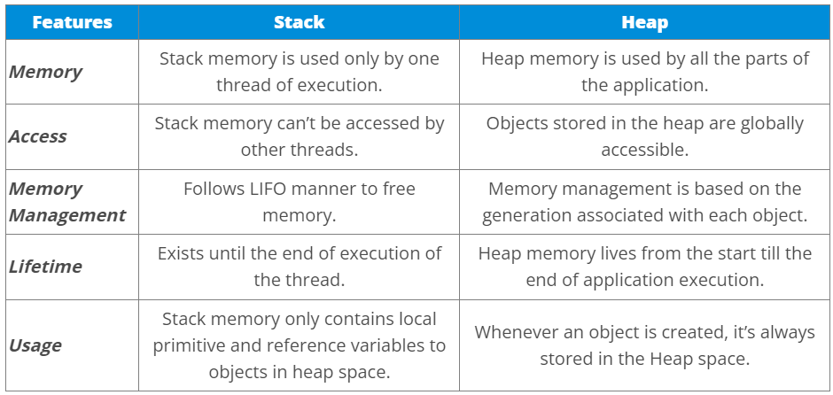

1. **Will the program run if we write static public void main?**

Yes, using Java you have some freedom with the order of the specifiers.

1. **Explain the expected output of the following code segment?**

public class Simplilearn

{

>public static void main (String args[])

>{

>>System.out.println(100 + 100 +“Simplilearn");

>>System.out.println(“E-Learning Company" + 100 + 100);

>}

}

Since there are only "+" operators in the above expressions, precedence is not a concern, the evaluation proceeds from left to right. The first output will be "200Simplilearn", because during the evaluation the two integers are added first, then since we use “+” for an integer and a string, Java takes the overload for the operator which concatenates two strings, converting the left side to a string.

The second output will be "E-Learning Company100100", because now the first operation is performed on a string and an integer, just like before, so it concatenates the two operands, the situation is the same with the second “+”.

1. **What is an Association?**

Association is the loosest type of connection between two objects, when there is no ownership or being part of something modelled.

Association is a relationship where all object have their own lifecycle and there is no owner. Let’s take the example of Teacher and Student. Multiple students can associate with a single teacher and a single student can associate with multiple teachers but there is no ownership between the objects and both have their own lifecycle. These relationships can be one to one, one to many, many to one and many to many.

1. **What do you mean by aggregation?**

An aggregation is a specialized form of Association where all object has their own lifecycle but there is ownership and child object can not belong to another parent object. Let’s take an example of Department and teacher. A single teacher can not belong to multiple departments, but if we delete the department teacher object will not destroy.

Aggregation can be defined as the relationship between two classes where the aggregate class contains a reference to the class it owns. Aggregation is best described as a has-a relationship. For example, The aggregate class Employee having various fields such as age, name, and salary also contains an object of Address class having various fields such as Address-Line 1, City, State, and pin-code. In other words, we can say that Employee (class) has an object of Address class. Consider the following example.

Address.java

public class Address {

>String city,state,country;

>public Address(String city, String state, String country) {

>>this.city = city;

>>this.state = state;

>>this.country = country;

>}

}

Employee.java

public class Emp {

>int id;

>String name;

>Address address;

>public Emp(int id, String name,Address address) {

>>this.id = id;

>>this.name = name;

>>this.address=address;

>}

>void display() {

>>System.out.println(id+" "+name);

>>System.out.println(address.city+" "+address.state+" "+address.country);

>}

>public static void main(String[] args) {

>>Address address1=new Address("gzb","UP","india");

>>Address address2=new Address("gno","UP","india");

>>Emp e=new Emp(111,"varun",address1);

>>Emp e2=new Emp(112,"arun",address2);

>>e.display();

>>e2.display();

>}

}

Output

111 varun

gzb UP india

112 arun

gno UP india

1. **Define Copy Constructor in Java**

Copy constructor is a member function that is used to initialize an object using another object of the same class.

There is no copy constructor in java. However, we can copy the values from one object to another like copy constructor in C++.

There are many ways to copy the values of one object into another in java. They are:

* By constructor
* By assigning the values of one object into another
* By clone() method of Object class

In this example, we are going to copy the values of one object into another using java constructor.

//Java program to initialize the values from one object to another

class Student6{

>int id;

>String name;

>//constructor to initialize integer and string

>Student6(int i,String n){

>id = i;

>name = n;

>}

>//constructor to initialize another object

>Student6(Student6 s){

>id = s.id;

>name =s.name;

>}

>void display(){System.out.println(id+" "+name);}

>public static void main(String args[]){

>Student6 s1 = new Student6(111,"Karan");

>Student6 s2 = new Student6(s1);

>s1.display();

>s2.display();

}

}

Output:

111 Karan

111 Karan

1. **What is a Marker Interface?**

In Java, a marker interface is an interface that does not declare any methods or fields. Its sole purpose is to mark or tag a class as having a certain characteristic or capability. By implementing a marker interface, a class indicates that it possesses specific behavior or qualifies for a particular treatment.

Marker interfaces are purely a convention and serve as a form of metadata. They provide a way for developers or frameworks to identify classes that meet certain criteria without requiring any additional methods or fields.

Some common examples of marker interfaces in Java include:

* Serializable: The Serializable interface is a marker interface that indicates a class can be serialized, allowing objects of that class to be converted into a byte stream for storage or transmission.
* Cloneable: The Cloneable interface is a marker interface that indicates a class can be cloned using the `clone()` method. Implementing this interface allows for creating a copy of an object.
* Remote: The Remote interface is a marker interface used in Java’s Remote Method Invocation (RMI) framework. It marks an interface that can be invoked remotely, enabling the execution of methods across different JVMs.

Marker interfaces can be useful in various scenarios, such as:

* + Providing hints to the Java runtime or frameworks about special handling or optimizations for certain classes.
  + Enabling conditional behavior based on the presence of a marker interface during runtime.
  + Supporting integration with external libraries or frameworks that recognize and operate on marker interfaces.

It’s important to note that with the introduction of annotations in Java, the use of marker interfaces has become less common. Annotations offer a more flexible and expressive way to attach metadata to classes and methods. However, marker interfaces still have their place in certain contexts and are part of the Java language’s design and heritage.

The marker interface can be declared as follows.

public interface Serializable {

}

1. **What is Object Cloning?**

It is the process of creating an exact copy of any object. In order to support this, a java class has to implement the Cloneable interface of java.lang package and override the clone() method provided by the Object class the syntax of which is:

protected Object clone() throws CloneNotSupportedException {

>return (Object) super.clone();

}

In case the Cloneable interface is not implemented and just the method is overridden, it results in CloneNotSupportedException in Java.

1. **Can Java be said to be the complete object-oriented programming language**

No, Java cannot be treated as a complete object-oriented programming language

1. **What is an object-oriented paradigm?**

It is a programming paradigm based on objects having data and methods defined in the class to which it belongs. Object-oriented paradigm aims to incorporate the advantages of modularity and reusability. Objects are the instances of classes which interacts with one another to design applications and programs. There are the following features of the object-oriented paradigm.

* Follows the bottom-up approach in program design.
* Focus on data with methods to operate upon the object's data
* Includes the concept like Encapsulation and abstraction which hides the complexities from the user and show only functionality.
* Implements the real-time approach like inheritance, abstraction, etc.
* The examples of the object-oriented paradigm are C++, Simula, Smalltalk, Python, C#, etc.

1. **Define Wrapper Classes in Java.**

Wrapper classes are classes that allow primitive types to be accessed as objects. In other words, we can say that wrapper classes are built-in java classes which allow the conversion of objects to primitives and primitives to objects. The process of converting primitives to objects is called autoboxing, and the process of converting objects to primitives is called unboxing. There are eight wrapper classes present in java.lang package is given below.

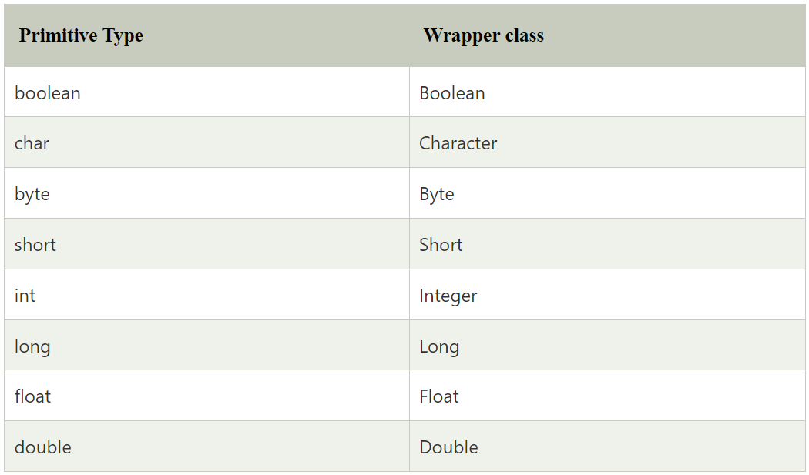

1. **What is a singleton class in Java? And How to implement a singleton class?**

A singleton class is a class which can only be instantiated once and only has one instance. One example to implement it is to set all constructors to private then add a static getter method to the class which returns that one instance (and instantiate it before if it haven’t been already).

One example to implement a singleton class:

class WaterJug{

private int waterQuantity = 500;

private WaterJug(){}

private WaterJug object = null;

// Method to provide the service of Giving Water.

public int getWater(int quantity){

> waterQuantity -= quantity;

> return quantity;

}

// Method to return the object to the user.

public static Waterjug getInstance(){

> // Will Create a new object if the object is not already created and return the object.

> if(object == null){

>> object = new WaterJug();

> }

> return object;

}

}

1. **Define package in Java.**

A package is a group of similar type of classes, interfaces, and sub-packages. It provides access protection and removes naming collision. The packages in Java can be categorized into two forms, inbuilt package, and user-defined package. There are many built-in packages such as Java, lang, awt, javax, swing, net, io, util, sql, etc. Consider the following example to create a package in Java.

//save as Simple.java

package mypack;

public class Simple {

>public static void main(String args[]) {

>>System.out.println("Welcome to package");

>}

}

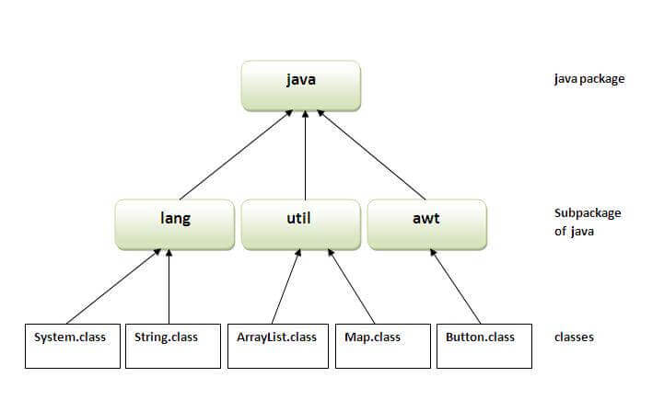

1. **Can you implement pointers in a Java Program?**

Java Virtual Machine takes care of memory management implicitly. Java's primary motto was to keep programming simple. So, accessing memory directly through pointers is not a recommended action as it can cause safety issues. Hence, pointers are eliminated in Java.

1. **Differentiate between instance and local variables.**

Variables declared on class-level can be accessed in any code inside that class, meanwhile local variables are declared in the functions which means they can only be accessed in their scope (the next “}”) and they don’t even exist continuously during the whole lifecycle of the given object.

1. **Explain Java String Pool.**

String pool is the space reserved in the heap memory that can be used to store the strings. The main advantage of using the String pool is whenever we create a string literal; the JVM checks the "string constant pool" first. If the string already exists in the pool, a reference to the pooled instance is returned. If the string doesn't exist in the pool, a new string instance is created and placed in the pool. Therefore, it saves the memory by avoiding the duplicacy.

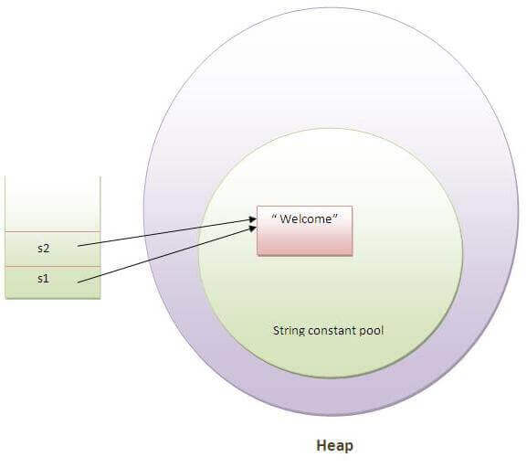

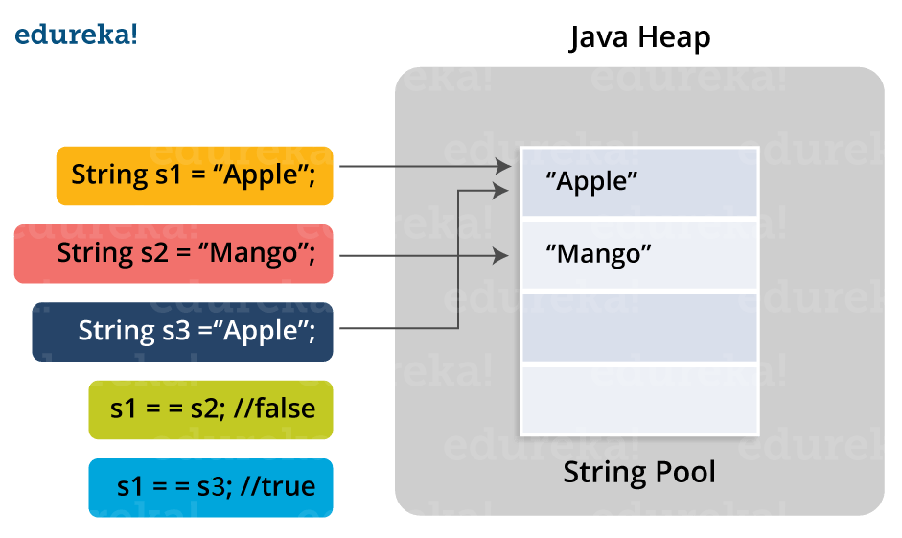

1. **What is an Exception? How does an exception propagate in the code?**

An Exception handling in Java is considered an unexpected event that can disrupt the program's normal flow. These events can be fixed through the process of Exception Handling.

An exception happens on the top level of the call stack, and it stops the running of the code. The JVM then starts to look in the call stack for the highest try-catch block with a compatible catch branch (same or ancestor class of the exception), and executes it. If no such block exists, the program crashes.

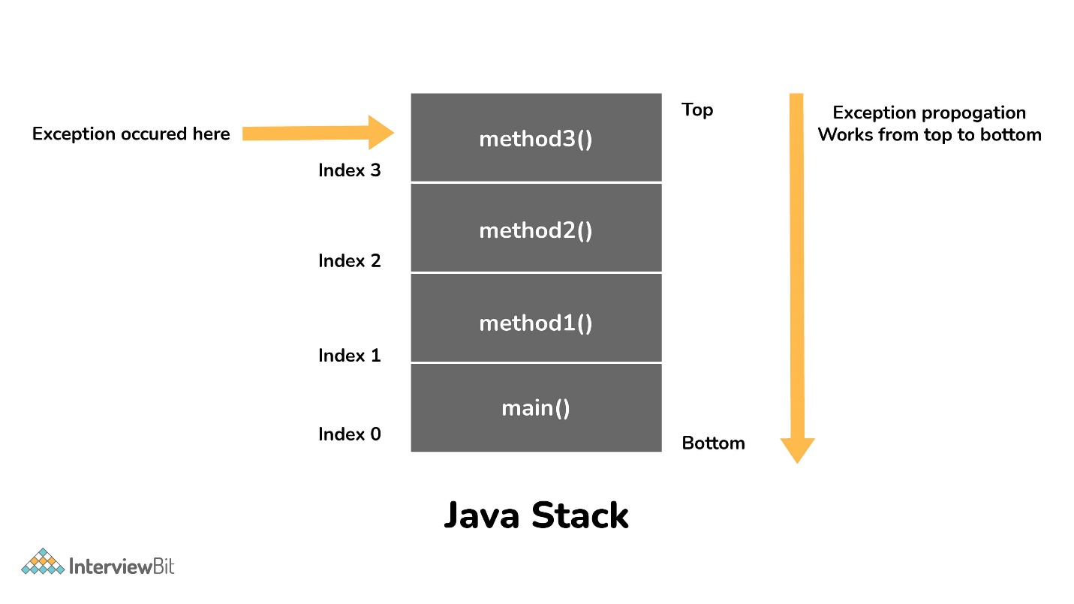

An exception is first thrown from the top of the stack and if it is not caught, it drops down the call stack to the previous method, If not caught there, the exception again drops down to the previous method, and so on until they are caught or until they reach the very bottom of the call stack. This procedure is called exception propagation. By default, checked exceptions are not propagated.

class TestExceptionPropagation1 {

>void m() {

>>int data = 50 / 0;

>}

>void n() {

>>m();

>}

>void p() {

>>try {

>>>n();

>>} catch (Exception e) {

>>>System.out.println("exception handled");

>>}

>}

>public static void main(String args[]) {

>>TestExceptionPropagation1 obj = new TestExceptionPropagation1();

>>obj.p();

>>System.out.println("normal flow...");

>}

}

Output:

exception handled

normal flow...

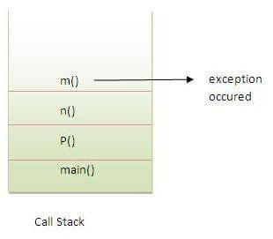

1. **What is the final keyword in Java?**

The term final is a predefined word in Java that is used while declaring values to variables. When a value is declared using the final keyword, then the variable's value remains constant throughout the program's execution.

1. **What happens when the main() isn't declared as static and why is it static?**

When the main method is not declared as static, then the program may be compiled correctly but ends up with a severe ambiguity and throws a run time error that reads "NoSuchMethodError." Java's main() function is static by default, allowing the compiler to call it either before or after creating a class object. The main () function is where the compiler begins programme execution in every Java programme. Thus, the main () method needs to be called by the compiler. If the main () method is permitted to be non-static, the JVM must instantiate its class when calling the function.

The main method is always static because static members are those methods that belong to the classes, not to an individual object. JVM calls the main method based on the class name itself, not by creating the object.

If we made the main method non-static, JVM would have to create its object first and then call main() method which will lead to the extra memory allocation.

1. **What part of memory - Stack or Heap - is cleaned in the garbage collection process?**

Heap as the memory area of the stack is freed automatically by the system.

1. **What is the difference between the program and the process?**

A program is a non-active entity which contains the code to perform its task. Process is the active, running instance of a program.

1. **What are the differences between constructor and method of a class in Java?**

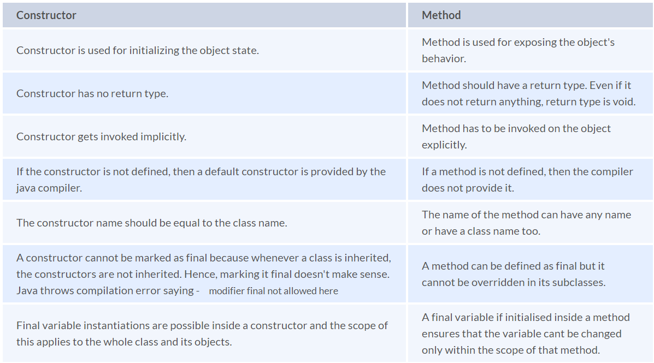

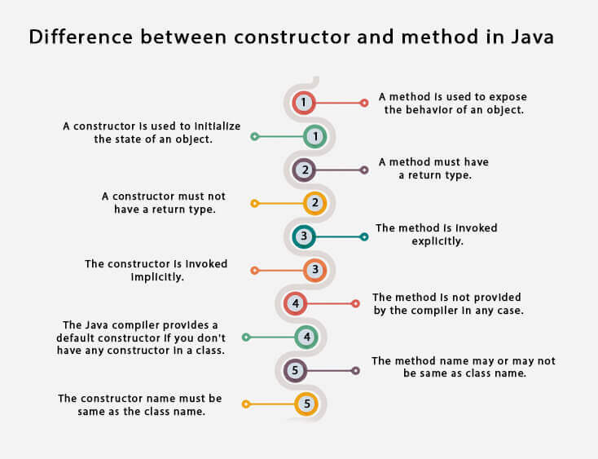

1. **Which among StringBuilder or StringBuffer should be preferred when there are a lot of updates required to be done in the data?**

Because StringBuilder is quicker than StringBuffer, it is advised to utilize it wherever possible. However, StringBuffer objects are the best choice if thread safety is required.

1. **Can we make the main() thread a daemon thread?**

This technique designates whether the active thread is a user thread or a daemon thread. For instance, tU.setDaemon(true) would convert a user thread named tU into a daemon thread. On the other side, executing tD.setDaemon(false) would convert a Daemon thread, tD, into a user thread.

1. **What happens if there are multiple main methods inside one class in Java?**

You can overload the main method, however, the one with the signature of “main(String[])” is the one which JVM will start when the program is started.

1. **Can you call a constructor of a class inside another constructor?**

Yes, the concept can be termed as constructor chaining and can be achieved using this().

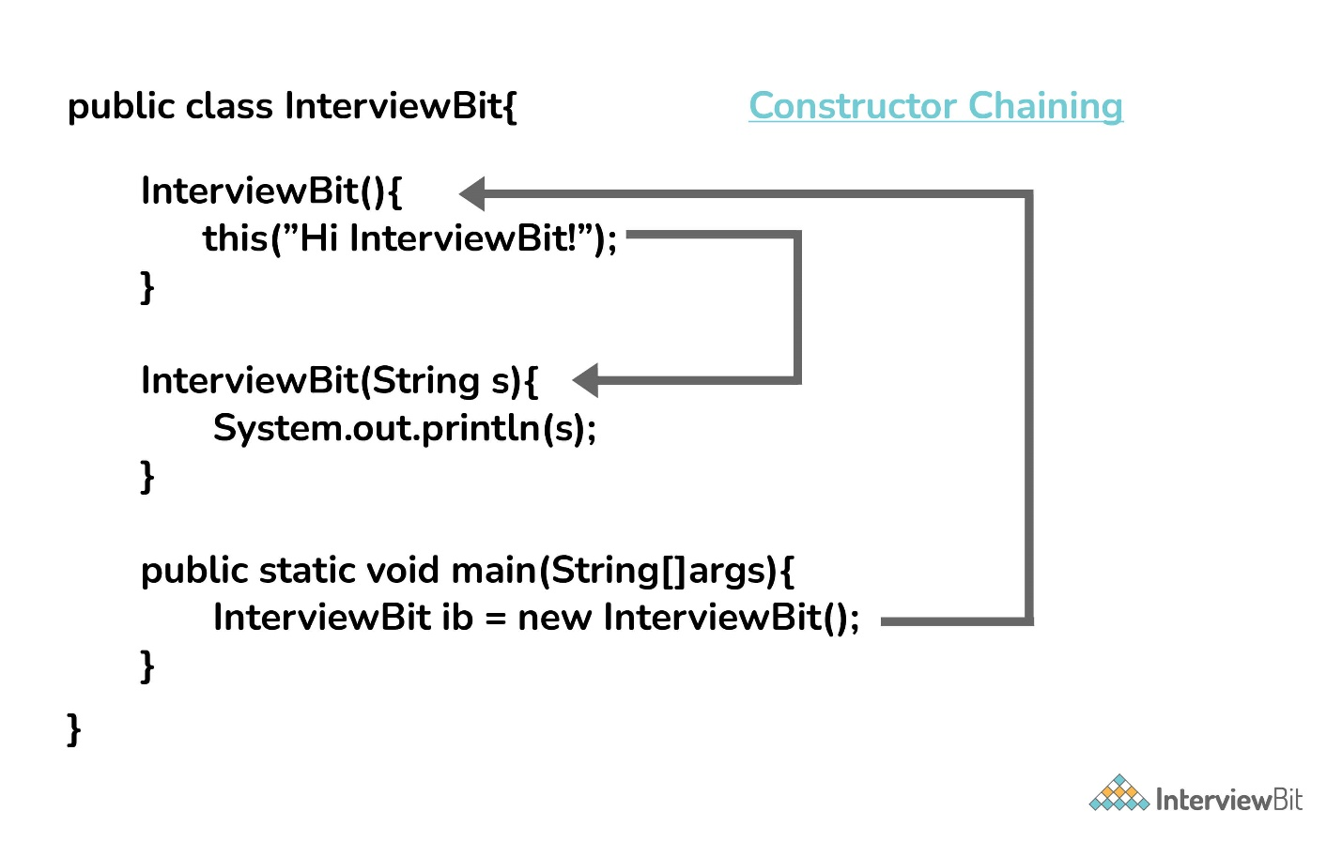

From the base class: The super() keyword is used to call the constructor from the base class.

The constructor chaining follows the process of inheritance. The constructor of the sub class first calls the constructor of the super class. Due to this, the creation of sub class’s object starts with the initialization of the data members of the super class. The constructor chaining works similarly with any number of classes. Every constructor keeps calling the chain till the top of the chain.

1. **Why does the Java array index start with 0?**

That’s because with arrays, the containing variable is a reference to the beginning of the array. The indexing is an offset from the beginning, so it starts with 0 because the first element in an array is right at the beginning.

This way the 0 index array avoids the extra arithmetic operation to calculate the memory address.

Example - Consider the array and assume each element takes 4-byte memory space. Then the address will be like this:

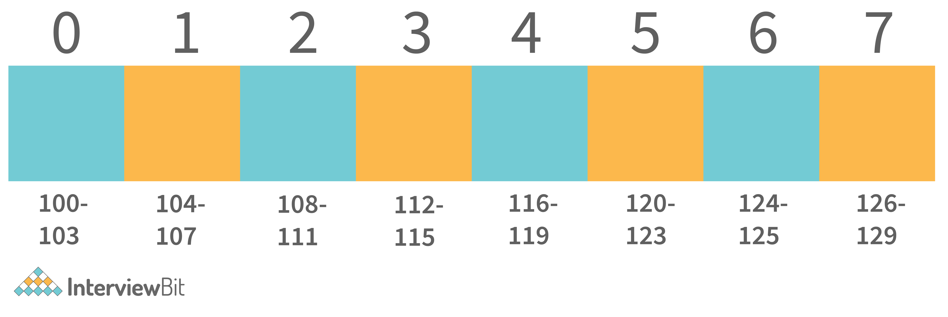

Now if we want to access index 4. Then internally java calculates the address using the formula:

[Base Address + (index * no_of_bytes)]. So according to this. The starting address of the index 4 will be - [100 + (4*4)] = 116. And exactly that's what the address is calculated.

Now consider the same with 1 index Array:

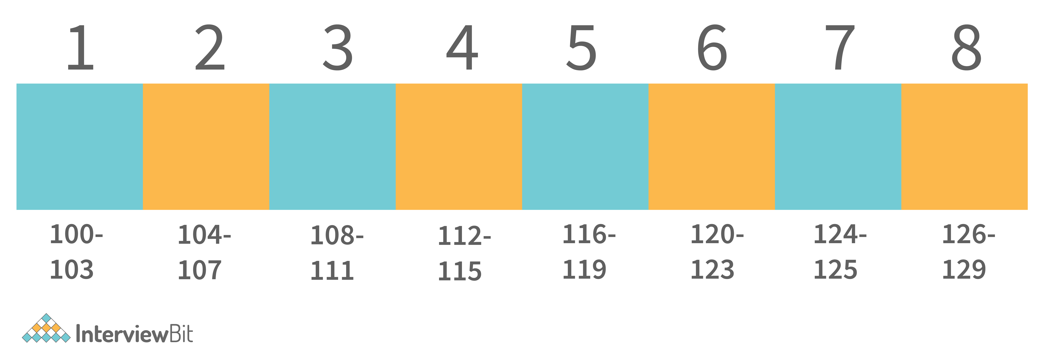

Now if we apply the same formula here. Then we get - 116 as the starting address of the 4th index. Which is wrong. Then we need to apply formula - [Base Address + ((index-1) * no_of_bytes)].

And for calculating this, an extra arithmetic operation has to be performed. And consider the case where millions of addresses need to be calculated, this causes complexity. So to avoid this, ) the index array is supported by java.

1. **Why is the remove method faster in the linked list than in an array?**

Because less operations have to be performed. In an array, when deleting an item, all the following items have to be shifted by one to the direction of the beginning in the array. In a linked list only the neighboring elements have to be updated, more precisely their reference to the previous and next element.

In the linked list, we only need to adjust the references when we want to delete the element from either end or the front of the linked list. But in the array, indexes are used. So to manage proper indexing, we need to adjust the values from the array So this adjustment of value is costlier than the adjustment of references.

Example: To Delete from the front of the linked list, internally the references adjustments happened like this.

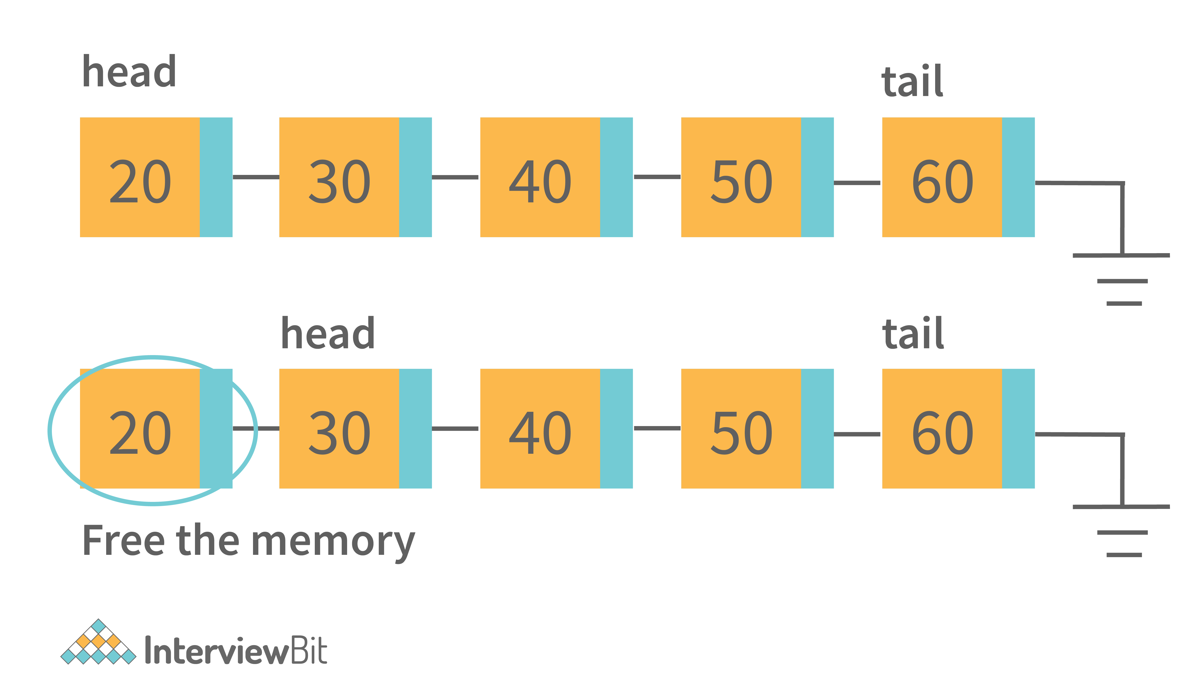

The only thing that will change is that the head pointer will point to the head’s next node. And delete the previous node. That is the constant time operation.

Whereas in the ArrayList, internally it should work like this:

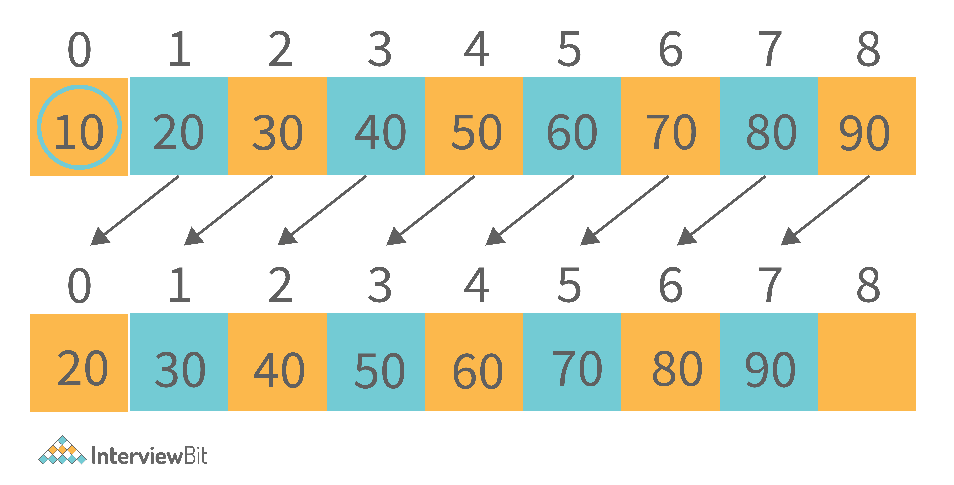

For deletion of the first element, all the next element has to move to one place ahead. So this copying value takes time. So that is the reason why removing in ArrayList is slower than LinkedList.

1. **How many overloaded add() and addAll() methods are available in the List interface? Describe the need and uses.**

There are a total of 4 overloaded methods for add() and addAll() methods available in List Interface. The below table states the description of all.

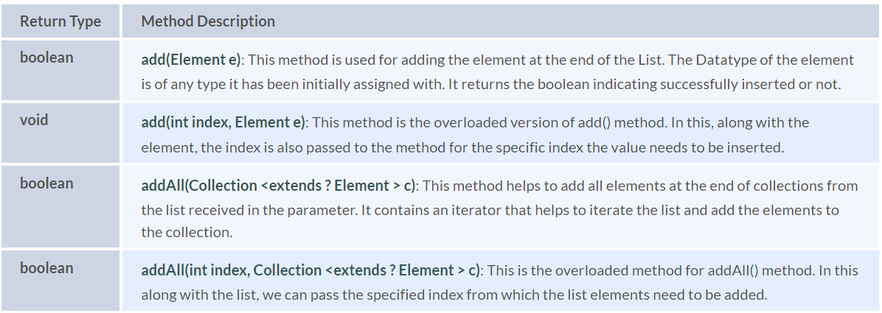

1. **How does the size of ArrayList grow dynamically? And also state how it is implemented internally?**

ArrayList is implemented in such a way that it can grow dynamically. We don't need to specify the size of ArrayList. For adding the values in it, the methodology it uses is:

1. Consider initially that there are 2 elements in the ArrayList. [2, 3].



2. If we need to add the element into this. Then internally what will happen is:

* ArrayList will allocate the new ArrayList of Size (current size + half of the current size). And add the old elements into the new. Old - [2, 3],>New - [2, 3, null].

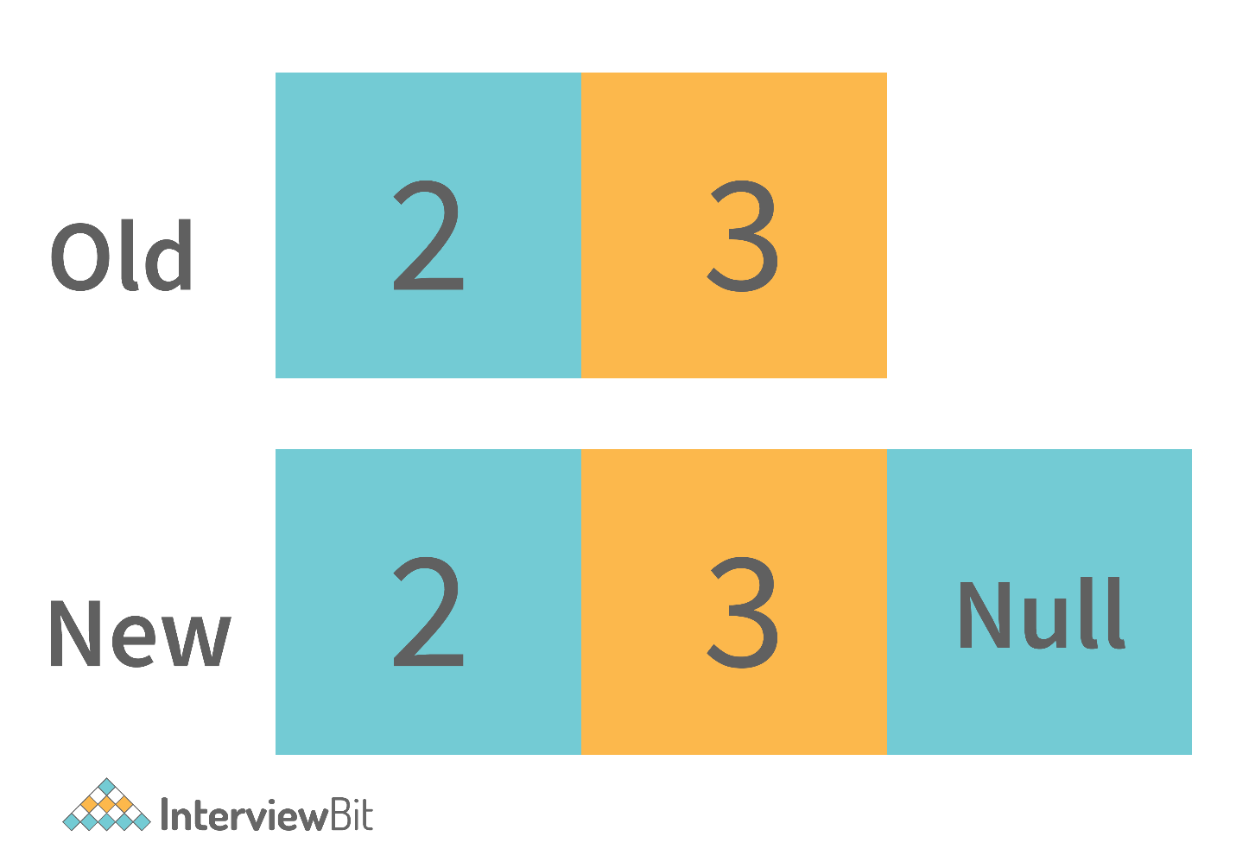

* Then the new value will be inserted into it. [2, 3, 4, null]. And for the next time, the extra space will be available for the value to be inserted.



3. This process continues and the time taken to perform all of these is considered as the amortized constant time.

This is how the ArrayList grows dynamically. And when we delete any entry from the ArrayList then the following steps are performed.

1. It searches for the element index in the array. Searching takes some time. Typically it’s O(n) because it needs to search for the element in the entire array.

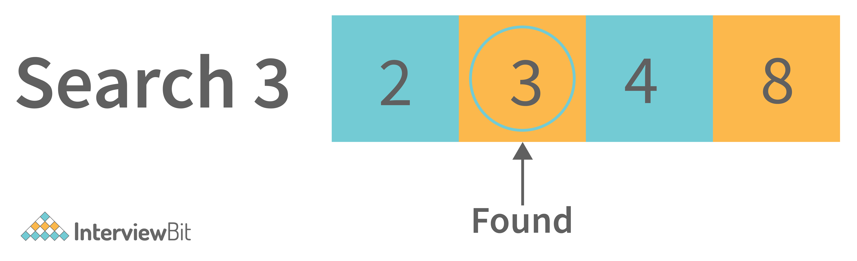

2. After searching the element, it needs to shift the element from the right side to fill the index.

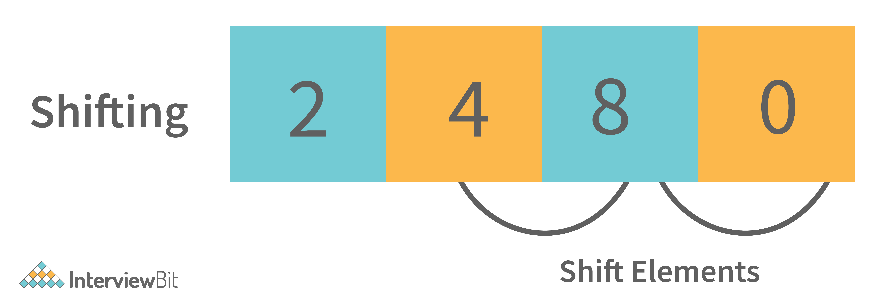

So this is how the elements are deleted from the ArrayList internally. Similarly, the search operations are also implemented internally as defined in removing elements from the list (searching for elements to delete).

1. **How is the creation of a String using new() different from that of a literal?**

When a String is formed as a literal with the assistance of an assignment operator, it makes its way into the String constant pool so that String Interning can take place. This same object in the heap will be referenced by a different String if the content is the same for both of them.

public bool checking() {

>String first = "InterviewBit";

>String second = "InterviewBit";

>if (first == second)

>>return true;

>else

>>return false;

}

The checking() function will return true as the same content is referenced by both the variables.

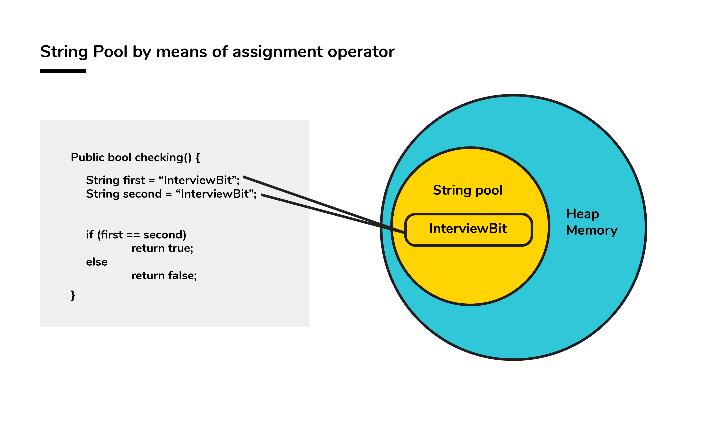

Conversely, when a String formation takes place with the help of a new() operator, interning does not take place. The object gets created in the heap memory even if the same content object is present.

public bool checking() {

>String first = new String("InterviewBit");

>String second = new String("InterviewBit");

>if (first == second)

>>return true;

>else

>>return false;

}

The checking() function will return false as the same content is not referenced by both the variables.

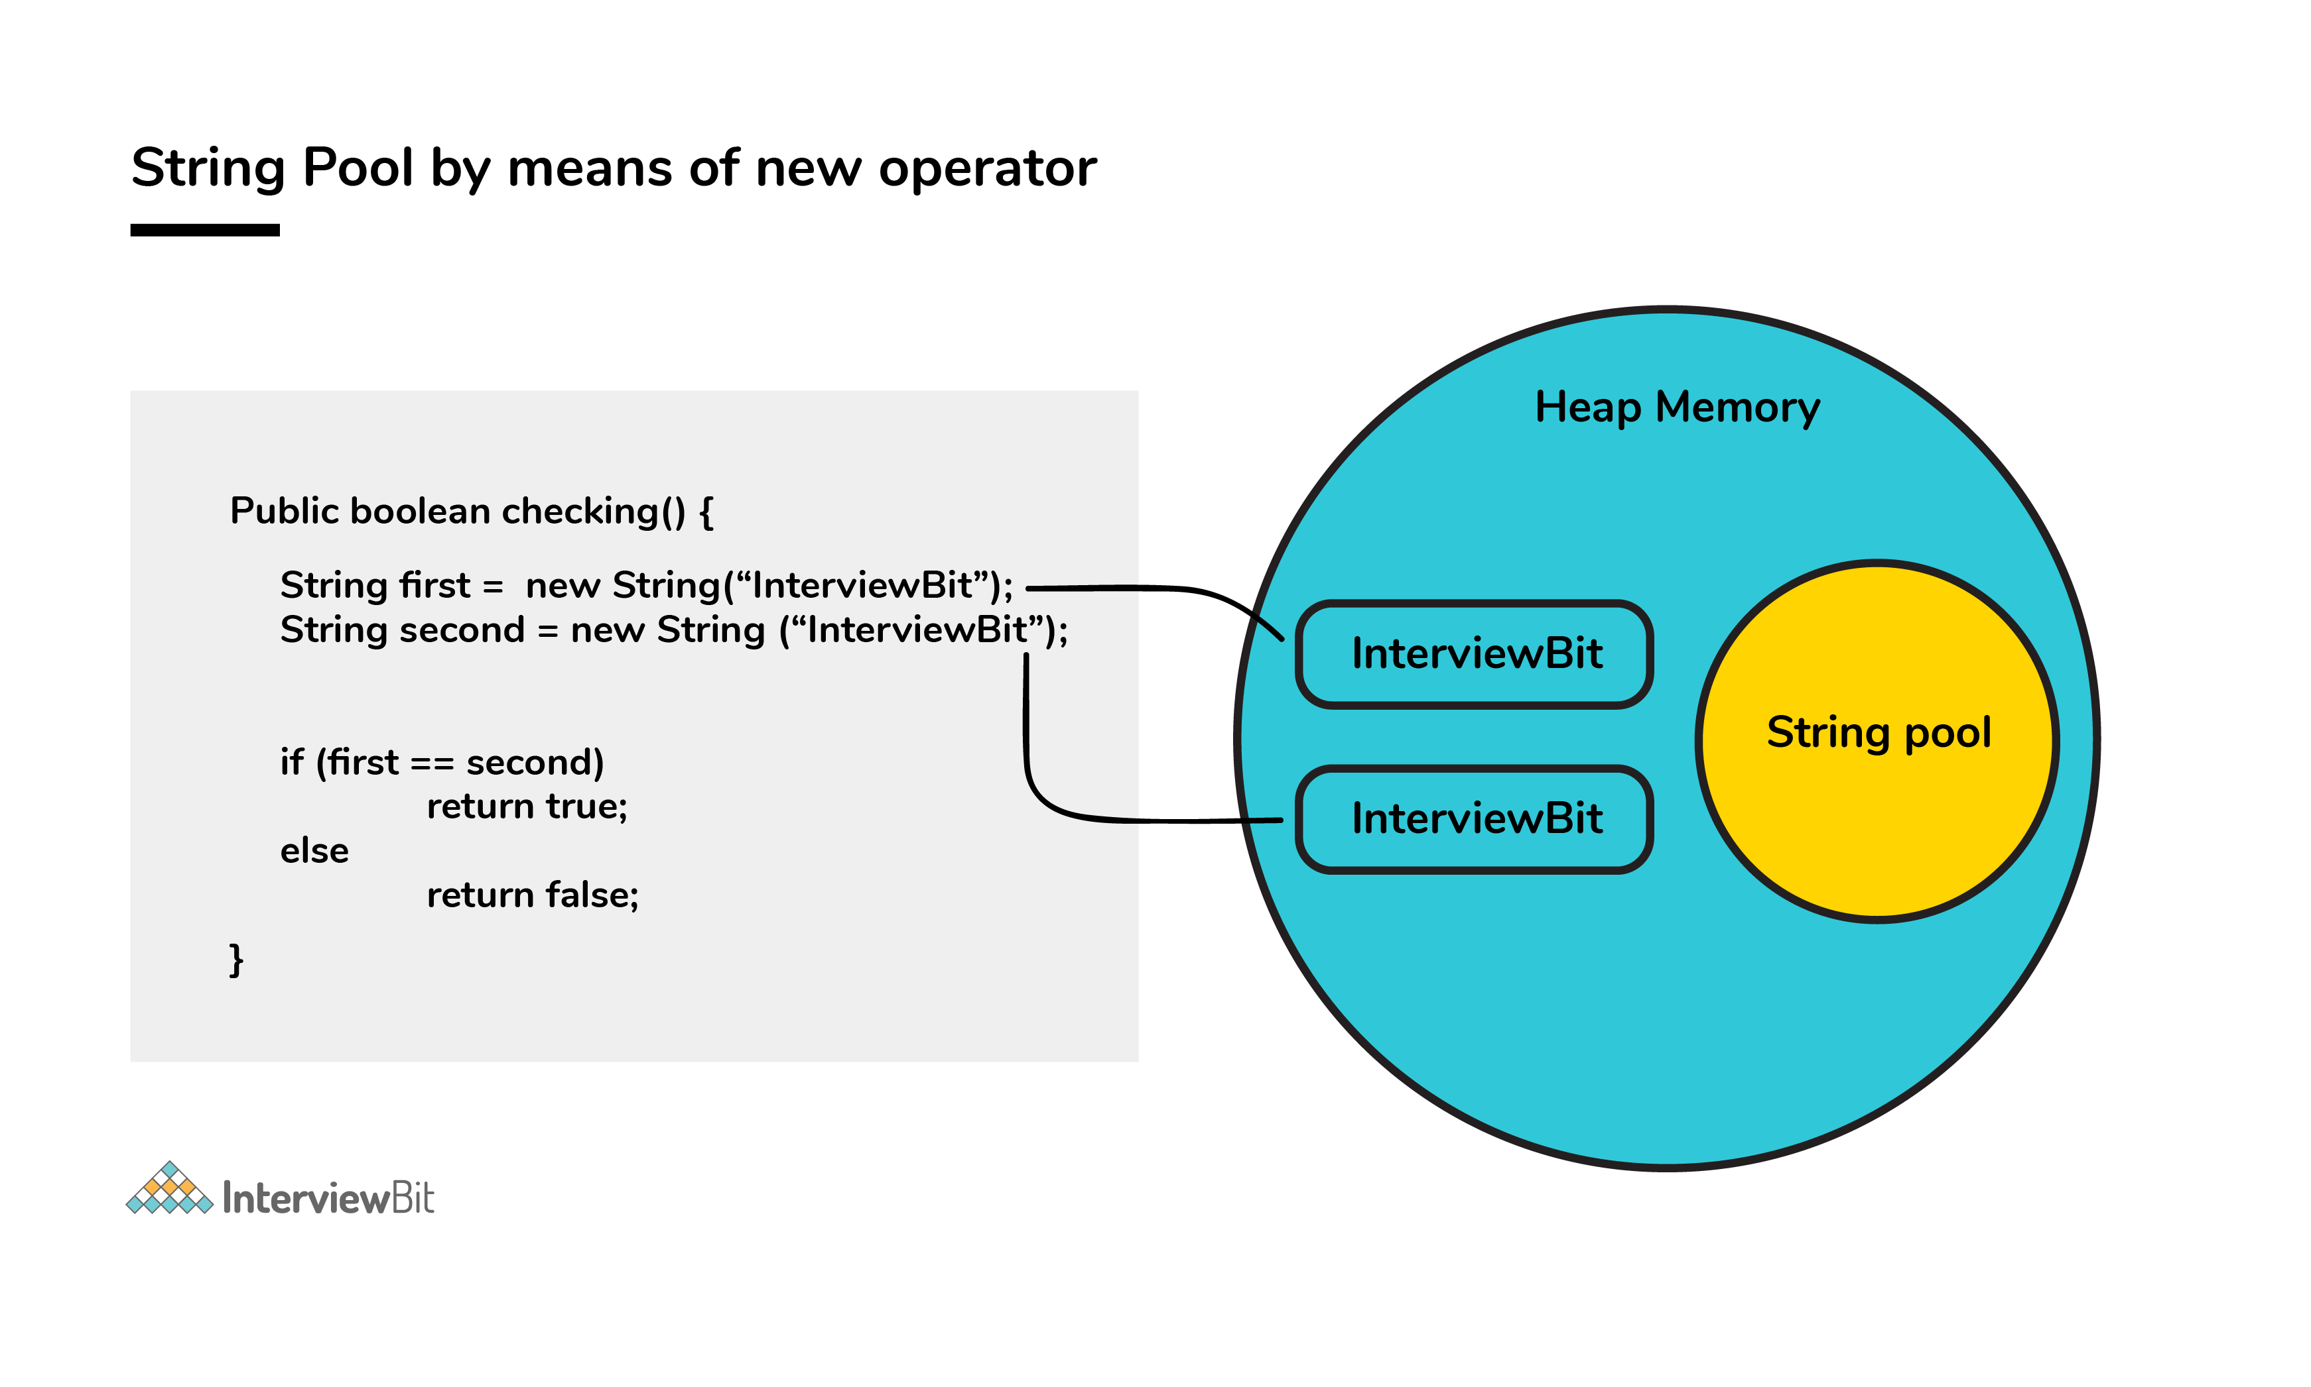

1. **How is the ‘new' operator different from the ‘newInstance()' operator in java?**

Both ‘new’ and ‘newInstance()’ operators are used to creating objects. The difference is- that when we already know the class name for which we have to create the object then we use a new operator. But suppose we don’t know the class name for which we need to create the object, Or we get the class name from the command line argument, or the database, or the file. Then in that case we use the ‘newInstance()’ operator.

The ‘newInstance()’ keyword throws an exception that we need to handle. It is because there are chances that the class definition doesn’t exist, and we get the class name from runtime. So it will throw an exception.

1. **Is exceeding the memory limit possible in a program despite having a garbage collector?**

Yes, it is possible for the program to go out of memory in spite of the presence of a garbage collector. Garbage collection assists in recognizing and eliminating those objects which are not required in the program anymore, in order to free up the resources used by them.

In a program, if an object is unreachable, then the execution of garbage collection takes place with respect to that object. If the amount of memory required for creating a new object is not sufficient, then memory is released for those objects which are no longer in the scope with the help of a garbage collector. The memory limit is exceeded for the program when the memory released is not enough for creating new objects.

Moreover, exhaustion of the heap memory takes place if objects are created in such a manner that they remain in the scope and consume memory. The developer should make sure to dereference the object after its work is accomplished. Although the garbage collector endeavors its level best to reclaim memory as much as possible, memory limits can still be exceeded.

Let’s take a look at the following example:

List<String> example = new LinkedList<String>();

while(true) {

>example.add(new String("Memory Limit Exceeded"));

}

1. **Why is synchronization necessary? Explain with the help of a relevant example.**

Concurrent execution of different processes is made possible by synchronization. When a particular resource is shared between many threads, situations may arise in which multiple threads require the same shared resource.

Synchronization assists in resolving the issue and the resource is shared by a single thread at a time. Let’s take an example to understand it more clearly. For example, you have a URL and you have to find out the number of requests made to it. Two simultaneous requests can make the count erratic.

No synchronization:

package anonymous;

public class Counting {

> private int increase_counter;

> public int increase() {

>>> increase_counter = increase_counter + 1;

>>> return increase_counter;

> }

}

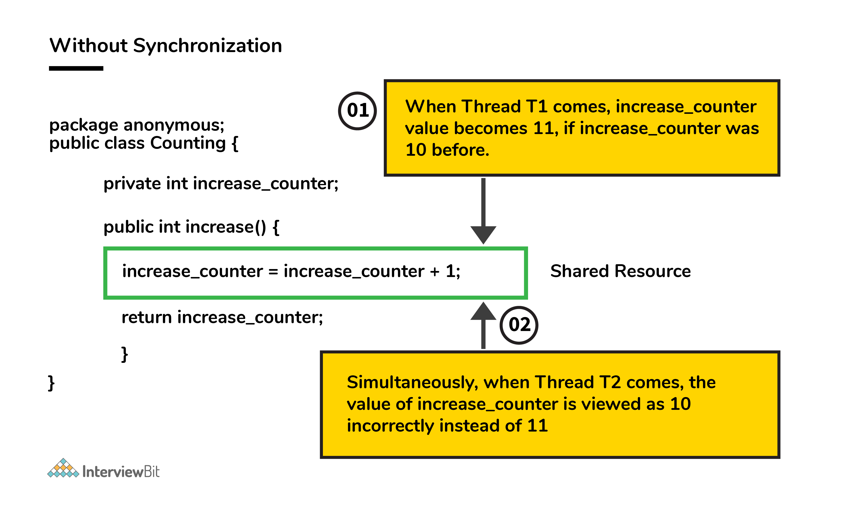

If a thread Thread1 views the count as 10, it will be increased by 1 to 11. Simultaneously, if another thread Thread2 views the count as 10, it will be increased by 1 to 11. Thus, inconsistency in count values takes place because the expected final value is 12 but the actual final value we get will be 11.

Now, the function increase() is made synchronized so that simultaneous accessing cannot take place.

With synchronization:

package anonymous;

public class Counting {

> private int increase_counter;

> public synchronized int increase() {

>>> increase_counter = increase_counter + 1;

>>> return increase_counter;

> }

}

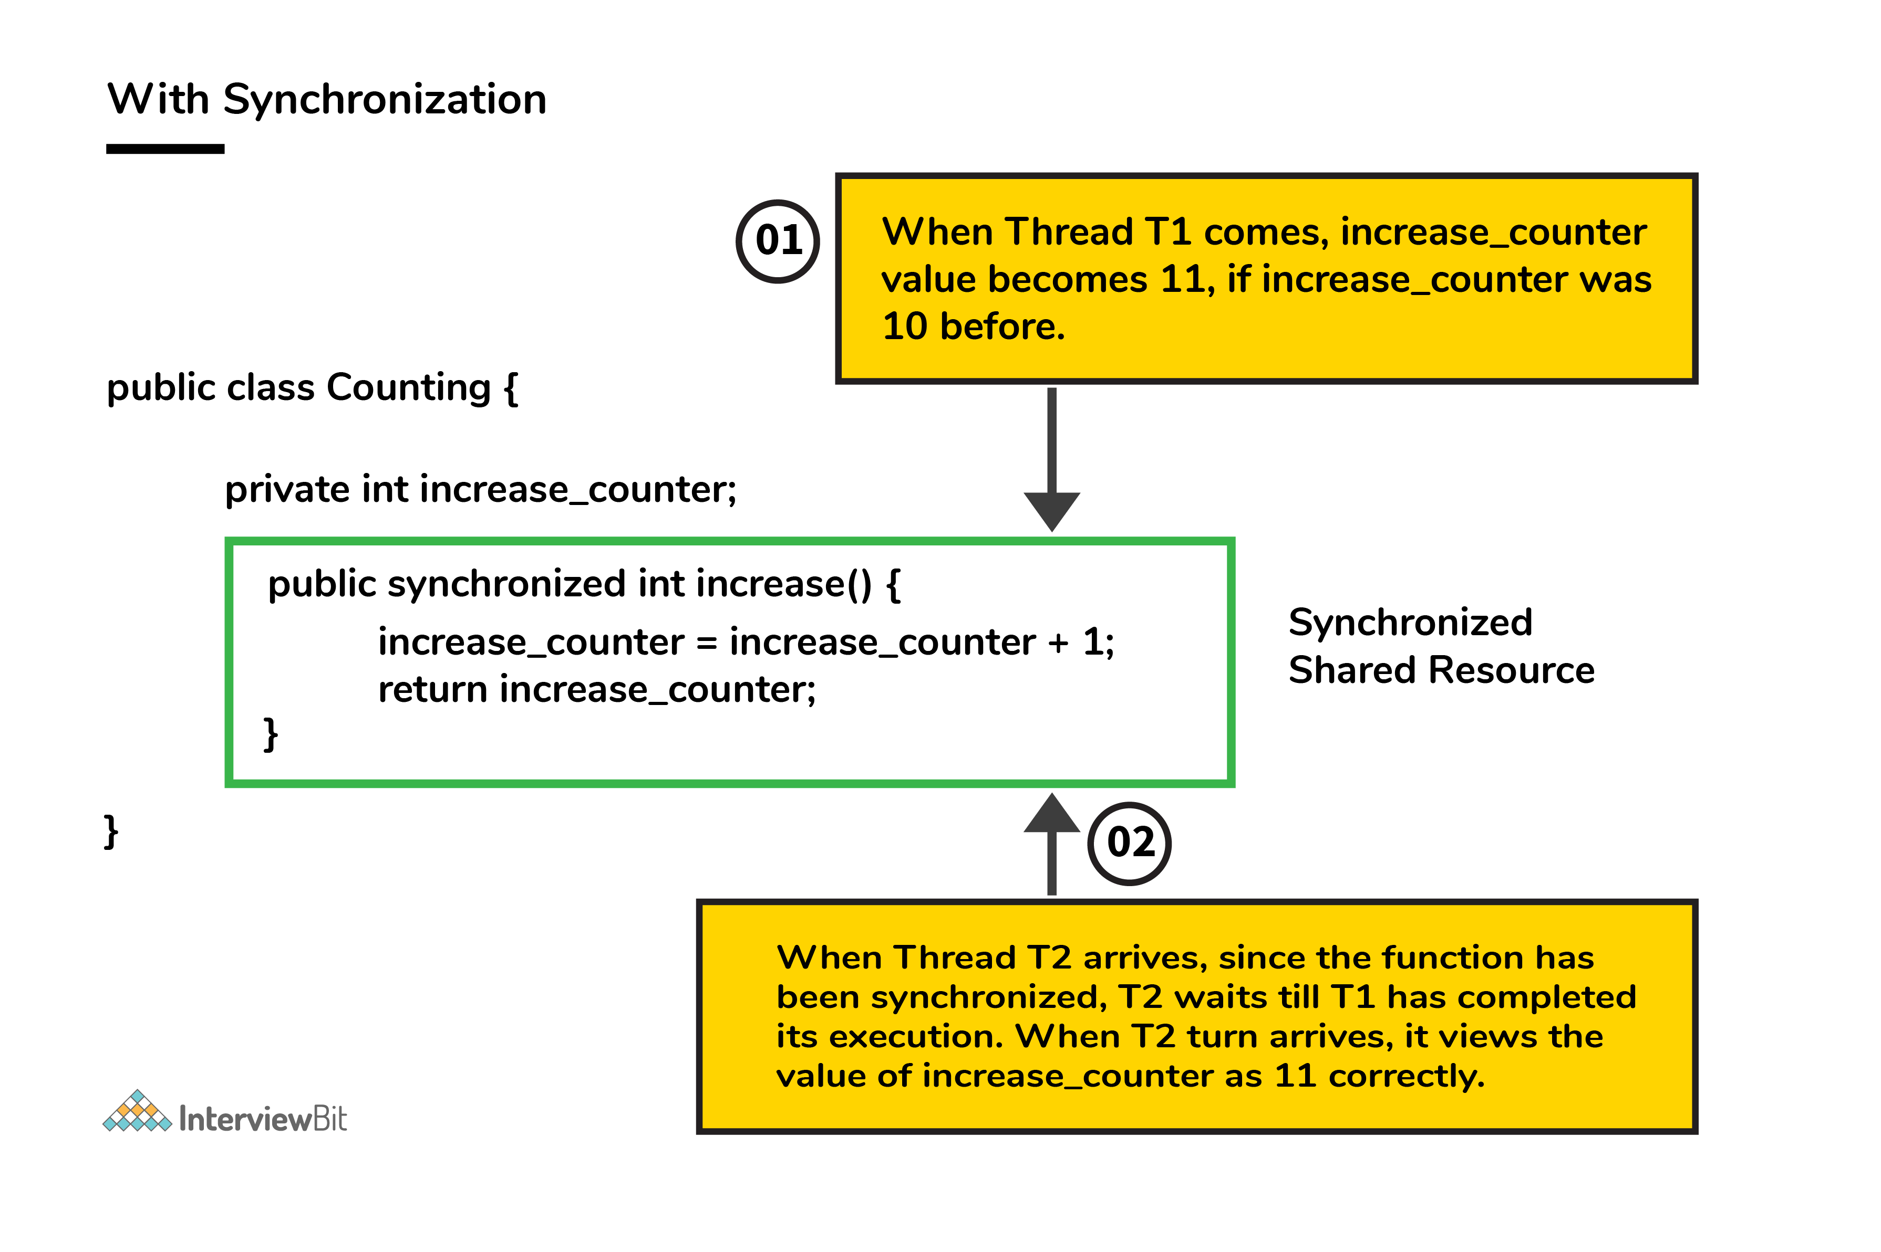

If a thread Thread1 views the count as 10, it will be increased by 1 to 11, then the thread Thread2 will view the count as 11, it will be increased by 1 to 12. Thus, consistency in count values takes place.

1. **Define System.out.println().**

System.out.println() is used to print the message on the console. System - It is a class present in java.lang package. Out is the static variable of type PrintStream class present in the System class. println() is the method present in the PrintStream class. It prints its argument to the standard output.

So if we justify the statement, then we can say that if we want to print anything on the console then we need to call the println() method that was present in PrintStream class. And we can call this using the output object that is present in the System class.

1. **Can you explain the Java thread lifecycle?**

Java thread life cycle is as follows:

* New – When the instance of the thread is created and the start() method has not been invoked, the thread is considered to be alive and hence in the NEW state.
* Runnable – Once the start() method is invoked, before the run() method is called by JVM, the thread is said to be in RUNNABLE (ready to run) state. This state can also be entered from the Waiting or Sleeping state of the thread.
* Running – When the run() method has been invoked and the thread starts its execution, the thread is said to be in a RUNNING state.
* Non-Runnable (Blocked/Waiting) – When the thread is not able to run despite the fact of its aliveness, the thread is said to be in a NON-RUNNABLE state. Ideally, after some time of its aliveness, the thread should go to a runnable state.
  + A thread is said to be in a Blocked state if it wants to enter synchronized code but it is unable to as another thread is operating in that synchronized block on the same object. The first thread has to wait until the other thread exits the synchronized block.
  + A thread is said to be in a Waiting state if it is waiting for the signal to execute from another thread, i.e it waits for work until the signal is received.
* Terminated – Once the run() method execution is completed, the thread is said to enter the TERMINATED step and is considered to not be alive.

The following flowchart clearly explains the lifecycle of the thread in Java.

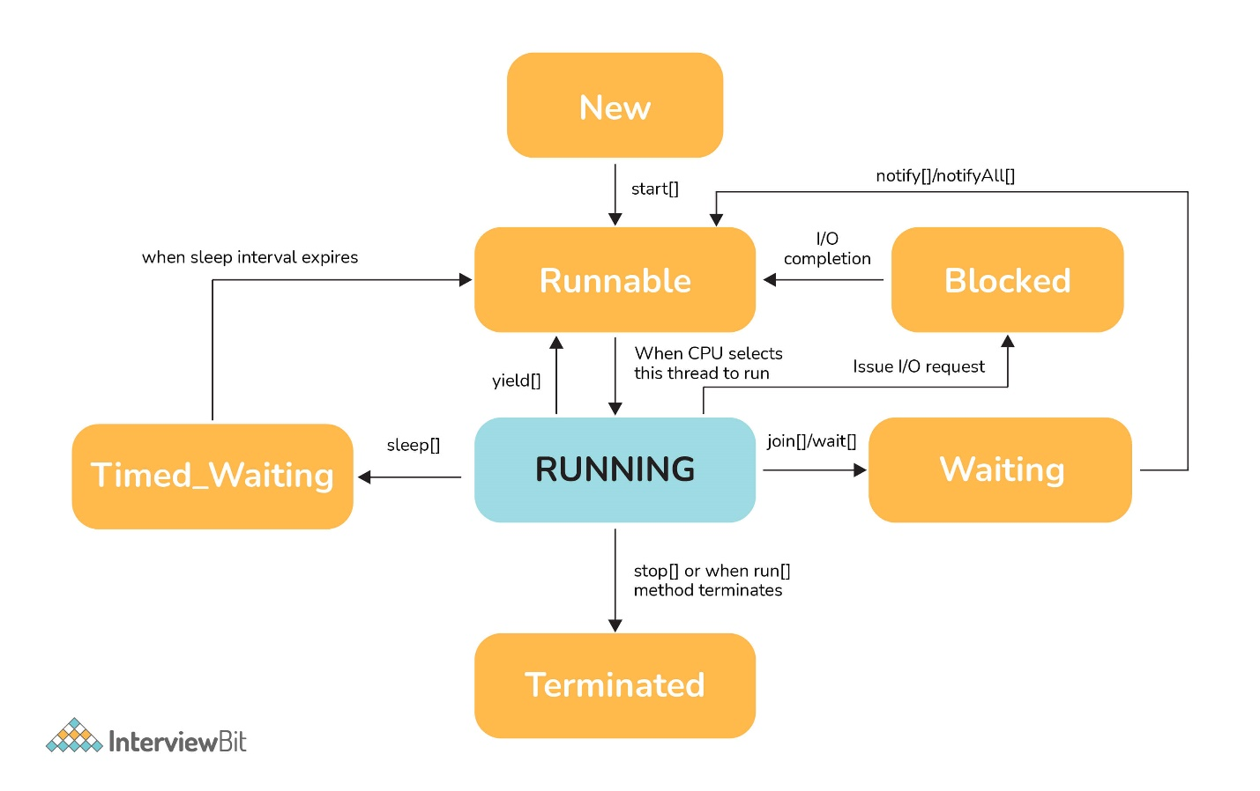

1. **What could be the tradeoff between the usage of an unordered array versus the usage of an ordered array?**

* The main advantage of having an ordered array is the reduced search time complexity of O(log n) whereas the time complexity in an unordered array is O(n).
* The main drawback of the ordered array is its increased insertion time which is O(n) due to the fact that its element has to reordered to maintain the order of array during every insertion whereas the time complexity in the unordered array is only O(1).
* Considering the above 2 key points and depending on what kind of scenario a developer requires, the appropriate data structure can be used for implementation.

1. **Is it possible to import the same class or package twice in Java and what happens to it during runtime?**

One can import the same package or the same class multiple times. Neither compiler nor JVM complains about it. However, the JVM will internally load the class only once no matter how many times you import the same class.

1. **In case a package has sub packages, will it suffice to import only the main package? e.g. Does importing of com.myMainPackage.* also import com.myMainPackage.mySubPackage.*?**

Sub-packages won't be imported when a package is imported. When you import a package, all of its classes and interfaces—with the exception of those from its sub-packages—are imported.

1. **Will the final block be executed if the code System.exit(0) is written at the end of the try block?**

NO. The control of the program post System.exit(0) is immediately gone and the program gets terminated which is why the finally block never gets executed.

1. **Explain the term “Double Brace Initialization” in Java?**

This is a convenient means of initializing any collections in Java. Consider the below example.

import java.util.HashSet;

import java.util.Set;

public class IBDoubleBraceDemo{

public static void main(String[] args){

> Set<String> stringSets = new HashSet<String>()

> {

>> {

>>> add("set1");

>>> add("set2");

>>> add("set3");

>> }

> };

> doSomething(stringSets);

}

private static void doSomething(Set<String> stringSets){

> System.out.println(stringSets);

}

}

In the above example, we see that the stringSets were initialized by using double braces.

The first brace does the task of creating an anonymous inner class that has the capability of accessing the parent class’s behavior. In our example, we are creating the subclass of HashSet so that it can use the add() method of HashSet.

The second brace is an initialization block.

Care should be taken while initializing through this method as the method involves the creation of anonymous inner classes which can cause problems during the garbage collection or serialization processes and may also result in memory leaks.

1. **Why is it said that the length() method of String class doesn't return accurate results?**

* The length method returns the number of Unicode units of the String. Let's understand what Unicode units are and what is the confusion below.
* We know that Java uses UTF-16 for String representation. With this Unicode, we need to understand the below two Unicode related terms:
  + Code Point: This represents an integer denoting a character in the code space.
  + Code Unit: This is a bit sequence used for encoding the code points. In order to do this, one or more units might be required for representing a code point.
* Under the UTF-16 scheme, the code points were divided logically into 17 planes and the first plane was called the Basic Multilingual Plane (BMP). The BMP has classic characters - U+0000 to U+FFFF. The rest of the characters- U+10000 to U+10FFFF were termed as the supplementary characters as they were contained in the remaining planes.
  + The code points from the first plane are encoded using one 16-bit code unit
  + The code points from the remaining planes are encoded using two code units.

Now if a string contained supplementary characters, the length function would count that as 2 units and the result of the length() function would not be as per what is expected.

In other words, if there is 1 supplementary character of 2 units, the length of that SINGLE character is considered to be TWO - Notice the inaccuracy here? As per the java documentation, it is expected, but as per the real logic, it is inaccurate.

1. **What are the possible ways of making objects eligible for garbage collection (GC) in Java?**

First Approach: Set the object references to null once the object creation purpose is served.

public class IBGarbageCollect {

public static void main (String [] args){

> String s1 = "Some String";

>> // s1 referencing String object - not yet eligible for GC

> s1 = null; // now s1 is eligible for GC

}

}

Second Approach: Point the reference variable to another object. Doing this, the object which the reference variable was referencing before becomes eligible for GC.

public class IBGarbageCollect {

public static void main(String [] args){

> String s1 = "To Garbage Collect";

> String s2 = "Another Object";

> System.out.println(s1); // s1 is not yet eligible for GC

> s1 = s2; // Point s1 to other object pointed by s2

> /* Here, the string object having the content "To Garbage Collect" is not referred by any reference variable. Therefore, it is eligible for GC */

}

}

Third Approach: Island of Isolation Approach: When 2 reference variables pointing to instances of the same class, and these variables refer to only each other and the objects pointed by these 2 variables don't have any other references, then it is said to have formed an “Island of Isolation” and these 2 objects are eligible for GC.

public class IBGarbageCollect {

IBGarbageCollect ib;>

public static void main(String [] str){

> IBGarbageCollect ibgc1 = new IBGarbageCollect();

> IBGarbageCollect ibgc2 = new IBGarbageCollect();

> ibgc1.ib = ibgc2; //ibgc1 points to ibgc2

> ibgc2.ib = ibgc1; //ibgc2 points to ibgc1

> ibgc1 = null;

> ibgc2 = null;

> /*

> * We see that ibgc1 and ibgc2 objects refer

> * to only each other and have no valid

> * references- these 2 objects for island of isolcation - eligible for GC

> */

}

}

1. **What is the best way to inject dependency? Also, state the reason.**

The best way to inject dependencies in an application is through constructor injection. Constructor injection involves passing dependencies as parameters to a class’s constructor. Here are the reasons why constructor injection is considered the best approach:

* Explicit dependencies: Constructor injection makes dependencies explicit, as they are clearly defined as constructor parameters. This improves code readability and makes it easier to understand the class’s dependencies.
* Compile-time safety: With constructor injection, dependencies are resolved at compile-time rather than runtime. This allows for early detection of missing or incorrect dependencies, reducing the chances of runtime errors.
* Testability: Constructor injection facilitates easy testing of classes by allowing for the injection of mock or stub dependencies during unit testing. By providing test doubles through the constructor, you can isolate the class under test and verify its behavior without relying on real dependencies.
* Immutability: Constructor injection promotes immutability as dependencies can be declared as final or read-only. Immutable objects are generally easier to reason about and less prone to bugs related to state changes.
* Dependency inversion principle: Constructor injection adheres to the Dependency Inversion Principle (DIP) of the SOLID principles. DIP states that high-level modules should not depend on low-level modules, but both should depend on abstractions. Constructor injection allows for the injection of abstractions rather than concrete implementations, enabling flexibility and loose coupling between classes.

While other dependency injection techniques like setter injection and field injection exist, they have certain drawbacks compared to constructor injection. Setter injection can lead to optional dependencies or unexpected null values, while field injection tightly couples classes and makes it harder to identify dependencies. Hence, constructor injection is generally recommended as the best way to inject dependencies.

1. **How we can set the spring bean scope. And what supported scopes does it have?**

There are four supported scopes of a Spring bean: singleton, prototype, request, and session.

The singleton scope creates a single instance of a bean, which is shared by all objects that request it.

The prototype scope creates a new instance of a bean for each object that requests it.

The request and session scopes are only available in a web-based context. The request scope creates a new bean instance for each HTTP request, and the session scope creates a single instance of a bean shared by all objects in a single HTTP session.

The ways we can set a scope are using the @Scope annotation or the scope attribute in the configuration XML file.

To set the scope using the `@Scope` annotation, you can specify it on the bean class or the bean definition method within a configuration class. Here’s an example:

@Configuration

public class MyConfig {

>@Bean

>@Scope("singleton")

>public MyBean singletonBean() {

>>return new MyBean();

>}

>@Bean

>@Scope("prototype")

>public MyBean prototypeBean() {

>>return new MyBean();

>}

}

In this example, the `singletonBean` method is annotated with `@Scope(“singleton”)`, indicating that the bean will have a singleton scope. The `prototypeBean` method is annotated with `@Scope(“prototype”)`, specifying a prototype scope.

1. **What are the different categories of Design patterns?**

Design patterns are categorized into the following different types. And those are also further categorized as

Structural patterns:

* Adapter
* Bridge
* Filter
* Composite
* Decorator
* Facade
* Flyweight
* Proxy

Behavioral patterns:

* Interpreter
* Template method/ pattern
* Chain of responsibility
* Command pattern
* Iterator pattern
* Strategy pattern
* Visitor pattern

J2EE patterns:

* MVC Pattern
* Data Access Object pattern
* Front controller pattern
* Intercepting filter pattern
* Transfer object pattern

Creational patterns:

* Factory method/Template
* Abstract Factory
* Builder
* Prototype
* Singleton

1. **What is a Memory Leak? Discuss some common causes of it.**

The Java Garbage Collector (GC) typically removes unused objects when they are no longer required, but when they are still referenced, the unused objects cannot be removed. So this causes the memory leak problem. Example: Consider a linked list like the structure below:

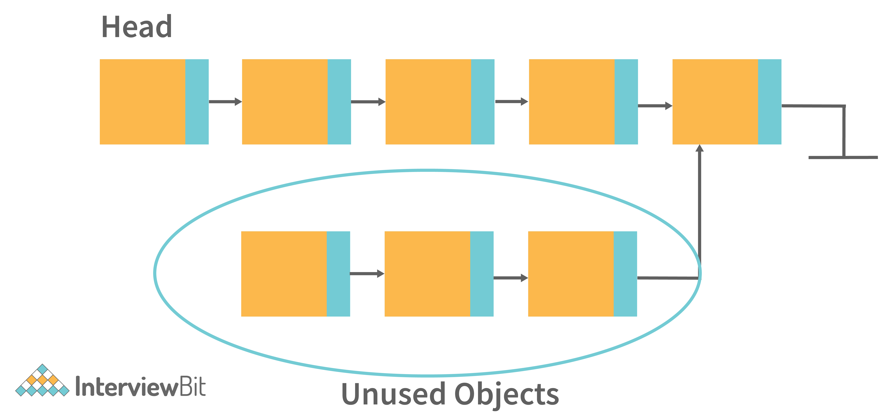

In the above image, there are unused objects that are not referenced. But then also Garbage collection will not free it. Because it is referencing some existing referenced object. So this can be the situation of memory leak.

Some common causes of Memory leaks are -

* When there are Unbounded caches.
* Excessive page swapping is done by the operating system.
* Improper written custom data structures.
* Inserting into a collection object without first deleting it.
* etc.

1. **Assume a thread has a lock on it, calling the sleep() method on that thread will release the lock?**

A thread that has a lock won't be released even after it calls sleep(). Despite the thread sleeping for a specified period of time, the lock will not be released.

1. **Write a Java Program to print Fibonacci Series using Recursion.**

public class Main {

>public static void main(String[] args) {

>>int n = 10;

>>for (int i = 0; i < n; i++) {

>>>System.out.print(fibonacci(i) + " ");

>>}

>}

>public static int fibonacci(int depth) {

>>if (depth <= 1) {

>>>return depth;

>>}

>>return fibonacci(depth - 1) + fibonacci(depth - 2);

>}

}

1. **Write a Java program to check if the two strings are anagrams.**

public class Main

{

>public static void main(String[] args) {

>>areAnagram("apple", "elppa");

>>areAnagram("watermelon", "pear");

>}

>public static void areAnagram(String s1, String s2) {

>>System.out.print(s1 + " and " + s2 + " are ");

>>s1 = s1.toLowerCase().replaceAll(" ", "");

>>s2 = s2.toLowerCase().replaceAll(" ", "");

>>StringBuilder s1Reversed = new StringBuilder();

>>for (int i = s1.length() - 1; i >= 0; i--) {

>>>s1Reversed.append(s1.charAt(i));

>>}

>>if (!s1Reversed.toString().equals(s2)) {

>>>System.out.print("not ");

>>}

>>System.out.println("anagrams.");

>}

}

1. **Write a Java Program to find the factorial of a given number.**

public class Main

{

>public static void main(String[] args) {

>>System.out.println(solution1(5));

>>System.out.println(solution2(5));

>}

>public static int solution1(int n) {

>>if (n == 1) {

>>>return n;

>>}

>>return n * solution1(n - 1);

>}

>public static int solution2(int n) {

>>int result = 1;

>>for (int i = 2; i <= n; i++) {

>>>result *= i;

>>}

>>return result;

>}

}

1. **Given an array of non-duplicating numbers from 1 to n where one number is missing, write an efficient java program to find that missing number.**

A possible solution with a time complexity of O(n):

public class Main

{

>public static void main(String[] args) {

>>int[] arr = {1, 2, 4, 6, 3, 7, 8};

>>find(arr);

>}

>public static void find(int[] arr) {

>>boolean[] contains = new boolean[arr.length + 1];

>>for (int i = 0; i < contains.length; i++) {

>>>contains[i] = false;

>>}

>>for (int i : arr) {

>>>contains[i - 1] = true;

>>}

>>for (int i = 0; i < contains.length; i++) {

>>>if (!contains[i]) {

>>>>System.out.println("Number " + (i + 1) + " is missing.");

>>>}

>>}

>}

}

1. **Write a Java Program to check if any number is a magic number or not. A number is said to be a magic number if after doing the sum of digits in each step and in turn doing the sum of digits of that sum, the ultimate result (when there is only one digit left) is 1.**

public class Main

{

>public static void main(String[] args) {

>>magic(1234);

>>magic(1235);

>}

>public static void magic(int n) {

>>String numAsString = String.valueOf(n);

>>while (!(numAsString.length() == 1)) {

>>>int sum = 0;

>>>for (int i = 0; i < numAsString.length(); i++) {

>>>>sum += Character.getNumericValue(numAsString.charAt(i));

>>>}

>>>numAsString = String.valueOf(sum);

>>}

>>if (numAsString.equals("1")) {

>>>System.out.println(n + " is a magic number.");

>>} else {

>>>System.out.println(n + " is not a magic number.");

>>}

>}

}

1. **Write a Java program to create and throw custom exceptions.**

To create you own exception extend the Exception class or any of its subclasses.

* class New1Exception extends Exception { }>>> // this will create Checked Exception
* class NewException extends IOException { }>>> // this will create Checked exception
* class NewException extends NullPonterExcpetion { } // this will create UnChecked exception

First we create the custom exception in InvalidAgeException.java:

public class InvalidAgeException extends Exception {

>public InvalidAgeException() {

>super(“The given age doesn’t have the right to vote yet.”);

}

}

Then we can use it (of course inside a class):

static void validate(int age) throws InvalidAgeException {

>if (age < 18) {

>>throw new InvalidAgeException();

>} else {

>>System.out.println("You can vote!");

>}

}

public static void main(String[] args) {

>try {

>>validate(13);

>} catch (InvalidAgeException e) {

>>System.err.println(e.toString());

>}

}

1. **Write a Java program to rotate arrays 90 degree clockwise by taking matrices from user input.**

public class Main {

>public static void main(String args[]) {

>>//matrix to rotate

>>int a[][] = {

>>>{ 1, 2, 3 },

>>>{ 4, 5, 6 },

>>>{ 7, 8, 9 }

>>};

>>System.out.println("Original Matrix: \n");

>>//loop for rows

>>for (int i = 0; i < 3; i++) {

>>>//loop for columns

>>>for (int j = 0; j < 3; j++) {

>>>>//prints the elements of the original matrix

>>>>System.out.print(" " + a[i][j] + "\t");

>>>}

>>>System.out.println("\n");

>>}

>>System.out.println("Rotate Matrix by 90 Degrees Clockwise: \n");

>>for (int i = 0; i < 3; i++) {

>>>for (int j = 2; j >= 0; j--) {

>>>>//prints the elements of the rotated matrix

>>>>System.out.print("" + a[j][i] + "\t");

>>>}

>>>System.out.println("\n");

>>}

>}

}

1. **Write a java program to check if any number given as input is the sum of 2 prime numbers.**

public class Main {

>static ArrayList<Integer> calculatePrimesList(int to) {

>>ArrayList<Integer> primes = new ArrayList<>();

>>primes.add(2);

>>for (int i = 3; i <= to; i++) {

>>>boolean found = false;

>>>for (int j : primes) {

>>>>if (i % j == 0) {

>>>>>found = true;

>>>>>break;

>>>>}

>>>}

>>>if (!found) {

>>>>primes.add(i);

>>>}

>>}

>>return primes;

>}

>public static void main(String args[]) {

>>int numberToCheck = 14;

>>ArrayList<Integer> primes = calculatePrimesList(14);

>>for (int i : primes) {

>>>for (int j : primes) {

>>>>if (i + j == numberToCheck) {

>>>>>System.out.println(numberToCheck + " can be described as the sum of 2 primes: " + i + "+" + j);

>>>>}

>>>}

>>}

>}

}

1. **Write a Java program for solving the Tower of Hanoi Problem.**

class Main {

>// Java recursive function to solve tower of hanoi puzzle

>static void towerOfHanoi(int n, char from_rod, char to_rod, char aux_rod) {

>>if (n == 1) {

>>>System.out.println("Move disk 1 from rod " + from_rod + " to rod " + to_rod);

>>>return;

>>}

>>towerOfHanoi(n - 1, from_rod, aux_rod, to_rod);

>>System.out.println("Move disk " + n + " from rod " + from_rod + " to rod " + to_rod);

>>towerOfHanoi(n - 1, aux_rod, to_rod, from_rod);

>}

>public static void main(String args[]) {

>>int n = 4; // Number of disks

>>towerOfHanoi(n, 'A', 'C', 'B'); // A, B and C are names of rods

>>}

>}

1. **Implement Binary Search in Java using recursion.**

class Main {

>// returns the index of the found element, -1 if not found

>// top is exclusive

>static int binarySearch(int[] array, int toSearch, int bottom, int top) {

>>if (bottom >= top)

>>>return -1;

>>int index = (bottom + top) / 2;

>>int current = array[index];

>>if (current == toSearch)

>>>return index;

>>if (toSearch < current)

>>>return binarySearch(array, toSearch, bottom, index);

>>return binarySearch(array, toSearch, index + 1, top);

>}

>public static void main(String args[]) {

>>int[] array = { 1, 3, 4, 7, 11, 25, 27, 30, 45 };

>>System.out.println(binarySearch(array, 7, 0, array.length)); // 7 is at 3

>>System.out.println(binarySearch(array, 12, 0, array.length)); // not found

>}

}

1. **Are delete, next, main, exit or null keywords in java?**

No, they are not keywords. Delete, next, exit are operations, which the program might does, main is the name of the method which serves as an entry point at launch, null is the value of a variable which doesn’t refer to a memory area at the moment.

1. **What is a JIT compiler?**

In general JIT (just in time compilation) refers to a compilation method, where the code gets compiled during runtime. (Opposed to AOT (ahead of time), when the code is compiled completely before the program starts running.) One advantage of JIT compiling is having reduced compilation time. The compiler is nothing but a translator of source code to machine-executable code. But what is special about the JIT compiler? Let us see how it works:

* First, the Java source code (.java) conversion to byte code (.class) occurs with the help of the javac compiler.
* Then, the .class files are loaded at run time by JVM and with the help of an interpreter, these are converted to machine understandable code.
* JIT compiler is a part of JVM. When the JIT compiler is enabled, the JVM analyzes the method calls in the .class files and compiles them to get more efficient and native code. It also ensures that the prioritized method calls are optimized.
* Once the above step is done, the JVM executes the optimized code directly instead of interpreting the code again. This increases the performance and speed of the execution.

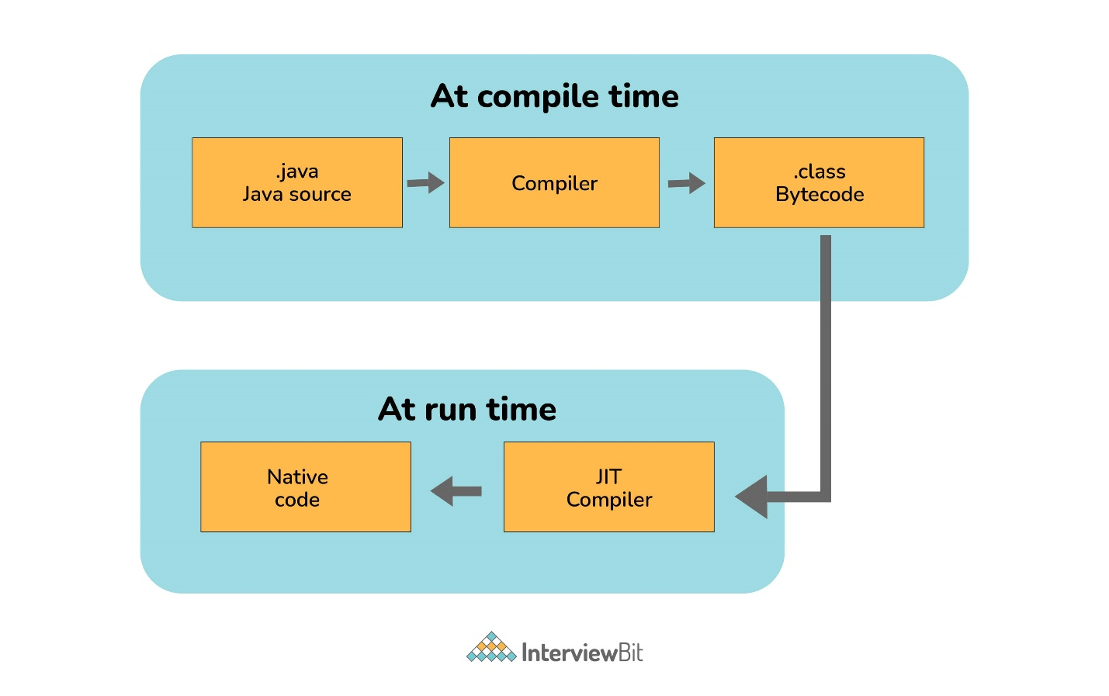

1. **What are Brief Access Specifiers and Types of Access Specifiers?**

Access specifiers or access modifiers are used to set the availability scope of an attribute of an object. There are 4 of them:

* Private: only visible from inside the object
* Protected: only visible from inside the object and from the descendants of the object
* Public: visible from everywhere
* Package: only visible from objects in the same package (this one has no keyword, it’s the default value)

1. **How many types of constructors are used in Java?**

There are two types of constructors in Java.

Parameterized Constructors: Parameterized constructor accepts the parameters with which users can initialize the instance variables. Users can initialize the class variables dynamically at the time of instantiating the class.

Default constructors: This type doesn’t accept any parameters; rather, it instantiates the class variables with their default values. It is used mainly for object creation.

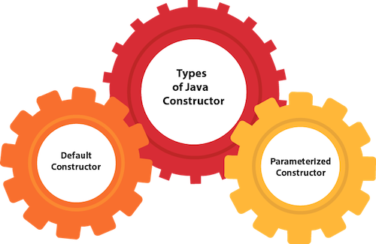

1. **Can a constructor return a value?**

Not explicitly, because it implicitly returns with the reference of the newly created object.

1. **Explain ‘this’ keyword in Java.**

The **this** keyword is a reference variable that refers to the current object. There are the various uses of this keyword in Java. It can be used to refer to current class properties such as instance methods, variable, constructors, etc. It can also be passed as an argument into the methods or constructors. It can also be returned from the method as the current class instance.

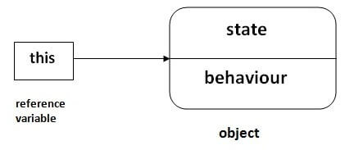

1. **Explain ‘super’ keyword in Java.**

The super keyword in Java is a reference variable that is used to refer to the immediate parent class object. Whenever you create the instance of the subclass, an instance of the parent class is created implicitly which is referred by super reference variable. The super() is called in the class constructor implicitly by the compiler if there is no super or this.

class Animal {

>Animal() {

>>System.out.println("animal is created");

>}

}

class Dog extends Animal {

>Dog() {

>>System.out.println("dog is created");

>}

}

class TestSuper4 {

>public static void main(String args[]) {

>>Dog d = new Dog();

>}

}

Output:

animal is created

dog is created

1. **Explain Method Overloading in Java.**

Method overloading is the polymorphism technique which allows us to create multiple methods with the same name but different signature. We can achieve method overloading in two ways.

* By Changing the number of arguments
* By Changing the data type of arguments

Method overloading increases the readability of the program. Method overloading is performed to figure out the program quickly.

1. **Can we overload a static method?**

Yes, but there is a restriction: a static method cannot have a non-static overload.

1. **Define Late Binding.**

It happens when the class type is determined during the runtime, thus a method implementation cannot be selected before runtime.

1. **Define Dynamic Method Dispatch.**

Also known as polymorphism from the OOP principles, it means that if we reference a descendant object through an ancestor type variable, and the descendant class has an overwritten method from the ancestor, the method of the descendant will run.

1. **Explain the difference between >> and >>> operators.**

These 2 are the bitwise right shift operators. Although both operators look similar. But there is a minimal difference between these two right shift operators.

* ‘>>’ Bitwise Right Shift Operator- This operator shifts each bit to its right position. And this maintains the signed bit.
* ‘>>>’ Bitwise Right Shift Operator with trailing zero- This operator also shifts each bit to its right. But this doesn’t maintain the signed bit. This operator makes the Most significant bit to 0.

Example: Num1 = 8, Num2 = -8.

So the binary form of these numbers are:

Num1 = 00000000 00000000 00000000 00001000

Num2 = 11111111 11111111 11111111 11111000

‘>>’ Operator : 8 >> 1 (Shift by one bit):

Num1 = 00000000 00000000 00000000 00000100

Num2 = 11111111 11111111 11111111 11111100

‘>>>’ Operator : 8 >>> 1 (Shift by one bit):

Num1 = 00000000 00000000 00000000 00000100

Num2 = 01111111 11111111 11111111 11111100

1. **Brief the life cycle of an applet.**

When an applet is created, the following methods are invoked in order.

* init()
* start()
* paint()

When an applet is destroyed, the following functions are invoked in order.

* stop()
* destroy()

However, Java applets are deprecated since 2017.

1. **Why are generics used in Java Programming?**

Compile-time type safety is provided by using generics. Compile-time type safety allows users to catch unnecessary invalid types at compile time. Generic methods and classes help programmers specify a single method declaration, a set of related methods, or related types with an available class declaration.

1. **Explain the Externalizable interface.**

The Externalizable interface helps with control over the process of serialization. An "externalisable" interface incorporates readExternal and writeExternal methods.

1. **What is the Daemon Thread?**

The Daemon thread can be defined as a thread with the least priority. This Daemon thread is designed to run in the background during the Garbage Collection in Java.

The setDaemon() method creates a Daemon thread in Java.

1. **Explain the term enumeration in Java.**

Enumeration (or enum for short) is a special data type which is intended to store predefined constants. It is useful when we have a set of values which doesn’t change, e.g., the days of the week.

1. **Why is Java dynamic?**

Java is considered to be more dynamic than C or C++ since it is designed to adapt to an evolving environment. Java programs can carry an extensive amount of run-time information that can be used to verify and resolve accesses to objects at run-time.

1. **Can you run a code before executing the main method?**

Yes, the code you write in a static block is running immediately after the class is loaded, which means it runs before the main method starts running.

1. **How many times is the finalize method called?**

The finalize method is called the Garbage collector. For every object, the Garbage Collector calls the finalize() method just for one time, before destroying the object.

1. **Can "this()" and "super()" keywords be used together?**

No. Both of them are meant to be the first statement in a constructor, you can use either of them, if necessary, but not both at the same time.

1. **What is a JSP page?**

JSP is an abbreviation for Java Servlet Page. JSP is a backend technology used to generate dynamic webpages. The JSP page consists of two types of text.

* Static Data
* JSP elements

1. **What is JDBC?**

JDBC is an abbreviation for Java Database Connector.

JDBC is an abstraction layer used to establish connectivity between an existing database and a Java application.

1. **Explain the various directives in JSP.**

Directives are instructions processed by JSP Engine. After the JSP page is compiled into a Servlet, Directives set page-level instructions, insert external files, and define customized tag libraries. Directives are defined using the symbols below:

start with "< %@" and then end with "% >"

The various types of directives are shown below:

* Include directive: It includes a file and combines the content of the whole file with the currently active pages.
* Page directive: Page Directive defines specific attributes in the JSP page, like the buffer and error page.
* Taglib: Taglib declares a custom tag library, which is used on the page.

1. **What are the observer and observable classes?**

They are part of the observer design pattern, Java has a predefined abstract class and an interface to implement it. Observable classes can be subscribed to and this class keeps track of the subscribed Observer objects. When the observable class changes, it calls the update() method of each subscribed observers, which then do their operations.

1. **What is Session Management in Java?**

Session management in Java refers to the process of maintaining a dynamic state of interaction between a client and a server during a user's visit to a web application. It involves the exchange of information, typically in the form of requests and responses, between the client's web browser and the server. One common approach to implementing session management is by using a session ID, which is a unique identifier assigned to each client's communication session and is exchanged between the client and the server to keep track of the session's state.

1. **Briefly explain the term Spring Framework.**

The Spring Framework is an essential Java application framework and an inversion of control container. It is primarily used for building enterprise-level Java applications. It's important to note that the Spring Framework offers a set of core features that can benefit virtually any Java application.

1. **How to handle exceptions in Spring MVC Framework?**

Spring MVC Framework provides the following ways to help us achieving robust exception handling.

* Controller Based:

We can define exception handler methods in our controller classes. All we need is to annotate these methods with @ExceptionHandler annotation.

* Global Exception Handler:

Exception Handling is a cross-cutting concern and Spring provides @ControllerAdvice annotation that we can use with any class to define our global exception handler.

* HandlerExceptionResolver implementation:

For generic exceptions, most of the times we serve static pages. Spring Framework provides HandlerExceptionResolver interface that we can implement to create global exception handler. The reason behind this additional way to define global exception handler is that Spring framework also provides default implementation classes that we can define in our spring bean configuration file to get spring framework exception handling benefits.

* XML Configuration: The user can use the SimpleMappingExceptionResolver bean in Spring’s application file and map the exception.

1. **What is JCA in Java?**

JCA (Java Cryptography Architecture) in Java is a framework that provides a platform and a set of architecture and application programming interfaces (APIs) for implementing encryption and decryption operations. Developers use JCA to integrate security features into their applications. It facilitates the incorporation of third-party security protocols and compliance with various security regulations.

JCA utilizes cryptographic techniques such as hash tables and encryption message digests to enhance the security of Java applications.

1. **Explain JPA in Java.**

Java Persistence API is one possible way to create a persistence layer for desktop and web applications. Java Persistence deals in the following:

* Java Persistence API
* Query Language
* Java Persistence Criteria API
* Object Mapping Metadata

1. **Explain the different authentications in Java Servlets.**

Java Servlets provide several authentication options:

* Basic Authentication: Usernames and passwords are provided by the client to authenticate the user.
* Form-Based Authentication: Programmers create a login form using HTML.
* Digest Authentication: Similar to basic authentication, but passwords are encrypted using a Hash formula, making it more secure.
* Client Certificate Authentication: Requires each client to have a certificate, which it sends to authenticate itself. Typically used with the SSL protocol for added security.

1. **Explain FailFast iterator and FailSafe iterator along with examples for each.**

FailFast and FailSafe iterators are used in Java Collections.

FailFast iterators do not allow changes to the collection while iterating. If an element is added or removed during iteration, they throw a ConcurrentModificationException.

Example: ArrayList, HashMap

On the contrary, FailSafe iterators allow modifications to the collection. They operate on a cloned copy of the collection, so no exceptions are thrown even if the collection is modified during iteration.

Example: CopyOnWriteArrayList

1. **How do we reverse a string?**

public class Main

{

>public static void main(String[] args) {

>>String toReverse = "This is an example.";

>>StringBuilder reversed = new StringBuilder();

>>for (int i = toReverse.length() - 1; i >= 0; i--) {

>>>reversed.append(toReverse.charAt(i));

>>}

>>System.out.println("The string is reversed: " + reversed.toString());

>}

}

1. **Write a program that detects the duplicate characters in a string.**

public class Main {

>public static void main(String[] args) {

>>String toDetect = "We are looking for duplicates here";

>>Map<Character, Boolean> chars = new HashMap<>();

>>for (int i = 0; i < toDetect.length(); i++) {

>>>char current = Character.toLowerCase(toDetect.charAt(i));

>>>if (chars.containsKey(current)) {

>>>>chars.replace(current, true);

>>>} else {

>>>>chars.put(current, false);

>>>}

>>}

>>System.out.print("Duplicated characters are: ");

>>for (Entry<Character, Boolean> e : chars.entrySet()) {

>>>if (e.getValue()) {

>>>>System.out.print(e.getKey() + " ");

>>>}

>>}

>}

}

1. **Write a Program to remove duplicates in an ArrayList.**

public class Main{

>public static void main(String args[]) {

>>List<Integer> num = new ArrayList<Integer>();

>>num.add(1);

>>num.add(2);

>>num.add(3);

>>num.add(4);

>>num.add(5);

>>num.add(6);

>>num.add(3);

>>num.add(4);

>>num.add(5);

>>num.add(6);

>>System.out.println("Your list of elements in ArrayList : " + num);

>>Set<Integer> primesWithoutDuplicates = new LinkedHashSet<Integer>(num);

>>num.clear();

>>num.addAll(primesWithoutDuplicates);

>>System.out.println("list of original numbers without duplication: " + num);

>}

}

1. **Find the word count in a string using HashMap Collection.**

public class Main {

>public static void main(String[] args) {

>>String str = "Counting words in this string";

>>String[] split = str.toLowerCase().split(" ");

>>HashMap<String, Integer> map = new HashMap<String, Integer>();

>>for (int i = 0; i < split.length; i++) {

>>>if (map.containsKey(split[i])) {

>>>>int count = map.get(split[i]);

>>>>map.put(split[i], count + 1);

>>>} else {

>>>>map.put(split[i], 1);

>>>}

>>}

>>System.out.println(map);

>}

}

1. **Write a program to find the Second Highest number in an ArrayList**

public class Main {

>public static void main(String[] args) {

>>int array[] = { 1, 2, 3, 4, 11, 12, 13, 14, 21, 22, 23, 24, 31, 32};

>>int high = array[0];

>>int nextHigh = array[0];

>>for (int i = 0; i < array.length; i++) {

>>>if (array[i] > high) {

>>>>nextHigh = high;

>>>>high = array[i];

>>>}

>>>else if (array[i] > nextHigh) {

>>>>nextHigh = array[i];

>>>}

>>}

>>System.out.println("Second Highest is: " + nextHigh);

>>System.out.println("Highest Number is: " + high);

>}

}

1. **What is the difference between System.out, System.err, and System.in?**

Both System.out and System.err are used to print text on the console, System.out writes to the standard output and System.err writes to standard error output. (The differentiation is useful e.g. when redirecting the output.) System.in represents the standard input as an InputStream object, which, as the name implies, is used to input text.

1. **Could you provide an implementation for a Dictionary with a large number of words?**

The simplest implementation is to use a List where you can store words in order and perform binary searches. Another implementation with better search performance is to use a HashMap, where the key is the first character of the word, and the value is a LinkedList.

1. **What do you understand by an instance variable and a local variable?**

Generally, by instance variables we mean the class level variables, while local variables are inside a block of code, where their scope ends, as they aren’t available from the outside.

1. **Comment on method overloading and overriding by citing relevant examples.**

Method overloading occurs during the compile time, whereas method overriding occurs during the run time. Static binding is used during overloading, whereas dynamic binding is used during methods overriding. In Java , method overloading is made possible by introducing different methods in the same class consisting of the same name. Still, all the functions differ in the number or type of parameters. It takes place inside a class and enhances program readability. The only difference in the return type of the method does not promote method overloading.

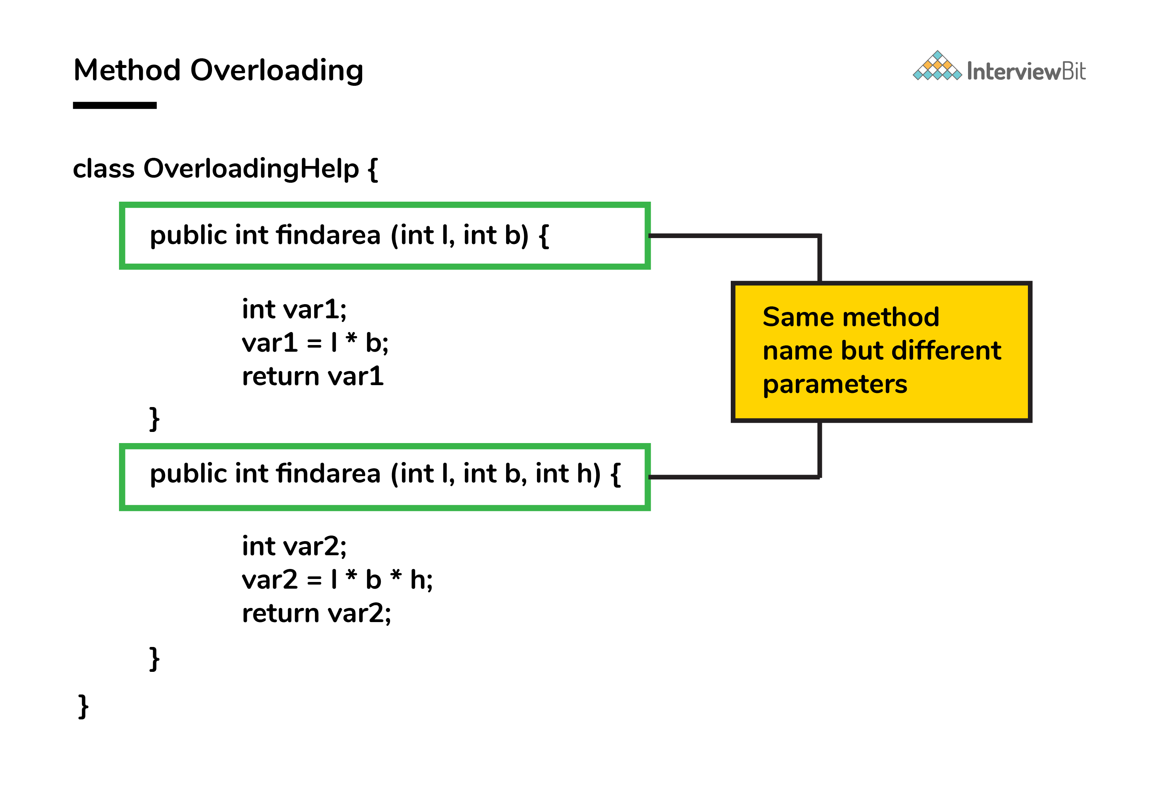

Method overriding is the concept in which two methods having the same method signature are present in two different classes in which an inheritance relationship is present. A particular method implementation (already present in the base class) is possible for the derived class by using method overriding.

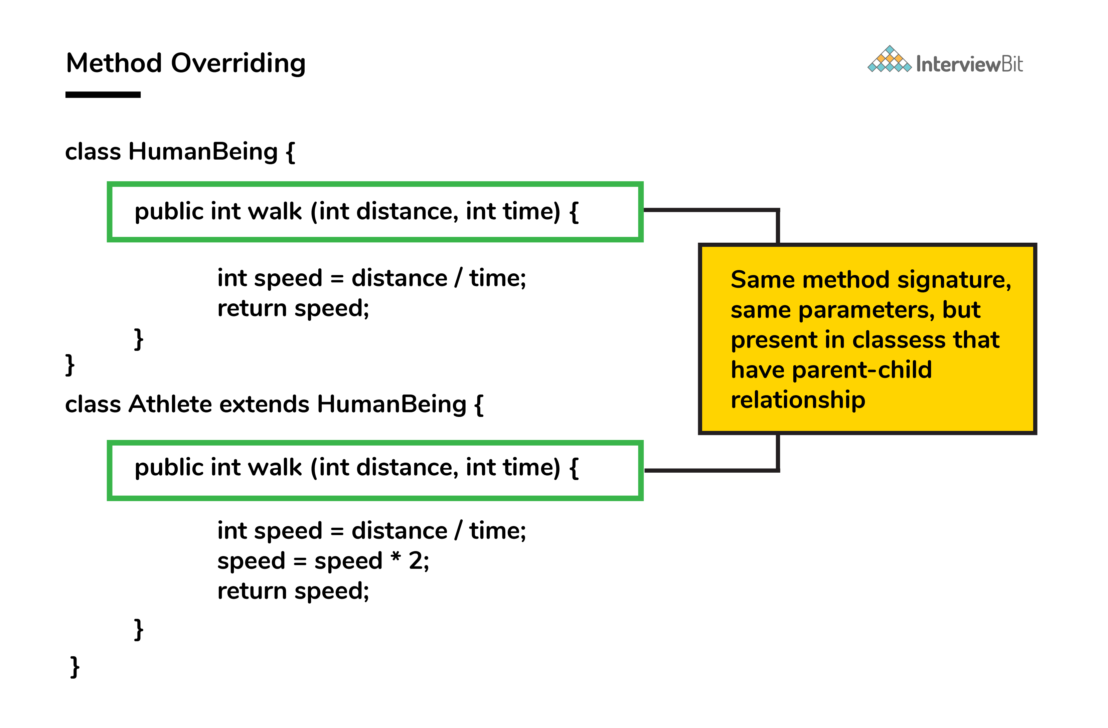

//Function overloading

//function1

void addPodium(int a, int b) {

>System.out.println(a + b);

}

//function2

float addPodium(float a, float b, float c) {

>System.out.println(a + b + c);

}

//Function overriding

class Parent {

>void show() {

>>System.out.println("I am Parent");

>}

}

class Child extends Parent {

>void show() {

>>System.out.println("I am Child");

>}

}

class Main {

>public static void main(String[] args) {

>>Parent obja = new Parent();

>>obja.show();

>>Parent objb = new Child();

>>objb.show();

>}

}

Using the @Override annotation is not necessary but it can be really helpful as we will get a compile-time error if we made a mistake.

1. **A single try block and multiple catch blocks can co-exist in a Java Program. Explain.**

That’s because a code inside a try block might be able to throw multiple types of exceptions and we would like to handle them differently. See this example:

public class Example {

>public static void main(String args[]) {

>>try {

>>>int a[] = new int[10];

>>>a[10] = 10 / 0;

>>} catch (ArithmeticException e) {

>>>System.out.println("Arithmetic exception in first catch block");

>>} catch (ArrayIndexOutOfBoundsException e) {

>>>System.out.println("Array index out of bounds in second catch block");

>>} catch (Exception e) {

>>>System.out.println("Any exception in third catch block");

>>}

>}

}

1. **Do final, finally and finalize keywords have the same function?**

All three keywords have their own utility while programming.

Final: If any restriction is required for classes, variables, or methods, the final keyword comes in handy. Inheritance of a final class and overriding of a final method is restricted by the use of the final keyword. The variable value becomes fixed after incorporating the final keyword. Example:

final int a=100;

a = 0; // error

The second statement will throw an error.

Finally: It is the block present in a program where all the codes written inside it get executed irrespective of handling of exceptions. Example:

try {

int variable = 5;

}

catch (Exception exception) {

System.out.println("Exception occurred");

}

finally {

System.out.println("Execution of finally block");

}

Finalize: Prior to the garbage collection of an object, the finalize method is called so that the clean-up activity is implemented. Example:

public static void main(String[] args) {

String example = new String("InterviewBit");

example = null;

System.gc(); // Garbage collector called

}

public void finalize() {

// Finalize called

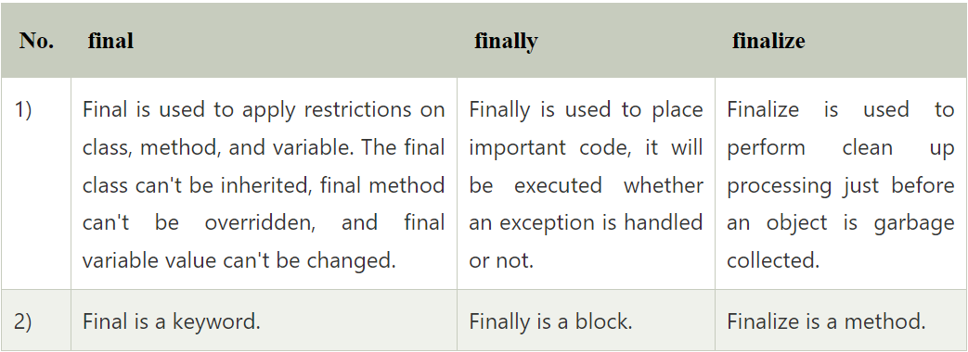

1. **When can you use the "super" keyword?**

You can use super in a descendant class, where super refers to the ancestor class’s methods and variables.

1. **What are shallow copy and deep copy in Java?**

To copy the object's data, we have several methods like deep copy and shallow copy.

Example:

class Rectangle{

int length = 5;

> int breadth = 3;

}

Object for this Rectangle class - Rectangle obj1 = new Rectangle();

Shallow copy - The shallow copy only creates a new reference and points to the same object. Example: for Shallow copy, we can do this by:

Rectangle obj2 = obj1;

Now by doing this what will happen is the new reference is created with the name obj2 and that will point to the same memory location.

Deep Copy - In a deep copy, we create a new object and copy the old object value to the new object. Example:

Rectangle obj3 = new Rectangle();

Obj3.length = obj1.length;

Obj3.breadth = obj1.breadth;

Both these objects will point to the memory location as stated below:

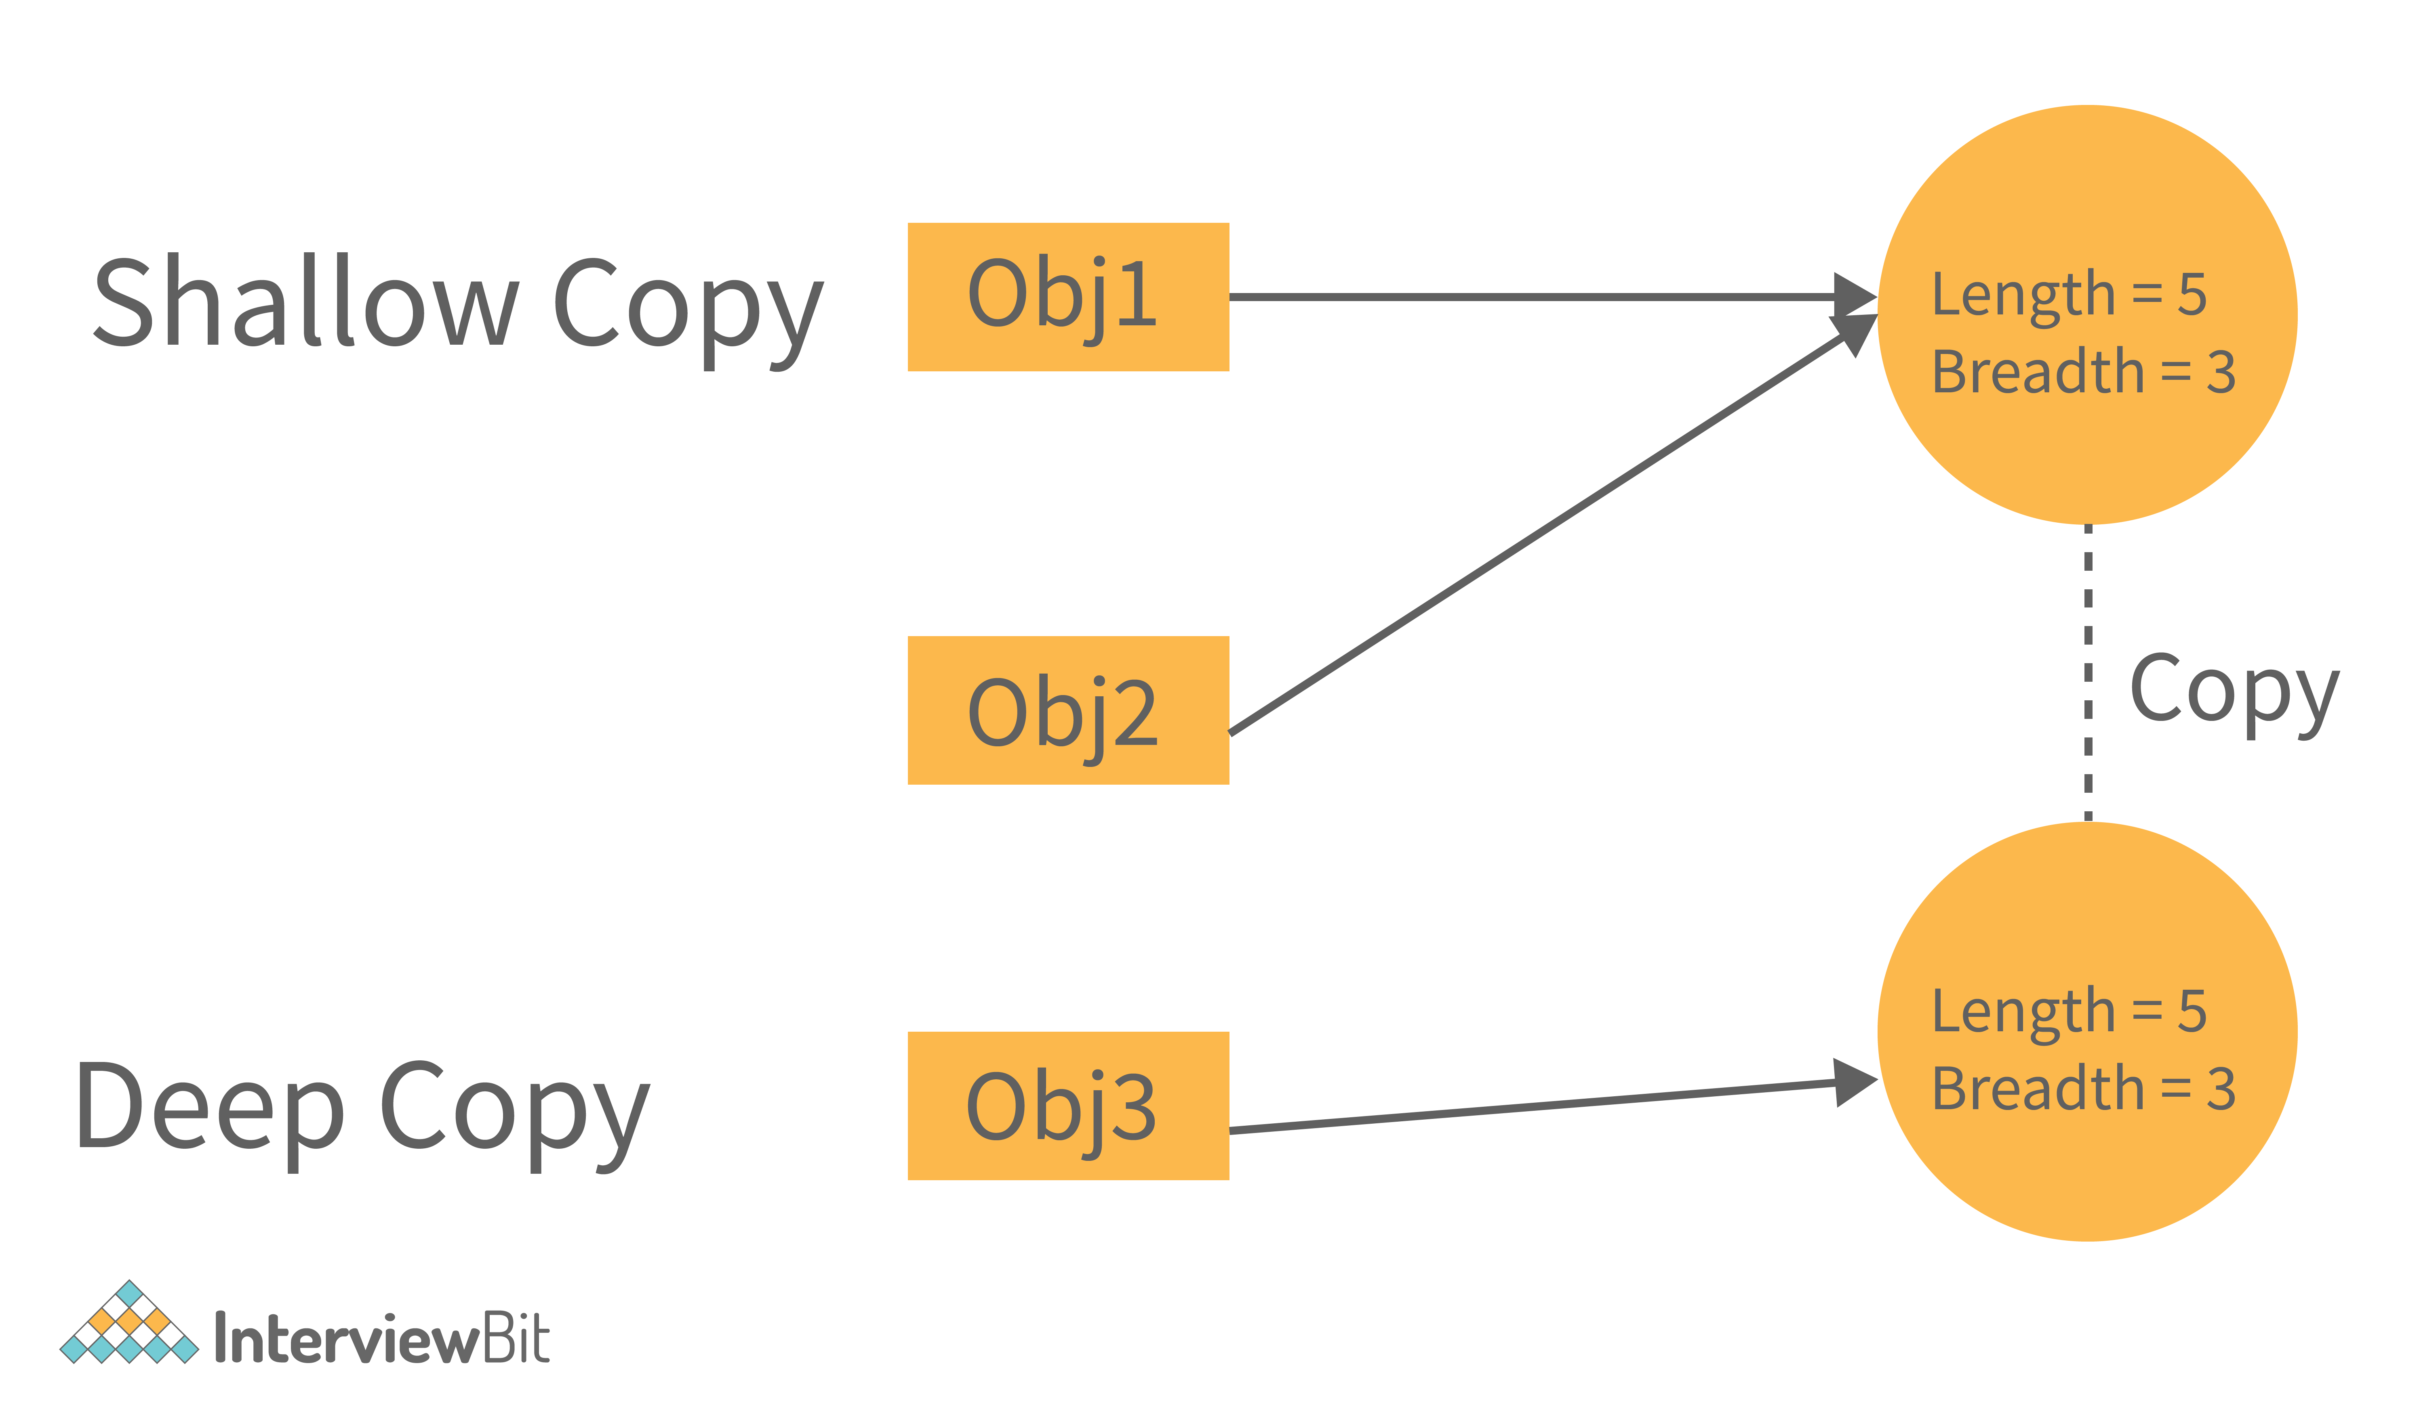

1. **Using relevant properties highlight the differences between interfaces and abstract classes.**

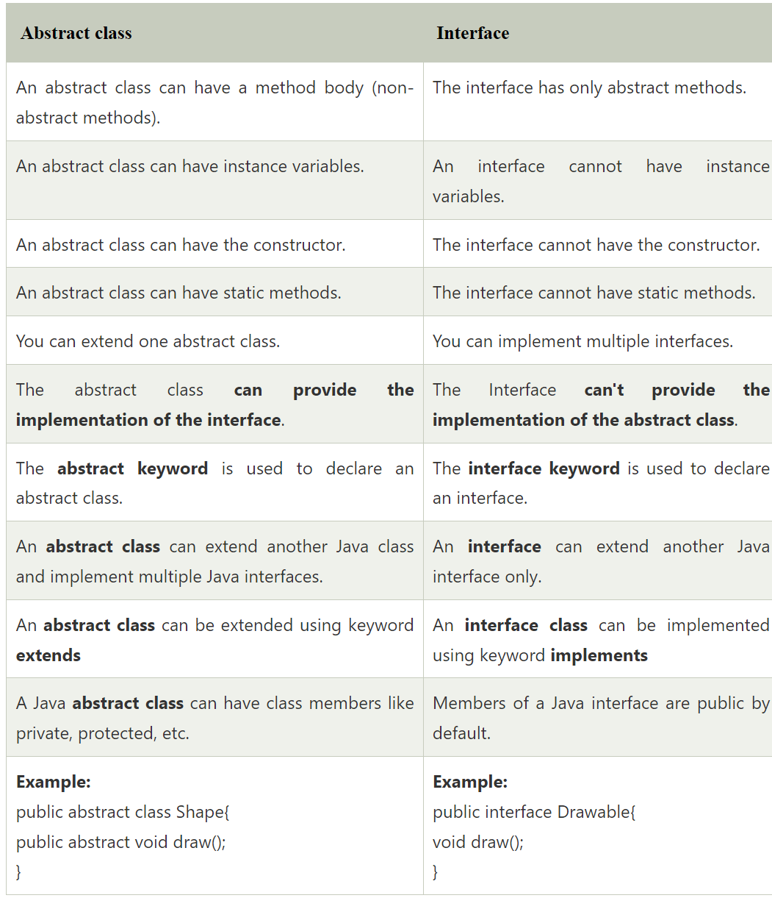

1. **What are the different ways of thread usage?**

There are two ways to create a thread:

* Extending Thread class
  + This creates a thread by creating an instance of a new class that extends the Thread class. The extending class must override the run() function, which is the thread’s entry point.
* Implementing Runnable interface
  + This is the easiest way to create a thread, by creating a class that implements the runnable interface. After implementing the runnable interface, the class must implement the public void run() method ()

The run() method creates a parallel thread in your programme. When run() returns, the thread will come to an end.

Within the run() method, you must specify the thread’s code.

Like any other method, the run() method can call other methods, use other classes, and define variables.

1. **What is the difference between the ‘throw' and ‘throws' keyword in Java?**

The ‘throw’ keyword is used to manually throw the exception to the calling method.

And the ‘throws’ keyword is used in the function definition to inform the calling method that this method throws the exception. So if you are calling, then you have to handle the exception.

Example:

class Main {

public static int testExceptionDivide(int a, int b) throws ArithmeticException{

> if(a == 0 || b == 0)

>> throw new ArithmeticException();

> return a/b;

}

public static void main(String args[]) {

> try{

>> testExceptionDivide(10, 0);

> }

> catch(ArithmeticException e){

>> //Handle the exception

> }

}

}

Here in the above snippet, the method testExceptionDivide throws an exception. So if the main method is calling it then it must have handled the exception. Otherwise, the main method can also throw the exception to JVM.

And the method testExceptionDivide 'throws’ the exception based on the condition.

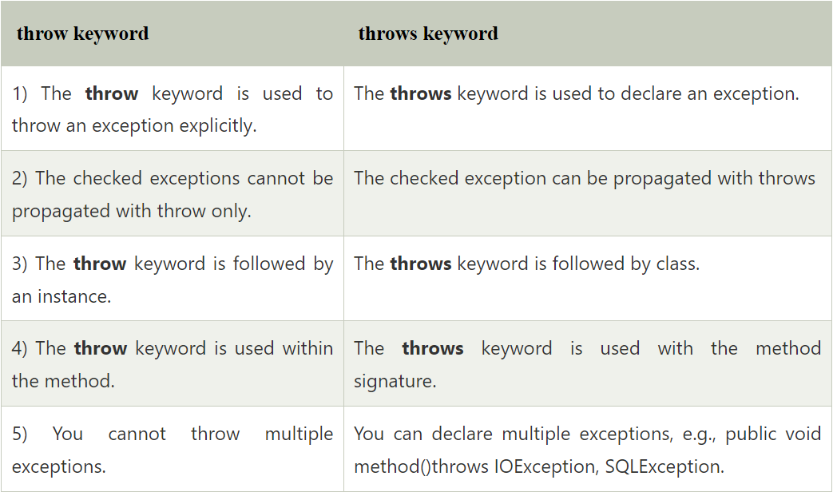

1. **Java works as a “pass by value” or “pass by reference” phenomenon?**

Java always works as a “pass by value”. There is nothing called a “pass by reference” in Java. However, when the object is passed in any method, the address of the value is passed due to the nature of object handling in Java. When an object is passed, a copy of the reference is created by Java and that is passed to the method. The objects point to the same memory location. 2 cases might happen inside the method:

Case 1: When the object is pointed to another location: In this case, the changes made to that object do not get reflected the original object before it was passed to the method as the reference points to another location.

For example:

class InterviewBitTest {

int num;

InterviewBitTest(int x) {

> num = x;

}

InterviewBitTest() {

> num = 0;

}

}

class Driver {

public static void main(String[] args) {

> //create a reference

> InterviewBitTest ibTestObj = new InterviewBitTest(20);

> //Pass the reference to updateObject Method

> updateObject(ibTestObj);

> //After the updateObject is executed, check for the value of num in the object.

> System.out.println(ibTestObj.num);

}

public static void updateObject(InterviewBitTest ibObj) {

> // Point the object to new reference

> ibObj = new InterviewBitTest();

> // Update the value

> ibObj.num = 50;

}

}

Output:

20

Case 2: When object references are not modified: In this case, since we have the copy of reference the main object pointing to the same memory location, any changes in the content of the object get reflected in the original object.

For example:

class InterviewBitTest {

int num;

InterviewBitTest(int x) {

> num = x;

}

InterviewBitTest() {

> num = 0;

}

}

class Driver {

public static void main(String[] args) {

> //create a reference

> InterviewBitTest ibTestObj = new InterviewBitTest(20);

> //Pass the reference to updateObject Method

> updateObject(ibTestObj);

> //After the updateObject is executed, check for the value of num in the object.

> System.out.println(ibTestObj.num);

}

public static void updateObject(InterviewBitTest ibObj) {

> // no changes are made to point the ibObj to new location

> // Update the value of num

> ibObj.num = 50;

}

}

Output:

50

1. **How to not allow serialization of attributes of a class in Java?**

One approach to not allow serialization of attributes of a class in Java is by using writeObject() and readObject() methods in the subclass and throwing a not Serializable exception.

Other, probably better approach is the following:

In order to achieve this, the attribute can be declared along with the usage of transient keyword as shown below:

public class InterviewBitExample {

private transient String someInfo;

private String name;

private int id;

// :

// Getters setters

// :

}

In the above example, all the fields except someInfo can be serialized.

1. **What are the default values assigned to variables and instances in Java?**

By default for the wrapper classes, for a numerical value it is 0, for the boolean value it is false and for objects it is NULL. However, leaving a primitive type uninitialized leads to a compilation time error.

1. **What do you mean by data encapsulation?**

Data encapsulation is one of the properties of OOP concepts, where all the data such as variables and methods are enclosed together as a single unit. It helps developers to follow modularity while developing software by ensuring that each object is independent of other objects by having its own methods, attributes, and functionalities. It is used for the security of the private properties of an object and hence serves the purpose of data hiding.

We can achieve encapsulation in Java by:

* Declaring the variables of a class as private.
* Providing public setter and getter methods to modify and view the values of the variables.

1. **Can you tell the difference between equals() method and equality operator (==) in Java?**

In the case of objects, == checks the memory reference, while equals() checks the value/contenth of the objects. In order to understand this better, let’s consider this with the example:

String str1 = "InterviewBit";

String str2 = "InterviewBit";

System.out.println(str1 == str2);

This code will print true. We know that both strings are equals so it will print true. But here (==) Operators don’t compare each character in this case. It compares the memory location. And because the string uses the constant pool for storing the values in the memory, both str1 and str2 are stored at the same memory location.

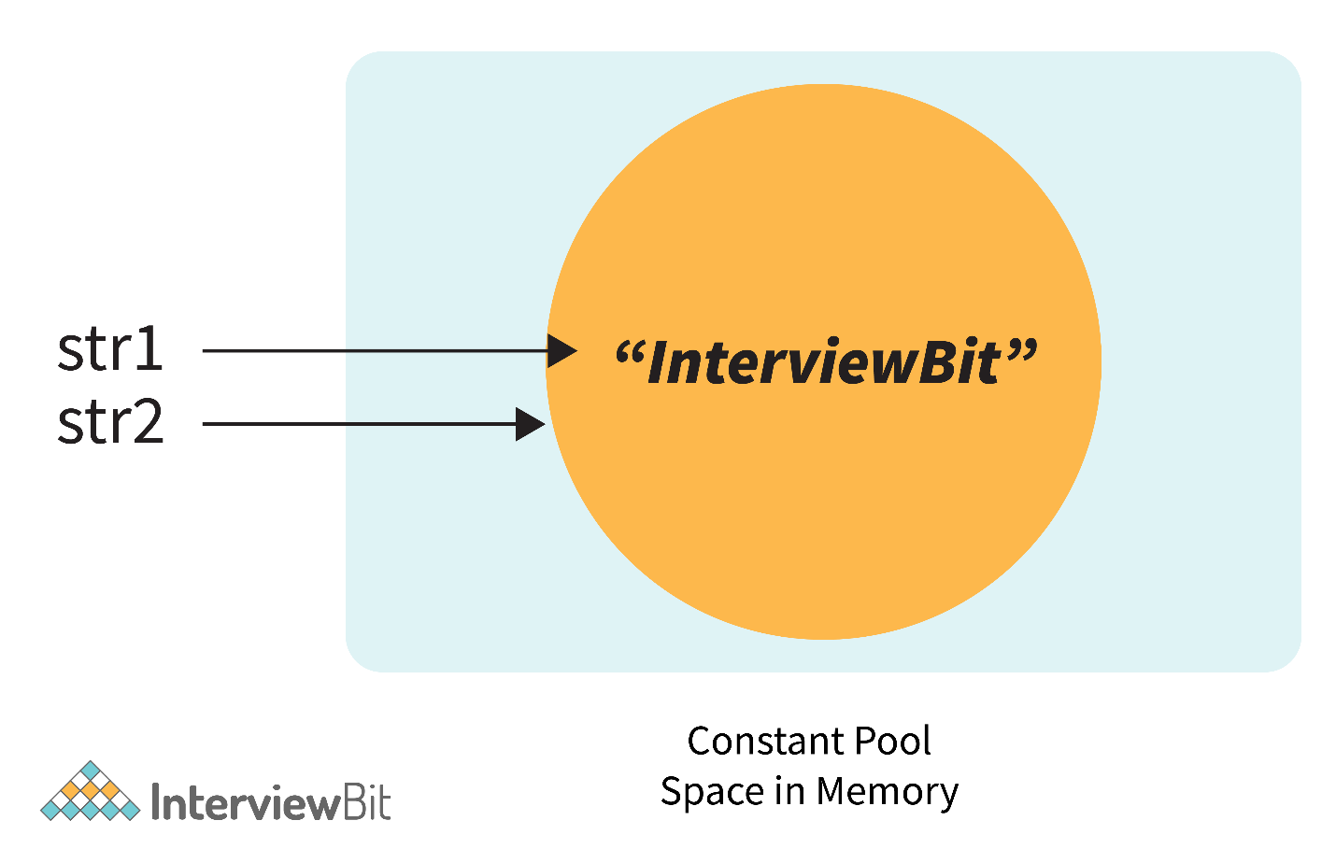

Now, if we modify the program a little bit with:

String str1 = new String("InterviewBit");

String str2 = "InterviewBit";

System.out.println(str1 == str2);

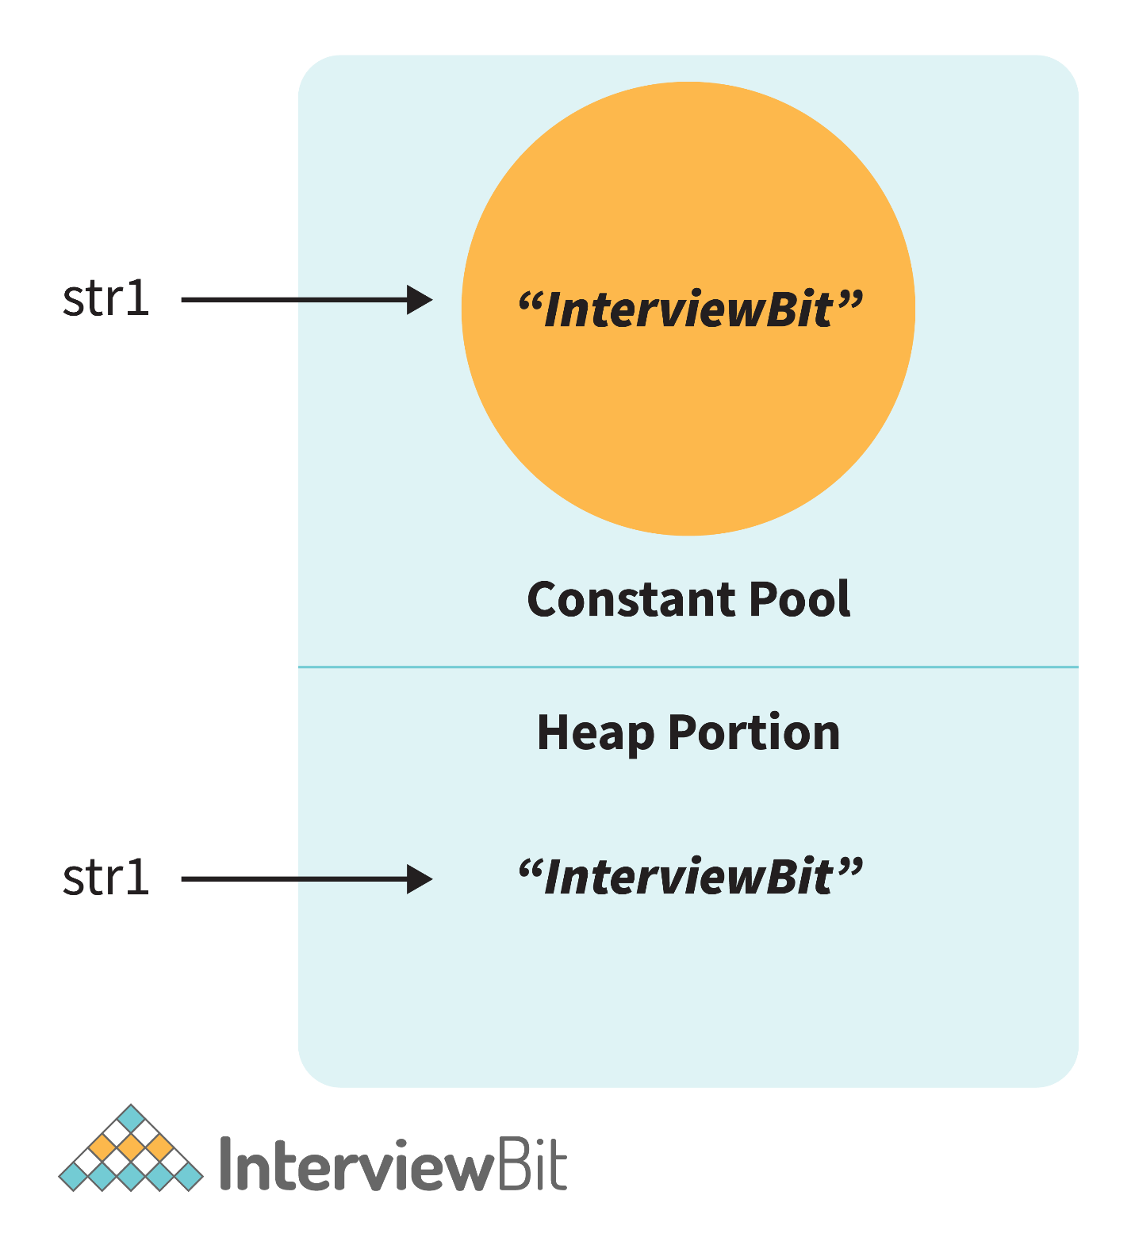

Then in this case, it will print false. Because here no longer the constant pool concepts are used. Here, new memory is allocated. So here the memory address is different, therefore ( == ) Operator returns false. But the twist is that the values are the same in both strings. So how to compare the values? Here the .equals() method is used.

.equals() method compares the values and returns the result accordingly. If we modify the above code with:

System.out.println(str1.equals(str2));

Then it returns true.

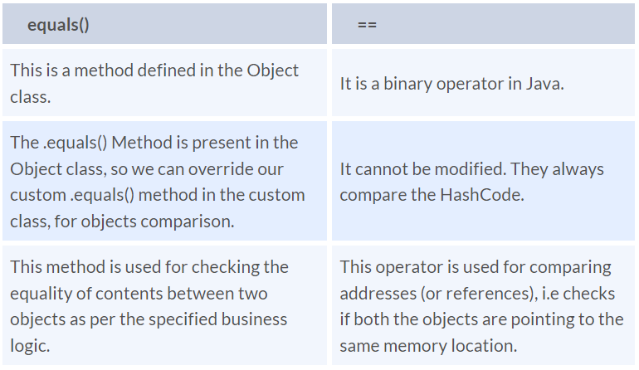

Note:

* In the cases where the equals method is not overridden in a class, then the class uses the default implementation of the equals method that is closest to the parent class.
* Object class is considered as the parent class of all the java classes. The implementation of the equals method in the Object class uses the == operator to compare two objects. This default implementation can be overridden as per the business logic.

1. **Explain the use of the final keyword in variable, method and class.**

With a variable, its value can’t be changed, with a method, it can’t be overridden (not even in descendant classes) and with a class, it can’t have any descendants. Constructors cannot be marked as final.

1. **Is it possible that the ‘finally' block will not be executed? If yes then list the case.**

Yes, it’s possible. Some examples are if the JVM crashes, the program runs into a fatal error or if we explicitly interrupt the run of the program with System.exit().

Here is an example:

public int someMethod(int i){

try{

> //some statement

> return 1;

}catch(Exception e){

> //some statement

> return 999;

}finally{

> //finally block statements

}

}

finally block will be executed irrespective of the exception or not. The only case where finally block is not executed is when it encounters ‘System.exit()’ method anywhere in try/catch block.

1. **Difference between static methods, static variables, and static classes in Java.**

* Static Methods and Static variables are those methods and variables that belong to the class of the java program, not to the object of the class. This gets memory where the class is loaded. And these can directly be called with the help of class names.
  + For example - We have used mathematical functions in the java program like - max(), min(), sqrt(), pow(), etc. And if we notice that, then we will find that we call it directly with the class name. Like - Math.max(), Math.min(), etc. So that is a static method. And Similarly static variables we have used like (length) for the array to get the length. So that is the static method.
* Static classes - A class in the java program cannot be static except if it is the inner class. If it is an inner static class, then it exactly works like other static members of the class.

1. **What is the main objective of garbage collection?**

The main goal of using garbage collection is to free the heap memory by eliminating unnecessary objects, which have no references to them. This ensures that the memory resource is used efficiently, but it provides no guarantee that there would be sufficient memory for the program execution.

1. **Apart from the security aspect, what are the reasons behind making strings immutable in Java?**

* String Pool: Designers of Java were aware of the fact that String data type is going to be majorly used by the programmers and developers. Thus, they wanted optimization from the beginning. They came up with the notion of using the String pool (a storage area in Java heap) to store the String literals. They intended to decrease the temporary String object with the help of sharing. An immutable class is needed to facilitate sharing. The sharing of the mutable structures between two unknown parties is not possible. Thus, immutable Java String helps in executing the concept of String Pool.

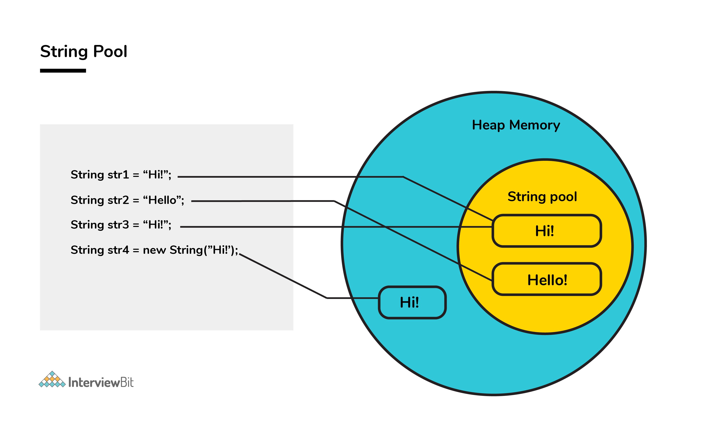

* Multithreading: The safety of threads regarding the String objects is an important aspect in Java. No external synchronization is required if the String objects are immutable. Thus, a cleaner code can be written for sharing the String objects across different threads. The complex process of concurrency is facilitated by this method.
* Collections: In the case of Hashtables and HashMaps, keys are String objects. If the String objects are not immutable, then it can get modified during the period when it resides in the HashMaps. Consequently, the retrieval of the desired data is not possible. Such changing states pose a lot of risks. Therefore, it is quite safe to make the string immutable.
* Java uses the concept of the string literal. Suppose there are five reference variables, all refer to one object "sachin". If one reference variable changes the value of the object, it will be affected by all the reference variables. That is why string objects are immutable in java.

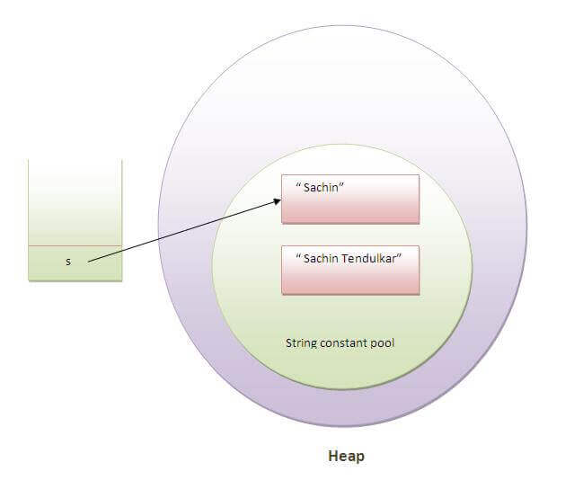

1. **Which of the below generates a compile-time error? State the reason.**

int[] n1 = new int[0];

boolean[] n2 = new boolean[-200];

double[] n3 = new double[2241423798];

char[] ch = new char[20];

n3 will give a compile time error, because array sizes are in int and that number is bigger than what an integer can store. Other than that, n2 will give a runtime exception of NegativeArraySizeException. The reason because it doesn’t give a compile-time error is that JVM will try to allocate the memory area in runtime, and that’s when it notices the negative integer. Also, an integer too big can’t happen during runtime, so we can check that during the compilation, meanwhile the size of an array can be decided during runtime, which means a compile-time can’t filter out these cases.

1. **How would you differentiate between a String, StringBuffer, and a StringBuilder?**

The String class is immutable, whereas the other two are mutable in nature. StringBuffer is synchronous, meaning it is thread-safe, whereas StringBuilder is asynchronous, which means it is not thread-safe. String uses the string pool as memory storage for string literals, whereas the other two use the heap memory for storage purposes. StringBuilder is the fastest in performing operations. The speed of a StringBuffer is more than a String and less than a StringBuilder. (For example appending a character is fastest in StringBuilder and very slow in String because a new memory is required for the new String with appended character.)

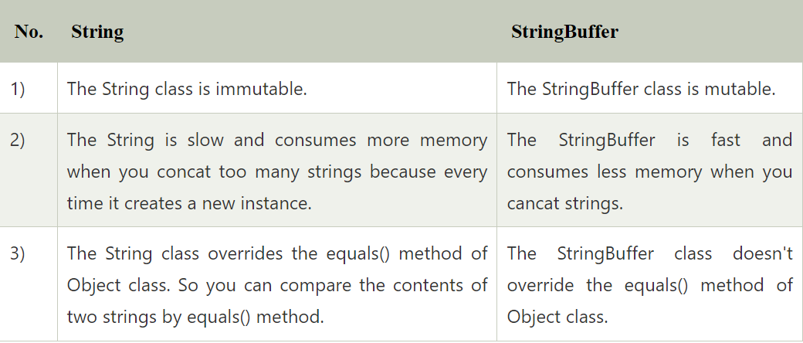

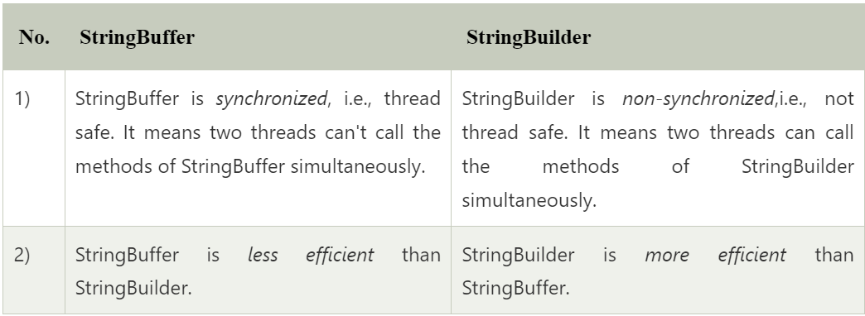

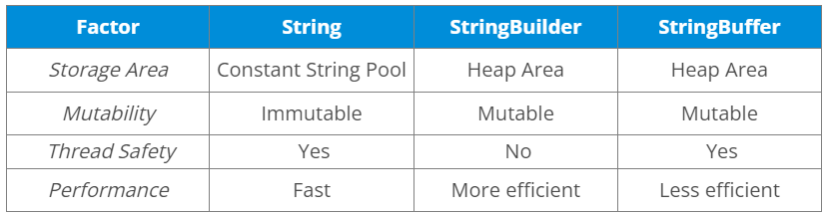

1. **What is a Comparator in Java?**

Consider the example where we have an ArrayList of employees like( EId, Ename, Salary), etc. Now if we want to sort this list of employees based on the names of employees. Then that is not possible to sort using the Collections.sort() method. We need to provide something to the sort() function depending on what values we have to perform sorting. Then in that case a comparator is used.

A comparator is an interface, which makes it possible to compare two objects, mostly used for sorting.

1. **In Java, overriding static methods is not possible, but private method overriding is possible. Comment on the statement.**

In Java, you cannot override a static method. However, you can override a private method in a subclass if you create a similar method with the same return type and method arguments; this is known as method hiding. It's important to note that private methods are not directly accessible in a subclass, so you're essentially creating a new method with the same name and signature in the subclass. About overriding static methods, declaration of static methods having the same signature can be done in the subclass but run time polymorphism cannot take place in such cases. Overriding or dynamic polymorphism occurs during the runtime, but the static methods are loaded and looked up at the compile time statically. Hence, these methods can’t be overridden.

1. **What makes a HashSet different from a TreeSet?**

Although both HashSet and TreeSet are not synchronized and ensure that duplicates are not present, there are certain properties that distinguish a HashSet from a TreeSet.

* Implementation: For a HashSet, the hash table is utilized for storing the elements in an unordered manner. However, TreeSet makes use of the red-black tree to store the elements in a sorted manner.
* Complexity/ Performance: For adding, retrieving, and deleting elements, the time amortized complexity is O(1) for a HashSet. The time complexity for performing the same operations is a bit higher for TreeSet and is equal to O(log n). Overall, the performance of HashSet is faster in comparison to TreeSet.
* Methods: hashCode() and equals() are the methods utilized by HashSet for making comparisons between the objects. Conversely, compareTo() and compare() methods are utilized by TreeSet to facilitate object comparisons.
* Objects type: Heterogeneous and null objects can be stored with the help of HashSet. In the case of a TreeSet, runtime exception occurs while inserting heterogeneous objects or null objects.

1. **Why is the character array preferred over string for storing confidential information?**

In Java, a string is basically immutable i.e. it cannot be modified. After its declaration, it continues to stay in the string pool as long as it is not removed in the form of garbage. In other words, a string resides in the heap section of the memory for an unregulated and unspecified time interval after string value processing is executed.

As a result, vital information can be stolen for pursuing harmful activities by hackers if a memory dump is illegally accessed by them. Such risks can be eliminated by using mutable objects or structures like character arrays for storing any variable. After the work of the character array variable is done, the variable can be configured to blank at the same instant. Consequently, it helps in saving heap memory and also gives no chance to the hackers to extract vital data.

1. **What are the differences between HashMap and HashTable in Java?**

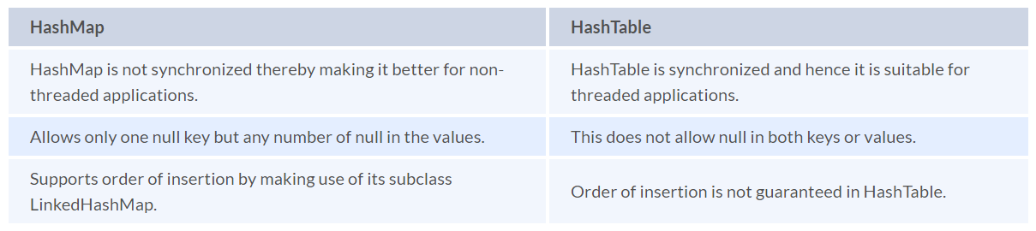

1. **What is the importance of reflection in Java?**

* The term reflection is used for describing the inspection capability of a code on other code either of itself or of its system and modify it during runtime.
* Consider an example where we have an object of unknown type and we have a method ‘fooBar()’ which we need to call on the object. The static typing system of Java doesn't allow this method invocation unless the type of the object is known beforehand. This can be achieved using reflection which allows the code to scan the object and identify if it has any method called “fooBar()” and only then call the method if needed.

Method methodOfFoo = fooObject.getClass().getMethod("fooBar", null);

methodOfFoo.invoke(fooObject, null);

* Using reflection has its own cons:
  + Speed — Method invocations due to reflection are about three times slower than the direct method calls.
  + Type safety — When a method is invoked via its reference wrongly using reflection, invocation fails at runtime as it is not detected at compile/load time.
  + Traceability — Whenever a reflective method fails, it is very difficult to find the root cause of this failure due to a huge stack trace. One has to deep dive into the invoke() and proxy() method logs to identify the root cause.
* Hence, it is advisable to follow solutions that don't involve reflection and use this method as a last resort.

Reflection is the process of examining or modifying the runtime behavior of a class at runtime. The java.lang.Class class provides various methods that can be used to get metadata, examine and change the runtime behavior of a class. The java.lang and java.lang.reflect packages provide classes for java reflection. It is used in:

* IDE (Integrated Development Environment), e.g., Eclipse, MyEclipse, NetBeans.
* Debugger
* Test Tools, etc.

1. **What are the different types of Thread Priorities in Java? And what is the default priority of a thread assigned by JVM?**

There are a total of 3 different types of priority available in Java.

* MIN_PRIORITY: It has an integer value assigned with 1.
* MAX_PRIORITY: It has an integer value assigned with 10.
* NORM_PRIORITY: It has an integer value assigned with 5.

In Java, Thread with MAX_PRIORITY gets the first chance to execute. But the default priority for any thread is NORM_PRIORITY assigned by JVM. Also, besides these predefined values, assigning a number between 1 and 10 by hand as a priority will also work.

1. **What is the ‘IS-A‘ relationship in OOPs Java?**

‘IS-A’ relationship is another name for inheritance. When we inherit the base class from the derived class, then it forms a relationship between the classes. So that relationship is termed an ‘IS-A’ Relationship.

Example: Consider a Television (Typical CRT TV). Now another Smart TV that is inherited from television class. So we can say that the Smart iv is also a TV. Because CRT TV things can also be done in the Smart TV.

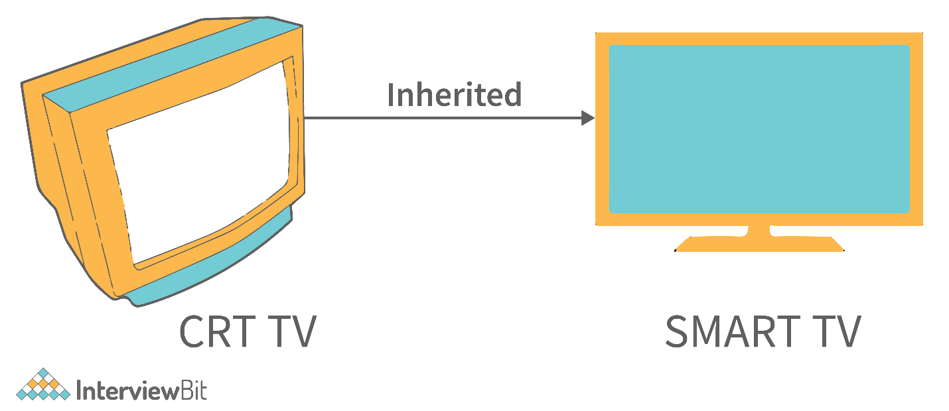

So here ‘IS-A’ Relationship formed. [ SmartTV ‘IS-A’ TV ].

1. Example - Consider a Television (Typical CRT TV). Now another Smart TV that is inherited from television class. So we can say that the Smart iv is also a TV. Because CRT TV things can also be done in the Smart TV.**Why is Java, not a pure object-oriented language?**

It is not a pure object-oriented language because it supports primitive data types like int, double, and char, which are not objects, and it supports static methods and variables.

However, it’s not wrong to call Java a completely object-oriented language as the primitive data types have their respective wrapper classes.

1. **Explain static variables with examples and a diagram.**

A static variable in Java is a variable that is associated with the class rather than an instance of the class. This means that all instances of the class share the same static variable. They are declared using the static keyword.

public class Example {

>static int count = 0;

>public Example() {

>>count++;

>}

}

1. **Explain static block**

Static block is used to initialize the static data member. It is executed before the main method, at the time of classloading.

class A2 {

static {

System.out.println("static block is invoked");

}

public static void main(String args[]) {

System.out.println("Hello main");

}

}

Test it Now

Output:

static block is invoked

Hello main

1. **How can constructor chaining be done using this keyword?**

Constructor chaining enables us to call one constructor from another constructor of the class with respect to the current class object. We can use this keyword to perform constructor chaining within the same class. Consider the following example which illustrates how can we use this keyword to achieve constructor chaining.

public class Employee {

>int id,age;

>String name, address;

>public Employee (int age) {

>>this.age = age;

>}

>public Employee(int id, int age) {

>>this(age);

>>this.id = id;

>}

>public Employee(int id, int age, String name, String address) {

>>this(id, age);

>>this.name = name;

>>this.address = address;

>}

>public static void main (String args[]) {

>>Employee emp = new Employee(105, 22, "Vikas", "Delhi");

>>System.out.println("ID: "+emp.id+" Name:"+emp.name+" age:"+emp.age+" address: "+emp.address);

>}

}

Output

ID: 105 Name:Vikas age:22 address: Delhi

1. **Why are multiple inheritances not supported in Java?**

To reduce the complexity and simplify the language, multiple inheritance is not supported in java. Consider a scenario where A, B, and C are three classes. The C class inherits A and B classes. If A and B classes have the same method and you call it from child class object, there will be ambiguity to call the method of A or B class.

Since the compile-time errors are better than runtime errors, Java renders compile-time error if you inherit 2 classes. So whether you have the same method or different, there will be a compile time error.

class A {

>void msg(){System.out.println("Hello");}

}

class B {

>void msg(){System.out.println("Welcome");}

}

class C extends A,B{//suppose if it were

>Public Static void main(String args[]){

> C obj=new C();

> obj.msg();//Now which msg() method would be invoked?

>}

}

Output

Compile Time Error

1. **Why is method overloading not possible by changing the return type in Java?**

In Java, method overloading is not possible by changing the return type of the program due to avoid the ambiguity.

class Adder {

>static int add(int a, int b) {

>>return a + b;

>}

>static double add(int a, int b) {

>>return a + b;

>}

}

class TestOverloading3 {

>public static void main(String[] args) {

>>System.out.println(Adder.add(11, 11)); //ambiguity

>}

}

Output:

Compile Time Error: method add(int, int) is already defined in class Adder

1. **What is method overloading with type promotion?**

By Type promotion is method overloading, we mean that one data type can be promoted to another implicitly if no exact matching is found.

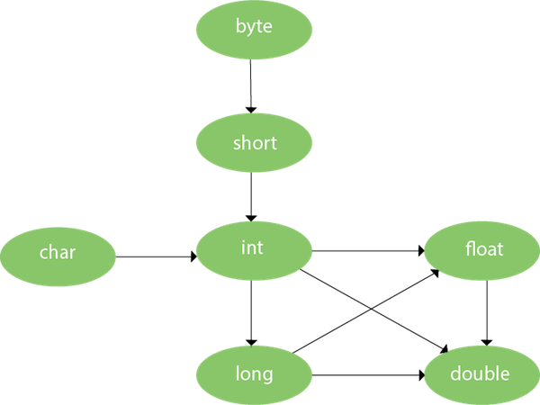

As displayed in the above diagram, the byte can be promoted to short, int, long, float or double. The short datatype can be promoted to int, long, float or double. The char datatype can be promoted to int, long, float or double and so on. Consider the following example.

class OverloadingCalculation1 {

>void sum(int a, long b) {

>>System.out.println(a + b);

>}

>void sum(int a, int b, int c) {

>>System.out.println(a + b + c);

>}

>public static void main(String args[]) {

>>OverloadingCalculation1 obj = new OverloadingCalculation1();

>>obj.sum(20, 20); //now second int literal will be promoted to long

>>obj.sum(20, 20, 20);

>}

}

Output

40

60

1. **Can we change the scope of the overridden method in the subclass?**

No, we cannot change the scope of the overridden method in the subclass.

1. **Can you have virtual functions in Java?**

In Java, all non-static methods are virtual functions by default.

1. **What is the covariant return type?**

Now, since java5, it is possible to override any method by changing the return type if the return type of the subclass overriding method is subclass type. It is known as covariant return type. The covariant return type specifies that the return type may vary in the same direction as the subclass.

class A {

>A get() {

>>return this;

>}

}

class B1 extends A {

>B1 get() {

>>return this;

>}

>void message() {

>>System.out.println("welcome to covariant return type");

>}

>public static void main(String args[]) {

>>new B1().get().message();

>}

}

Output: welcome to covariant return type

1. **Difference between the final method and the abstract method**

The main difference between a final method and an abstract method in Java is that a final method cannot be overridden in a subclass, while an abstract method must be overridden in a subclass.

[Core Java Interview Questions and Answers (2023) - InterviewBit](https://www.interviewbit.com/java-interview-questions/#instance-variables-and-local-variables-in-java)

1. **What do you understand about an instance variable and a local variable?**

Instance variables and local variables are two types of variables in Java. Instance variables are declared inside a class but outside any method. They are used to store data that is specific to an object and are accessible from any method of the given class. Local variables, on the other hand, are declared inside a method or a code block and are used to store temporary data that is required only within that method.

In Java, a local variable is typically used inside a method, constructor, or a block and has only local scope. Thus, this variable can be used only within the scope of a block. The best benefit of having a local variable is that other methods in the class won’t be even aware of that variable.

Example

if(x > 100) {

>String test = "Edureka";

}

Whereas, an instance variable in Java, is a variable which is bounded to its object itself. These variables are declared within a class, but outside a method. Every object of that class will create it’s own copy of the variable while using it. Thus, any changes made to the variable won’t reflect in any other instances of that class and will be bound to that particular instance only.

class Test {

>public String EmpName;

>public int empAge;

}

1. **How is an infinite loop declared in Java?**

Infinite loops are those loops that run infinitely without any breaking conditions. Some examples of consciously declaring infinite loop is:

Using For Loop:

for (;;)

{

// Business logic

// Any break logic

}

Using while loop:

while(true){

// Business logic

// Any break logic

}

Using do-while loop:

do{

// Business logic

// Any break logic

}while(true);

1. **Briefly explain the concept of constructor overloading**

Constructor overloading is the process of creating multiple constructors in the class consisting of the same name with a difference in the constructor parameters. Depending upon the number of parameters and their corresponding types, distinguishing of the different types of constructors is done by the compiler.

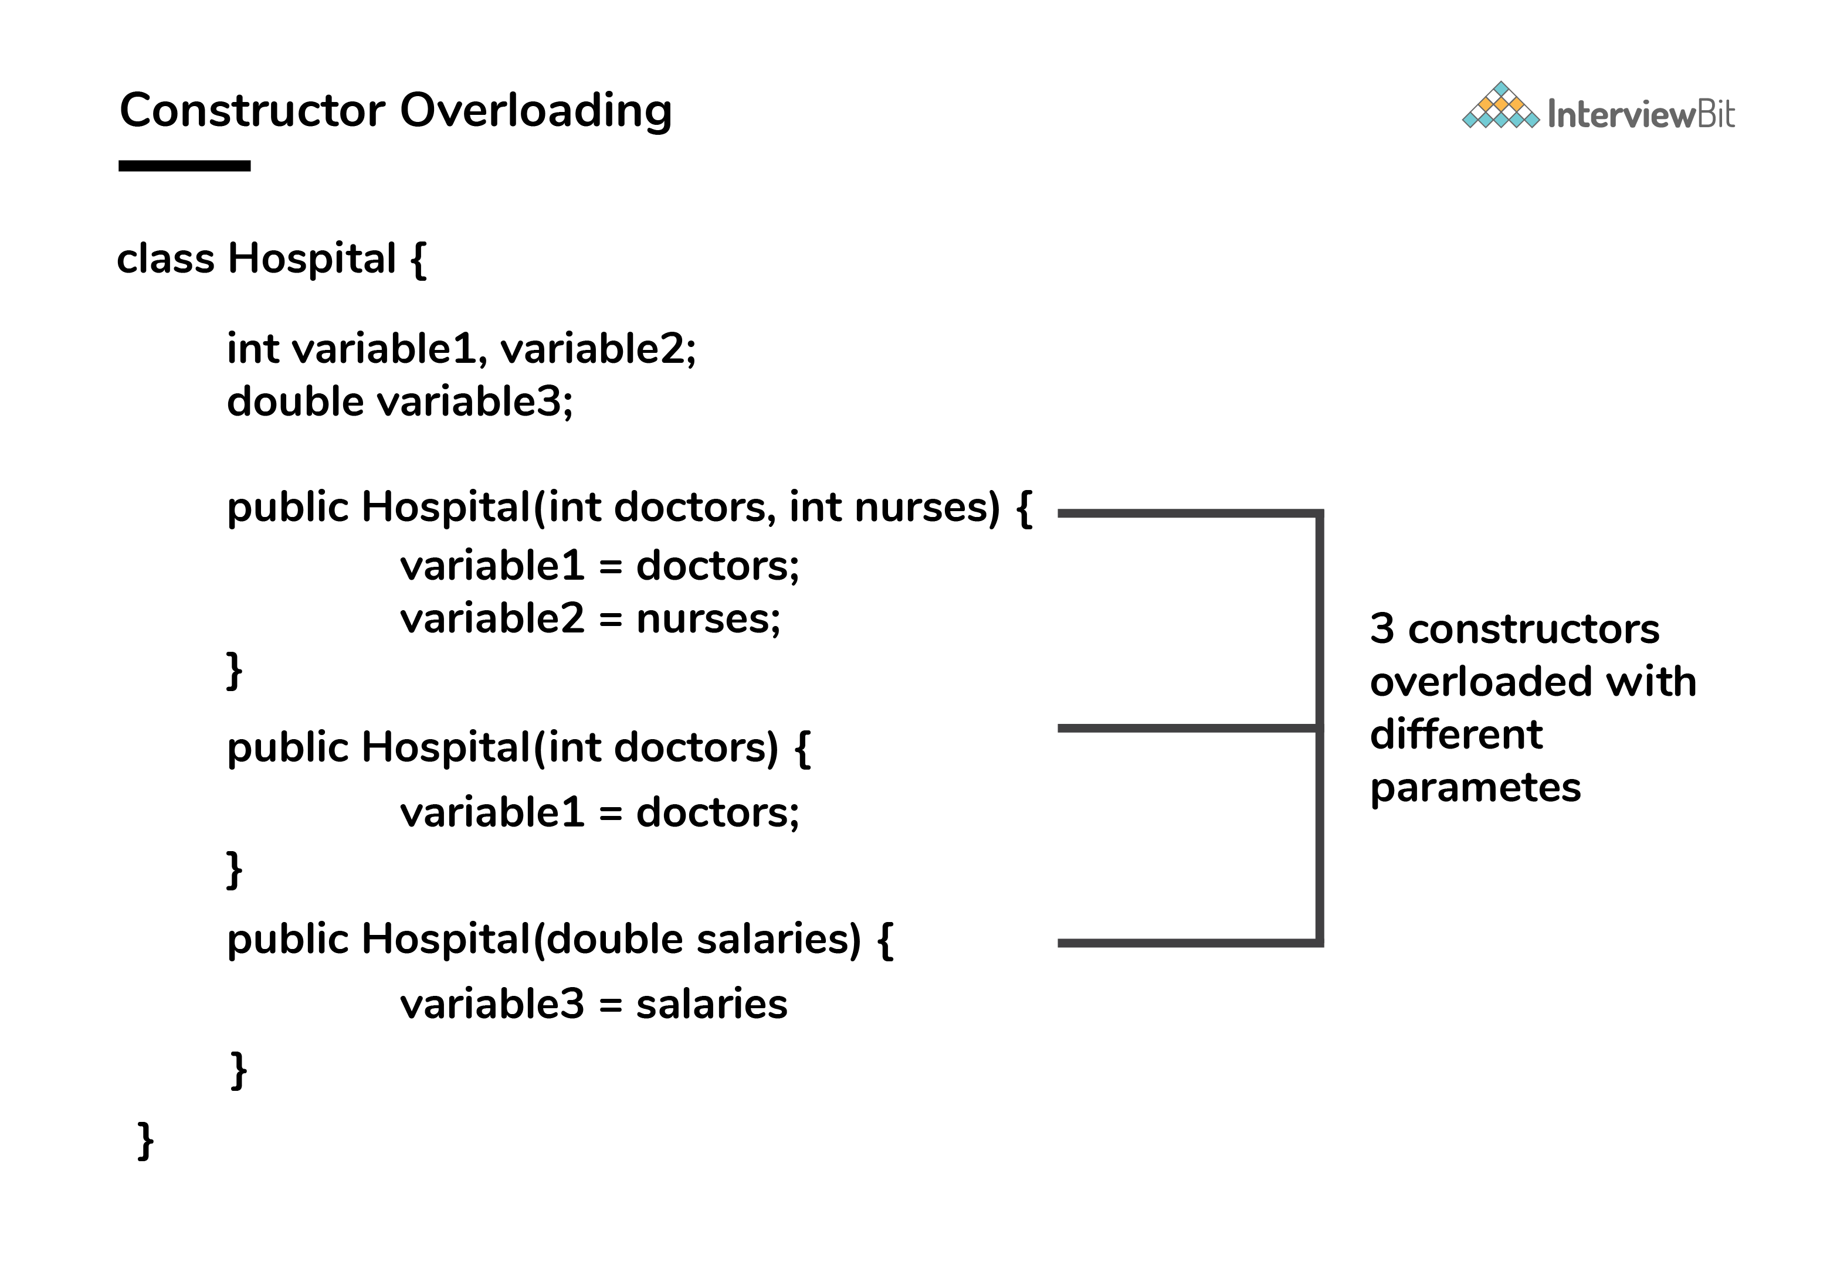

Three constructors are defined here but they differ on the basis of parameter type and their numbers. There is no limit regarding the number of created constructors.

1. **Can the main method be Overloaded?**

Yes, It is possible to overload the main method. We can create as many overloaded main methods we want. However, JVM has a predefined calling method that JVM will only call the main method with the definition of:

public static void main(string[] args)

Consider the below code snippets:

class Main {

>public static void main(String args[]) {

>>System.out.println(" Main Method");

>}

>public static void main(int[] args){

>>System.out.println("Overloaded Integer array Main Method");

>}

>public static void main(char[] args){

>>System.out.println("Overloaded Character array Main Method");

>}

>public static void main(double[] args){

>>System.out.println("Overloaded Double array Main Method");

>}

>public static void main(float args){

>>System.out.println("Overloaded float Main Method");

>}

}

1. **Identify the output of the java program and state the reason.**

1. public class InterviewBit

2. {

3.> public static void main(String[] args) {

4.> > final int i;

5.>> i = 20;

6.>> int j = i+20;

7.>> i = j+30;

8.>> System.out.println(i + " " + j);

9.> }

10. }

The above code will generate a compile-time error at Line 7 saying - [error: variable i might already have been initialized]. It is because variable ‘i’ is the final variable. And final variables are allowed to be initialized only once, and that was already done on line no 5.

1. **When can you use super keyword?**

* The super keyword is used to access hidden fields and overridden methods or attributes of the parent class.
* Following are the cases when this keyword can be used:
  + Accessing data members of parent class when the member names of the class and its child subclasses are same.
  + To call the default and parameterized constructor of the parent class inside the child class.
  + Accessing the parent class methods when the child classes have overridden them.

1. **Is this program giving a compile-time error? If Yes then state the reason and number of errors it will give. If not then state the reason.**

abstract final class InterviewBit {

>public abstract void printMessage();

}

class ScalarAcademy extends InterviewBit {

>public void printMessage() {

>>System.out.println("Welcome to Scalar Academy By InterviewBit");

>}

}

class ScalarTopics extends ScalarAcademy {

>public void printMessage() {

>>System.out.println("Welcome to Scalar Topics By Scalar Academy");

>}

}

public class Main {

>public static void main(String[] args) {

>>InterviewBit ib = new ScalarTopics();

>>ib.printMessage();

>}

}

The above program will give a compile-time error. The compiler will throw 2 errors in this.

* [Illegal Combination of modifiers: abstract and final] at line 1.
* [Cannot inherit from final ‘InterviewBit’] at line 4.

It is because abstract classes are incomplete classes that need to be inherited for making their concrete classes. And on the other hand, the final keywords in class are used for avoiding inheritance. So these combinations are not allowed in Java.

1. **What do we get in the JDK file?**

JDK: For making java programs, we need some tools that are provided by JDK (Java Development Kit). JDK is the package that contains various tools, Compiler, Java Runtime Environment, etc.

JRE: To execute the java program we need an environment. (Java Runtime Environment) JRE contains a library of Java classes + JVM. What are JAVA Classes? It contains some predefined methods that help Java programs to use that feature, build and execute. For example - there is a system class in java that contains the print-stream method, and with the help of this, we can print something on the console.

JVM: (Java Virtual Machine) JVM is a part of JRE that executes the Java program at the end. Actually, it is part of JRE, but it is software that converts bytecode into machine-executable code to execute on hardware.

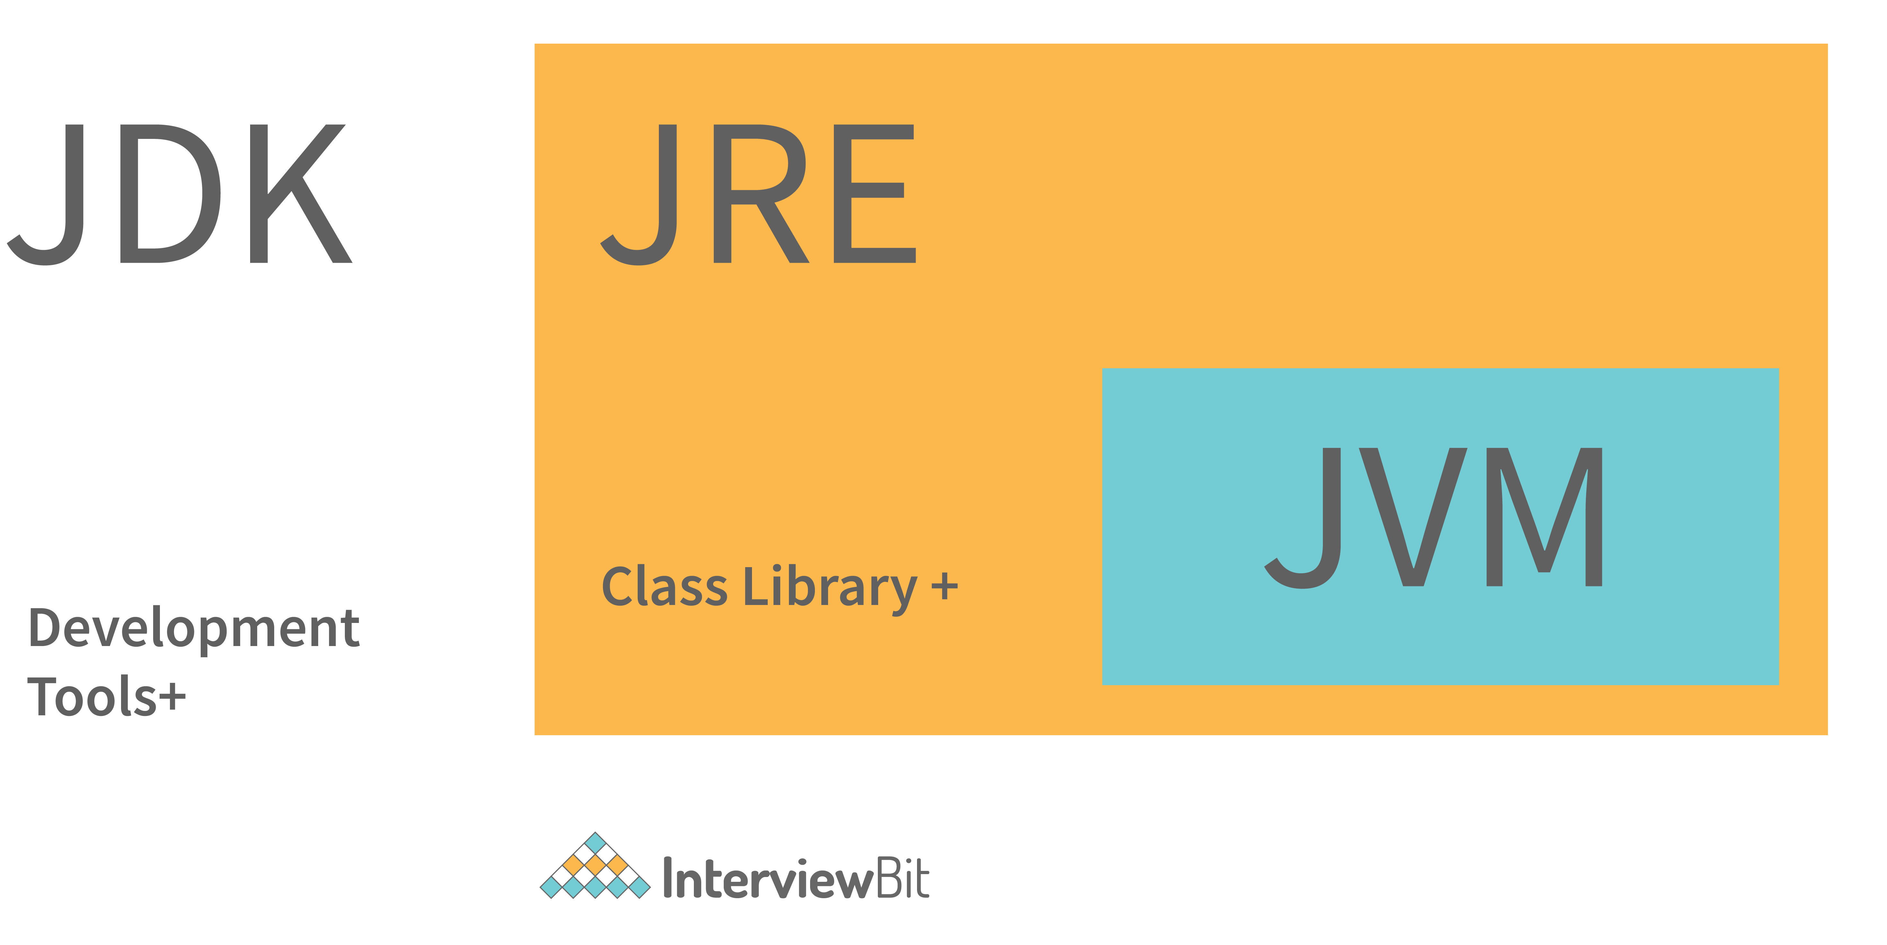

1. **What are the differences between JVM, JRE and JDK in Java?**

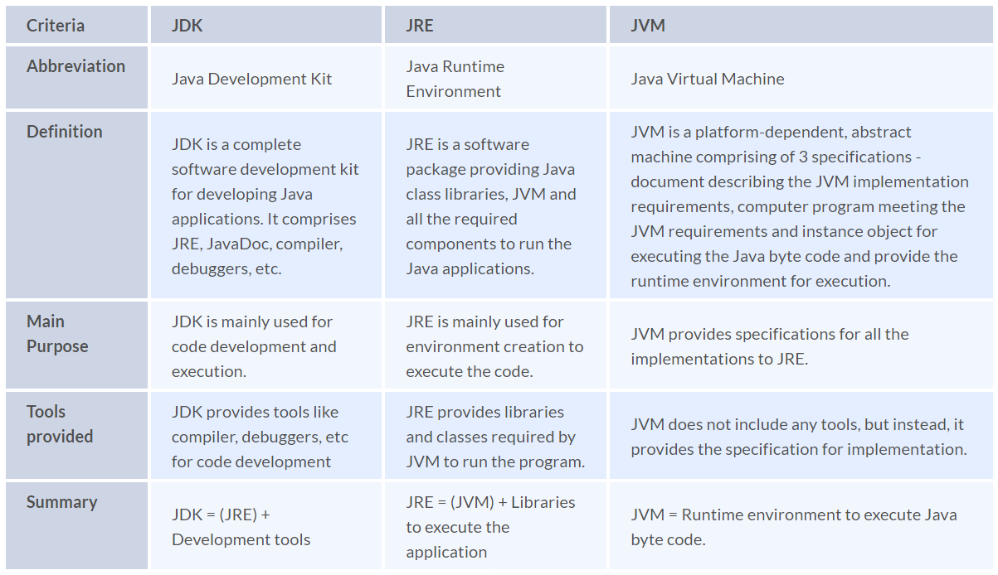

1. **Identify the output of the below java program and Justify your answer.**

class Main {

>public static void main(String args[]) {

>>Scaler s = new Scaler(5);

>}

}

class InterviewBit {

>InterviewBit() {

>>System.out.println(" Welcome to InterviewBit ");

>}

}

class Scaler extends InterviewBit {

>Scaler() {

>>System.out.println(" Welcome to Scaler Academy ");

>}

>Scaler(int x) {

>>this();

>>super();

>>System.out.println(" Welcome to Scaler Academy 2");

>}

}

The above code will throw the compilation error. It is because the super() is used to call the parent class constructor. But there is the condition that super() must be the first statement in the block. Now in this case, if we replace this() with super() then also it will throw the compilation error. Because this() also has to be the first statement in the block. So in conclusion, we can say that we cannot use this() and super() keywords in the same block.

1. **Which among String or String Buffer should be preferred when there are lot of updates required to be done in the data?**

StringBuffer is mutable and dynamic in nature whereas String is immutable. Every updation / modification of String creates a new String thereby overloading the string pool with unnecessary objects. Hence, in the cases of a lot of updates, it is always preferred to use StringBuffer as it will reduce the overhead of the creation of multiple String objects in the string pool.

1. **Consider the below program, identify the output, and also state the reason for that.**

public class Main {

>public static void main(String[] args) {

>>System.out.println(" Hello. Main Method. ");

>}

>public static void main(int[] args) {

>>System.out.println(" Hello. Main Method2. ");

>}

}

The output of the above program will be Hello. Main Method. This is because JVM will always call the main method based on the definition it already has. Doesn't matter how many main methods we overload it will only execute one main method based on its declaration in JVM. The main method JVM starts is always the public static void one, with only a String[] object as a parameter.

1. **Can we make the main() thread a daemon thread?**

In java multithreading, the main() threads are always non-daemon threads. And there is no way we can change the nature of the non-daemon thread to the daemon thread. If we tried with the following code snippet, an IllegalThreadStateException would be thrown:

public static void main(String[] args) {

>Thread current = Thread.currentThread();

>current.setDaemon(true);

}

1. **What happens if there are multiple main methods inside one class in Java?**

If the signature is not the same, it wont be an issue, as it’s just a simple overloading, but if it’s the same, the compiler will throw an error, regardless if it’s a main method or not.

1. **How do exceptions affect the program if it doesn't handle them?**

Exceptions are runtime errors. Suppose we are making an android application with java. And it all works fine but there is an exceptional case when the application tries to get the file from storage and the file doesn’t exist (This is the case of exception in java). And if this case is not handled properly then the application will crash. This will be a bad experience for users. This is the type of error that cannot be controlled by the programmer. But programmers can take some steps to avoid this so that the application won’t crash. The proper action can be taken at this step.

1. **Is it mandatory for a catch block to be followed after a try block?**

It is not necessary that each try block must be followed by a catch block. It should be followed by either a catch block OR a finally block. So whatever exceptions are likely to be thrown should be declared in the throws clause of the method. Consider the following example.

public class Main {

>public static void main(String[] args) {

>>try {

>>>int a = 1;

>>>System.out.println(a / 0);

>>} finally {

>>>System.out.println("rest of the code...");

>>}

>}

}

Output:

Exception in thread main java.lang.ArithmeticException:/ by zero

rest of the code...

1. **Contiguous memory locations are usually used for storing actual values in an array but not in ArrayList. Explain.**

In the case of ArrayList, data storing in the form of primitive data types (like int, float, etc.) is not possible. The data members/objects present in the ArrayList have references to the objects which are located at various sites in the memory. Thus, storing of actual objects or non-primitive data types (like Integer, Double, etc.) takes place in various memory locations.

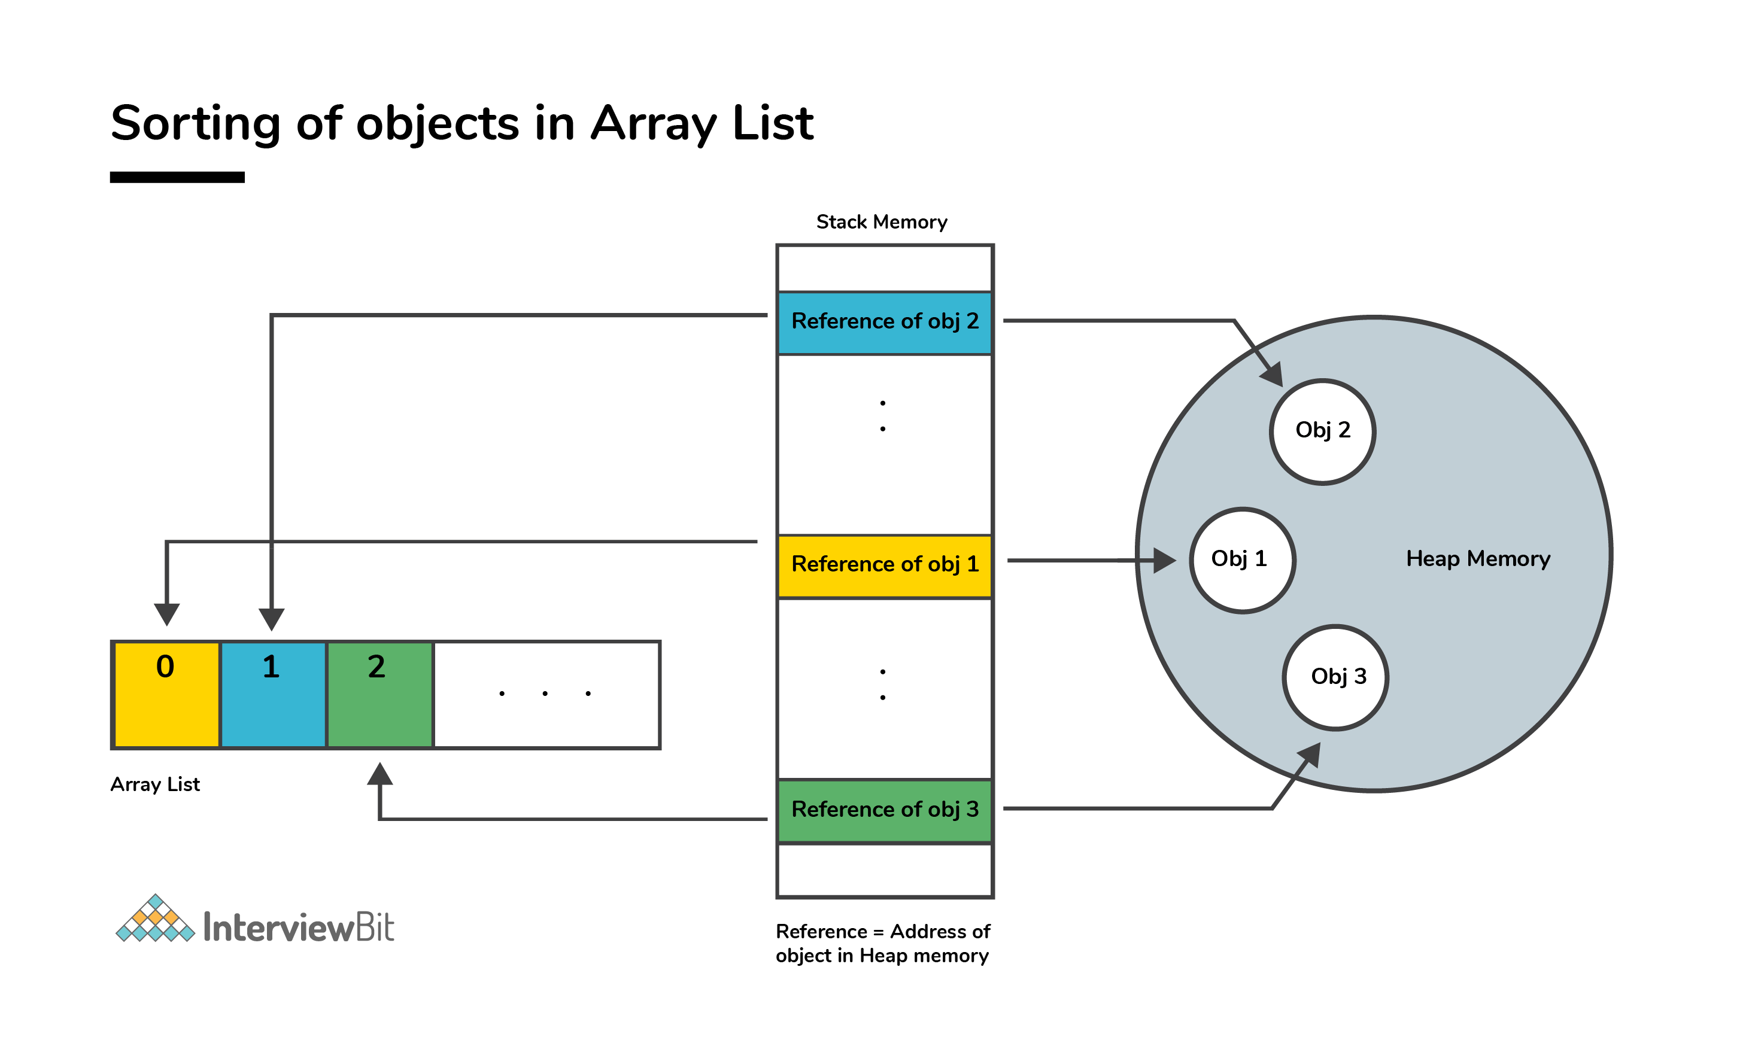

However, the same does not apply to the arrays. Object or primitive type values can be stored in arrays in contiguous memory locations, hence every element does not require any reference to the next element.

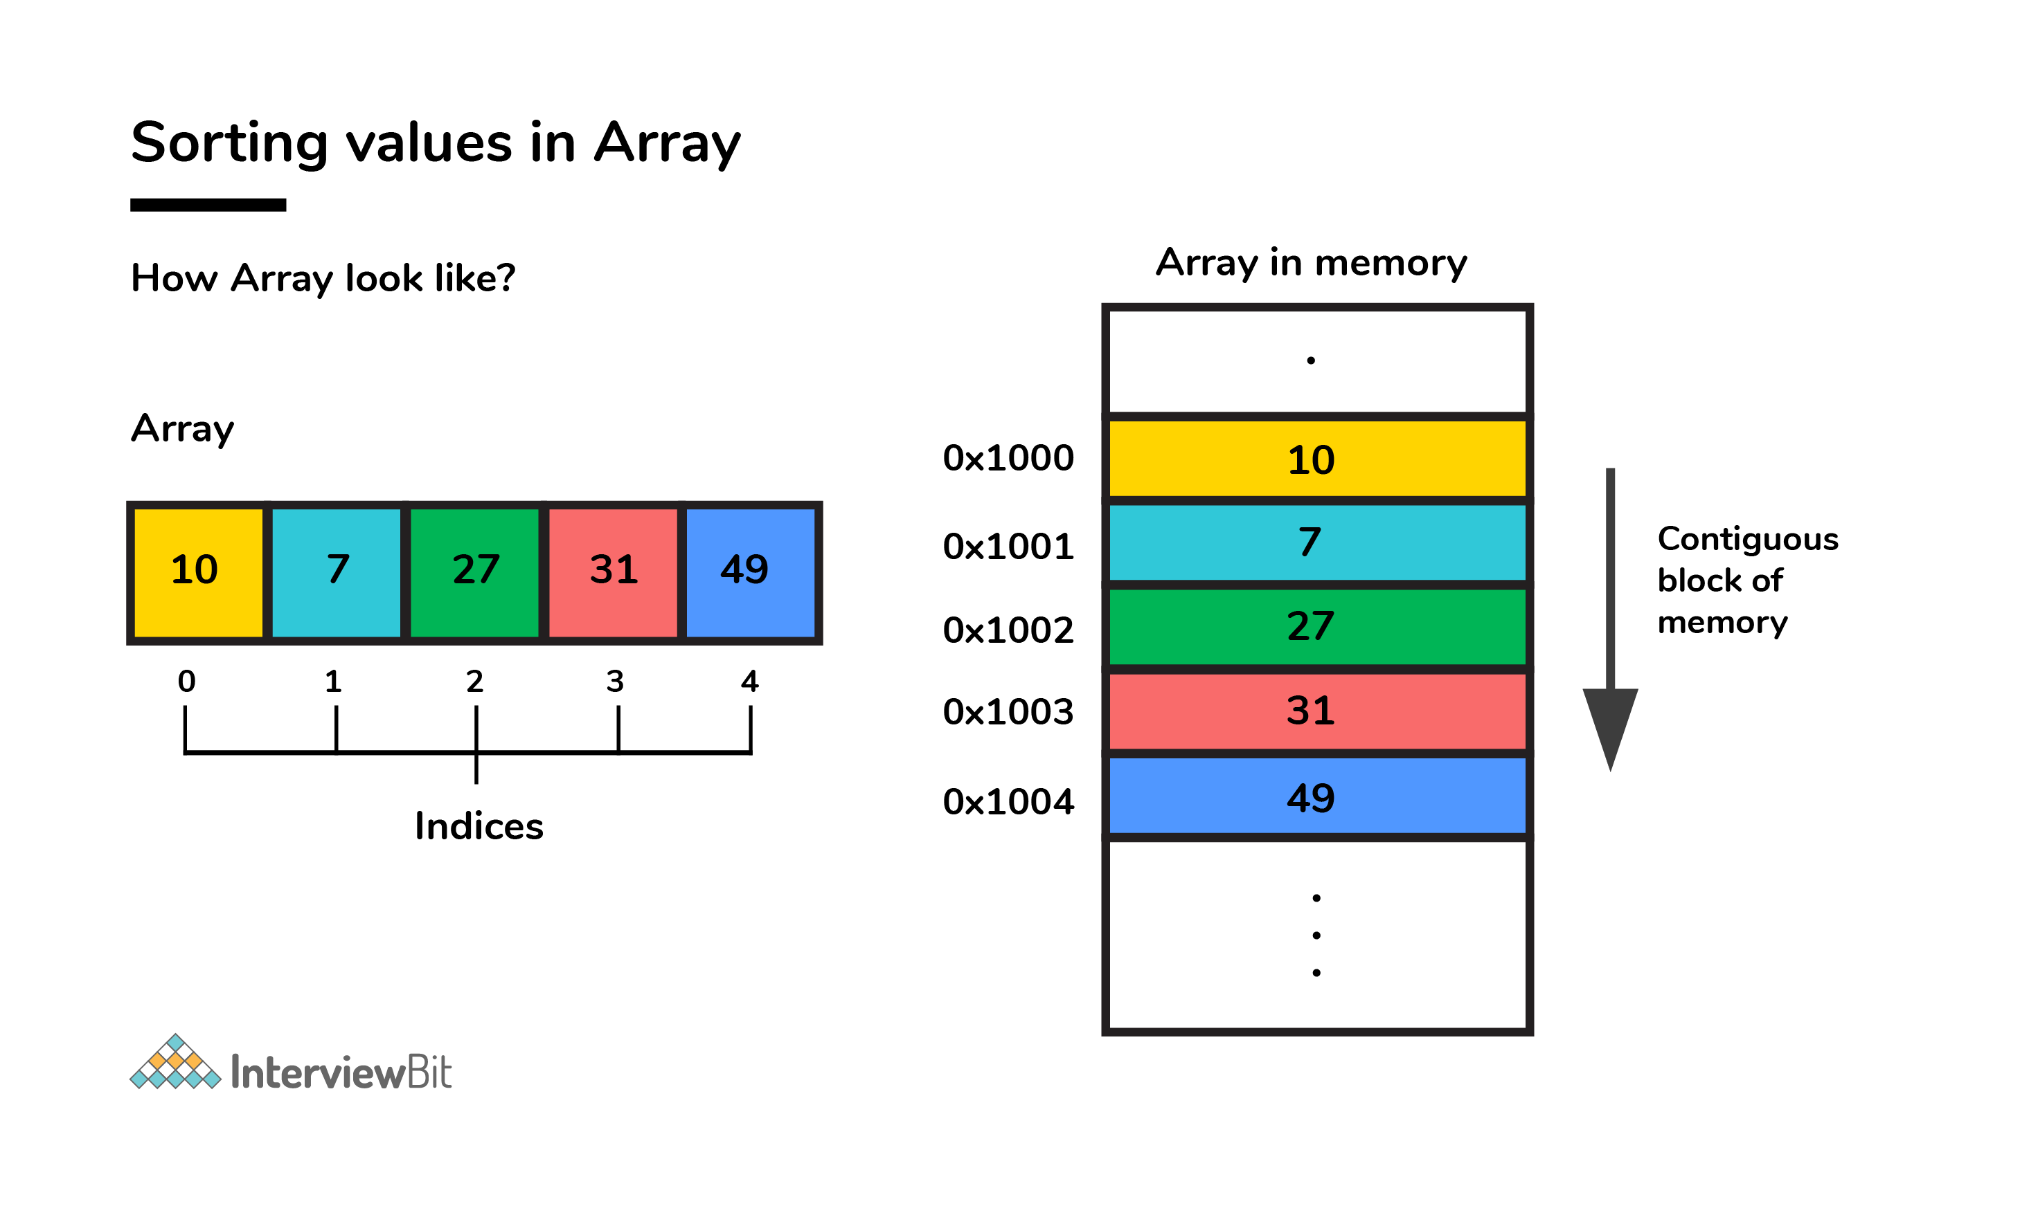

1. **Although inheritance is a popular OOPs concept, it is less advantageous than composition. Explain.**

Inheritance lags behind composition in the following scenarios:

Multiple-inheritance is not possible in Java. Classes can only extend from one superclass. In cases where multiple functionalities are required, for example - to read and write information into the file, the pattern of composition is preferred. The writer, as well as reader functionalities, can be made use of by considering them as the private members.

Composition assists in attaining high flexibility and prevents breaking of encapsulation.

Unit testing is possible with composition and not inheritance. When a developer wants to test a class composing a different class, then Mock Object can be created for signifying the composed class to facilitate testing. This technique is not possible with the help of inheritance as the derived class cannot be tested without the help of the superclass in inheritance.

The loosely coupled nature of composition is preferable over the tightly coupled nature of inheritance.

Let’s take an example:

package comparison;

public class Top {

public int start() {

>return 0;

}

}

class Bottom extends Top {

>public int stop() {

>>return 0;

>}

}

In the above example, inheritance is followed. Now, some modifications are done to the Top class like this:

public class Top {

>public int start() {

>>return 0;

>}

public void stop() {

>}

}

If the new implementation of the Top class is followed, a compile-time error is bound to occur in the Bottom class. Incompatible return type is there for the Top.stop() function. Changes have to be made to either the Top or the Bottom class to ensure compatibility. However, the composition technique can be utilized to solve the given problem:

class Bottom {

>Top par = new Top();

>public int stop() {

>>par.start();

>>par.stop();

>>return 0;

>}

}

1. **What are Composition and Aggregation? State the difference.**

Composition, and Aggregation help to build (Has - A - Relationship) between classes and objects. But both are not the same in the end. Let’s understand with the help of an example.

* Consider the University as a class that has some departments in it. So the university will be the container object. And departments in it will contain objects. Now in this case, if the container object destroys then the contained objects will also get destroyed automatically. So here we can say that there is a strong association between the objects. So this Strong Association is called Composition.
* Now consider one more example. Suppose we have a class department and there are several professors' objects there in the department. Now if the department class is destroyed then the professor's object will become free to bind with other objects. Because container objects (Department) only hold the references of contained objects (Professor’s). So here is the weak association between the objects. And this weak association is called Aggregation.

1. **In the given code below, what is the significance of ... ?**

public void fooBarMethod(String... variables){

// method code

}

* Ability to provide ... is a feature called varargs (variable arguments) which was introduced as part of Java 5.
* The function having ... in the above example indicates that it can receive multiple arguments of the datatype String.
* For example, the fooBarMethod can be called in multiple ways and we can still have one method to process the data as shown below:

fooBarMethod("foo", "bar");

fooBarMethod("foo", "bar", "boo");

fooBarMethod(new String[]{"foo", "var", "boo"});

public void myMethod(String... variables){

for(String variable : variables){

> // business logic

}

}

1. **What will be the output of the below java program and define the steps of Execution of the java program with the help of the below code?**

class InterviewBit{

>int i;

>static int j;

>{

>>System.out.println(" Instance Block 1. Value of i = "+i);

>}

>static{

>>System.out.println(" Static Block 1. Value of j = "+j);

>>method_2();

>}

>{

>>i = 5;

>}

>static{

>>j = 10;

>}

>InterviewBit(){

>>System.out.println(" Welcome to InterviewBit ");

>}

>public static void main(String[] args){

>>InterviewBit ib = new InterviewBit();

>}

>public void method_1(){

>>System.out.println(" Instance method. ");

>}

>static{

>>System.out.println(" Static Block 2. Value of j = "+j);

>}

>{

>>System.out.println(" Instance Block 2. Value of i = "+i);

>>method_1();

>}

>public static void method_2(){

>>System.out.println(" Static method. ");

>}

}

The Output we get by executing this program will be:

**Static Block 1. Value of j = 0**

**Static method.**

**Static Block 2. Value of j = 10**

**Instance Block 1. Value of i = 0**

**Instance Block 2. Value of i = 5**

**Instance method.**

**Welcome to InterviewBit**

This is a java tricky interview question frequently asked in java interviews for the experienced. The output will be like this because, when the java program is compiled and gets executed, then there are various steps followed for execution. And the steps are -

* Identification of Static Members from top to bottom.
* Execution of Static variable assignment and a Static block from top to bottom.
* Execution of the main method.
* Identification of Instance Members from top to bottom.
* Execution of Instance variable assignment and Instance block from top to bottom.
* Execution of Constructor.

In above steps from 4 to 6, will be executed for every object creation. If we create multiple objects then for every object these steps will be performed.

Now from the above code, the execution will happen like this -

1. In the step of identification of static members. It is found that -

* static int j.
* static block.
* main method.
* static method_2.

During identification, the JVM will assign the default value in the static int j variable. Then it is currently in the state of reading and indirectly writing. Because the original value is not assigned.

2. In the next step, it will execute the static block and assign the value in static variables.

* First static block it will print and because execution from top to bottom and original value in j is not assigned. So it will print the default value of 0.
* After executing static block 1. It will execute the static method_1 because it is called from the static block 1.
* Then it will assign the original value of 5 in the j variable. And executes the remaining static block.

3. Now it will execute the main method. In which it will create an object for the class InterviewBit. And then the execution of instances will happen.

4. Identify the instance variables and blocks from top to bottom.

* int i.
* Instance block 1.
* Instance method_1.

Like a static variable, the instance variable also has been initialized with the default value 0 and will be in the state of reading and writing indirectly.

5. It will execute the instance methods and assign the original value to the instance variable.

* Prints the Instance block 1. And the current value of i is not assigned till now, so it will print 0.
* Assign the original value to i. Then print instance block 2. And after that instance method will be called and printed because it is being called in the instance block.

6. And at the last step, the constructor will be invoked and the lines will be executed in the constructor.

This is how the java program gets executed.

1. **What is the output of the below code and why?**

public class InterviewBit{

public static void main(String[] args)

{

> System.out.println('b' + 'i' + 't');

}

}

“bit” would have been the result printed if the letters were used in double-quotes (or the string literals). But the question has the character literals (single quotes) being used which is why concatenation wouldn't occur. The corresponding ASCII values of each character would be added and the result of that sum would be printed.

The ASCII values of ‘b’, ‘i’, ‘t’ are:

* ‘b’ = 98
* ‘i’ = 105
* ‘t’ = 116

98 + 105 + 116 = 319

Hence 319 would be printed

1. **In the below Java Program, how many objects are eligible for garbage collection?**

class Main{

public static void main(String[] args){

> int[][] num = new int[3][];

> num[0] = new int[5];

> num[1] = new int[2];

> num[2] = new int[3];

>

> num[2] = new int[5];

> num[0] = new int[4];

> num[1] = new int[3];

>

> num = new int[2][];

}

}

In the above program, a total of 7 objects will be eligible for garbage collection. Let’s visually understand what's happening in the code.





In the above figure on line 3, we can see that on each array index we are declaring a new array so the reference will be of that new array on all the 3 indexes. So the old array will be pointed to by none. So these three are eligible for garbage collection. And on line 4, we are creating a new array object on the older reference. So that will point to a new array and older multidimensional objects will become eligible for garbage collection.

1. **Check if a given string is palindrome using recursion.**

/*

* Java program to check if a given inputted string is palindrome or not using recursion.

*/

import java.util.*;

public class InterviewBit {

public static void main(String args[]) {

> Scanner s = new Scanner(System.in);

> String word = s.nextLine();

> System.out.println("Is "+word+" palindrome? - "+isWordPalindrome(word));

}

public static boolean isWordPalindrome(String word){

> String reverseWord = getReverseWord(word);

> //if word equals its reverse, then it is a palindrome

> if(word.equals(reverseWord)){

>> return true;

> }

> return false;

}

public static String getReverseWord(String word){

> if(word == null || word.isEmpty()){

>> return word;

> }

>

> return word.charAt(word.length()- 1) + getReverseWord(word.substring(0, word.length() - 1));

}

}

[300 Core Java Interview Questions (2023) - javatpoint](https://www.javatpoint.com/corejava-interview-questions)

1. **What do you understand by Java virtual machine?**

Java Virtual Machine is a virtual machine that enables the computer to run the Java program. JVM acts like a run-time engine which calls the main method present in the Java code. JVM is the specification which must be implemented in the computer system. The Java code is compiled by JVM to be a Bytecode which is machine independent and close to the native code.

1. **What is the platform?**

A platform is the hardware or software environment in which a piece of software is executed. There are two types of platforms, software-based and hardware-based. Java provides the software-based platform.

1. **What are the main differences between the Java platform and other platforms?**

There are the following differences between the Java platform and other platforms.

* Java is the software-based platform whereas other platforms may be the hardware platforms or software-based platforms.
* Java is executed on the top of other hardware platforms whereas other platforms can only have the hardware components.

1. **What gives Java its 'write once and run anywhere' nature?**

The bytecode. Java compiler converts the Java programs into the class file (Byte Code) which is the intermediate language between source code and machine code. This bytecode is not platform specific and can be executed on any computer.

1. **Is Empty .java file name a valid source file name?**

Yes, Java allows to save our java file by .java only, we need to compile it by javac .java and run by java classname Let's take a simple example:

//save by .java only

class A {

>public static void main(String args[]){

>>System.out.println("Hello java");

>}

}

compile it by javac .java

run it by java A

1. **If I don't provide any arguments on the command line, then what will the value stored in the String array passed into the main() method, empty or NULL?**

It is empty, but not null.

1. **What is the purpose of static methods and variables?**

The methods or variables defined as static are shared among all the instances of the class. The static is the part of the class and not of the object. The static variables are stored in the class area, and we do not need to create the object to access such variables. Therefore, static is used in the case, where we need to define variables or methods which are common to all the objects of the class.

For example, In the class simulating the collection of the students in a college, the name of the college is the common attribute to all the students. Therefore, the college name will be defined as static.

1. **What are the advantages of Packages in Java?**

There are various advantages of defining packages in Java.

* Packages avoid the name clashes.
* The Package provides easier access control.
* We can also have the hidden classes that are not visible outside and used by the package.
* It is easier to locate the related classes.
* Packages enable the developer to organize the similar classes more effectively. For example, one can clearly understand that the classes present in java.io package are used to perform io related operations.

1. **What is the output of the following Java program?**

class Test

{

>public static void main (String args[])

>{

>>System.out.println(10 * 20 + "Javatpoint");

>>System.out.println("Javatpoint" + 10 * 20);

>}

}

The output of the above code will be

200Javatpoint

Javatpoint200

Explanation

In the first case, The numbers 10 and 20 will be multiplied first and then the result 200 is treated as the string and concatenated with the string Javatpoint to produce the output 200Javatpoint.b

In the second case, The numbers 10 and 20 will be multiplied first to be 200 because the precedence of the multiplication is higher than addition. The result 200 will be treated as the string and concatenated with the string Javatpointto produce the output as Javatpoint200.

1. **What is the output of the following Java program?**

class Test

{

>public static void main (String args[])

>{

>>for(int i=0; 0; i++)

>>{

>>>System.out.println("Hello Javatpoint");

>>}

>}

}

The above code will give the compile-time error because the for loop demands a boolean value in the second part and we are providing an integer value, i.e., 0.

1. **What is an object?**

The Object is the real-time entity having some state and behavior. In Java, Object is an instance of the class having the instance variables as the state of the object and the methods as the behavior of the object. The object of a class can be created by using the new keyword.

An object has three characteristics:

* State
* Behavior
* Identity

An object is created using the ‘new’ keyword. For example:

ClassName obj = new ClassName();

1. **What is the difference between an object-oriented programming language and object-based programming language?**

There are the following basic differences between the object-oriented language and object-based language.

* Object-oriented languages follow all the concepts of OOPs whereas, the object-based language doesn't follow all the concepts of OOPs like inheritance and polymorphism.
* Object-oriented languages do not have the inbuilt objects whereas Object-based languages have the inbuilt objects, for example, JavaScript has window object.
* Examples of object-oriented programming are Java, C#, Smalltalk, etc. whereas the examples of object-based languages are JavaScript, VBScript, etc.

1. **What is the constructor?**

The constructor can be defined as the special type of method that is used to initialize the state of an object. It is invoked when the class is instantiated, and the memory is allocated for the object. Every time, an object is created using the new keyword, the default constructor of the class is called. The name of the constructor must be similar to the class name. The constructor must not have an explicit return type.

* When a new object is created in a program a constructor gets invoked corresponding to the class.
* The constructor is a method which has the same name as the class name.
* If a user doesn’t create a constructor implicitly a default constructor will be created.
* The constructor can be overloaded.
* If the user created a constructor with a parameter then he should create another constructor explicitly without a parameter.

1. **What is the purpose of a default constructor?**

The purpose of the default constructor is to assign the default value to the objects. The java compiler creates a default constructor implicitly if there is no constructor in the class.

class Student3 {

>int id;

>String name;

>void display() {

>>System.out.println(id+" "+name);

>}

>public static void main(String args[]) {

>>Student3 s1=new Student3();

>>Student3 s2=new Student3();

>>s1.display();

>>s2.display();

>}

}

Output:

0 null

0 null

Explanation: In the above class, you are not creating any constructor, so compiler provides you a default constructor. Here 0 and null values are provided by default constructor.

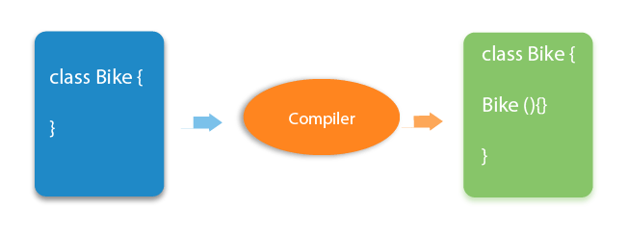

1. **Is constructor inherited?**

No, The constructor is not inherited.

1. **Can you make a constructor final?**

No, the constructor can't be final.

1. **What is the output of the following Java program?**

public class Test

{

>Test(int a, int b)

>{

>>System.out.println("a = "+a+" b = "+b);

>}

>Test(int a, float b)

>{

>>System.out.println("a = "+a+" b = "+b);

>}

>public static void main (String args[])

>{

>>byte a = 10;

>>byte b = 15;

>>Test test = new Test(a,b);

>}

}

The output of the following program is:

a = 10 b = 15

Here, the data type of the variables a and b, i.e., byte gets promoted to int, and the first parameterized constructor with the two integer parameters is called.

1. **What is the output of the following Java program?**

class Test {

>int i;

}

public class Main {

>public static void main (String args[]) {

>>Test test = new Test();

>>System.out.println(test.i);

>}

}

The output of the program is 0 because the variable i is initialized to 0 internally. As we know that a default constructor is invoked implicitly if there is no constructor in the class, the variable i is initialized to 0 since there is no constructor in the class.

1. **What is the output of the following Java program?**

class Test {

>int test_a, test_b;

>Test(int a, int b) {

>test_a = a;

>test_b = b;

>}

>public static void main (String args[]) {

>>Test test = new Test();

>>System.out.println(test.test_a+" "+test.test_b);

>}

}

There is a compiler error in the program because there is a call to the default constructor in the main method which is not present in the class. However, there is only one parameterized constructor in the class Test. Therefore, no default constructor is invoked by the constructor implicitly.

1. **What is the static variable?**

The static variable is used to refer to the common property of all objects (that is not unique for each object), e.g., The company name of employees, college name of students, etc. Static variable gets memory only once in the class area at the time of class loading. Using a static variable makes your program more memory efficient (it saves memory). Static variable belongs to the class rather than the object.

//Program of static variable

class Student8 {

int rollno;

String name;

static String college ="ITS";

>

Student8(int r,String n){

rollno = r;

name = n;

}

void display (){System.out.println(rollno+" "+name+" "+college);

}

public static void main(String args[]) {

Student8 s1 = new Student8(111,"Karan");

Student8 s2 = new Student8(222,"Aryan");

s1.display();

s2.display();

}

}

Output:

111 Karan ITS

222 Aryan ITS

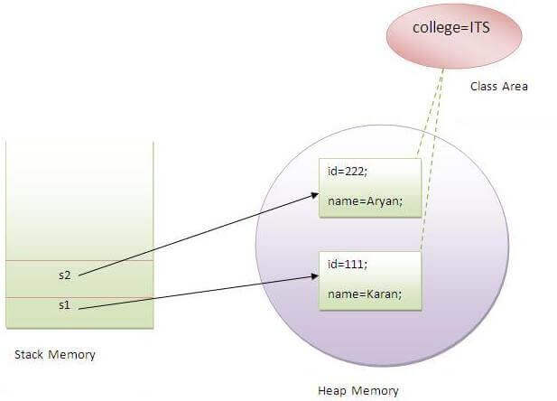

1. **What is the static method?**

* A static method belongs to the class rather than the object.
* There is no need to create the object to call the static methods.
* A static method can access and change the value of the static variable.

1. **What are the restrictions that are applied to the Java static methods?**

Two main restrictions are applied to the static methods.

* The static method can not use non-static data member or call the non-static method directly.
* this and super cannot be used in static context as they are non-static.

1. **Can we override the static methods?**

No, we can't override static methods.

1. **Can we execute a program without main() method?**

No, It was possible before JDK 1.7 using the static block. Since JDK 1.7, it is not possible.

1. **What is the difference between static (class) method and instance method?**

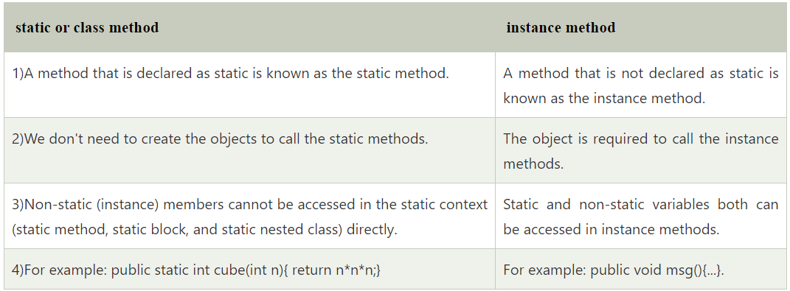

1. **Can we make constructors static?**

As we know that the static context (method, block, or variable) belongs to the class, not the object. Since Constructors are invoked only when the object is created, there is no sense to make the constructors static. However, if you try to do so, the compiler will show the compiler error.

1. **Can we make the abstract methods static in Java?**

In Java, if we make the abstract methods static, It will become the part of the class, and we can directly call it which is unnecessary. Calling an undefined method is completely useless therefore it is not allowed.

1. **Can we declare the static variables and methods in an abstract class?**

Yes, we can declare static variables and methods in an abstract method. As we know that there is no requirement to make the object to access the static context, therefore, we can access the static context declared inside the abstract class by using the name of the abstract class. Consider the following example.

abstract class Test {

>static int i = 102;

>static void TestMethod()

>{

>>System.out.println("hi !! I am good !!");

>}

}

public class TestClass extends Test {

>public static void main (String args[]) {

>>Test.TestMethod();

>>System.out.println("i = "+Test.i);

>}

}

Output

hi !! I am good !!

i = 102

1. **What are the main uses of this keyword?**

There are the following uses of this keyword.

* this can be used to refer to the current class instance variable.
* this can be used to invoke current class method (implicitly)
* this() can be used to invoke the current class constructor.
* this can be passed as an argument in the method call.
* this can be passed as an argument in the constructor call.
* this can be used to return the current class instance from the method.

1. **Can we assign the reference to this variable?**

No, this cannot be assigned to any value because it always points to the current class object and this is the final reference in Java. However, if we try to do so, the compiler error will be shown. Consider the following example.

public class Test {

>public Test() {

>>this = null;

>>System.out.println("Test class constructor called");

>}

>public static void main (String args[]) {

>>Test t = new Test();

>}

}

Output

Test.java:5: error: cannot assign a value to final variable this

>>this = null;

>>^

1 error

1. **Can this keyword be used to refer static members?**

Yes, It is possible to use this keyword to refer static members because this is just a reference variable which refers to the current class object. However, as we know that, it is unnecessary to access static variables through objects, therefore, it is not the best practice to use this to refer static members. Consider the following example.

public class Test {

>static int i = 10;

>public Test () {

>>System.out.println(this.i);>

>}

>public static void main (String args[]) {

>>Test t = new Test();

>}

}

Output

10

1. **What are the advantages of passing this into a method instead of the current class object itself?**

As we know, that this refers to the current class object, therefore, it must be similar to the current class object. However, there can be two main advantages of passing this into a method instead of the current class object.

this is a final variable. Therefore, this cannot be assigned to any new value whereas the current class object might not be final and can be changed.

this can be used in the synchronized block.

1. **What is the Inheritance?**

Inheritance is a mechanism by which one object acquires all the properties and behavior of another object of another class. It is used for Code Reusability and Method Overriding. The idea behind inheritance in Java is that you can create new classes that are built upon existing classes. When you inherit from an existing class, you can reuse methods and fields of the parent class. Moreover, you can add new methods and fields in your current class also. Inheritance represents the IS-A relationship which is also known as a parent-child relationship.

There are five types of inheritance in Java.

* Single-level inheritance: In single inheritance, one class inherits the properties of another i.e there will be only one parent as well as one child class.
* Multi-level inheritance: When a class is derived from a class which is also derived from another class, i.e. a class having more than one parent class but at different levels, such type of inheritance is called Multilevel Inheritance.
* Multiple Inheritance
* Hierarchical Inheritance: When a class has more than one child classes (subclasses) or in other words, more than one child classes have the same parent class, then such kind of inheritance is known as hierarchical.
* Hybrid Inheritance: Hybrid inheritance is a combination of two or more types of inheritance.

Multiple inheritance is not supported in Java through class.

1. **Why is Inheritance used in Java?**

There are various advantages of using inheritance in Java that is given below.

* Inheritance provides code reusability. The derived class does not need to redefine the method of base class unless it needs to provide the specific implementation of the method.
* Runtime polymorphism cannot be achieved without using inheritance.
* We can simulate the inheritance of classes with the real-time objects which makes OOPs more realistic.
* Inheritance provides data hiding. The base class can hide some data from the derived class by making it private.
* Method overriding cannot be achieved without inheritance. By method overriding, we can give a specific implementation of some basic method contained by the base class.

1. **How can constructor chaining be done by using the super keyword?**

class Person {

>String name, address;

>int age;

>public Person(int age, String name, String address) {

>>this.age = age;

>>this.name = name;

>>this.address = address;

>}

}

class Employee extends Person {

>float salary;

>public Employee(int age, String name, String address, float salary) {

>>super(age, name, address);

>>this.salary = salary;

>}

}

public class Test {

>public static void main(String args[]) {

>>Employee e = new Employee(22, "Mukesh", "Delhi", 90000);

>>System.out.println("Name: " + e.name + " Salary: " + e.salary + " Age: " + e.age + " Address: " + e.address);

>}

}

Output

Name: Mukesh Salary: 90000.0 Age: 22 Address: Delhi

1. **What are the main uses of the super keyword?**

There are the following uses of super keyword.

* super can be used to refer to the immediate parent class instance variable.
* super can be used to invoke the immediate parent class method.
* super() can be used to invoke immediate parent class constructor.
* What are the differences between this and super keyword?

There are the following differences between this and super keyword.

The super keyword always points to the parent class contexts whereas this keyword always points to the current class context.

The super keyword is primarily used for initializing the base class variables within the derived class constructor whereas this keyword primarily used to differentiate between local and instance variables when passed in the class constructor.

The super and this must be the first statement inside constructor otherwise the compiler will throw an error.

1. **What are the differences between this and super keyword?**

There are the following differences between this and super keyword.

* The super keyword always points to the parent class contexts whereas this keyword always points to the current class context.
* The super keyword is primarily used for initializing the base class variables within the derived class constructor whereas this keyword primarily used to differentiate between local and instance variables when passed in the class constructor.
* The super and this must be the first statement inside constructor otherwise the compiler will throw an error.

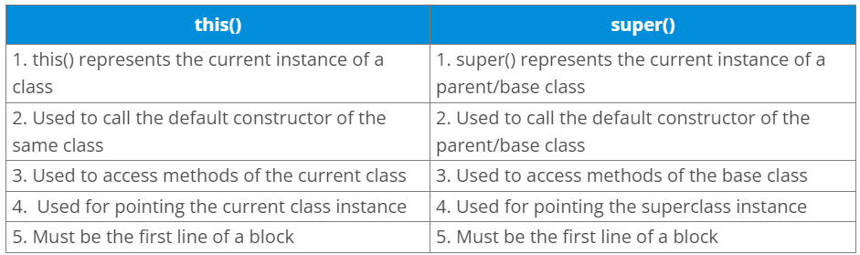

1. **What is the output of the following Java program?**

class Person {

>public Person() {

>>System.out.println("Person class constructor called");

>}

}

public class Employee extends Person {

>public Employee() {

>>System.out.println("Employee class constructor called");

>}

>public static void main(String args[]) {

>>Employee e = new Employee();

>}

}

Output:

Person class constructor called

Employee class constructor called

Explanation:

The super() is implicitly invoked by the compiler if no super() or this() is included explicitly within the derived class constructor. Therefore, in this case, The Person class constructor is called first and then the Employee class constructor is called.

1. **Can we overload the methods by making them static?**

No, We cannot overload the methods by just applying the static keyword to them(number of parameters and types are the same). Consider the following example.

public class Animal {

>void consume(int a) {

>>System.out.println(a + " consumed!!");

>}

>static void consume(int a) {

>>System.out.println("consumed static " + a);

>}

>public static void main(String args[]) {

>>Animal a = new Animal();

>>a.consume(10);

>>Animal.consume(20);

>}

}

Output:

Animal.java:7: error: method consume(int) is already defined in class Animal

>static void consume(int a)

>>>>^

Animal.java:15: error: non-static method consume(int) cannot be referenced from a static context

>>Animal.consume(20);

>>> ^

2 errors

1. **What is the output of the following Java program?**

class OverloadingCalculation3 {

>void sum(int a, long b) {

>>System.out.println("a method invoked");

>}

>void sum(long a, int b) {

>>System.out.println("b method invoked");

>}

>public static void main(String args[]) {

>>OverloadingCalculation3 obj = new OverloadingCalculation3();

>>obj.sum(20, 20); //now ambiguity>

>}

}

Output

OverloadingCalculation3.java:7: error: reference to sum is ambiguous

obj.sum(20,20);//now ambiguity

> ^

> both method sum(int,long) in OverloadingCalculation3

> and method sum(long,int) in OverloadingCalculation3 match

1 error

Explanation

There are two methods defined with the same name, i.e., sum. The first method accepts the integer and long type whereas the second method accepts long and the integer type. The parameter passed that are a = 20, b = 20. We can not tell that which method will be called as there is no clear differentiation mentioned between integer literal and long literal. This is the case of ambiguity. Therefore, the compiler will throw an error.

1. **What is method overriding?**

If a subclass provides a specific implementation of a method that is already provided by its parent class, it is known as Method Overriding. It is used for runtime polymorphism and to implement the interface methods.

Rules for Method overriding

* The method must have the same name as in the parent class.
* The method must have the same signature as in the parent class.
* Two classes must have an IS-A relationship between them.

1. **Can we override the overloaded method?**

Yes.

1. **Difference between method Overloading and Overriding.**

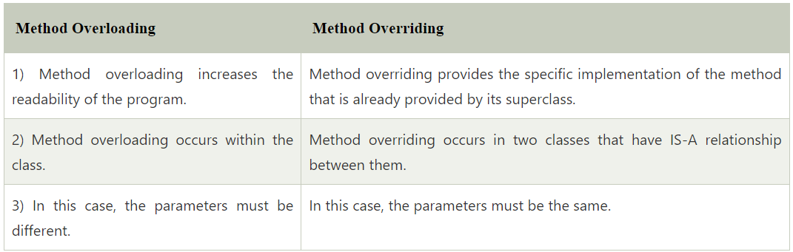

1. **Can we override the private methods?**

No, we cannot override the private methods because the scope of private methods is limited to the class and we cannot access them outside of the class.

1. **Can we change the scope of the overridden method in the subclass?**

Yes, we can change the scope of the overridden method in the subclass. However, we must notice that we cannot decrease the accessibility of the method. The following point must be taken care of while changing the accessibility of the method.

* The private can be changed to protected, public, or default.
* The protected can be changed to public or default.
* The default can be changed to public.
* The public will always remain public.

1. **Can we modify the throws clause of the superclass method while overriding it in the subclass?**

Yes, we can modify the throws clause of the superclass method while overriding it in the subclass. However, there are some rules which are to be followed while overriding in case of exception handling.

* If the superclass method does not declare an exception, subclass overridden method cannot declare the checked exception, but it can declare the unchecked exception.
* If the superclass method declares an exception, subclass overridden method can declare same, subclass exception or no exception but cannot declare parent exception.

1. **What is the output of the following Java program?**

class Base {

>void method(int a) {

>>System.out.println("Base class method called with integer a = " + a);

>}

>void method(double d) {

>>System.out.println("Base class method called with double d =" + d);

>}

}

class Derived extends Base {

>@Override

>void method(double d) {

>>System.out.println("Derived class method called with double d =" + d);

>}

}

public class Main {

>public static void main(String[] args) {

>>new Derived().method(10);

>}

}

Output

Base class method called with integer a = 10

Explanation

The method() is overloaded in class Base whereas it is derived in class Derived with the double type as the parameter. In the method call, the integer is passed.

1. **What is the output of the following Java program?**

class Base {

>public void baseMethod() {

>>System.out.println("BaseMethod called ...");

>}

}

class Derived extends Base {

>public void baseMethod() {

>>System.out.println("Derived method called ...");

>}

}

public class Test {

>public static void main(String args[]) {

>>Base b = new Derived();

>>b.baseMethod();

>}

}

Output

Derived method called ...

Explanation

The method of Base class, i.e., baseMethod() is overridden in Derived class. In Test class, the reference variable b (of type Base class) refers to the instance of the Derived class. Here, Runtime polymorphism is achieved between class Base and Derived. At compile time, the presence of method baseMethod checked in Base class, If it presence then the program compiled otherwise the compiler error will be shown. In this case, baseMethod is present in Base class; therefore, it is compiled successfully. However, at runtime, It checks whether the baseMethod has been overridden by Derived class, if so then the Derived class method is called otherwise Base class method is called. In this case, the Derived class overrides the baseMethod; therefore, the Derived class method is called.

1. **What is the final variable?**

In Java, the final variable is used to restrict the user from updating it. If we initialize the final variable, we can't change its value. In other words, we can say that the final variable once assigned to a value, can never be changed after that. The final variable which is not assigned to any value can only be assigned through the class constructor.

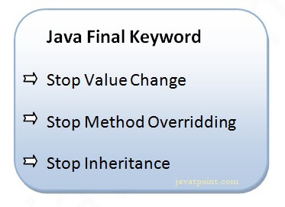

class Bike9 {

>final int speedlimit = 90; //final variable

>void run() {

>>speedlimit = 400;

>}

>public static void main(String args[]) {

>>Bike9 obj = new Bike9();

>>obj.run();

>}

} //end of class

Output:

Compile Time Error

1. **What is the final method?**

If we change any method to a final method, we can't override it.

class Bike {

>final void run() {

>>System.out.println("running");

>}

}

class Honda extends Bike {

>void run() {

>>System.out.println("running safely with 100kmph");

>}

>public static void main(String args[]) {

>>Honda honda = new Honda();

>>honda.run();

>}

}

Output:

Compile Time Error

1. **What is the final class?**

If we make any class final, we can't inherit it into any of the subclasses.

final class Bike {}

class Honda1 extends Bike {

>void run() {

>>System.out.println("running safely with 100kmph");

>}

>public static void main(String args[]) {

>>Honda1 honda = new Honda1();

>>honda.run();

>}

}

Output:

Compile Time Error

1. **What is the final blank variable?**

A final variable, not initialized at the time of declaration, is known as the final blank variable. We can't initialize the final blank variable directly. Instead, we have to initialize it by using the class constructor. If it is static blank final variable, it can be initialized only in the static block. It is useful in the case when the user has some data which must not be changed by others, for example, PAN Number. Consider the following example:

class Student {

>int id;

>String name;

>final String PAN_CARD_NUMBER;

>...

}

1. **Can you declare the main method as final?**

Yes, We can declare the main method as public static final void main(String[] args){}.

1. **What is the output of the following Java program?**

class Main {

>public static void main(String args[]) {

>>final int i;

>>i = 20;

>>System.out.println(i);

>}

}

Output

20

Explanation

Since i is the blank final variable. It can be initialized only once. We have initialized it to 20. Therefore, 20 will be printed.

1. **What is the output of the following Java program?**

class Base {

>protected final void getInfo() {

>>System.out.println("method of Base class");

>}

}

public class Derived extends Base {

>protected final void getInfo() {

>>System.out.println("method of Derived class");

>}

>public static void main(String[] args) {

>>Base obj = new Base();

>>obj.getInfo();

>}

}

Output

>Derived.java:11: error: getInfo() in Derived cannot override getInfo() in Base

>protected final void getInfo()

>>>>>> ^

overridden method is final

1 error

Explanation

The getDetails() method is final; therefore it can not be overridden in the subclass.

1. **What is the difference between compile-time polymorphism and runtime polymorphism?**

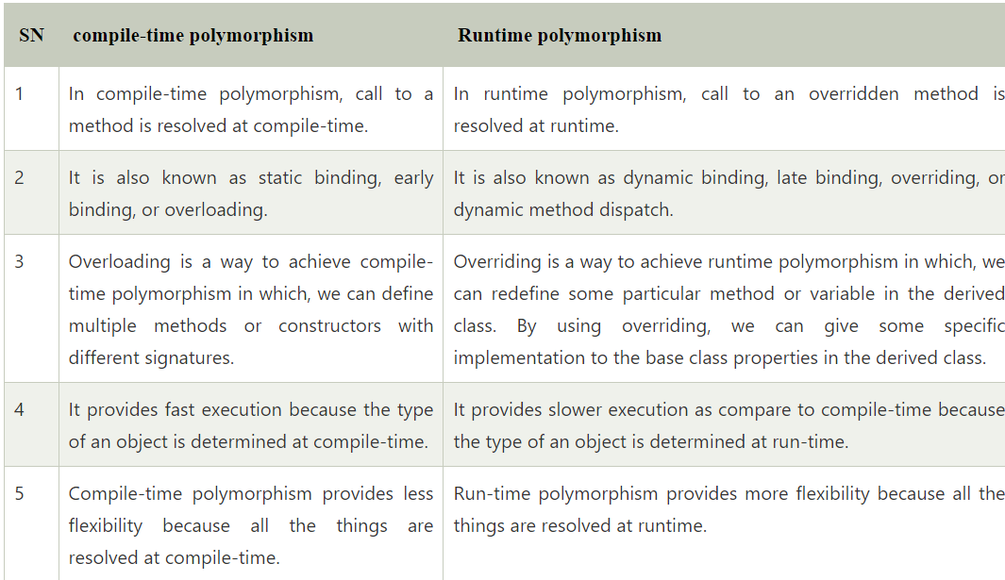

1. **What is Runtime Polymorphism?**

Runtime polymorphism or dynamic method dispatch is a process in which a call to an overridden method is resolved at runtime rather than at compile-time. In this process, an overridden method is called through the reference variable of a superclass. The determination of the method to be called is based on the object being referred to by the reference variable.

class Bike {

>void run() {

>>System.out.println("running");

>}

}

class Splendor extends Bike {

>void run() {

>>System.out.println("running safely with 60km");

>}

>public static void main(String args[]) {

>>Bike b = new Splendor(); //upcasting

>>b.run();

>}

}

Output:

running safely with 60km.

In this process, an overridden method is called through the reference variable of a superclass. The determination of the method to be called is based on the object being referred to by the reference variable.

1. **Can you achieve Runtime Polymorphism by data members?**

No, because method overriding is used to achieve runtime polymorphism and data members cannot be overridden. We can override the member functions but not the data members. Consider the example given below.

class Bike {

>int speedlimit = 90;

}

class Honda3 extends Bike {

>int speedlimit = 150;

>public static void main(String args[]) {

>>Bike obj = new Honda3();

>>System.out.println(obj.speedlimit); //90

>}

}

Output:

90

1. **What is the difference between static binding and dynamic binding?**

In case of the static binding, the type of the object is determined at compile-time whereas, in the dynamic binding, the type of the object is determined at runtime.

Static Binding

class Dog {

>private void eat() {

>>System.out.println("dog is eating...");

>}

>public static void main(String args[]) {

>>Dog d1 = new Dog();

>>d1.eat();

>}

}

Dynamic Binding

class Animal {

>void eat() {

>>System.out.println("animal is eating...");

>}

}

class Dog extends Animal {

>void eat() {

>>System.out.println("dog is eating...");

>}

>public static void main(String args[]) {

>>Animal a = new Dog();

>>a.eat();

>}

}

1. **What is the output of the following Java program?**

class BaseTest {

>void print() {

>>System.out.println("BaseTest:print() called");

>}

}

public class Test extends BaseTest {

>void print() {

>>System.out.println("Test:print() called");

>}

>public static void main(String args[]) {

>>BaseTest b = new Test();

>>b.print();

>}

}

Output

Test:print() called

Explanation

It is an example of Dynamic method dispatch. The type of reference variable b is determined at runtime. At compile-time, it is checked whether that method is present in the Base class. In this case, it is overridden in the child class, therefore, at runtime the derived class method is called.

1. **What is Java instanceOf operator?**

The instanceof in Java is also known as type comparison operator because it compares the instance with type. It returns either true or false. If we apply the instanceof operator with any variable that has a null value, it returns false. Consider the following example.

class Simple1 {

>public static void main(String args[]) {

>>Simple1 s = new Simple1();

>>System.out.println(s instanceof Simple1); //true

>}

}

Output

true

An object of subclass type is also a type of parent class. For example, if Dog extends Animal then object of Dog can be referred by either Dog or Animal class.

1. **What is the abstraction?**

Abstraction is a process of hiding the implementation details and showing only functionality to the user. It displays just the essential things to the user and hides the internal information, for example, sending SMS where you type the text and send the message. You don't know the internal processing about the message delivery. Abstraction enables you to focus on what the object does instead of how it does it. Abstraction lets you focus on what the object does instead of how it does it.

In Java, there are two ways to achieve the abstraction.

* Abstract Class
* Interface

1. **What is the difference between abstraction and encapsulation?**

Abstraction hides the implementation details whereas encapsulation wraps code and data into a single unit.

1. **What is the abstract class?**

A class that is declared as abstract is known as an abstract class. It needs to be extended and its method implemented. It cannot be instantiated. It can have abstract methods, non-abstract methods, constructors, and static methods. It can also have the final methods which will force the subclass not to change the body of the method. Consider the following example.

abstract class Bike {

>abstract void run();

}

class Honda4 extends Bike {

>void run() {

>>System.out.println("running safely");

>}

>public static void main(String args[]) {

>>Bike obj = new Honda4();

>>obj.run();

>}

}

Output

running safely

1. **Can there be an abstract method without an abstract class?**

No, if there is an abstract method in a class, that class must be abstract.

1. **Is the following program written correctly? If yes then what will be the output of the program?**

abstract class Calculate {

>abstract int multiply(int a, int b);

}

public class Main {

>public static void main(String[] args) {

>>int result = new Calculate() {

>>>@Override

>>>int multiply(int a, int b) {

>>>>return a * b;

>>>}

>>}.multiply(12, 32);

>>System.out.println("result = " + result);

>}

}

Yes, the program is written correctly. The Main class provides the definition of abstract method multiply declared in abstract class Calculation. The output of the program will be:

Output

384

1. **Can you use abstract and final both with a method?**

No, because we need to override the abstract method to provide its implementation, whereas we can't override the final method.

1. **Is it possible to instantiate the abstract class?**

No, the abstract class can never be instantiated even if it contains a constructor and all of its methods are implemented.

1. **What is the interface?**

The interface is a blueprint for a class that has static constants and abstract methods. It can be used to achieve full abstraction and multiple inheritance. It is a mechanism to achieve abstraction. There can be only abstract methods in the Java interface, not method body. It is used to achieve abstraction and multiple inheritance in Java. In other words, you can say that interfaces can have abstract methods and variables. Java Interface also represents the IS-A relationship. It cannot be instantiated just like the abstract class. However, we need to implement it to define its methods. Since Java 8, we can have the default, static, and private methods in an interface.

Example:

public interface Animal {

>public void eat();

>public void sleep();

>public void run();

}

1. **Can you declare an interface method static?**

No, because methods of an interface are abstract by default, and we can not use static and abstract together.

1. **Can the Interface be final?**

No, because an interface needs to be implemented by the other class and if it is final, it can't be implemented by any class.

1. **Can we define private and protected modifiers for the members in interfaces?**

No, they are implicitly public.

1. **When can an object reference be cast to an interface reference?**

An object reference can be cast to an interface reference when the object implements the referenced interface.

1. **How to make a read-only class in Java?**

A class can be made read-only by making all of the fields private. The read-only class will have only getter methods which return the private property of the class to the main method. We cannot modify this property because there is no setter method available in the class. Consider the following example.

//A Java class which has only getter methods.>

public class Student {

>//private data member>

>private String college = "AKG";

>//getter method for college>

>public String getCollege() {

>>return college;

>}

}

1. **How to make a write-only class in Java?**

A class can be made write-only by making all of the fields private. The write-only class will have only setter methods which set the value passed from the main method to the private fields. We cannot read the properties of the class because there is no getter method in this class. Consider the following example.

//A Java class which has only setter methods.>

public class Student {

>//private data member>

>private String college;

>//setter method for college>

>public void setCollege(String college) {

>>this.college = college;

>}

}

1. **What are the advantages of Encapsulation in Java?**

There are the following advantages of Encapsulation in Java:

* By providing only the setter or getter method, you can make the class read-only or write-only. In other words, you can skip the getter or setter methods.
* It provides you the control over the data. Suppose you want to set the value of id which should be greater than 100 only, you can write the logic inside the setter method. You can write the logic not to store the negative numbers in the setter methods.
* It is a way to achieve data hiding in Java because other class will not be able to access the data through the private data members.
* The encapsulate class is easy to test. So, it is better for unit testing.
* The standard IDEs are providing the facility to generate the getters and setters. So, it is easy and fast to create an encapsulated class in Java.

1. **How to create packages in Java?**

If you are using the programming IDEs like Eclipse, NetBeans, MyEclipse, etc. click on file->new->project and eclipse will ask you to enter the name of the package. It will create the project package containing various directories such as src, etc. If you are using an editor like notepad for java programming, use the following steps to create the package.

* Define a package package_name. Create the class with the name class_name and save this file with your_class_name.java.
* Now compile the file by running the following command on the terminal.

javac -d . your_class_name.java

The above command creates the package with the name package_name in the present working directory.

* Now, run the class file by using the absolute class file name, like following.

java package_name.class_name

1. **How can we access some class in another class in Java?**

There are two ways to access a class in another class.

* By using the fully qualified name: To access a class in a different package, either we must use the fully qualified name of that class, or we must import the package containing that class.
* By using the relative path, We can use the path of the class that is related to the package that contains our class. It can be the same or subpackage.

1. **Do I need to import java.lang package any time? Why?**

No. It is by default loaded internally by the JVM.

1. **What is the static import?**

By static import, we can access the static members of a class directly, and there is no to qualify it with the class name.

1. **How many types of exception can occur in a Java program?**

There are mainly two types of exceptions: checked and unchecked. Here, an error is considered as the unchecked exception. According to Oracle, there are three types of exceptions:

* Checked Exception: Checked exceptions are the one which are checked at compile-time. For example, SQLException, ClassNotFoundException, etc.
* Unchecked Exception: Unchecked exceptions are the one which are handled at runtime because they can not be checked at compile-time. For example, ArithmaticException, NullPointerException, ArrayIndexOutOfBoundsException, etc.
* Error: Error cause the program to exit since they are not recoverable. For Example, OutOfMemoryError, AssertionError, etc.

1. **What is Exception Handling?**

Exception Handling is a mechanism that is used to handle runtime errors. It is used primarily to handle checked exceptions. Exception handling maintains the normal flow of the program. There are mainly two types of exceptions: checked and unchecked. Here, the error is considered as the unchecked exception.

There are five keywords used to handle exceptions in Java:

* try
* catch
* finally
* throw
* throws

Two different ways to handle exceptions are explained below:

* Using try/catch:

The risky code is surrounded by try block. If an exception occurs, then it is caught by the catch block which is followed by the try block.

Example:

class Manipulation {

>public static void main(String[] args) {

>>add();

>}

>Public void add() {

>>try {

>>>addition();

>>} catch (Exception e) {

>>>e.printStacktrace();

>>}

>}

}

* By declaring throws keyword:

At the end of the method, we can declare the exception using throws keyword.

Example:

class Manipulation {

>public static void main(String[] args) {

>>add();

>}

>public void add() throws Exception {

>>addition();

>}

}

1. **Explain the hierarchy of Java Exception classes?**

The java.lang.Throwable class is the root class of Java Exception hierarchy which is inherited by two subclasses: Exception and Error. A hierarchy of Java Exception classes are given below:

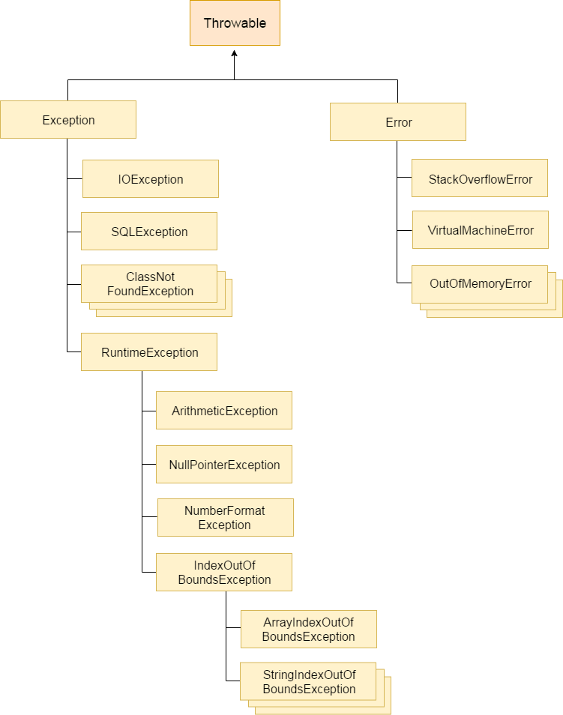

1. **What is the difference between Checked Exception and Unchecked Exception?**

* Checked Exception

The classes that extend Throwable class except RuntimeException and Error are known as checked exceptions, e.g., IOException, SQLException, etc. Checked exceptions are checked at compile-time.

* Unchecked Exception

The classes that extend RuntimeException are known as unchecked exceptions, e.g., ArithmeticException, NullPointerException, etc. Unchecked exceptions are not checked at compile-time.

1. **What is the base class for Error and Exception?**

The Throwable class is the base class for Error and Exception.

1. **What is the output of the following Java program?**

public class ExceptionHandlingExample {

>public static void main(String args[]) {

>>try {

>>>int a = 1 / 0;

>>>System.out.println("a = " + a);

>>} catch (Exception e) {

>>>System.out.println(e);

>>} catch (ArithmeticException ex) {

>>>System.out.println(ex);

>>}

>}

}

Output

ExceptionHandlingExample.java:10: error: exception ArithmeticException has already been caught

>catch(ArithmeticException ex){System.out.println(ex);}>

>^

1 error

Explanation

ArithmaticException is the subclass of Exception. Therefore, it can not be used after Exception. Since Exception is the base class for all the exceptions, therefore, it must be used at last to handle the exception. No class can be used after this.

1. **What is finally block?**

The "finally" block is used to execute the important code of the program. It is executed whether an exception is handled or not. In other words, we can say that finally block is the block which is always executed. Finally block follows try or catch block. If you don't handle the exception, before terminating the program, JVM runs finally block, (if any). The finally block is mainly used to place the cleanup code such as closing a file or closing a connection. Here, we must know that for each try block there can be zero or more catch blocks, but only one finally block. The finally block will not be executed if program exits(either by calling System.exit() or by causing a fatal error that causes the process to abort).

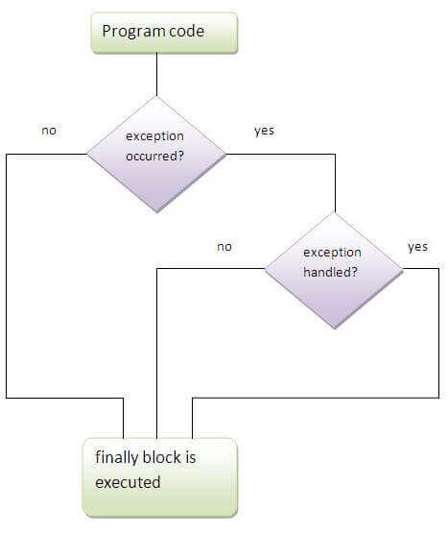

1. **Can finally block be used without a catch?**

Yes, According to the definition of finally block, it must be followed by a try or catch block, therefore, we can use try block instead of catch.

1. **What is the output of the following Java program?**

public class Main {

>public static void main(String[] args) {

>>try {

>>>throw 90;

>>} catch (int e) {

>>>System.out.println("Caught the exception " + e);

>>}

>}

}

Output

Main.java:6: error: incompatible types: int cannot be converted to Throwable

>>>throw 90;

>>>^

Main.java:8: error: unexpected type

>>catch(int e){

>>> ^

required: class

found:>int

2 errors

Explanation

In Java, the throwable objects can only be thrown. If we try to throw an integer object, The compiler will show an error since we can not throw basic data type from a block of code.

1. **What is the output of the following Java program?**

class Calculation extends Exception {

>public Calculation() {

>>System.out.println("Calculation class is instantiated");

>}

>public void add(int a, int b) {

>>System.out.println("The sum is " + (a + b));

>}

}

public class Main {

>public static void main(String[] args) {

>>try {

>>>throw new Calculation();

>>} catch (Calculation c) {

>>>c.add(10, 20);

>>}

>}

}

Output

Calculation class is instantiated

The sum is 30

Explanation

The object of Calculation is thrown from the try block which is caught in the catch block. The add() of Calculation class is called with the integer values 10 and 20 by using the object of this class. Therefore there sum 30 is printed. The object of the Main class can only be thrown in the case when the type of the object is throwable. To do so, we need to extend the throwable class.

1. **Can an exception be rethrown?**

Yes.

1. **Can subclass overriding method declare an exception if parent class method doesn't throw an exception?**

Yes but only unchecked exception not checked.

1. **What is the output of the following Java program?**

public class Main {

>void a() {

>>try {

>>>System.out.println("a(): Main called");

>>>b();

>>} catch (Exception e) {

>>>System.out.println("Exception is caught");

>>}

>}

>void b() throws Exception {

>>try {

>>>System.out.println("b(): Main called");

>>>c();

>>} catch (Exception e) {

>>>throw new Exception();

>>} finally {

>>>System.out.println("finally block is called");

>>}

>}

>void c() throws Exception {

>>throw new Exception();

>}

>public static void main(String args[]) {

>>Main m = new Main();

>>m.a();

>}

}

Output

a(): Main called

b(): Main called

finally block is called

Exception is caught

Explanation

In the main method, a() of Main is called which prints a message and call b(). The method b() prints some message and then call c(). The method c() throws an exception which is handled by the catch block of method b. However, It propagates this exception by using throw Exception() to be handled by the method a(). As we know, finally block is always executed therefore the finally block in the method b() is executed first and prints a message. At last, the exception is handled by the catch block of the method a().

1. **What is the output of the following Java program?**

public class Calculation {

>int a;

>public Calculation(int a) {

>>this.a = a;

>}

>public int add() {

>>a = a + 10;

>>try {

>>>a = a + 10;

>>>try {

>>>>a = a * 10;

>>>>throw new Exception();

>>>} catch (Exception e) {

>>>>a = a - 10;

>>>}

>>} catch (Exception e) {

>>>a = a - 10;

>>}

>>return a;

>}

>public static void main(String args[]) {

>>Calculation c = new Calculation(10);

>>int result = c.add();

>>System.out.println("result = " + result);

>}

}

Output

result = 290

Explanation

The instance variable a of class Calculation is initialized to 10 using the class constructor which is called while instantiating the class. The add method is called which returns an integer value result. In add() method, a is incremented by 10 to be 20. Then, in the first try block, 10 is again incremented by 10 to be 30. In the second try block, a is multiplied by 10 to be 300. The second try block throws the exception which is caught by the catch block associated with this try block. The catch block again alters the value of a by decrementing it by 10 to make it 290. Thus the add() method returns 290 which is assigned to result. However, the catch block associated with the outermost try block will never be executed since there is no exception which can be handled by this catch block.

1. **What is the meaning of immutable regarding String?**

The simple meaning of immutable is unmodifiable or unchangeable. In Java, String is immutable, i.e., once string object has been created, its value can't be changed. Consider the following example for better understanding.

class Testimmutablestring {

>public static void main(String args[]) {

>>String s = "Sachin";

>>s.concat(" Tendulkar"); //concat() method appends the string at the end

>>System.out.println(s); //will print Sachin because strings are immutable objects

>}

}

Output:

Sachin

1. **How many ways can we create the string object?**

* String Literal

Java String literal is created by using double quotes. For Example:

String s="welcome";

Each time you create a string literal, the JVM checks the "string constant pool" first. If the string already exists in the pool, a reference to the pooled instance is returned. If the string doesn't exist in the pool, a new string instance is created and placed in the pool. String objects are stored in a special memory area known as the string constant pool For example:

String s1="Welcome";

String s2="Welcome";//It doesn't create a new instance

* By new keyword

String s=new String("Welcome");//creates two objects and one reference variable

In such case, JVM will create a new string object in normal (non-pool) heap memory, and the literal "Welcome" will be placed in the constant string pool. The variable s will refer to the object in a heap (non-pool).

1. **How many objects will be created in the following code?**

String s1="Welcome";

String s2="Welcome";

String s3="Welcome";

Only one object will be created using the above code because strings in Java are immutable.

1. **Why java uses the concept of the string literal?**

To make Java more memory efficient (because no new objects are created if it exists already in the string constant pool).

1. **How many objects will be created in the following code?**

String s = new String("Welcome");

Two objects, one in string constant pool and other in non-pool(heap).

1. **What is the output of the following Java program?**

public class Test {

>public static void main(String args[]) {

>>String a = new String("Sharma is a good player");

>>String b = "Sharma is a good player";

>>if (a == b) {

>>>System.out.println("a == b");

>>}

>>if (a.equals(b)) {

>>>System.out.println("a equals b");

>>}

>}

}

Output

a equals b

Explanation

The operator == also check whether the references of the two string objects are equal or not. Although both of the strings contain the same content, their references are not equal because both are created by different ways(Constructor and String literal) therefore, a == b is unequal. On the other hand, the equal() method always check for the content. Since their content is equal hence, a equals b is printed.

1. **What is the output of the following Java program?**

public class Test {

>public static void main(String args[]) {

>>String s1 = "Sharma is a good player";

>>String s2 = new String("Sharma is a good player");

>>s2 = s2.intern();

>>System.out.println(s1 == s2);

>}

}

Output

true

Explanation

The intern method returns the String object reference from the string pool. In this case, s1 is created by using string literal whereas, s2 is created by using the String pool. However, s2 is changed to the reference of s1, and the operator == returns true.

1. **How can we create an immutable class in Java?**

We can create an immutable class by defining a final class having all of its members as final. Consider the following example.

public final class Employee {

>final String pancardNumber;

>public Employee(String pancardNumber) {

>>this.pancardNumber = pancardNumber;

>}

>public String getPancardNumber() {

>>return pancardNumber;

>}

}

1. **What is the purpose of toString() method in Java?**

The toString() method returns the string representation of an object. If you print any object, java compiler internally invokes the toString() method on the object. So overriding the toString() method, returns the desired output, it can be the state of an object, etc. depending upon your implementation. By overriding the toString() method of the Object class, we can return the values of the object, so we don't need to write much code. Consider the following example.

class Student {

>int rollno;

>String name;

>String city;

>Student(int rollno, String name, String city) {

>>this.rollno = rollno;

>>this.name = name;

>>this.city = city;

>}

>public String toString() { //overriding the toString() method

>>return rollno + " " + name + " " + city;

>}

>public static void main(String args[]) {

>>Student s1 = new Student(101, "Raj", "lucknow");

>>Student s2 = new Student(102, "Vijay", "ghaziabad");

>>System.out.println(s1); //compiler writes here s1.toString()

>>System.out.println(s2); //compiler writes here s2.toString()

>}

}

Output:

101 Raj lucknow

102 Vijay Ghaziabad

1. **Write a Java program to count the number of words present in a string?**

Program:

public class Test {

>public static void main(String args[]) {

>>String s = "Sharma is a good player and he is so punctual";

>>String words[] = s.split(" ");

>>System.out.println("The Number of words present in the string are : " + words.length);

>}

}

Output

The Number of words present in the string are: 10

1. **Name some classes present in java.util.regex package.**

There are the following classes and interfaces present in java.util.regex package.

* MatchResult Interface
* Matcher class
* Pattern class
* PatternSyntaxException class

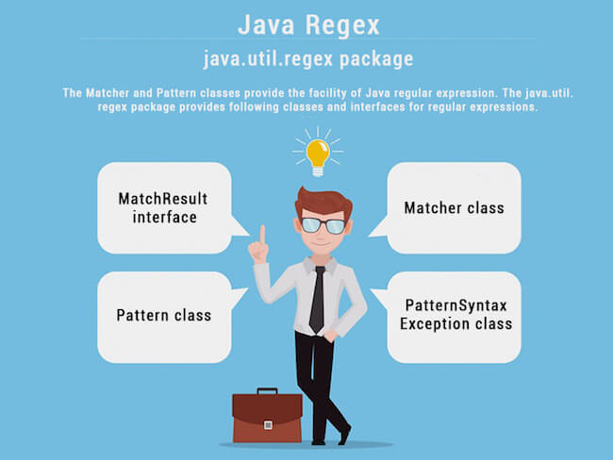

1. **How the metacharacters are different from the ordinary characters?**

Metacharacters have the special meaning to the regular expression engine. The metacharacters are ^, $, ., *, +, etc. The regular expression engine does not consider them as the regular characters. To enable the regular expression engine treating the metacharacters as ordinary characters, we need to escape the metacharacters with the backslash.

1. **Write a regular expression to validate a password. A password must start with an alphabet and followed by alphanumeric characters; Its length must be in between 8 to 20.**

The regular expression for the above criteria will be: ^[a-zA-Z][a-zA-Z0-9]{8,19} where ^ represents the start of the regex, [a-zA-Z] represents that the first character must be an alphabet, [a-zA-Z0-9] represents the alphanumeric character, {8,19} represents that the length of the password must be in between 8 and 20.

1. **What is the output of the following Java program?**

import java.util.regex.*;

class RegexExample2 {

>public static void main(String args[]) {

>>System.out.println(Pattern.matches(".s", "as")); //line 4

>>System.out.println(Pattern.matches(".s", "mk")); //line 5

>>System.out.println(Pattern.matches(".s", "mst")); //line 6

>>System.out.println(Pattern.matches(".s", "amms")); //line 7

>>System.out.println(Pattern.matches("..s", "mas")); //line 8

>}

}

Output

true

false

false

false

true

Explanation

line 4 prints true since the second character of string is s, line 5 prints false since the second character is not s, line 6 prints false since there are more than 3 characters in the string, line 7 prints false since there are more than 2 characters in the string, and it contains more than 2 characters as well, line 8 prints true since the third character of the string is s.

1. **What are the advantages of Java inner classes?**

There are two types of advantages of Java inner classes.

* Nested classes represent a special type of relationship that is it can access all the members (data members and methods) of the outer class including private.
* Nested classes are used to develop a more readable and maintainable code because it logically groups classes and interfaces in one place only.
* Code Optimization: It requires less code to write.

1. **What is a nested class?**

The nested class can be defined as the class which is defined inside another class or interface. We use the nested class to logically group classes and interfaces in one place so that it can be more readable and maintainable. A nested class can access all the data members of the outer class including private data members and methods. The syntax of the nested class is defined below.

class Java_Outer_class {

>//code>

>class Java_Nested_class {

>>//code>

>}

}

There are two types of nested classes, static nested class, and non-static nested class. The non-static nested class can also be called as inner-class.

1. **What are the disadvantages of using inner classes?**

There are the following main disadvantages of using inner classes.

* Inner classes increase the total number of classes used by the developer and therefore increases the workload of JVM since it has to perform some routine operations for those extra classes which result in slower performance.
* IDEs provide less support to the inner classes as compare to the top level classes and therefore it annoys the developers while working with inner classes.

1. **What are the types of inner classes (non-static nested class) used in Java?**

There are mainly three types of inner classes used in Java.

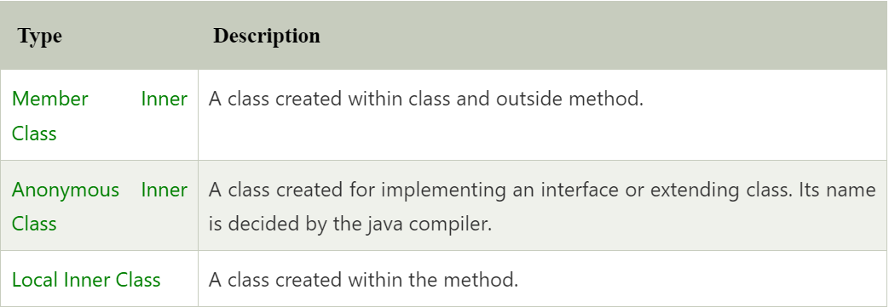

1. **Is there any difference between nested classes and inner classes?**

Yes, inner classes are non-static nested classes. In other words, we can say that inner classes are the part of nested classes.

1. **Can we access the non-final local variable, inside the local inner class?**

No, the local variable must be constant if you want to access it in the local inner class.

1. **How many class files are created on compiling the OuterClass in the following program?**

public class Person {

>String name, age, address;

>class Employee {

>>float salary = 10000;

>}

>class BusinessMen {

>>final String gstin = "£4433drt3$";

>}

>public static void main(String args[]) {

>>Person p = new Person();

>}

}

3 class-files will be created named as Person.class, Person$BusinessMen.class, and Person$Employee.class.

1. **What are anonymous inner classes?**

Anonymous inner classes are the classes that are automatically declared and instantiated within an expression. We cannot apply different access modifiers to them. Anonymous class cannot be static, and cannot define any static fields, method, or class. In other words, we can say that it a class without the name and can have only one object that is created by its definition. Consider the following example.

abstract class Person {

>abstract void eat();

}

class TestAnonymousInner {

>public static void main(String args[]) {

>>Person p = new Person() {

>>>void eat() {

>>>>System.out.println("nice fruits");

>>>}

>>};

>>p.eat();

>}

}

Output:

nice fruits

Consider the following example for the working of the anonymous class using interface.

interface Eatable {

>void eat();

}

class TestAnnonymousInner1 {

>public static void main(String args[]) {

>>Eatable e = new Eatable() {

>>>public void eat() {

>>>>System.out.println("nice fruits");

>>>}

>>};

>>e.eat();

>}

}

Output:

nice fruits

1. **What is the nested interface?**

An Interface that is declared inside the interface or class is known as the nested interface. It is static by default. The nested interfaces are used to group related interfaces so that they can be easy to maintain. The external interface or class must refer to the nested interface. It can't be accessed directly. The nested interface must be public if it is declared inside the interface but it can have any access modifier if declared within the class. The syntax of the nested interface is given as follows.

interface interface_name {

>...

>interface nested_interface_name {

>>...

>}

}

1. **Can a class have an interface?**

Yes, an interface can be defined within the class. It is called a nested interface.

1. **Can an Interface have a class?**

Yes, they are static implicitly.

1. **What is Garbage Collection?**

Garbage collection is a process of reclaiming the unused runtime objects. It is performed for memory management. In other words, we can say that It is the process of removing unused objects from the memory to free up space and make this space available for Java Virtual Machine. Due to garbage collection java gives 0 as output to a variable whose value is not set, i.e., the variable has been defined but not initialized. For this purpose, we were using free() function in the C language and delete() in C++. In Java, it is performed automatically. So, java provides better memory management.

1. **What is gc()?**

The gc() method is used to invoke the garbage collector for cleanup processing. This method is found in System and Runtime classes. This function explicitly makes the Java Virtual Machine free up the space occupied by the unused objects so that it can be utilized or reused. Consider the following example for the better understanding of how the gc() method invoke the garbage collector.

public class TestGarbage1 {

>public void finalize() {

>>System.out.println("object is garbage collected");

>}

>public static void main(String args[]) {

>>TestGarbage1 s1 = new TestGarbage1();

>>TestGarbage1 s2 = new TestGarbage1();

>>s1 = null;

>>s2 = null;

>>System.gc();

>}

}

Output:

object is garbage collected

object is garbage collected

1. **How is garbage collection controlled?**

Garbage collection is managed by JVM. It is performed when there is not enough space in the memory and memory is running low. We can externally call the System.gc() for the garbage collection. However, it depends upon the JVM whether to perform it or not.

1. **How can an object be unreferenced?**

There are many ways:

* By nulling the reference
* By assigning a reference to another
* By anonymous object etc.

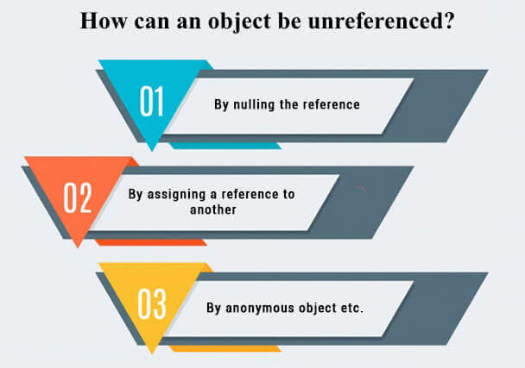

* By nulling a reference:

Employee e=new Employee();

e=null;

* By assigning a reference to another:

Employee e1=new Employee();

Employee e2=new Employee();

e1=e2;//now the first object referred by e1 is available for garbage collection

* By anonymous object:

new Employee();

1. **What is the purpose of the finalize() method?**

The finalize() method is invoked just before the object is garbage collected. It is used to perform cleanup processing. The Garbage collector of JVM collects only those objects that are created by new keyword. So if you have created an object without new, you can use the finalize method to perform cleanup processing (destroying remaining objects). The cleanup processing is the process to free up all the resources, network which was previously used and no longer needed. It is essential to remember that it is not a reserved keyword, finalize method is present in the object class hence it is available in every class as object class is the superclass of every class in java. Here, we must note that neither finalization nor garbage collection is guaranteed. Consider the following example.

public class FinalizeTest {

>int j = 12;

>void add() {

>>j = j + 12;

>>System.out.println("J=" + j);

>}

>public void finalize() {

>>System.out.println("Object is garbage collected");

>}

>public static void main(String[] args) {

>>new FinalizeTest().add();

>>System.gc();

>>new FinalizeTest().add();

>}

}

1. **Can an unreferenced object be referenced again?**

Yes, see the example below.

public class Resurrect {

>static Resurrect resurrect = null;

>public static void main(String[] args) {

>>Resurrect localInstance = new Resurrect();

>>System.out.println("first instance: " + localInstance.hashCode());

>>// after this code there is no more reference to the first instance

>>localInstance = new Resurrect();

>>System.out.println("second instance: " + localInstance.hashCode());

>>// will (in this simple example) request the execution of the finalize() method of the first instance

>>System.gc();

>}

>@Override

>public void finalize() {

>>resurrect = this;

>>System.out.println("resurrected: " + resurrect.hashCode());

>}

}

1. **What kind of thread is the Garbage collector thread?**

Daemon thread.

1. **What is the purpose of the Runtime class?**

Java Runtime class is used to interact with a java runtime environment. Java Runtime class provides methods to execute a process, invoke GC, get total and free memory, etc. There is only one instance of java.lang.Runtime class is available for one java application. The Runtime.getRuntime() method returns the singleton instance of Runtime class.

1. **How will you invoke any external process in Java?**

By Runtime.getRuntime().exec(?) method. Consider the following example.

public class Runtime1 {

>public static void main(String args[]) throws Exception {

>>Runtime.getRuntime().exec("notepad"); //will open a new notepad

>}

}

1. **Give the hierarchy of InputStream and OutputStream classes.**

OutputStream Hierarchy



InputStream Hierarchy



1. **What do you understand by an IO stream?**

The stream is a sequence of data that flows from source to destination. It is composed of bytes. In Java, three streams are created for us automatically.

* System.out: standard output stream
* System.in: standard input stream
* System.err: standard error stream

1. **What is the difference between the Reader/Writer class hierarchy and the InputStream/OutputStream class hierarchy?**

The Reader/Writer class hierarchy is character-oriented, and the InputStream/OutputStream class hierarchy is byte-oriented. The ByteStream classes are used to perform input-output of 8-bit bytes whereas the CharacterStream classes are used to perform the input/output for the 16-bit Unicode system. There are many classes in the ByteStream class hierarchy, but the most frequently used classes are FileInputStream and FileOutputStream. The most frequently used classes CharacterStream class hierarchy is FileReader and FileWriter.

1. **What are the super most classes for all the streams?**

All the stream classes can be divided into two types of classes that are ByteStream classes and CharacterStream Classes. The ByteStream classes are further divided into InputStream classes and OutputStream classes. CharacterStream classes are also divided into Reader classes and Writer classes. The SuperMost classes for all the InputStream classes is java.io.InputStream and for all the output stream classes is java.io.OutPutStream. Similarly, for all the reader classes, the super-most class is java.io.Reader, and for all the writer classes, it is java.io.Writer.

1. **What are the FileInputStream and FileOutputStream?**

Java FileOutputStream is an output stream used for writing data to a file. If you have some primitive values to write into a file, use FileOutputStream class. You can write byte-oriented as well as character-oriented data through the FileOutputStream class. However, for character-oriented data, it is preferred to use FileWriter than FileOutputStream. Consider the following example of writing a byte into a file.

import java.io.FileOutputStream;

public class FileOutputStreamExample {

>public static void main(String args[]) {

>>try {

>>>FileOutputStream fout = new FileOutputStream("D:\\testout.txt");

>>>fout.write(65);

>>>fout.close();

>>>System.out.println("success...");

>>} catch (Exception e) {

>>>System.out.println(e);

>>}

>}

}

Java FileInputStream class obtains input bytes from a file. It is used for reading byte-oriented data (streams of raw bytes) such as image data, audio, video, etc. You can also read character-stream data. However, for reading streams of characters, it is recommended to use FileReader class. Consider the following example for reading bytes from a file.

import java.io.FileInputStream;

public class DataStreamExample {

>public static void main(String args[]) {

>>try {

>>>FileInputStream fin = new FileInputStream("D:\\testout.txt");

>>>int i = fin.read();

>>>System.out.print((char) i);

>>>fin.close();

>>} catch (Exception e) {

>>>System.out.println(e);

>>}

>}

}

1. **What is the purpose of using BufferedInputStream and BufferedOutputStream classes?**

Java BufferedOutputStream class is used for buffering an output stream. It internally uses a buffer to store data. It adds more efficiency than to write data directly into a stream. So, it makes the performance fast. Whereas, Java BufferedInputStream class is used to read information from the stream. It internally uses the buffer mechanism to make the performance fast.

1. **How to set the Permissions to a file in Java?**

In Java, FilePermission class is used to alter the permissions set on a file. Java FilePermission class contains the permission related to a directory or file. All the permissions are related to the path. The path can be of two types:

D:\\IO\\-: It indicates that the permission is associated with all subdirectories and files recursively.

D:\\IO\\*: It indicates that the permission is associated with all directory and files within this directory excluding subdirectories.

Let's see the simple example in which permission of a directory path is granted with read permission and a file of this directory is granted for write permission.

package com.javatpoint;

import java.io.*;

import java.security.PermissionCollection;

public class FilePermissionExample {

>public static void main(String[] args) throws IOException {

>>String srg = "D:\\IO Package\\java.txt";

>>FilePermission file1 = new FilePermission("D:\\IO Package\\-", "read");

>>PermissionCollection permission = file1.newPermissionCollection();

>>permission.add(file1);

>>FilePermission file2 = new FilePermission(srg, "write");

>>permission.add(file2);

>>if (permission.implies(new FilePermission(srg, "read,write"))) {

>>>System.out.println("Read, Write permission is granted for the path " + srg);

>>} else {

>>>System.out.println("No Read, Write permission is granted for the path " + srg);

>>}

>}

}

Output

Read, Write permission is granted for the path D:\IO Package\java.txt

1. **What are FilterStreams?**

FilterStream classes are used to add additional functionalities to the other stream classes. FilterStream classes act like an interface which read the data from a stream, filters it, and pass the filtered data to the caller. The FilterStream classes provide extra functionalities like adding line numbers to the destination file, etc.

1. **What is an I/O filter?**

An I/O filter is an object that reads from one stream and writes to another, usually altering the data in some way as it is passed from one stream to another. Many Filter classes that allow a user to make a chain using multiple input streams. It generates a combined effect on several filters.

1. **In Java, How many ways you can take input from the console?**

In Java, there are three ways by using which, we can take input from the console.

* Using BufferedReader class: we can take input from the console by wrapping System.in into an InputStreamReader and passing it into the BufferedReader. It provides an efficient reading as the input gets buffered. Consider the following example.

import java.io.BufferedReader;

import java.io.IOException;

import java.io.InputStreamReader;

public class Person {

>public static void main(String[] args) throws IOException {

>>System.out.println("Enter the name of the person");

>>BufferedReader reader = new BufferedReader(new InputStreamReader(System.in));

>>String name = reader.readLine();

>>System.out.println(name);

>}

}

* Using Scanner class: The Java Scanner class breaks the input into tokens using a delimiter that is whitespace by default. It provides many methods to read and parse various primitive values. Java Scanner class is widely used to parse text for string and primitive types using a regular expression. Java Scanner class extends Object class and implements Iterator and Closeable interfaces. Consider the following example.

import java.util.*;

public class ScannerClassExample2 {

>public static void main(String args[]) {

>>String str = "Hello/This is JavaTpoint/My name is Abhishek.";

>>//Create scanner with the specified String Object>

>>Scanner scanner = new Scanner(str);

>>System.out.println("Boolean Result: " + scanner.hasNextBoolean());

>>//Change the delimiter of this scanner>

>>scanner.useDelimiter("/");

>>//Printing the tokenized Strings>

>>System.out.println("---Tokenizes String---");

>>while (scanner.hasNext()) {

>>>System.out.println(scanner.next());

>>}

>>//Display the new delimiter>

>>System.out.println("Delimiter used: " + scanner.delimiter());

>>scanner.close();

>}

}

* Using Console class: The Java Console class is used to get input from the console. It provides methods to read texts and passwords. If you read the password using the Console class, it will not be displayed to the user. The java.io.Console class is attached to the system console internally. The Console class is introduced since 1.5. Consider the following example.

import java.io.Console;

class ReadStringTest {

>public static void main(String args[]) {

>>Console c = System.console();

>>System.out.println("Enter your name: ");

>>String n = c.readLine();

>>System.out.println("Welcome " + n);

>}

}

1. **What is serialization?**

Serialization in Java is a mechanism of writing the state of an object into a byte stream. It is used primarily in Hibernate, RMI, JPA, EJB and JMS technologies. It is mainly used to travel object's state on the network (which is known as marshaling). Serializable interface is used to perform serialization. It is helpful when you require to save the state of a program to storage such as the file. At a later point of time, the content of this file can be restored using deserialization. It is also required to implement RMI(Remote Method Invocation). With the help of RMI, it is possible to invoke the method of a Java object on one machine to another machine.

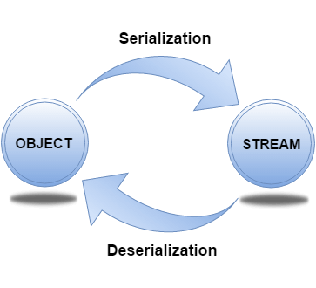

1. **How can you make a class serializable in Java?**

A class can become serializable by implementing the Serializable interface.

1. **How can you avoid serialization in child class if the base class is implementing the Serializable interface?**

It is very tricky to prevent serialization of child class if the base class is intended to implement the Serializable interface. However, we cannot do it directly, but the serialization can be avoided by implementing the writeObject() or readObject() methods in the subclass and throw NotSerializableException from these methods. Consider the following example.

import java.io.FileInputStream;

import java.io.FileOutputStream;

import java.io.IOException;

import java.io.NotSerializableException;

import java.io.ObjectInputStream;

import java.io.ObjectOutputStream;

import java.io.Serializable;

class Person implements Serializable {

>String name = " ";

>public Person(String name) {

>>this.name = name;

>}

}

class Employee extends Person {

>float salary;

>public Employee(String name, float salary) {

>>super(name);

>>this.salary = salary;

>}

>private void writeObject(ObjectOutputStream out) throws IOException {

>>throw new NotSerializableException();

>}

>private void readObject(ObjectInputStream in ) throws IOException {

>>throw new NotSerializableException();

>}

}

public class Test {

>public static void main(String[] args)

>throws Exception {

>>Employee emp = new Employee("Sharma", 10000);

>>System.out.println("name = " + emp.name);

>>System.out.println("salary = " + emp.salary);

>>FileOutputStream fos = new FileOutputStream("abc.ser");

>>ObjectOutputStream oos = new ObjectOutputStream(fos);

>>oos.writeObject(emp);

>>oos.close();

>>fos.close();

>>System.out.println("Object has been serialized");

>>FileInputStream f = new FileInputStream("ab.txt");

>>ObjectInputStream o = new ObjectInputStream(f);

>>Employee emp1 = (Employee) o.readObject();

>>o.close();

>>f.close();

>>System.out.println("Object has been deserialized");

>>System.out.println("name = " + emp1.name);

>>System.out.println("salary = " + emp1.salary);

>}

}

1. **Can a Serialized object be transferred via network?**

Yes, we can transfer a serialized object via network because the serialized object is stored in the memory in the form of bytes and can be transmitted over the network. We can also write the serialized object to the disk or the database.

1. **What is Deserialization?**

Deserialization is the process of reconstructing the object from the serialized state. It is the reverse operation of serialization. An ObjectInputStream deserializes objects and primitive data written using an ObjectOutputStream.

import java.io.*;

class Depersist {

>public static void main(String args[]) throws Exception {

>>ObjectInputStream in = new ObjectInputStream(new FileInputStream("f.txt"));

>>Student s = (Student) in .readObject();

>>System.out.println(s.id + " " + s.name);

>>in .close();

>}

}

211 ravi

1. **What is the transient keyword?**

If you define any data member as transient, it will not be serialized. By determining transient keyword, the value of variable need not persist when it is restored.

1. **What is the difference between Serializable and Externalizable interface?**

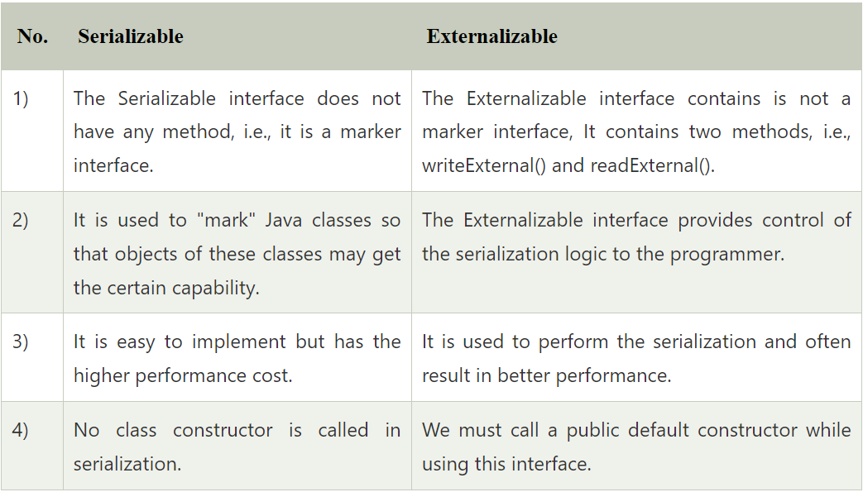

1. **Give a brief description of Java socket programming?**

Java Socket programming is used for communication between the applications running on different JRE. Java Socket programming can be connection-oriented or connectionless. Socket and ServerSocket classes are used for connection-oriented socket programming and DatagramSocket, and DatagramPacket classes are used for connectionless socket programming. The client in socket programming must know two information:

* IP address of the server
* port number

1. **What is Socket?**

A socket is simply an endpoint for communications between the machines. It provides the connection mechanism to connect the two computers using TCP. The Socket class can be used to create a socket.

1. **What are the steps that are followed when two computers connect through TCP?**

There are the following steps that are performed when two computers connect through TCP.

* The ServerSocket object is instantiated by the server which denotes the port number to which, the connection will be made.
* After instantiating the ServerSocket object, the server invokes accept() method of ServerSocket class which makes server wait until the client attempts to connect to the server on the given port.
* Meanwhile, the server is waiting, a socket is created by the client by instantiating Socket class. The socket class constructor accepts the server port number and server name.
* The Socket class constructor attempts to connect with the server on the specified name. If the connection is established, the client will have a socket object that can communicate with the server.
* The accept() method invoked by the server returns a reference to the new socket on the server that is connected with the server.

1. **Write a program in Java to establish a connection between client and server?**

Consider the following program where the connection between the client and server is established.

File: MyServer.java

import java.io.*;

import java.net.*;

public class MyServer {

>public static void main(String[] args) {

>>try {

>>>ServerSocket ss = new ServerSocket(6666);

>>>Socket s = ss.accept(); //establishes connection

>>>DataInputStream dis = new DataInputStream(s.getInputStream());

>>>String str = (String) dis.readUTF();

>>>System.out.println("message= " + str);

>>>ss.close();

>>} catch (Exception e) {

>>>System.out.println(e);

>>}

>}

}

File: MyClient.java

import java.io.*;

import java.net.*;

public class MyClient {

>public static void main(String[] args) {

>>try {

>>>Socket s = new Socket("localhost", 6666);

>>>DataOutputStream dout = new DataOutputStream(s.getOutputStream());

>>>dout.writeUTF("Hello Server");

>>>dout.flush();

>>>dout.close();

>>>s.close();

>>} catch (Exception e) {

>>>System.out.println(e);

>>}

>}

}

1. **How do I convert a numeric IP address like 192.18.97.39 into a hostname like java.sun.com?**

By InetAddress.getByName("192.18.97.39").getHostName() where 192.18.97.39 is the IP address. Consider the following example.

import java.io.*;

import java.net.*;

public class InetDemo {

>public static void main(String[] args) {

>>try {

>>>InetAddress ip = InetAddress.getByName("195.201.10.8");

>>>System.out.println("Host Name: " + ip.getHostName());

>>} catch (Exception e) {

>>>System.out.println(e);

>>}

>}

}

1. **What is the purpose of using java.lang.Class class?**

The java.lang.Class class performs mainly two tasks:

* Provides methods to get the metadata of a class at runtime.
* Provides methods to examine and change the runtime behavior of a class.

1. **What are the ways to instantiate the Class class?**

There are three ways to instantiate the Class class.

* forName() method of Class class: The forName() method is used to load the class dynamically. It returns the instance of Class class. It should be used if you know the fully qualified name of the class. This cannot be used for primitive types.
* getClass() method of Object class: It returns the instance of Class class. It should be used if you know the type. Moreover, it can be used with primitives.
* the .class syntax: If a type is available, but there is no instance then it is possible to obtain a Class by appending ".class" to the name of the type. It can be used for primitive data type also.

1. **What is the output of the following Java program?**

class Simple {

>public Simple() {

>>System.out.println("Constructor of Simple class is invoked");

>}

>void message() {

>>System.out.println("Hello Java");

>}

}

class Test1 {

>public static void main(String args[]) {

>>try {

>>>Class c = Class.forName("Simple");

>>>Simple s = (Simple) c.newInstance();

>>>s.message();

>>} catch (Exception e) {

>>>System.out.println(e);

>>}

>}

}

Output

Constructor of Simple class is invoked

Hello Java

Explanation

The newInstance() method of the Class class is used to invoke the constructor at runtime. In this program, the instance of the Simple class is created.

1. **What is the purpose of using javap?**

The javap command disassembles a class file. The javap command displays information about the fields, constructors and methods present in a class file.

Syntax

javap fully_class_name

1. **Can you access the private method from outside the class?**

Yes, by changing the runtime behavior of a class if the class is not secured.

1. **What are autoboxing and unboxing? When does it occur?**

The autoboxing is the process of converting primitive data type to the corresponding wrapper class object, eg., int to Integer. The unboxing is the process of converting wrapper class object to primitive data type. For eg., integer to int. Unboxing and autoboxing occur automatically in Java. However, we can externally convert one into another by using the methods like valueOf() or xxxValue().

It can occur whenever a wrapper class object is expected, and primitive data type is provided or vice versa.

* Adding primitive types into Collection like ArrayList in Java.
* Creating an instance of parameterized classes ,e.g., ThreadLocal which expect Type.
* Java automatically converts primitive to object whenever one is required and another is provided in the method calling.
* When a primitive type is assigned to an object type.

1. **What is the output of the below Java program?**

public class Test1 {

>public static void main(String[] args) {

>>Integer i = new Integer(201);

>>Integer j = new Integer(201);

>>if (i == j) {

>>>System.out.println("hello");

>>} else {

>>>System.out.println("bye");

>>}

>}

}

Output

bye

Explanation

Above we create two Integer objects, which is the wrapper class of int. In case of objects the == operator checks equality by reference, so checks if the two variables point to the same object. Even though the two objects hold the same value, they are two separate objects, so i == j will return false.

1. **What are the advantages and disadvantages of object cloning?**

Advantages of Object Cloning

* You don't need to write lengthy and repetitive codes. Just use an abstract class with a 4- or 5-line long clone() method.
* It is the easiest and most efficient way of copying objects, especially if we are applying it to an already developed or an old project. Just define a parent class, implement Cloneable in it, provide the definition of the clone() method and the task will be done.
* Clone() is the fastest way to copy the array.

Disadvantages of Object Cloning

* To use the Object.clone() method, we have to change many syntaxes to our code, like implementing a Cloneable interface, defining the clone() method and handling CloneNotSupportedException, and finally, calling Object.clone(), etc.
* We have to implement the Cloneable interface while it does not have any methods in it. We have to use it to tell the JVM that we can perform a clone() on our object.
* Object.clone() is protected, so we have to provide our own clone() and indirectly call Object.clone() from it.
* Object.clone() does not invoke any constructor, so we do not have any control over object construction.
* If you want to write a clone method in a child class, then all of its superclasses should define the clone() method in them or inherit it from another parent class. Otherwise, the super.clone() chain will fail.
* Object.clone() supports only shallow copying, but we will need to override it if we need deep cloning.

1. **What is a native method?**

A native method is a method that is implemented in a language other than Java. Natives methods are sometimes also referred to as foreign methods.

1. **What is the purpose of the strictfp keyword?**

Java strictfp keyword ensures that you will get the same result on every platform if you perform operations in the floating-point variable. The precision may differ from platform to platform that is why java programming language has provided the strictfp keyword so that you get the same result on every platform. So, now you have better control over the floating-point arithmetic.

It can be used for classes, methods or interfaces. Example:

public strictfp class ScientificCalculator {

>public double sum(double value1, double value2) {

>>return value1 + value2;

>}

>public double diff(double value1, double value2) {

>>return value1 - value2;

>}

}

public strictfp void calculateMarksPercentage() {

>...

}

public strictfp interface Circle {

>double computeArea(double radius);

}

1. **What is the purpose of the System class?**

The purpose of the System class is to provide access to system resources such as standard input and output. It cannot be instantiated. Facilities provided by System class are given below.

* Standard input
* Error output streams
* Standard output
* utility method to copy the portion of an array
* utilities to load files and libraries

There are the three fields of Java System class, i.e., static printstream err, static inputstream in, and standard output stream.

1. **What comes to mind when someone mentions a shallow copy in Java?**

Object cloning.

1. **Write a Java program that prints all the values given at command-line.**

Program

class A {

>public static void main(String args[]) {

>>for (int i = 0; i < args.length; i++)

>>>System.out.println(args[i]);

>}

}

compile by > javac A.java

run by > java A sonoo jaiswal 1 3 abc

Output

sonoo

jaiswal

1

3

abc

1. **Which containers use a border layout as their default layout?**

The Window, Frame and Dialog classes use a border layout as their default layout.

1. **Which containers use a FlowLayout as their default layout?**

The Panel and Applet classes use the FlowLayout as their default layout.

1. **What are peerless components?**

The lightweight component of Swing is called peerless components. Spring has its libraries, so it does not use resources from the Operating System, and hence it has lightweight components.

1. **is there is any difference between a Scrollbar and a ScrollPane?**

The Scrollbar is a Component whereas the ScrollPane is a Container. A ScrollPane handles its events and performs its scrolling.

1. **What is a lightweight component?**

Lightweight components are the one which does not go with the native call to obtain the graphical units. They share their parent component graphical units to render them. For example, Swing components, and JavaFX Components.

1. **What is a heavyweight component?**

The portable elements provided by the operating system are called heavyweight components. AWT is limited to the graphical classes provided by the operating system and therefore, It implements only the minimal subset of screen elements supported by all platforms. The Operating system dependent UI discovery tools are called heavyweight components.

1. **What is an applet?**

An applet is a small java program that runs inside the browser and generates dynamic content. It is embedded in the webpage and runs on the client side. It is secured and takes less response time. It can be executed by browsers running under many platforms, including Linux, Windows, Mac Os, etc. However, the plugins are required at the client browser to execute the applet. The following image shows the architecture of Applet.

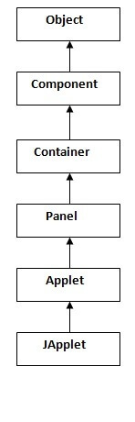

1. **Can you write a Java class that could be used both as an applet as well as an application?**

Yes. Add a main() method to the applet.

1. **What is Locale?**

A Locale object represents a specific geographical, political, or cultural region. This object can be used to get the locale-specific information such as country name, language, variant, etc.

import java.util.*;

public class LocaleExample {

>public static void main(String[] args) {

>>Locale locale = Locale.getDefault();

>>//Locale locale=new Locale("fr","fr");//for the specific locale

>>System.out.println(locale.getDisplayCountry());

>>System.out.println(locale.getDisplayLanguage());

>>System.out.println(locale.getDisplayName());

>>System.out.println(locale.getISO3Country());

>>System.out.println(locale.getISO3Language());

>>System.out.println(locale.getLanguage());

>>System.out.println(locale.getCountry());

>}

}

Output:

United States

English

English (United States)

USA

eng

en

US

1. **How will you load a specific locale?**

By ResourceBundle.getBundle(?) method.

1. **What is a JavaBean?**

JavaBean is a reusable software component written in the Java programming language, designed to be manipulated visually by a software development environment, like JBuilder or VisualAge for Java. t. A JavaBean encapsulates many objects into one object so that we can access this object from multiple places. Moreover, it provides the easy maintenance. Consider the following example to create a JavaBean class.

//Employee.java

package mypack;

public class Employee implements java.io.Serializable {

>private int id;

>private String name;

>public Employee() {}

>public void setId(int id) {

>>this.id = id;

>}

>public int getId() {

>>return id;

>}

>public void setName(String name) {

>>this.name = name;

>}

>public String getName() {

>>return name;

>}

}

1. **What is the purpose of using the Java bean?**

According to Java white paper, it is a reusable software component. A bean encapsulates many objects into one object so that we can access this object from multiple places. Moreover, it provides the easy maintenance.

1. **What do you understand by the bean persistent property?**

The persistence property of Java bean comes into the act when the properties, fields, and state information are saved to or retrieve from the storage.

1. **What is RMI?**

The RMI (Remote Method Invocation) is an API that provides a mechanism to create the distributed application in java. The RMI allows an object to invoke methods on an object running in another JVM. The RMI provides remote communication between the applications using two objects stub and skeleton.

1. **What is the purpose of stub and skeleton?**

Stub

The stub is an object, acts as a gateway for the client side. All the outgoing requests are routed through it. It resides at the client side and represents the remote object. When the caller invokes the method on the stub object, it does the following tasks:

* It initiates a connection with remote Virtual Machine (JVM).
* It writes and transmits (marshals) the parameters to the remote Virtual Machine (JVM).
* It waits for the result.
* It reads (unmarshals) the return value or exception.
* It finally, returns the value to the caller.

Skeleton

The skeleton is an object, acts as a gateway for the server side object. All the incoming requests are routed through it. When the skeleton receives the incoming request, it does the following tasks:

* It reads the parameter for the remote method.
* It invokes the method on the actual remote object.
* It writes and transmits (marshals) the result to the caller.

1. **What are the steps involved to write RMI based programs?**

There are 6 steps which are performed to write RMI based programs.

* Create the remote interface.
* Provide the implementation of the remote interface.
* Compile the implementation class and create the stub and skeleton objects using the rmic tool.
* Start the registry service by the rmiregistry tool.
* Create and start the remote application.
* Create and start the client application.

1. **What is the use of HTTP-tunneling in RMI?**

HTTP tunneling can be defined as the method which doesn't need any setup to work within the firewall environment. It handles the HTTP connections through the proxy servers. However, it does not allow outbound TCP connections.

1. **What is JRMP?**

JRMP (Java Remote Method Protocol) can be defined as the Java-specific, stream-based protocol which looks up and refers to the remote objects. It requires both client and server to use Java objects. It is wire level protocol which runs under RMI and over TCP/IP.

1. **Can RMI and CORBA based applications interact?**

Yes, they can. RMI is available with IIOP as the transport protocol instead of JRMP.

1. **How to perform Bubble Sort in Java?**

Consider the following program to perform Bubble sort in Java.

public class BubbleSort {

>public static void main(String[] args) {

>>int[] a = {

>>>10, 9, 7, 101, 23, 44, 12, 78, 34, 23

>>};

>>for (int i = 0; i < 10; i++) {

>>>for (int j = 0; j < 10; j++) {

>>>>if (a[i] < a[j]) {

>>>>>int temp = a[i];

>>>>>a[i] = a[j];

>>>>>a[j] = temp;

>>>>}

>>>}

>>}

>>System.out.println("Printing Sorted List ...");

>>for (int i = 0; i < 10; i++) {

>>>System.out.println(a[i]);

>>}

>}

}

Output:

Printing Sorted List . . .

7

9

10

12

23

34

34

44

78

101

1. **How to perform Binary Search in Java?**

Consider the following program to perform the binary search in Java.

import java.util.*;

public class BinarySearch {

>public static void main(String[] args) {

>>int[] arr = {

>>>16, 19, 20, 23, 45, 56, 78, 90, 96, 100

>>};

>>int item, location = -1;

>>System.out.println("Enter the item which you want to search");

>>Scanner sc = new Scanner(System.in);

>>item = sc.nextInt();

>>location = binarySearch(arr, 0, 9, item);

>>if (location != -1)

>>>System.out.println("the location of the item is " + location);

>>else

>>>System.out.println("Item not found");

>}

>public static int binarySearch(int[] a, int beg, int end, int item) {

>>int mid;

>>if (end >= beg) {

>>>mid = (beg + end) / 2;

>>>if (a[mid] == item) {

>>>>return mid + 1;

>>>} else if (a[mid] < item) {

>>>>return binarySearch(a, mid + 1, end, item);

>>>} else {

>>>>return binarySearch(a, beg, mid - 1, item);

>>>}

>>}

>>return -1;

>}

}

Output:

Enter the item which you want to search

45

the location of the item is 5

1. **How to perform Selection Sort in Java?**

Consider the following program to perform selection sort in Java.

public class SelectionSort {

>public static void main(String[] args) {

>>int[] a = {

>>>10, 9, 7, 101, 23, 44, 12, 78, 34, 23

>>};

>>int i, j, k, pos, temp;

>>for (i = 0; i < 10; i++) {

>>>pos = smallest(a, 10, i);

>>>temp = a[i];

>>>a[i] = a[pos];

>>>a[pos] = temp;

>>}

>>System.out.println("\nprinting sorted elements...\n");

>>for (i = 0; i < 10; i++) {

>>>System.out.println(a[i]);

>>}

>}

>public static int smallest(int a[], int n, int i) {

>>int small, pos, j;

>>small = a[i];

>>pos = i;

>>for (j = i + 1; j < 10; j++) {

>>>if (a[j] < small) {

>>>>small = a[j];

>>>>pos = j;

>>>}

>>}

>>return pos;

>}

}

Output:

printing sorted elements...

7

9

10

12

23

23

34

44

78

101

1. **How to perform Linear Search in Java?**

Consider the following program to perform Linear search in Java.

import java.util.Scanner;

public class Leniear_Search {

>public static void main(String[] args) {

>>int[] arr = {

>>>10, 23, 15, 8, 4, 3, 25, 30, 34, 2, 19

>>};

>>int item, flag = 0;

>>Scanner sc = new Scanner(System.in);

>>System.out.println("Enter Item ?");

>>item = sc.nextInt();

>>for (int i = 0; i < 10; i++) {

>>>if (arr[i] == item) {

>>>>flag = i + 1;

>>>>break;

>>>} else

>>>>flag = 0;

>>}

>>if (flag != 0) {

>>>System.out.println("Item found at location" + flag);

>>} else

>>>System.out.println("Item not found");

>}

}

Output:

Enter Item ?

23

Item found at location 2

Enter Item ?

22

Item not found

1. **How to perform merge sort in Java?**

Consider the following program to perform merge sort in Java.

public class MyMergeSort {

>void merge(int arr[], int beg, int mid, int end) {

>>int l = mid - beg + 1;

>>int r = end - mid;

>>intLeftArray[] = new int[l];

>>intRightArray[] = new int[r];

>>for (int i = 0; i < l; ++i)

>>>LeftArray[i] = arr[beg + i];

>>for (int j = 0; j < r; ++j)

>>>RightArray[j] = arr[mid + 1 + j];

>>int i = 0, j = 0;

>>int k = beg;

>>while (i < l && j < r) {

>>>if (LeftArray[i] <= RightArray[j]) {

>>>>arr[k] = LeftArray[i];

>>>>i++;

>>>} else {

>>>>arr[k] = RightArray[j];

>>>>j++;

>>>}

>>>k++;

>>}

>>while (i < l) {

>>>arr[k] = LeftArray[i];

>>>i++;

>>>k++;

>>}

>>while (j < r) {

>>>arr[k] = RightArray[j];

>>>j++;

>>>k++;

>>}

>}

>void sort(int arr[], int beg, int end) {

>>if (beg < end) {

>>>int mid = (beg + end) / 2;

>>>sort(arr, beg, mid);

>>>sort(arr, mid + 1, end);

>>>merge(arr, beg, mid, end);

>>}

>}

>public static void main(String args[]) {

>>intarr[] = {

>>>90,23,101,45,65,23,67,89,34,23

>>};

>>MyMergeSort ob = new MyMergeSort();

>>ob.sort(arr, 0, arr.length - 1);

>>System.out.println("\nSorted array");

>>for (int i = 0; i < arr.length; i++) {

>>>System.out.println(arr[i] + "");

>>}

>}

}

1. **How to perform quicksort in Java?**

Consider the following program to perform quicksort in Java.

public class QuickSort {

>public static void main(String[] args) {

>>int i;

>>int[] arr = {

>>>90, 23, 101, 45, 65, 23, 67, 89, 34, 23

>>};

>>quickSort(arr, 0, 9);

>>System.out.println("\n The sorted array is: \n");

>>for (i = 0; i < 10; i++)

>>>System.out.println(arr[i]);

>}

>public static int partition(int a[], int beg, int end) {

>>int left, right, temp, loc, flag;

>>loc = left = beg;

>>right = end;

>>flag = 0;

>>while (flag != 1) {

>>>while ((a[loc] <= a[right]) && (loc != right))

>>>>right--;

>>>if (loc == right)

>>>>flag = 1;

>>>else if (a[loc] > a[right]) {

>>>>temp = a[loc];

>>>>a[loc] = a[right];

>>>>a[right] = temp;

>>>>loc = right;

>>>}

>>>if (flag != 1) {

>>>>while ((a[loc] >= a[left]) && (loc != left))

>>>>>left++;

>>>>if (loc == left)

>>>>>flag = 1;

>>>>else if (a[loc] < a[left]) {

>>>>>temp = a[loc];

>>>>>a[loc] = a[left];

>>>>>a[left] = temp;

>>>>>loc = left;

>>>>}

>>>}

>>}

>>returnloc;

>}

>static void quickSort(int a[], int beg, int end) {

>>int loc;

>>if (beg < end) {

>>>loc = partition(a, beg, end);

>>>quickSort(a, beg, loc - 1);

>>>quickSort(a, loc + 1, end);

>>}

>}

}

Output:

The sorted array is:

23

23

23

34

45

65

67

89

90

101

1. **Write a program in Java to create a doubly linked list containing n nodes.**

Consider the following program to create a doubly linked list containing n nodes.

public class CountList {

>//Represent a node of the doubly linked list

>class Node {

>>int data;

>>Node previous;

>>Node next;

>>public Node(int data) {

>>>this.data = data;

>>}

>}

>//Represent the head and tail of the doubly linked list

>Node head, tail = null;

>//addNode() will add a node to the list

>public void addNode(int data) {

>>//Create a new node

>>Node newNode = new Node(data);

>>//If list is empty

>>if (head == null) {

>>>//Both head and tail will point to newNode

>>>head = tail = newNode;

>>>//head's previous will point to null

>>>head.previous = null;

>>>//tail's next will point to null, as it is the last node of the list

>>>tail.next = null;

>>} else {

>>>//newNode will be added after tail such that tail's next will point to newNode

>>>tail.next = newNode;

>>>//newNode's previous will point to tail

>>>newNode.previous = tail;

>>>//newNode will become new tail

>>>tail = newNode;

>>>//As it is last node, tail's next will point to null

>>>tail.next = null;

>>}

>}

>//countNodes() will count the nodes present in the list

>public int countNodes() {

>>int counter = 0;

>>//Node current will point to head

>>Node current = head;

>>while (current != null) {

>>>//Increment the counter by 1 for each node

>>>counter++;

>>>current = current.next;

>>}

>>return counter;

>}

>//display() will print out the elements of the list

>public void display() {

>>//Node current will point to head

>>Node current = head;

>>if (head == null) {

>>>System.out.println("List is empty");

>>>return;

>>}

>>System.out.println("Nodes of doubly linked list: ");

>>while (current != null) {

>>>//Prints each node by incrementing the pointer.

>>>System.out.print(current.data + " ");

>>>current = current.next;

>>}

>}

>public static void main(String[] args) {

>>CountList dList = new CountList();

>>//Add nodes to the list

>>dList.addNode(1);

>>dList.addNode(2);

>>dList.addNode(3);

>>dList.addNode(4);

>>dList.addNode(5);

>>//Displays the nodes present in the list

>>dList.display();

>>//Counts the nodes present in the given list

>>System.out.println("\nCount of nodes present in the list: " + dList.countNodes());

>}

}

Output:

Nodes of doubly linked list:

1 2 3 4 5

Count of nodes present in the list: 5

1. **Write a program in Java to find the maximum and minimum value node from a circular linked list.**

Consider the following program.

public class MinMax {

>//Represents the node of list.

>public class Node {

>>int data;

>>Node next;

>>public Node(int data) {

>>>this.data = data;

>>}

>}

>//Declaring head and tail pointer as null.

>public Node head = null;

>public Node tail = null;

>//This function will add the new node at the end of the list.

>public void add(int data) {

>>//Create new node

>>Node newNode = new Node(data);

>>//Checks if the list is empty.

>>if (head == null) {

>>>//If list is empty, both head and tail would point to new node

>>>head = newNode;

>>>tail = newNode;

>>>newNode.next = head;

>>} else {

>>>//tail will point to new node.

>>>tail.next = newNode;

>>>//New node will become new tail.

>>>tail = newNode;

>>>//Since, it is circular linked list tail will points to head.

>>>tail.next = head;

>>}

>}

>//Finds out the minimum value node in the list

>public void minNode() {

>>Node current = head;

>>//Initializing min to initial node data

>>int min = head.data;

>>if (head == null) {

>>>System.out.println("List is empty");

>>} else {

>>>do {

>>>>//If current node's data is smaller than min

>>>>//Then replace value of min with current node's data

>>>>if (min > current.data) {

>>>>>min = current.data;

>>>>}

>>>>current = current.next;

>>>} while (current != head);

>>>System.out.println("Minimum value node in the list: " + min);

>>}

>}

>//Finds out the maximum value node in the list

>public void maxNode() {

>>Node current = head;

>>//Initializing max to initial node data

>>int max = head.data;

>>if (head == null) {

>>>System.out.println("List is empty");

>>} else {

>>>do {

>>>>//If current node's data is greater than max

>>>>//Then replace value of max with current node's data

>>>>if (max < current.data) {

>>>>>max = current.data;

>>>>}

>>>>current = current.next;

>>>} while (current != head);

>>>System.out.println("Maximum value node in the list: " + max);

>>}

>}

>public static void main(String[] args) {

>>MinMax cl = new MinMax();

>>//Adds data to the list

>>cl.add(5);

>>cl.add(20);

>>cl.add(10);

>>cl.add(1);

>>//Prints the minimum value node in the list

>>cl.minNode();

>>//Prints the maximum value node in the list

>>cl.maxNode();

>}

}

Output:

Minimum value node in the list: 1

Maximum value node in the list: 20

1. **Write a program in Java to calculate the difference between the sum of the odd level and even level nodes of a Binary Tree.**

Consider the following program.

public class DiffOddEven {

>//Represent a node of binary tree

>public static class Node {

>>int data;

>>Node left;

>>Node right;

>>public Node(int data) {

>>>//Assign data to the new node, set left and right children to null

>>>this.data = data;

>>>this.left = null;

>>>this.right = null;

>>}

>}

>//Represent the root of binary tree

>public Node root;

>public DiffOddEven() {

>>root = null;

>}

>//difference() will calculate the difference between sum of odd and even levels of binary tree

>public int difference() {

>>int oddLevel = 0, evenLevel = 0, diffOddEven = 0;

>>//Variable nodesInLevel keep tracks of number of nodes in each level

>>int nodesInLevel = 0;

>>//Variable currentLevel keep track of level in binary tree

>>int currentLevel = 0;

>>//Queue will be used to keep track of nodes of tree level-wise

>>Queue < Node > queue = new LinkedList < Node > ();

>>//Check if root is null

>>if (root == null) {

>>>System.out.println("Tree is empty");

>>>return 0;

>>} else {

>>>//Add root node to queue as it represents the first level

>>>queue.add(root);

>>>currentLevel++;

>>>while (queue.size() != 0) {

>>>>//Variable nodesInLevel will hold the size of queue i.e. number of elements in queue

>>>>nodesInLevel = queue.size();

>>>>while (nodesInLevel > 0) {

>>>>>Node current = queue.remove();

>>>>>//Checks if currentLevel is even or not.

>>>>>if (currentLevel % 2 == 0)

>>>>>>//If level is even, add nodes's to variable evenLevel

>>>>>>evenLevel += current.data;

>>>>>else

>>>>>>//If level is odd, add nodes's to variable oddLevel

>>>>>>oddLevel += current.data;

>>>>>//Adds left child to queue

>>>>>if (current.left != null)

>>>>>>queue.add(current.left);

>>>>>//Adds right child to queue

>>>>>if (current.right != null)

>>>>>>queue.add(current.right);

>>>>>nodesInLevel--;

>>>>}

>>>>currentLevel++;

>>>}

>>>//Calculates difference between oddLevel and evenLevel

>>>diffOddEven = Math.abs(oddLevel - evenLevel);

>>}

>>return diffOddEven;

>}

>public static void main(String[] args) {

>>DiffOddEven bt = new DiffOddEven();

>>//Add nodes to the binary tree

>>bt.root = new Node(1);

>>bt.root.left = new Node(2);

>>bt.root.right = new Node(3);

>>bt.root.left.left = new Node(4);

>>bt.root.right.left = new Node(5);

>>bt.root.right.right = new Node(6);

>>//Display the difference between sum of odd level and even level nodes

>>System.out.println("Difference between sum of odd level and even level nodes: " + bt.difference());

>}

}

Output:

Difference between sum of odd level and even level nodes: 11

1. **What is multithreading?**

Multithreading is a process of executing multiple threads simultaneously. Multithreading is used to obtain the multitasking. It consumes less memory and gives the fast and efficient performance. Its main advantages are:

* Threads share the same address space.
* The thread is lightweight.
* The cost of communication between the processes is low.

1. **What is the thread?**

A thread is a lightweight subprocess. It is a separate path of execution because each thread runs in a different stack frame. A process may contain multiple threads. Threads share the process resources, but still, they execute independently. In Java, all the programs will have at least one thread which is known as the main thread. This main thread is created by the JVM when the program starts its execution. The main thread is used to invoke the main() of the program.

1. **Differentiate between process and thread?**

There are the following differences between the process and thread.

* A Program in the execution is called the process whereas; A thread is a subset of the process
* Processes are independent whereas threads are the subset of process.
* Process have different address space in memory, while threads contain a shared address space.
* Context switching is faster between the threads as compared to processes.
* Inter-process communication is slower and expensive than inter-thread communication.
* Any change in Parent process doesn't affect the child process whereas changes in parent thread can affect the child thread.

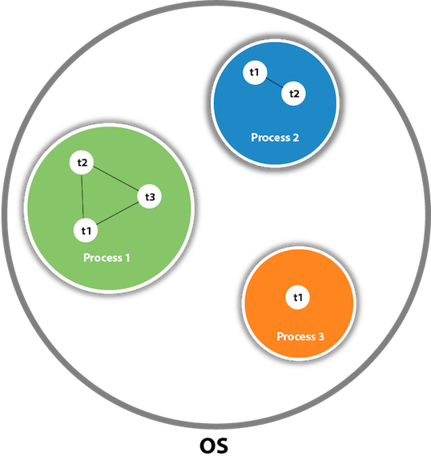

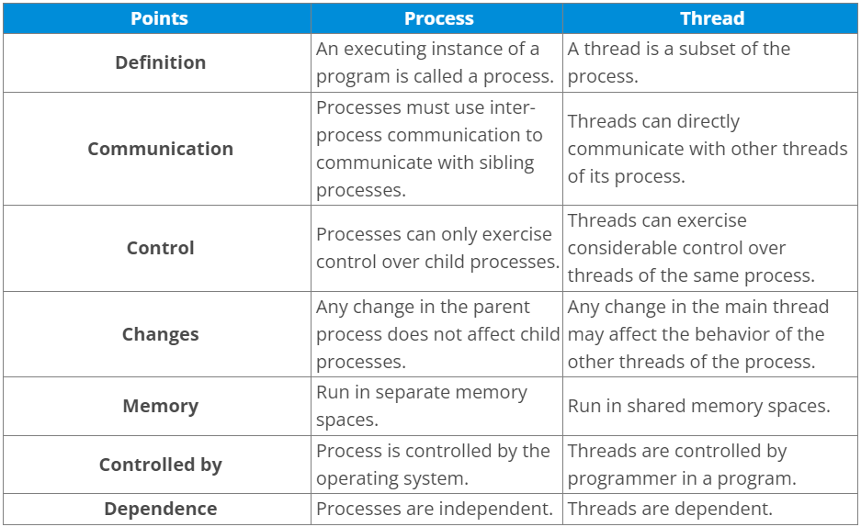

1. **What do you understand by inter-thread communication?**

* The process of communication between synchronized threads is termed as inter-thread communication.
* Inter-thread communication is used to avoid thread polling in Java.
* The thread is paused running in its critical section, and another thread is allowed to enter (or lock) in the same critical section to be executed.
* It can be obtained by wait(), notify(), and notifyAll() methods.

1. **What is the purpose of wait() method in Java?**

The wait() method is provided by the Object class in Java. This method is used for inter-thread communication in Java. The java.lang.Object.wait() is used to pause the current thread, and wait until another thread does not call the notify() or notifyAll() method. Its syntax is given below.

public final void wait()

wait () method is used to make the thread to wait in the waiting pool. When the wait () method is executed during a thread execution then immediately the thread gives up the lock on the object and goes to the waiting pool. Wait () method tells the thread to wait for a given amount of time.

Then the thread will wake up after notify () (or) notify all () method is called.

Wait() and the other above-mentioned methods do not give the lock on the object immediately until the currently executing thread completes the synchronized code. It is mostly used in synchronization.

Example:

public static void main(String[] args) {

>Thread t = new Thread();

>t.start();

>Synchronized(t) {

>>Wait();

>}

}

1. **Why must wait() method be called from the synchronized block?**

We must call the wait method otherwise it will throw java.lang.IllegalMonitorStateException exception. Moreover, we need wait() method for inter-thread communication with notify() and notifyAll(). Therefore It must be present in the synchronized block for the proper and correct communication.

1. **What are the advantages of multithreading?**

Multithreading programming has the following advantages:

* Multithreading allows an application/program to be always reactive for input, even already running with some background tasks
* Multithreading allows the faster execution of tasks, as threads execute independently.
* Multithreading provides better utilization of cache memory as threads share the common memory resources.
* Multithreading reduces the number of the required server as one server can execute multiple threads at a time.

1. **What are the states in the lifecycle of a Thread?**

A thread can have one of the following states during its lifetime:

* New: In this state, a Thread class object is created using a new operator, but the thread is not alive. Thread doesn't start until we call the start() method.
* Runnable: In this state, the thread is ready to run after calling the start() method. However, the thread is not yet selected by the thread scheduler.
* Running: In this state, the thread scheduler picks the thread from the ready state, and the thread is running.
* Waiting/Blocked: In this state, a thread is not running but still alive, or it is waiting for the other thread to finish.
* Dead/Terminated: A thread is in terminated or dead state when the run() method exits.

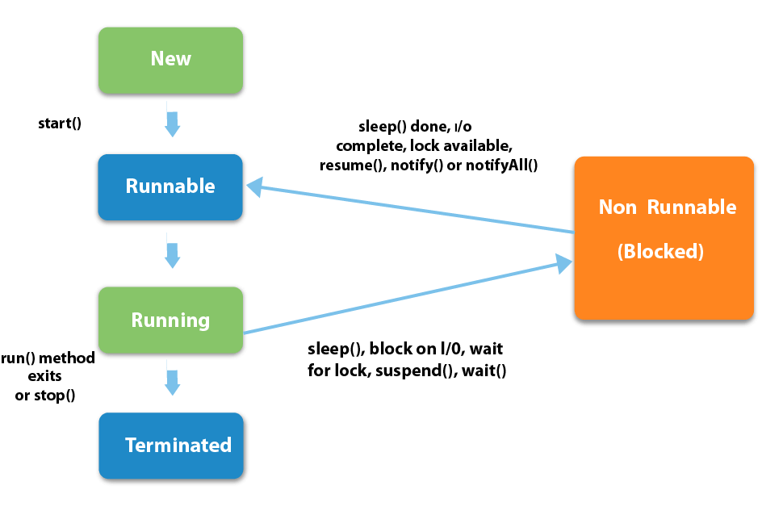

1. **What is the difference between preemptive scheduling and time slicing?**

Under preemptive scheduling, the highest priority task executes until it enters the waiting or dead states or a higher priority task comes into existence. Under time slicing, a task executes for a predefined slice of time and then reenters the pool of ready tasks. The scheduler then determines which task should execute next, based on priority and other factors.

1. **What is context switching?**

In Context switching the state of the process (or thread) is stored so that it can be restored and execution can be resumed from the same point later. Context switching enables the multiple processes to share the same CPU.

1. **Differentiate between the Thread class and Runnable interface for creating a Thread?**

The Thread can be created by using two ways.

* By extending the Thread class
* By implementing the Runnable interface

However, the primary differences between both the ways are given below:

* By extending the Thread class, we cannot extend any other class, as Java does not allow multiple inheritances while implementing the Runnable interface; we can also extend other base class(if required).
* By extending the Thread class, each of thread creates the unique object and associates with it while implementing the Runnable interface; multiple threads share the same object
* Thread class provides various inbuilt methods such as getPriority(), isAlive and many more while the Runnable interface provides a single method, i.e., run().

1. **What does join() method?**

The join() method waits for a thread to die. In other words, it causes the currently running threads to stop executing until the thread it joins with completes its task. Join method is overloaded in Thread class in the following ways.

* public void join()throws InterruptedException
* public void join(long milliseconds)throws InterruptedException

Join () method is used to join one thread with the end of the currently running thread.

Example:

public static void main(String[] args) {

>Thread t = new Thread();

>t.start();

>t.join();

}

Based on the above code, the main thread has started the execution. When it reaches the code t.start() then ‘thread t’ starts the own stack for the execution. JVM switches between the main thread and ‘thread t’.

Once it reaches the code t.join() then ‘thread t’ alone is executed and completes its task, then only the main thread starts the execution.

It is a non-static method. The Join () method has an overloaded version. So we can mention the time duration in join () method also “.s”.

1. **Describe the purpose and working of sleep() method.**

The sleep() method in java is used to block a thread for a particular time, which means it pause the execution of a thread for a specific time. There are two methods of doing so.

Syntax:

* public static void sleep(long milliseconds)throws InterruptedException
* public static void sleep(long milliseconds, int nanos)throws InterruptedException

Working of sleep() method

When we call the sleep() method, it pauses the execution of the current thread for the given time and gives priority to another thread(if available). Moreover, when the waiting time completed then again previous thread changes its state from waiting to runnable and comes in running state, and the whole process works so on till the execution doesn't complete.

1. **What is the difference between wait() and sleep() method?**

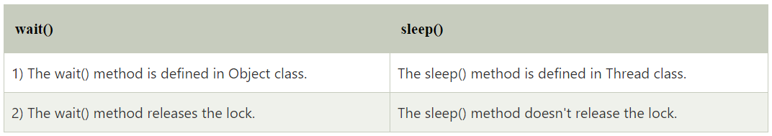

1. **Is it possible to start a thread twice?**

No, we cannot restart the thread, as once a thread started and executed, it goes to the Dead state. Therefore, if we try to start a thread twice, it will give a runtimeException "java.lang.IllegalThreadStateException". Consider the following example.

public class Multithread1 extends Thread {

>public void run() {

>>try {

>>>System.out.println("thread is executing now........");

>>} catch (Exception e) {}

>}

>public static void main(String[] args) {

>>Multithread1 m1 = new Multithread1();

>>m1.start();

>>m1.start();

>}

}

Output

thread is executing now........

Exception in thread "main" java.lang.IllegalThreadStateException

>at java.lang.Thread.start(Thread.java:708)

>at Multithread1.main(Multithread1.java:13)

1. **Can we call the run() method instead of start()?**

Yes, calling run() method directly is valid, but it will not work as a thread instead it will work as a normal object. There will not be context-switching between the threads. When we call the start() method, it internally calls the run() method, which creates a new stack for a thread while directly calling the run() will not create a new stack.

1. **What about the daemon threads?**

The daemon threads are the low priority threads that provide the background support and services to the user threads. Daemon thread gets automatically terminated by the JVM if the program remains with the daemon thread only, and all other user threads are ended/died. There are two methods for daemon thread available in the Thread class:

* public void setDaemon(boolean status): It used to mark the thread daemon thread or a user thread.
* public boolean isDaemon(): It checks the thread is daemon or not.

1. **What is shutdown hook?**

The shutdown hook is a thread that is invoked implicitly before JVM shuts down. So we can use it to perform clean up the resource or save the state when JVM shuts down normally or abruptly. We can add shutdown hook by using the following method:

public void addShutdownHook(Thread hook){}>

Runtime r=Runtime.getRuntime();

r.addShutdownHook(new MyThread());

Some important points about shutdown hooks are :

Shutdown hooks initialized but can only be started when JVM shutdown occurred.

Shutdown hooks are more reliable than the finalizer() because there are very fewer chances that shutdown hooks not run.

The shutdown hook can be stopped by calling the halt(int) method of Runtime class.

1. **When should we interrupt a thread?**

We should interrupt a thread when we want to break out the sleep or wait state of a thread. We can interrupt a thread by calling the interrupt() throwing the InterruptedException.

1. **What is the synchronization?**

Synchronization is the capability to control the access of multiple threads to any shared resource. It is used:

* To prevent thread interference.
* To prevent consistency problem.

When the multiple threads try to do the same task, there is a possibility of an erroneous result, hence to remove this issue, Java uses the process of synchronization which allows only one thread to be executed at a time. Synchronization can be achieved in three ways:

* by the synchronized method
* by synchronized block
* by static synchronization

Syntax for synchronized block

synchronized(object reference expression)

>{

>>//code block

>}

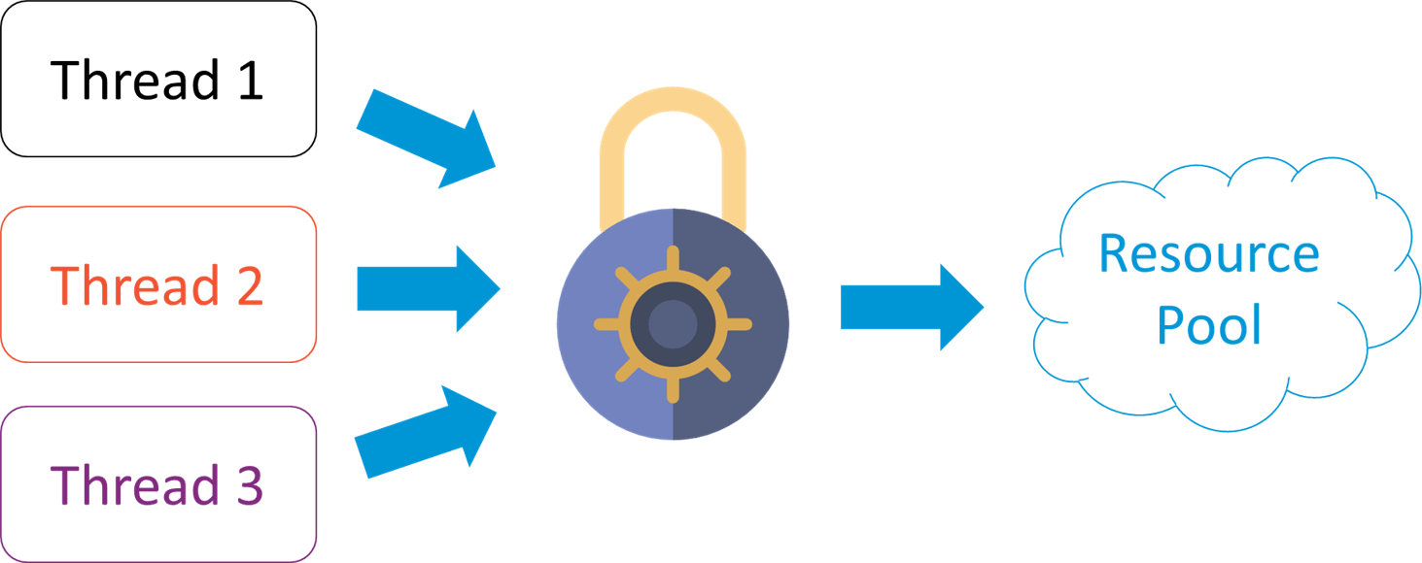

1. **What is the purpose of the Synchronized block?**

The Synchronized block can be used to perform synchronization on any specific resource of the method. Only one thread at a time can execute on a particular resource, and all other threads which attempt to enter the synchronized block are blocked.

* Synchronized block is used to lock an object for any shared resource.
* The scope of the synchronized block is limited to the block on which, it is applied. Its scope is smaller than a method.

1. **Can Java object be locked down for exclusive use by a given thread?**

Yes. You can lock an object by putting it in a "synchronized" block. The locked object is inaccessible to any thread other than the one that explicitly claimed it.

1. **What is static synchronization?**

If you make any static method as synchronized, the lock will be on the class not on the object. If we use the synchronized keyword before a method so it will lock the object (one thread can access an object at a time) but if we use static synchronized so it will lock a class (one thread can access a class at a time).

1. **What is the difference between notify() and notifyAll()?**

The notify() is used to unblock one waiting thread whereas notifyAll() method is used to unblock all the threads in waiting state.

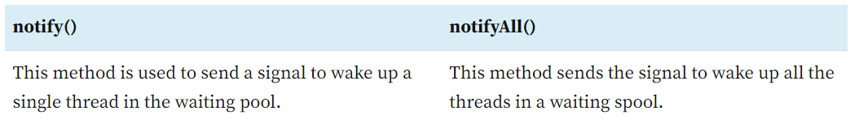

1. **What is the deadlock?**

Deadlock is a situation in which every thread is waiting for a resource which is held by some other waiting thread. In this situation, Neither of the thread executes nor it gets the chance to be executed. Instead, there exists a universal waiting state among all the threads. Deadlock is a very complicated situation which can break our code at runtime.

1. **How to detect a deadlock condition? How can it be avoided?**

We can detect the deadlock condition by running the code on cmd and collecting the Thread Dump, and if any deadlock is present in the code, then a message will appear on cmd.

Ways to avoid the deadlock condition in Java:

* Avoid Nested lock: Nested lock is the common reason for deadlock as deadlock occurs when we provide locks to various threads so we should give one lock to only one thread at some particular time.
* Avoid unnecessary locks: we must avoid the locks which are not required.
* Using thread join: Thread join helps to wait for a thread until another thread doesn't finish its execution so we can avoid deadlock by maximum use of join method.

1. **What is Thread Scheduler in java?**

In Java, when we create the threads, they are supervised with the help of a Thread Scheduler, which is the part of JVM. Thread scheduler is only responsible for deciding which thread should be executed. Thread scheduler uses two mechanisms for scheduling the threads: Preemptive and Time Slicing.

Java thread scheduler also works for deciding the following for a thread:

* It selects the priority of the thread.
* It determines the waiting time for a thread
* It checks the Nature of thread

1. **Does each thread have its stack in multithreaded programming?**

Yes, in multithreaded programming every thread maintains its own or separate stack area in memory due to which every thread is independent of each other.

1. **How is the safety of a thread achieved?**

If a method or class object can be used by multiple threads at a time without any race condition, then the class is thread-safe. Thread safety is used to make a program safe to use in multithreaded programming. It can be achieved by the following ways:

* Synchronization
* Using Volatile keyword
* Using a lock based mechanism
* Use of atomic wrapper classes

1. **What is race-condition?**

A Race condition is a problem which occurs in the multithreaded programming when various threads execute simultaneously accessing a shared resource at the same time. The proper use of synchronization can avoid the Race condition.

1. **What is the volatile keyword in java?**

Volatile keyword is used in multithreaded programming to achieve the thread safety, as a change in one volatile variable is visible to all other threads so one variable can be used by one thread at a time.

1. **What do you understand by thread pool?**

* Java Thread pool represents a group of worker threads, which are waiting for the task to be allocated.
* Threads in the thread pool are supervised by the service provider which pulls one thread from the pool and assign a job to it.
* After completion of the given task, thread again came to the thread pool.
* The size of the thread pool depends on the total number of threads kept at reserve for execution.

The advantages of the thread pool are :

* Using a thread pool, performance can be enhanced.
* Using a thread pool, better system stability can occur.

1. **What are the main components of concurrency API?**

Concurrency API can be developed using the class and interfaces of java.util.Concurrent package. There are the following classes and interfaces in java.util.Concurrent package.

* Executor
* FarkJoinPool
* ExecutorService
* ScheduledExecutorService
* Future
* TimeUnit(Enum)
* CountDownLatch
* CyclicBarrier
* Semaphore
* ThreadFactory
* BlockingQueue
* DelayQueue
* Locks
* Phaser

1. **What is the Executor interface in Concurrency API in Java?**

The Executor Interface provided by the package java.util.concurrent is the simple interface used to execute the new task. The execute() method of Executor interface is used to execute some given command. The syntax of the execute() method is given below.

void execute(Runnable command)

Consider the following example:

public class TestThread {

>public static void main(final String[] arguments) throws InterruptedException {

>>Executor e = Executors.newCachedThreadPool();

>>e.execute(new Thread());

>>ThreadPoolExecutor pool = (ThreadPoolExecutor) e;

>>pool.shutdown();

>}

>static class Thread implements Runnable {

>>public void run() {

>>>try {

>>>>Long duration = (long)(Math.random() * 5);

>>>>System.out.println("Running Thread!");

>>>>TimeUnit.SECONDS.sleep(duration);

>>>>System.out.println("Thread Completed");

>>>} catch (InterruptedException ex) {

>>>>ex.printStackTrace();

>>>}

>>}

>}

}

Output

Running Thread!

Thread Completed

1. **What is BlockingQueue?**

The java.util.concurrent.BlockingQueue is the subinterface of Queue that supports the operations such as waiting for the space availability before inserting a new value or waiting for the queue to become non-empty before retrieving an element from it. Consider the following example.

public class TestThread {

>public static void main(final String[] arguments) throws InterruptedException {

>>BlockingQueue < Integer > queue = new ArrayBlockingQueue < Integer > (10);

>>Insert i = new Insert(queue);

>>Retrieve r = new Retrieve(queue);

>>new Thread(i).start();

>>new Thread(r).start();

>>Thread.sleep(2000);

>}

>static class Insert implements Runnable {

>>private BlockingQueue < Integer > queue;

>>public Insert(BlockingQueue queue) {

>>>this.queue = queue;

>>}

>>@Override

>>public void run() {

>>>Random random = new Random();

>>>try {

>>>>int result = random.nextInt(200);

>>>>Thread.sleep(1000);

>>>>queue.put(result);

>>>>System.out.println("Added: " + result);

>>>>result = random.nextInt(10);

>>>>Thread.sleep(1000);

>>>>queue.put(result);

>>>>System.out.println("Added: " + result);

>>>>result = random.nextInt(50);

>>>>Thread.sleep(1000);

>>>>queue.put(result);

>>>>System.out.println("Added: " + result);

>>>} catch (InterruptedException e) {

>>>>e.printStackTrace();

>>>}

>>}

>}

>static class Retrieve implements Runnable {

>>private BlockingQueue < Integer > queue;

>>public Retrieve(BlockingQueue queue) {

>>>this.queue = queue;

>>}

>>@Override

>>public void run() {

>>>try {

>>>>System.out.println("Removed: " + queue.take());

>>>>System.out.println("Removed: " + queue.take());

>>>>System.out.println("Removed: " + queue.take());

>>>} catch (InterruptedException e) {

>>>>e.printStackTrace();

>>>}

>>}

>}

}

Output

Added: 96

Removed: 96

Added: 8

Removed: 8

Added: 5

Removed: 5

1. **How to implement producer-consumer problem by using BlockingQueue?**

The producer-consumer problem can be solved by using BlockingQueue in the following way.

public class ProducerConsumerProblem {

>public static void main(String args[]) {

>>//Creating shared object

>>BlockingQueue sharedQueue = new LinkedBlockingQueue();

>>//Creating Producer and Consumer Thread

>>Thread prod = new Thread(new Producer(sharedQueue));

>>Thread cons = new Thread(new Consumer(sharedQueue));

>>//Starting producer and Consumer thread

>>prod.start();

>>cons.start();

>}

}

//Producer Class in java

class Producer implements Runnable {

>private final BlockingQueue sharedQueue;

>public Producer(BlockingQueue sharedQueue) {

>>this.sharedQueue = sharedQueue;

>}

>@Override

>public void run() {

>>for (int i = 0; i < 10; i++) {

>>>try {

>>>>System.out.println("Produced: " + i);

>>>>sharedQueue.put(i);

>>>} catch (InterruptedException ex) {

>>>>Logger.getLogger(Producer.class.getName()).log(Level.SEVERE, null, ex);

>>>}

>>}

>}

}

//Consumer Class in Java

class Consumer implements Runnable {

>private final BlockingQueue sharedQueue;

>public Consumer(BlockingQueue sharedQueue) {

>>this.sharedQueue = sharedQueue;

>}

>@Override

>public void run() {

>>while (true) {

>>>try {

>>>>System.out.println("Consumed: " + sharedQueue.take());

>>>} catch (InterruptedException ex) {

>>>>Logger.getLogger(Consumer.class.getName()).log(Level.SEVERE, null, ex);

>>>}

>>}

>}

}

Output

Produced: 0

Produced: 1

Produced: 2

Produced: 3

Produced: 4

Produced: 5

Produced: 6

Produced: 7

Produced: 8

Produced: 9

Consumed: 0

Consumed: 1

Consumed: 2

Consumed: 3

Consumed: 4

Consumed: 5

Consumed: 6

Consumed: 7

Consumed: 8

Consumed: 9

1. **What is the difference between Java Callable interface and Runnable interface?**

The Callable interface and Runnable interface both are used by the classes which wanted to execute with multiple threads. However, there are two main differences between the both :

* A Callable <V> interface can return a result, whereas the Runnable interface cannot return any result.
* A Callable <V> interface can throw a checked exception, whereas the Runnable interface cannot throw checked exception.
* A Callable <V> interface cannot be used before the Java 5 whereas the Runnable interface can be used.

1. **What is the Atomic action in Concurrency in Java?**

* The Atomic action is the operation which can be performed in a single unit of a task without any interference of the other operations.
* The Atomic action cannot be stopped in between the task. Once started it fill stop after the completion of the task only.
* An increment operation such as a++ does not allow an atomic action.
* All reads and writes operation for the primitive variable (except long and double) are the atomic operation.
* All reads and writes operation for the volatile variable (including long and double) are the atomic operation.
* The Atomic methods are available in java.util.Concurrent package.

1. **What is lock interface in Concurrency API in Java?**

The java.util.concurrent.locks.Lock interface is used as the synchronization mechanism. It works similar to the synchronized block. There are a few differences between the lock and synchronized block that are given below.

* Lock interface provides the guarantee of sequence in which the waiting thread will be given the access, whereas the synchronized block doesn't guarantee it.
* Lock interface provides the option of timeout if the lock is not granted whereas the synchronized block doesn't provide that.
* The methods of Lock interface, i.e., Lock() and Unlock() can be called in different methods whereas single synchronized block must be fully contained in a single method.

1. **Explain the ExecutorService Interface.**

The ExecutorService Interface is the subinterface of Executor interface and adds the features to manage the lifecycle. Consider the following example.

public class TestThread {

>public static void main(final String[] arguments) throws InterruptedException {

>>ExecutorService e = Executors.newSingleThreadExecutor();

>>try {

>>>e.submit(new Thread());

>>>System.out.println("Shutdown executor");

>>>e.shutdown();

>>>e.awaitTermination(5, TimeUnit.SECONDS);

>>} catch (InterruptedException ex) {

>>>System.err.println("tasks interrupted");

>>} finally {

>>>if (!e.isTerminated()) {

>>>>System.err.println("cancel non-finished tasks");

>>>}

>>>e.shutdownNow();

>>>System.out.println("shutdown finished");

>>}

>}

>static class Task implements Runnable {

>>public void run() {

>>>try {

>>>>Long duration = (long)(Math.random() * 20);

>>>>System.out.println("Running Task!");

>>>>TimeUnit.SECONDS.sleep(duration);

>>>} catch (InterruptedException ex) {

>>>>ex.printStackTrace();

>>>}

>>}

>}

}

Output

Shutdown executor

shutdown finished

1. **What is the difference between Synchronous programming and Asynchronous programming regarding a thread?**

Synchronous programming: In Synchronous programming model, a thread is assigned to complete a task and hence thread started working on it, and it is only available for other tasks once it will end the assigned task.

Asynchronous Programming: In Asynchronous programming, one job can be completed by multiple threads and hence it provides maximum usability of the various threads.

1. **What do you understand by Callable and Future in Java?**

Java Callable interface: In Java5 callable interface was provided by the package java.util.concurrent. It is similar to the Runnable interface but it can return a result, and it can throw an Exception. It also provides a run() method for execution of a thread. Java Callable can return any object as it uses Generic.

Syntax:

public interface Callable<V>

Java Future interface: Java Future interface gives the result of a concurrent process. The Callable interface returns the object of java.util.concurrent.Future.

Java Future provides following methods for implementation.

* cancel(boolean mayInterruptIfRunning): It is used to cancel the execution of the assigned task.
* get(): It waits for the time if execution not completed and then retrieved the result.
* isCancelled(): It returns the Boolean value as it returns true if the task was canceled before the completion.
* isDone(): It returns true if the job is completed successfully else returns false.

1. **What is the difference between ScheduledExecutorService and ExecutorService interface?**

ExecutorServcie and ScheduledExecutorService both are the interfaces of java.util.Concurrent package but scheduledExecutorService provides some additional methods to execute the Runnable and Callable tasks with the delay or every fixed time period.

1. **Define FutureTask class in Java?**

Java FutureTask class provides a base implementation of the Future interface. The result can only be obtained if the execution of one task is completed, and if the computation is not achieved then get method will be blocked. If the execution is completed, then it cannot be re-started and can't be canceled.

Syntax

public class FutureTask<V> extends Object implements RunnableFuture<V>

1. **What is the Collection framework in Java?**

Collection Framework is a combination of classes and interface, which is used to store and manipulate the data in the form of objects. It provides various classes such as ArrayList, Vector, Stack, and HashSet, etc. and interfaces such as List, Queue, Set, etc. for this purpose.

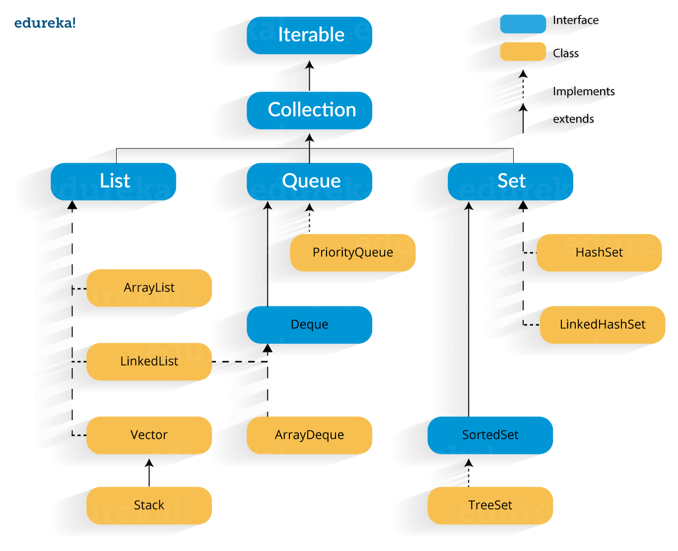

A group of objects in Java is known as collections. Java.util package contains, along with date and time facilities, internationalization, legacy collection classes, etc., the various classes and interfaces for collecting. Alternatively, collections can be considered as a framework designed for storing the objects and manipulating the design in which the objects are stored. You can use collections to perform the following operations on objects:

* Deletion
* Insertion
* Manipulation
* Searching
* Sorting

Following are the various constituents of the collections framework:

* Classes: Array List, Linked List, Lists, and Vector
* Interfaces: Collection, List, Map, Queue, Set, Sorted Map, and Sorted Set
* Maps: HashMap, HashTable, LinkedHashMap, and TreeMap
* Queues: Priority Queue
* Sets: Hash Set, Linked Hash Set, and Tree Set

1. **What are the main differences between array and collection?**

Array and Collection are somewhat similar regarding storing the references of objects and manipulating the data, but they differ in many ways. The main differences between the array and Collection are defined below:

* Arrays are always of fixed size, i.e., a user can not increase or decrease the length of the array according to their requirement or at runtime, but In Collection, size can be changed dynamically as per need.
* Arrays can only store homogeneous or similar type objects, but in Collection, heterogeneous objects can be stored.
* Arrays cannot provide the ready-made methods for user requirements as sorting, searching, etc. but Collection includes readymade methods to use.

1. **Explain various interfaces used in Collection framework?**

Collection framework implements various interfaces, Collection interface and Map interface (java.util.Map) are the mainly used interfaces of Java Collection Framework. List of interfaces of Collection Framework is given below:

* Collection interface: Collection (java.util.Collection) is the primary interface, and every collection must implement this interface.

Syntax:

public interface Collection<E>extends Iterable

Where <E> represents that this interface is of Generic type

* List interface: List interface extends the Collection interface, and it is an ordered collection of objects. It contains duplicate elements. It also allows random access of elements.

Syntax:

public interface List<E> extends Collection<E>

* Set interface: Set (java.util.Set) interface is a collection which cannot contain duplicate elements. It can only include inherited methods of Collection interface

Syntax:

public interface Set<E> extends Collection<E>

* Queue interface: Queue (java.util.Queue) interface defines queue data structure, which stores the elements in the form FIFO (first in first out).

Syntax:

public interface Queue<E> extends Collection<E>

* Dequeue interface: it is a double-ended-queue. It allows the insertion and removal of elements from both ends. It implants the properties of both Stack and queue so it can perform LIFO (Last in first out) stack and FIFO (first in first out) queue, operations.

Syntax:

public interface Dequeue<E> extends Queue<E>

* Map interface: A Map (java.util.Map) represents a key, value pair storage of elements. Map interface does not implement the Collection interface. It can only contain a unique key but can have duplicate elements. There are two interfaces which implement Map in java that are Map interface and Sorted Map.

1. **What is the difference between ArrayList and Vector?**

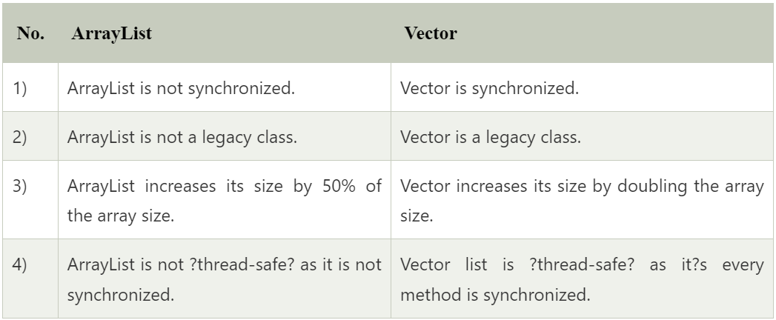





1. **What is the difference between ArrayList and LinkedList?**

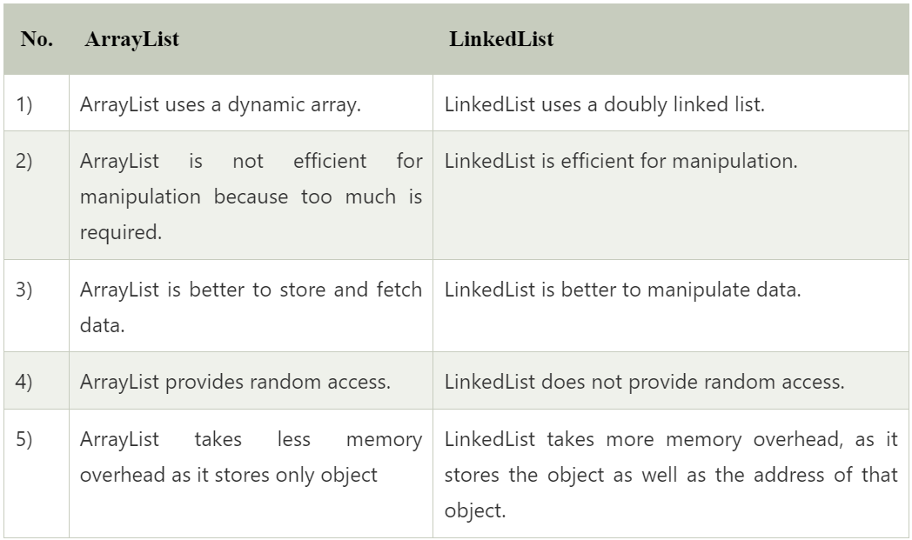

1. **What is the difference between Iterator and ListIterator?**

Iterator traverses the elements in the forward direction only whereas ListIterator traverses the elements into forward and backward direction.

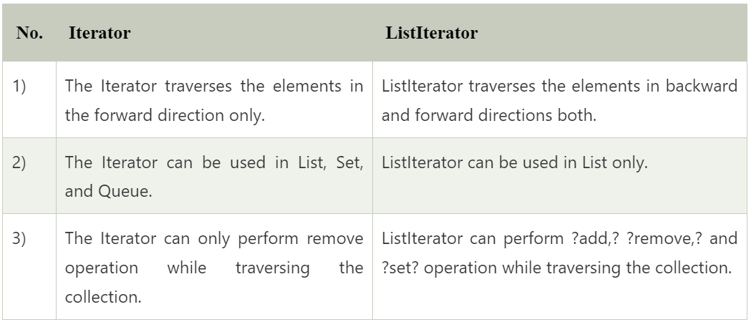

1. **What is the difference between Iterator and Enumeration?**

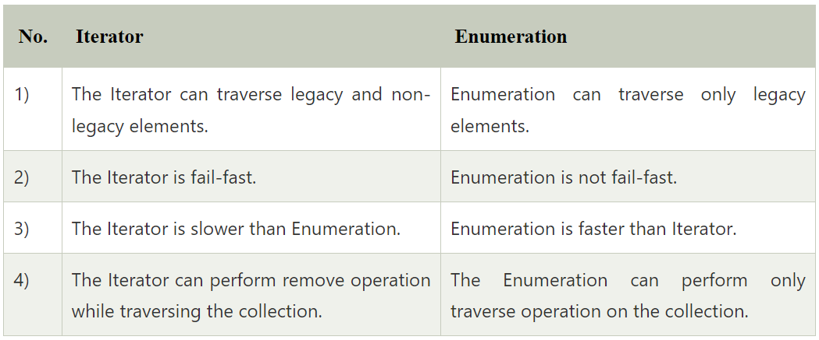

1. **What is the difference between List and Set?**

The List and Set both extend the collection interface. However, there are some differences between the both which are listed below.

* The List can contain duplicate elements whereas Set includes unique items.
* The List is an ordered collection which maintains the insertion order whereas Set is an unordered collection which does not preserve the insertion order.
* The List interface contains a single legacy class which is Vector class whereas Set interface does not have any legacy class.
* The List interface can allow n number of null values whereas Set interface only allows a single null value.

1. **What is the difference between HashSet and TreeSet?**

The HashSet and TreeSet, both classes, implement Set interface. The differences between the both are listed below.

* HashSet maintains no order whereas TreeSet maintains ascending order.
* HashSet impended by hash table whereas TreeSet implemented by a Tree structure.
* HashSet performs faster than TreeSet.
* HashSet is backed by HashMap whereas TreeSet is backed by TreeMap.

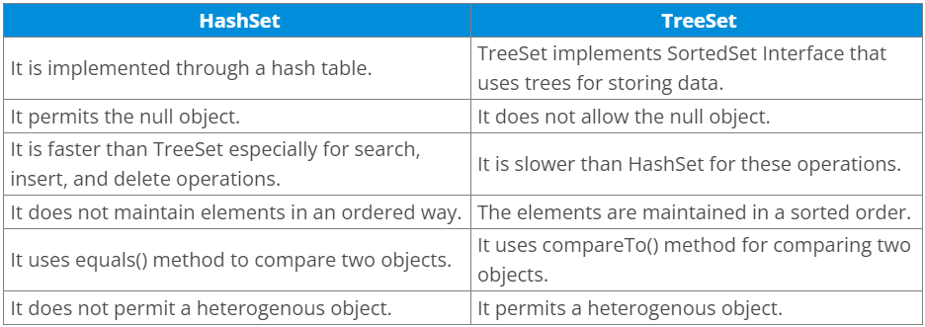

1. **What is the difference between Set and Map?**

The differences between the Set and Map are given below.

* Set contains values only whereas Map contains key and values both.
* Set contains unique values whereas Map can contain unique Keys with duplicate values.
* Set holds a single number of null value whereas Map can include a single null key with n number of null values.

1. **What is the difference between HashSet and HashMap?**

The differences between the HashSet and HashMap are listed below.

* HashSet contains only values whereas HashMap includes the entry (key, value). HashSet can be iterated, but HashMap needs to convert into Set to be iterated.
* HashSet implements Set interface whereas HashMap implements the Map interface
* HashSet cannot have any duplicate value whereas HashMap can contain duplicate values with unique keys.
* HashSet contains the only single number of null value whereas HashMap can hold a single null key with n number of null values.

1. **What is the difference between HashMap and TreeMap?**

The differences between the HashMap and TreeMap are given below.

* HashMap maintains no order, but TreeMap maintains ascending order.
* HashMap is implemented by hash table whereas TreeMap is implemented by a Tree structure.
* HashMap can be sorted by Key or value whereas TreeMap can be sorted by Key.
* HashMap may contain a null key with multiple null values whereas TreeMap cannot hold a null key but can have multiple null values.

1. **What is the difference between HashMap and Hashtable?**

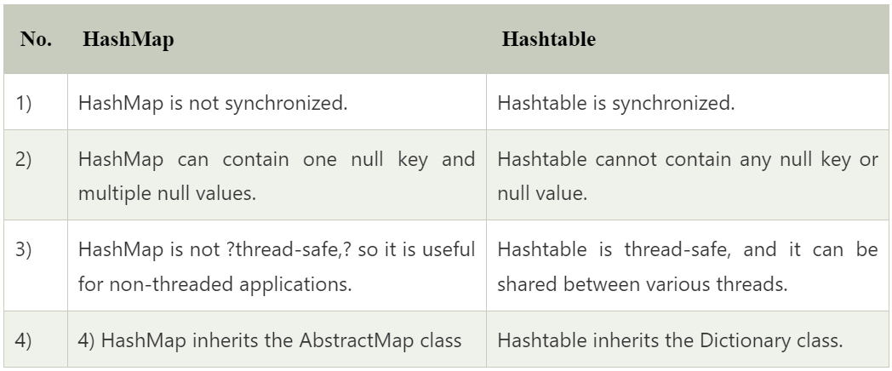

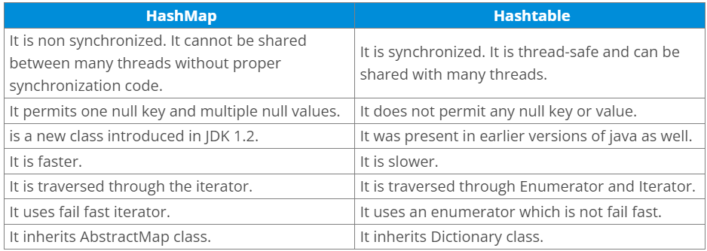

1. **What is the difference between Collection and Collections?**

The differences between the Collection and Collections are given below.

* The Collection is an interface whereas Collections is a class.
* The Collection interface provides the standard functionality of data structure to List, Set, and Queue. However, Collections class is to sort and synchronize the collection elements.
* The Collection interface provides the methods that can be used for data structure whereas Collections class provides the static methods which can be used for various operation on a collection.

1. **What is the difference between Comparable and Comparator?**

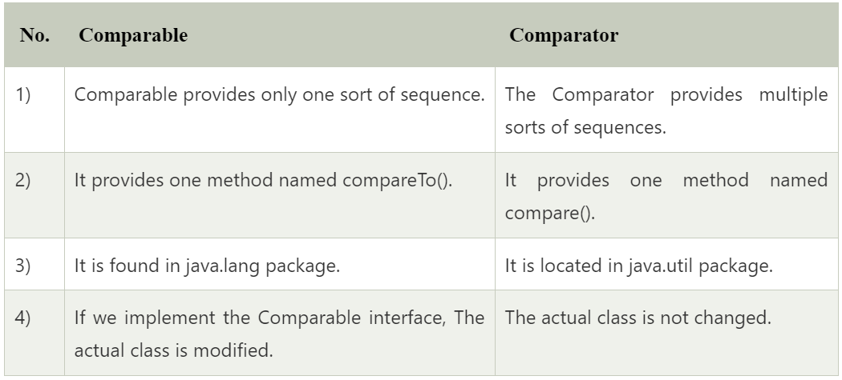

1. **What do you understand by BlockingQueue?**

BlockingQueue is an interface which extends the Queue interface. It provides concurrency in the operations like retrieval, insertion, deletion. While retrieval of any element, it waits for the queue to be non-empty. While storing the elements, it waits for the available space. BlockingQueue cannot contain null elements, and implementation of BlockingQueue is thread-safe.

Syntax:

public interface BlockingQueue<E> extends Queue <E>

1. **What is the advantage of Properties file?**

If you change the value in the properties file, you don't need to recompile the java class. So, it makes the application easy to manage. It is used to store information which is to be changed frequently. Consider the following example.

public static void main(String[] args) throws Exception {

>FileReader reader = new FileReader("db.properties");

>Properties p = new Properties();

>p.load(reader);

>System.out.println(p.getProperty("user"));

>System.out.println(p.getProperty("password"));

}

Output

system

oracle

1. **What does the hashCode() method?**

The hashCode() method returns a hash code value (an integer number).

The hashCode() method returns the same integer number if two keys (by calling equals() method) are identical.

However, it is possible that two hash code numbers can have different or the same keys.

If two objects do not produce an equal result by using the equals() method, then the hashcode() method will provide the different integer result for both the objects.

1. **Why we override equals() method?**

The equals method is used to check whether two objects are the same or not. It needs to be overridden if we want to check the objects based on the property.

For example, Employee is a class that has 3 data members: id, name, and salary. However, we want to check the equality of employee object by the salary. Then, we need to override the equals() method.

1. **How to synchronize List, Set and Map elements?**

Yes, Collections class provides methods to make List, Set or Map elements as synchronized:

public static List synchronizedList(List l){}

public static Set synchronizedSet(Set s){}

public static SortedSet synchronizedSortedSet(SortedSet s){}

public static Map synchronizedMap(Map m){}

public static SortedMap synchronizedSortedMap(SortedMap m){}

1. **What is the advantage of the generic collection?**

There are three main advantages of using the generic collection.

* If we use the generic class, we don't need typecasting.
* It is type-safe and checked at compile time.
* Generic confirms the stability of the code by making it bug detectable at compile time.

1. **What is hash-collision in Hashtable and how it is handled in Java?**

Two different keys with the same hash value are known as hash-collision. Two separate entries will be kept in a single hash bucket to avoid the collision. There are two ways to avoid hash-collision.

* Separate Chaining
* Open Addressing

1. **What is the Dictionary class?**

The Dictionary class provides the capability to store key-value pairs.

1. **What is the default size of load factor in hashing based collection?**

The default size of load factor is 0.75. The default capacity is computed as initial capacity * load factor. For example, 16 * 0.75 = 12. So, 12 is the default capacity of Map.

1. **What do you understand by fail-fast?**

The Iterator in java which immediately throws ConcurrentmodificationException, if any structural modification occurs in, is called as a Fail-fast iterator. Fail-fats iterator does not require any extra space in memory.

1. **What is the difference between Array and ArrayList?**

The main differences between the Array and ArrayList are given below.

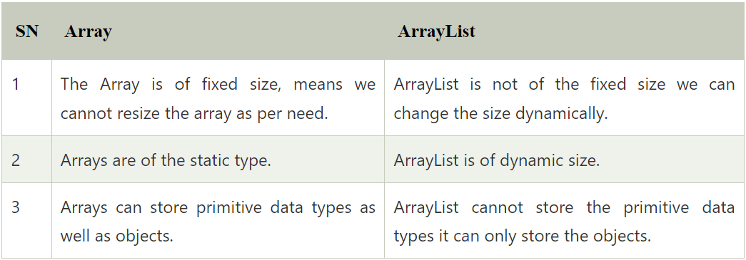

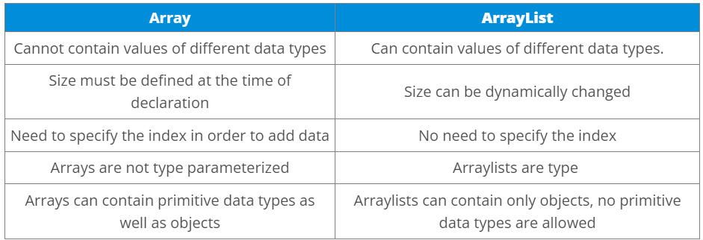

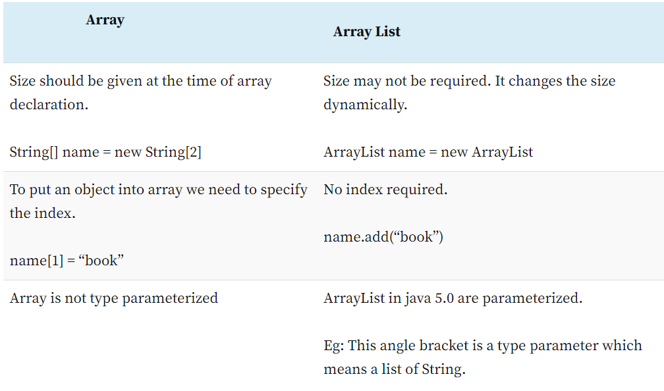

1. **What is the difference between the length of an Array and size of ArrayList?**

The length of an array can be obtained using the property of length whereas ArrayList does not support length property, but we can use size() method to get the number of objects in the list.

Finding the length of the array

Int [] array = new int[4];

System.out.println("The size of the array is " + array.length);

Finding the size of the ArrayList

ArrayList<String> list=new ArrayList<String>();>

list.add("ankit");>

list.add("nippun");

System.out.println(list.size());

1. **How to convert ArrayList to Array and Array to ArrayList?**

We can convert an Array to ArrayList by using the asList() method of Arrays class. asList() method is the static method of Arrays class and accepts the List object. Consider the following syntax:

Arrays.asList(item)

We can convert an ArrayList to Array using toArray() method of the ArrayList class. Consider the following syntax to convert the ArrayList to the List object.

List_object.toArray(new String[List_object.size()])

1. **How to make Java ArrayList Read-Only?**

We can obtain java ArrayList Read-only by calling the Collections.unmodifiableCollection() method. When we define an ArrayList as Read-only then we cannot perform any modification in the collection through add(), remove() or set() method.

1. **How to remove duplicates from ArrayList?**

There are two ways to remove duplicates from the ArrayList.

* Using HashSet: By using HashSet we can remove the duplicate element from the ArrayList, but it will not then preserve the insertion order.
* Using LinkedHashSet: We can also maintain the insertion order by using LinkedHashSet instead of HashSet.

The Process to remove duplicate elements from ArrayList using the LinkedHashSet:

* Copy all the elements of ArrayList to LinkedHashSet.
* Empty the ArrayList using clear() method, which will remove all the elements from the list.
* Now copy all the elements of LinkedHashset to ArrayList.

1. **How to reverse ArrayList?**

To reverse an ArrayList, we can use reverse() method of Collections class. Consider the following example.

public class ReverseArrayList {

>public static void main(String[] args) {

>>List list = new ArrayList < > ();

>>list.add(10);

>>list.add(50);

>>list.add(30);

>>Iterator i = list.iterator();

>>System.out.println("printing the list....");

>>while (i.hasNext()) {

>>>System.out.println(i.next());

>>}

>>Iterator i2 = list.iterator();

>>Collections.reverse(list);

>>System.out.println("printing list in reverse order....");

>>while (i2.hasNext()) {

>>>System.out.println(i2.next());

>>}

>}

}

Output

printing the list....

10

50

30

printing list in reverse order....

30

50

10

1. **How to sort ArrayList in descending order?**

To sort the ArrayList in descending order, we can use the reverseOrder method of Collections class. Consider the following example.

public class ReverseArrayList {

>public static void main(String[] args) {

>>List list = new ArrayList < > ();

>>list.add(10);

>>list.add(50);

>>list.add(30);

>>list.add(60);

>>list.add(20);

>>list.add(90);

>>Iterator i = list.iterator();

>>System.out.println("printing the list....");

>>while (i.hasNext()) {

>>>System.out.println(i.next());

>>}

>>Comparator cmp = Collections.reverseOrder();

>>Collections.sort(list, cmp);

>>System.out.println("printing list in descending order....");

>>Iterator i2 = list.iterator();

>>while (i2.hasNext()) {

>>>System.out.println(i2.next());

>>}

>}

}

Output

printing the list....

10

50

30

60

20

90

printing list in descending order....

90

60

50

30

20

10

1. **How to synchronize ArrayList?**

We can synchronize ArrayList in two ways.

* Using Collections.synchronizedList() method
* Using CopyOnWriteArrayList<T>

1. **When to use ArrayList and LinkedList?**

LinkedLists are better to use for the update operations whereas ArrayLists are better to use for the search operations.

1. **What is JDBC?**

JDBC is a Java API that is used to connect and execute the query to the database. JDBC API uses JDBC drivers to connect to the database. JDBC API can be used to access tabular data stored into any relational database.

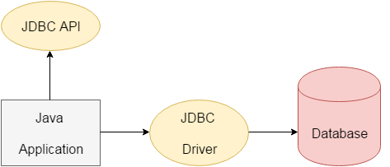

1. **What is JDBC Driver?**

JDBC Driver is a software component that enables Java application to interact with the database. There are 4 types of JDBC drivers:

* JDBC-ODBC bridge driver: The JDBC-ODBC bridge driver uses the ODBC driver to connect to the database. The JDBC-ODBC bridge driver converts JDBC method calls into the ODBC function calls. This is now discouraged because of the thin driver. It is easy to use and can be easily connected to any database.
* Native-API driver (partially java driver): The Native API driver uses the client-side libraries of the database. The driver converts JDBC method calls into native calls of the database API. It is not written entirely in Java. Its performance is better than JDBC-ODBC bridge driver. However, the native driver must be installed on each client machine.
* Network Protocol driver (fully java driver): The Network Protocol driver uses middleware (application server) that converts JDBC calls directly or indirectly into the vendor-specific database protocol. It is entirely written in Java. There is no requirement of the client-side library because of the application server that can perform many tasks like auditing, load balancing, logging, etc.
* Thin driver (fully java driver): The thin driver converts JDBC calls directly into the vendor-specific database protocol. That is why it is known as the thin driver. It is entirely written in Java language. Its performance is better than all other drivers however these drivers depend upon the database.

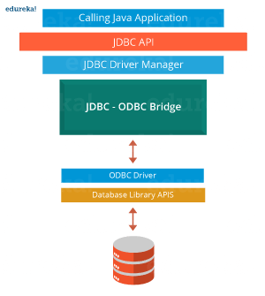

1. **What are the steps to connect to the database in java?**

The following steps are used in database connectivity.

* Registering the driver class:

The forName() method of the Class class is used to register the driver class. This method is used to load the driver class dynamically. Consider the following example to register OracleDriver class.

Class.forName("oracle.jdbc.driver.OracleDriver");

* Creating connection:

The getConnection() method of DriverManager class is used to establish the connection with the database. The syntax of the getConnection() method is given below.

* + public static Connection getConnection(String url)throws SQLException
  + public static Connection getConnection(String url,String name,String password)

throws SQLException

Consider the following example to establish the connection with the Oracle database.

Connection con=DriverManager.getConnection(

"jdbc:oracle:thin:@localhost:1521:xe","system","password");

* Creating the statement:

The createStatement() method of Connection interface is used to create the Statement. The object of the Statement is responsible for executing queries with the database.

public Statement createStatement()throws SQLException

consider the following example to create the statement object

Statement stmt=con.createStatement();

* Executing the queries:

The executeQuery() method of Statement interface is used to execute queries to the database. This method returns the object of ResultSet that can be used to get all the records of a table.

Syntax of executeQuery() method is given below.

public ResultSet executeQuery(String sql)throws SQLException

Example to execute the query

ResultSet rs=stmt.executeQuery("select * from emp");

while(rs.next()){

System.out.println(rs.getInt(1)+" "+rs.getString(2));

}

However, to perform the insert and update operations in the database, executeUpdate() method is used which returns the boolean value to indicate the successful completion of the operation.

* Closing connection:

By closing connection, object statement and ResultSet will be closed automatically. The close() method of Connection interface is used to close the connection.

Syntax of close() method is given below.

public void close()throws SQLException

Consider the following example to close the connection.

con.close();

1. **What are the JDBC API components?**

The java.sql package contains following interfaces and classes for JDBC API.

Interfaces:

* Connection: The Connection object is created by using getConnection() method of DriverManager class. DriverManager is the factory for connection.
* Statement: The Statement object is created by using createStatement() method of Connection class. The Connection interface is the factory for Statement.
* PreparedStatement: The PrepareStatement object is created by using prepareStatement() method of Connection class. It is used to execute the parameterized query.
* ResultSet: The object of ResultSet maintains a cursor pointing to a row of a table. Initially, cursor points before the first row. The executeQuery() method of Statement interface returns the ResultSet object.
* ResultSetMetaData: The object of ResultSetMetaData interface cotains the information about the data (table) such as numer of columns, column name, column type, etc. The getMetaData() method of ResultSet returns the object of ResultSetMetaData.
* DatabaseMetaData: DatabaseMetaData interface provides methods to get metadata of a database such as the database product name, database product version, driver name, name of the total number of tables, the name of the total number of views, etc. The getMetaData() method of Connection interface returns the object of DatabaseMetaData.
* CallableStatement: CallableStatement interface is used to call the stored procedures and functions. We can have business logic on the database through the use of stored procedures and functions that will make the performance better because these are precompiled. The prepareCall() method of Connection interface returns the instance of CallableStatement.

Classes:

* DriverManager: The DriverManager class acts as an interface between the user and drivers. It keeps track of the drivers that are available and handles establishing a connection between a database and the appropriate driver. It contains several methods to keep the interaction between the user and drivers.
* Blob: Blob stands for the binary large object. It represents a collection of binary data stored as a single entity in the database management system.
* Clob: Clob stands for Character large object. It is a data type that is used by various database management systems to store character files. It is similar to Blob except for the difference that BLOB represent binary data such as images, audio and video files, etc. whereas Clob represents character stream data such as character files, etc.
* SQLException It is an Exception class which provides information on database access errors.

1. **What are the JDBC statements?**

In JDBC, Statements are used to send SQL commands to the database and receive data from the database. There are various methods provided by JDBC statements such as execute(), executeUpdate(), executeQuery, etc. which helps you to interact with the database.

There is three type of JDBC statements given in the following table.

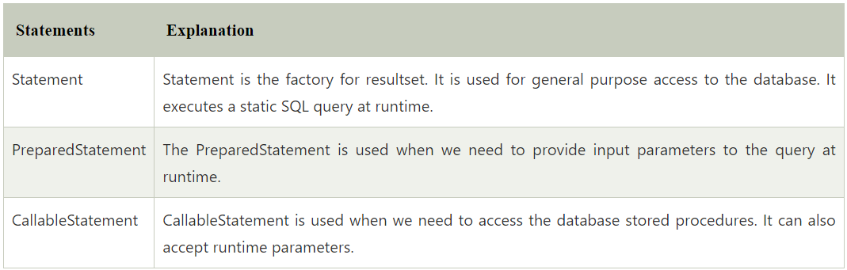

1. **What is the return type of Class.forName() method?**

The Class.forName() method returns the object of java.lang.Class object.

1. **What are the differences between Statement and PreparedStatement interface?**

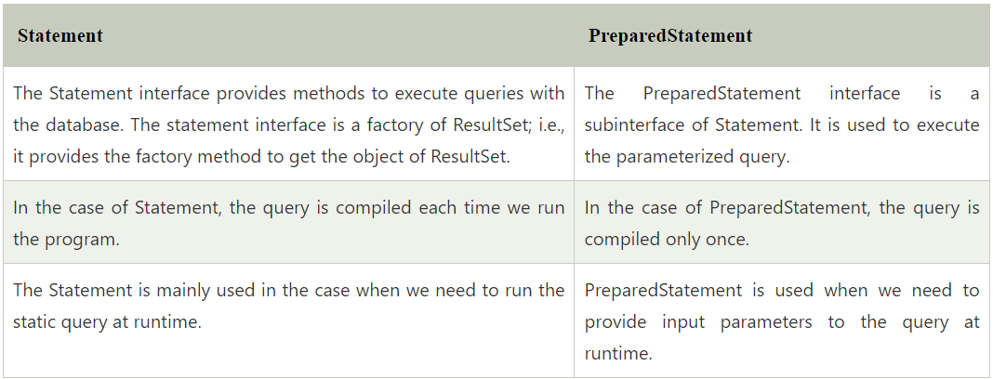

1. **How can we set null value in JDBC PreparedStatement?**

By using setNull() method of PreparedStatement interface, we can set the null value to an index. The syntax of the method is given below.

void setNull(int parameterIndex, int sqlType) throws SQLException

1. **What are the benefits of PreparedStatement over Statement?**

The benefits of using PreparedStatement over Statement interface is given below.

* The PreparedStatement performs faster as compare to Statement because the Statement needs to be compiled everytime we run the code whereas the PreparedStatement compiled once and then execute only on runtime.
* PreparedStatement can execute Parameterized query whereas Statement can only run static queries.
* The query used in PreparedStatement is appeared to be similar every time. Therefore, the database can reuse the previous access plan whereas, Statement inline the parameters into the String, therefore, the query doesn't appear to be same everytime which prevents cache reusage.

1. **What are the differences between execute, executeQuery, and executeUpdate?**

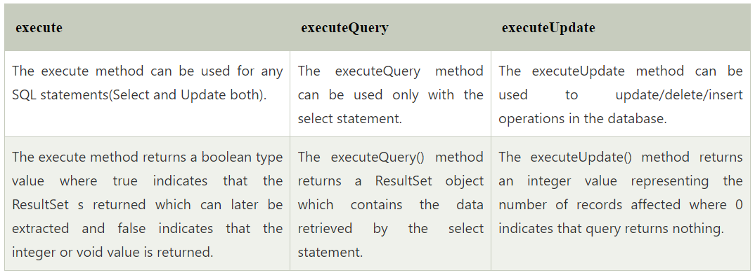

* Statement execute(String query) is used to execute any SQL query and it returns TRUE if the result is an ResultSet such as running Select queries. The output is FALSE when there is no ResultSet object such as running Insert or Update queries. We can use getResultSet() to get the ResultSet and getUpdateCount() method to retrieve the update count.
* Statement executeQuery(String query) is used to execute Select queries and returns the ResultSet. ResultSet returned is never null even if there are no records matching the query. When executing select queries we should use executeQuery method so that if someone tries to execute insert/update statement it will throw java.sql.SQLException with message “executeQuery method can not be used for update”.
* Statement executeUpdate(String query) is used to execute Insert/Update/Delete (DML) statements or DDL statements that returns nothing. The output is int and equals to the row count for SQL Data Manipulation Language (DML) statements. For DDL statements, the output is 0.

You should use execute() method only when you are not sure about the type of statement else use executeQuery or executeUpdate method.

1. **What are the different types of ResultSet?**

ResultSet is categorized by the direction of the reading head and sensitivity or insensitivity of the result provided by it. There are three general types of ResultSet.

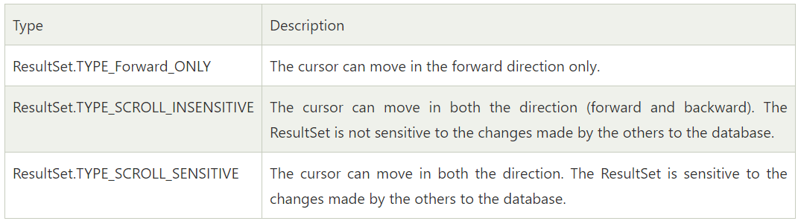

1. **What are the differences between ResultSet and RowSet?**

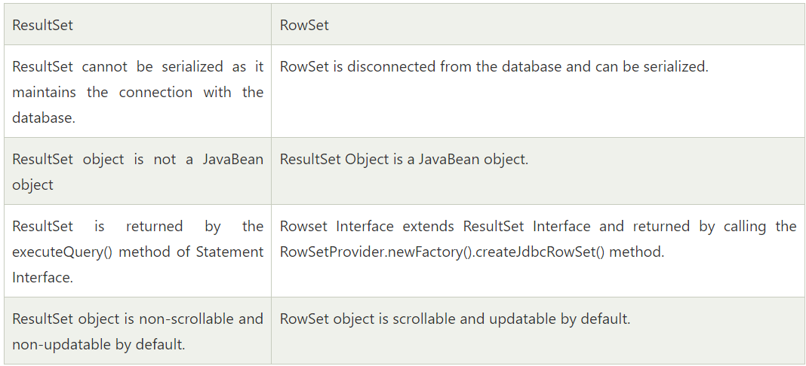

1. **How can we execute stored procedures using CallableStatement?**

Following are the steps to create and execute stored procedures. Here, we are creating a table user420 by using a stored procedure and inserting values into it.

* Create the procedure in the database.

To call the stored procedure, you need to create it in the database. Here, we are assuming that the stored procedure looks like this.

create or replace procedure "INSERTR"

(id IN NUMBER,

name IN VARCHAR2)

is

begin

insert into user420 values(id,name);

end;

/>

The table structure is given below:

create table user420(id number(10), name varchar2(200));

* Establish a network connection.

Class.forName("oracle.jdbc.driver.OracleDriver");

Connection con=DriverManager.getConnection(

"jdbc:oracle:thin:@localhost:1521:xe","system","oracle");

* Create the Object of CallableStatement.

CallableStatement stmt=con.prepareCall("{call insertR(?,?)}");

* Provide the values and execute the query by using the following syntax.

stmt.setInt(1,1011);

stmt.setString(2,"Amit");

stmt.execute();

* Check the database; the values will be found there. However, the complete code will look like the following.

public class Proc {

>public static void main(String[] args) throws Exception {

>>Class.forName("oracle.jdbc.driver.OracleDriver");

>>Connection con = DriverManager.getConnection(

>>"jdbc:oracle:thin:@localhost:1521:xe", "system", "oracle");

>>CallableStatement stmt = con.prepareCall("{call insertR(?,?)}");

>>stmt.setInt(1, 1011);

>>stmt.setString(2, "Amit");

>>stmt.execute();

>>System.out.println("success");

>}

}

1. **What is the role of the JDBC DriverManager class?**

The DriverManager class acts as an interface between user and drivers. It keeps track of the drivers that are available and handles establishing a connection between a database and the appropriate driver. The DriverManager class maintains a list of Driver classes that have registered themselves by calling the method DriverManager.registerDriver().

1. **What are the functions of the JDBC Connection interface?**

The Connection interface maintains a session with the database. It can be used for transaction management. It provides factory methods that return the instance of Statement, PreparedStatement, CallableStatement, and DatabaseMetaData.

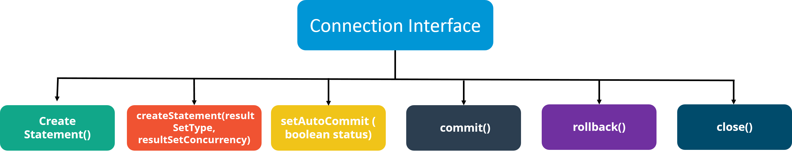

1. **What does the JDBC ResultSet interface?**

The ResultSet object represents a row of a table. It can be used to change the cursor pointer and get the information from the database. By default, ResultSet object can move in the forward direction only and is not updatable. However, we can make this object to move the forward and backward direction by passing either TYPE_SCROLL_INSENSITIVE or TYPE_SCROLL_SENSITIVE in createStatement(int, int) method.

1. **What does the JDBC ResultSetMetaData interface?**

The ResultSetMetaData interface returns the information of table such as the total number of columns, column name, column type, etc.

1. **What does the JDBC DatabaseMetaData interface?**

The DatabaseMetaData interface returns the information of the database such as username, driver name, driver version, number of tables, number of views, etc. Consider the following example.

class Dbmd {

>public static void main(String args[]) {

>>try {

>>>Class.forName("oracle.jdbc.driver.OracleDriver");

>>>Connection con = DriverManager.getConnection(

>>>>"jdbc:oracle:thin:@localhost:1521:xe", "system", "oracle");

>>>DatabaseMetaData dbmd = con.getMetaData();

>>>System.out.println("Driver Name: " + dbmd.getDriverName());

>>>System.out.println("Driver Version: " + dbmd.getDriverVersion());

>>>System.out.println("UserName: " + dbmd.getUserName());

>>>System.out.println("Database Product Name: " + dbmd.getDatabaseProductName());

>>>System.out.println("Database Product Version: " + dbmd.getDatabaseProductVersion());

>>>con.close();

>>} catch (Exception e) {

>>>System.out.println(e);

>>}

>}

}

Output

Driver Name: Oracle JDBC Driver

Driver Version: 10.2.0.1.0XE

Database Product Name: Oracle

Database Product Version: Oracle Database 10g Express Edition Release 10.2.0.1.0 -Production

1. **Which interface is responsible for transaction management in JDBC?**

The Connection interface provides methods for transaction management such as commit(), rollback() etc.

1. **What is batch processing and how to perform batch processing in JDBC?**

By using the batch processing technique in JDBC, we can execute multiple queries. It makes the performance fast. The java.sql.Statement and java.sql.PreparedStatement interfaces provide methods for batch processing. The batch processing in JDBC requires the following steps.

* Load the driver class
* Create Connection
* Create Statement
* Add query in the batch
* Execute the Batch
* Close Connection

Consider the following example to perform batch processing using the Statement interface.

class FetchRecords {

>public static void main(String args[]) throws Exception {

>>Class.forName("oracle.jdbc.driver.OracleDriver");

>>Connection con = DriverManager.getConnection("jdbc:oracle:thin:@localhost:1521:xe", "system", "oracle");

>>con.setAutoCommit(false);

>>Statement stmt = con.createStatement();

>>stmt.addBatch("insert into user420 values(190,'abhi',40000)");

>>stmt.addBatch("insert into user420 values(191,'umesh',50000)");

>>stmt.executeBatch(); //executing the batch

>>con.commit();

>>con.close();

>}

}

1. **What are CLOB and BLOB data types in JDBC?**

BLOB: Blob can be defined as the variable-length, binary large object which is used to hold the group of Binary data such as voice, images, and mixed media. It can hold up to 2GB data on MySQL database and 128 GB on Oracle database. BLOB is supported by many databases such as MySQL, Oracle, and DB2 to store the binary data (images, video, audio, and mixed media).

CLOB: Clob can be defined as the variable-length, character-large object which is used to hold the character-based data such as files in many databases. It can hold up to 2 GB on MySQL database, and 128 GB on Oracle Database. A CLOB is considered as a character string.

1. **What are the different types of lockings in JDBC?**

A lock is a certain type of software mechanism by using which, we can restrict other users from using the data resource. There are four type of locks given in JDBC that are described below.

* Row and Key Locks: These type of locks are used when we update the rows.
* Page Locks: These type of locks are applied to a page. They are used in the case, where a transaction remains in the process and is being updated, deleting, or inserting some data in a row of the table. The database server locks the entire page that contains the row. The page lock can be applied once by the database server.
* Table locks: Table locks are applied to the table. It can be applied in two ways, i.e., shared and exclusive. Shared lock lets the other transactions to read the table but not update it. However, The exclusive lock prevents others from reading and writing the table.
* Database locks: The Database lock is used to prevent the read and update access from other transactions when the database is open.

1. **How can we store and retrieve images from the database?**

By using the PreparedStatement interface, we can store and retrieve images. Create a table which contains two columns namely NAME and PHOTO.

CREATE TABLE "IMGTABLE"

(>"NAME" VARCHAR2(4000),

>"PHOTO" BLOB

)

Consider the following example to store the image in the database.

public class InsertImage {

>public static void main(String[] args) {

>>try {

>>>Class.forName("oracle.jdbc.driver.OracleDriver");

>>>Connection con = DriverManager.getConnection(

>>>>"jdbc:oracle:thin:@localhost:1521:xe", "system", "oracle");

>>>PreparedStatement ps = con.prepareStatement("insert into imgtable values(?,?)");

>>>ps.setString(1, "sonoo");

>>>FileInputStream fin = new FileInputStream("d:\\g.jpg");

>>>ps.setBinaryStream(2, fin, fin.available());

>>>int i = ps.executeUpdate();

>>>System.out.println(i + " records affected");

>>>con.close();

>>} catch (Exception e) {

>>>e.printStackTrace();

>>}

>}

}

Consider the following example to retrieve the image from the table.

public class RetrieveImage {

>public static void main(String[] args) {

>>try {

>>>Class.forName("oracle.jdbc.driver.OracleDriver");

>>>Connection con = DriverManager.getConnection(

>>>>"jdbc:oracle:thin:@localhost:1521:xe", "system", "oracle");

>>>PreparedStatement ps = con.prepareStatement("select * from imgtable");

>>>ResultSet rs = ps.executeQuery();

>>>if (rs.next()) { //now on 1st row

>>>>Blob b = rs.getBlob(2); //2 means 2nd column data

>>>>byte barr[] = b.getBytes(1, (int) b.length()); //1 means first image

>>>>FileOutputStream fout = new FileOutputStream("d:\\sonoo.jpg");

>>>>fout.write(barr);

>>>>fout.close();

>>>} //end of if

>>>System.out.println("ok");

>>>con.close();

>>} catch (Exception e) {

>>>e.printStackTrace();

>>}

>}

}

1. **How can we store the file in the Oracle database?**

The setCharacterStream() method of PreparedStatement interface is used to set character information into the parameterIndex. For storing the file into the database, CLOB (Character Large Object) datatype is used in the table. For example:

CREATE TABLE "FILETABLE"

(>"ID" NUMBER,

>"NAME" CLOB

)

Java Code

public class StoreFile {

>public static void main(String[] args) {

>>try {

>>>Class.forName("oracle.jdbc.driver.OracleDriver");

>>>Connection con = DriverManager.getConnection(

>>>>"jdbc:oracle:thin:@localhost:1521:xe", "system", "oracle");

>>>PreparedStatement ps = con.prepareStatement(

>>>>"insert into filetable values(?,?)");

>>>File f = new File("d:\\myfile.txt");

>>>FileReader fr = new FileReader(f);

>>>ps.setInt(1, 101);

>>>ps.setCharacterStream(2, fr, (int) f.length());

>>>int i = ps.executeUpdate();

>>>System.out.println(i + " records affected");

>>>con.close();

>>} catch (Exception e) {

>>>e.printStackTrace();

>>}

>}

}

1. **How can we retrieve the file in the Oracle database?**

The getClob() method of PreparedStatement is used to get file information from the database. Let's see the table structure of the example to retrieve the file.

CREATE TABLE "FILETABLE"

(>"ID" NUMBER,

>"NAME" CLOB

)

The example to retrieve the file from the Oracle database is given below.

public class RetrieveFile {

>public static void main(String[] args) {

>>try {

>>>Class.forName("oracle.jdbc.driver.OracleDriver");

>>>Connection con = DriverManager.getConnection(

>>>>"jdbc:oracle:thin:@localhost:1521:xe", "system", "oracle");

>>>PreparedStatement ps = con.prepareStatement("select * from filetable");

>>>ResultSet rs = ps.executeQuery();

>>>rs.next(); //now on 1st row

>>>Clob c = rs.getClob(2);

>>>Reader r = c.getCharacterStream();

>>>FileWriter fw = new FileWriter("d:\\retrivefile.txt");

>>>int i;

>>>while ((i = r.read()) != -1)

>>>>fw.write((char) i);

>>>fw.close();

>>>con.close();

>>>System.out.println("success");

>>} catch (Exception e) {

>>>e.printStackTrace();

>>}

>}

}

1. **What are the differences between stored procedure and functions?**

The differences between stored procedures and functions are given below:

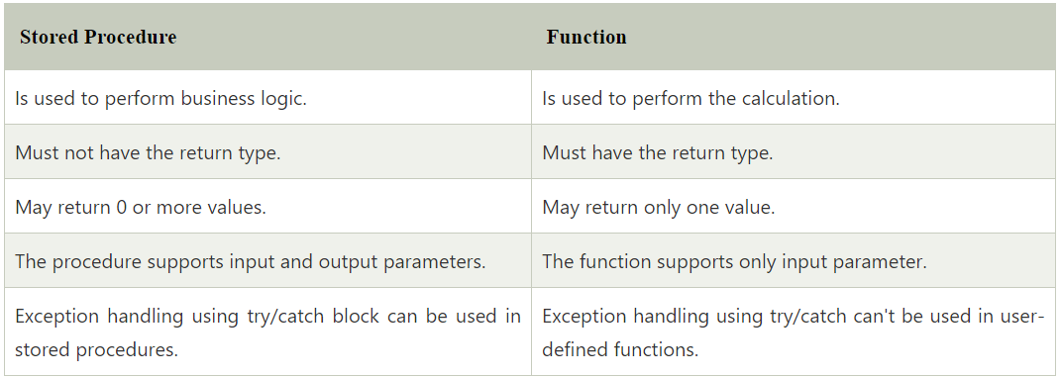

1. **How can we maintain the integrity of a database by using JDBC?**

To maintain the integrity of a database, we need to ensure the ACID properties. ACID properties mean Atomicity, Consistency, Isolation, and durability. In JDBC, Connection interface provides methods like setAutoCommit(), commit(), and rollback() which can be used to manage transaction. Let's see an example of transaction management in JDBC.

class FetchRecords {

>public static void main(String args[]) throws Exception {

>>Class.forName("oracle.jdbc.driver.OracleDriver");

>>Connection con = DriverManager.getConnection("jdbc:oracle:thin:@localhost:1521:xe", "system", "oracle");

>>con.setAutoCommit(false);

>>Statement stmt = con.createStatement();

>>stmt.executeUpdate("insert into user420 values(190,'abhi',40000)");

>>stmt.executeUpdate("insert into user420 values(191,'umesh',50000)");

>>con.commit();

>>con.close();

>}

}

1. **What is the JDBC Rowset?**

JDBC Rowset is the wrapper of ResultSet. It holds tabular data like ResultSet, but it is easy and flexible to use. The implementation classes of RowSet interface are as follows:

* JdbcRowSet
* CachedRowSet
* WebRowSet
* JoinRowSet
* FilteredRowSet

1. **What is the major difference between java.util.Date and java.sql.Date data type?**

The major difference between java.util.Date and java.sql.Date is that, java.sql.Date represents date without time information whereas, java.util.Date represents both date and time information.

1. **What does JDBC setMaxRows method do?**

The setMaxRows(int i) method limits the number of rows the database can return by using the query. This can also be done within the query as we can use the limit cause in MySQL.

[Top Core Java Interview Questions and Answers in 2024 (edureka.co)](https://www.edureka.co/blog/interview-questions/java-interview-questions/)

1. **Explain public static void main(String args[]) in Java.**

* main() in Java is the entry point for any Java program. It is always written as public static void main(String[] args).
* public: Public is an access modifier, which is used to specify who can access this method. Public means that this Method will be accessible by any Class.
* static: It is a keyword in java which identifies it is class-based. main() is made static in Java so that it can be accessed without creating the instance of a Class. In case, main is not made static then the compiler will throw an error as main() is called by the JVM before any objects are made and only static methods can be directly invoked via the class.
* void: It is the return type of the method. Void defines the method which will not return any value.
* main: It is the name of the method which is searched by JVM as a starting point for an application with a particular signature only. It is the method where the main execution occurs.
* String args[]: It is the parameter passed to the main method.

1. **Why pointers are not used in Java?**

Java doesn’t use pointers because they are unsafe and increases the complexity of the program. Since, Java is known for its simplicity of code, adding the concept of pointers will be contradicting. Moreover, since JVM is responsible for implicit memory allocation, thus in order to avoid direct access to memory by the user, pointers are discouraged in Java.

1. **What are access modifiers in Java?**

In Java, access modifiers are special keywords which are used to restrict the access of a class, constructor, data member and method in another class. Java supports four types of access modifiers:

* Default
* Private
* Protected
* Public

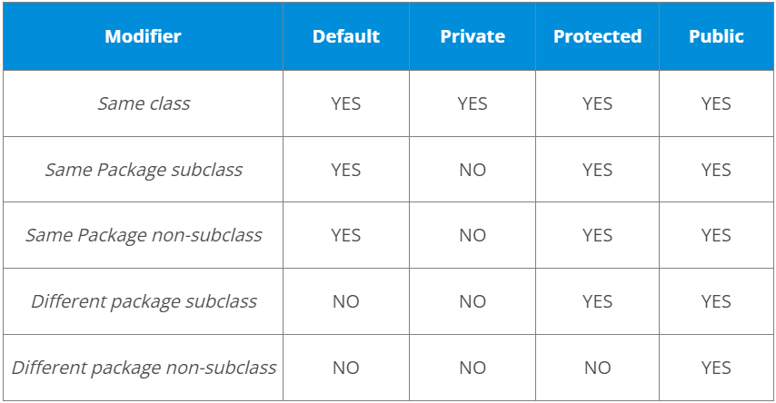

1. **Define a Java Class.**

All Java codes are defined in a Class. It has variables and methods.

Variables are attributes which define the state of a class.

Methods is a place where the exact business logic has to be done. It contains a set of statements (or) instructions to satisfy the particular requirement.

public class Addition { //Class name declaration

>int a = 5; //Variable declaration

>int b = 5;

>public void add() { //Method declaration

>>int c = a + b;

>}

}

1. **What is Object Oriented Programming?**

Object-oriented programming or popularly known as OOPs is a programming model or approach where the programs are organized around objects rather than logic and functions. In other words, OOP mainly focuses on the objects that are required to be manipulated instead of logic. This approach is ideal for the programs large and complex codes and needs to be actively updated or maintained.

1. **What are the main concepts of OOPs in Java?**

Object-Oriented Programming or OOPs is a programming style that is associated with concepts like:

* Inheritance: Inheritance is a process where one class acquires the properties of another.
* Encapsulation: Encapsulation in Java is a mechanism of wrapping up the data and code together as a single unit.
* Abstraction: Abstraction is the methodology of hiding the implementation details from the user and only providing the functionality to the users.
* Polymorphism: Polymorphism is the ability of a variable, function or object to take multiple forms.

1. **What is the difference between break and continue statements?**

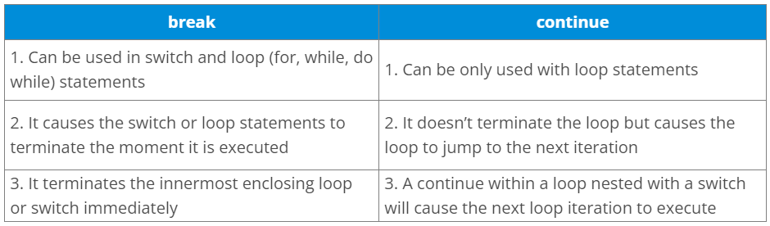

Example break:

for (int i = 0; i < 5; i++) {

>if (i == 3) {

>>break;

>}

>System.out.println(i);

}

Example continue:

for (int i = 0; i < 5; i++) {

>if (i == 2) {

>>continue;

>}

>System.out.println(i);

}

1. **Differentiate between static and non-static methods in Java.**

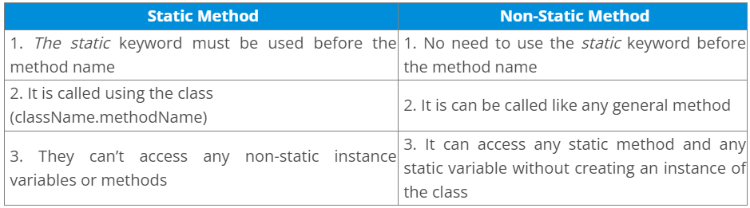

1. **What is constructor chaining in Java?**

In Java, constructor chaining is the process of calling one constructor from another with respect to the current object. Constructor chaining is possible only through legacy where a subclass constructor is responsible for invoking the superclass’ constructor first. There could be any number of classes in the constructor chain. Constructor chaining can be achieved in two ways:

* Within the same class using this()
* From base class using super()

1. **What is a Map in Java?**

In Java, Map is an interface of Util package which maps unique keys to values. The Map interface is not a subset of the main Collection interface and thus it behaves little different from the other collection types. Below are a few of the characteristics of Map interface:

* Map doesn’t contain duplicate keys.
* Each key can map at max one value.

Map cares about the unique identifier. We can map a unique key to a specific value. It is a key/value pair. We can search a value, based on the key. Like the set, the map also uses the “equals ( )” method to determine whether two keys are the same or different.

Map is of following types:

* Hash Map:
  + Unordered and unsorted map.
  + Hashmap is a good choice when we don’t care about the order.
  + It allows one null key and multiple null values.

Example:

Public class Fruit {

>Public static void main(String[] args) {

>>HashMap < Sting, String > names = new HashMap < String, String > ();

>>names.put(“key1”, “cherry”);

>>names.put(“key2”, “banana”);

>>names.put(“key3”, “apple”);

>>names.put(“key4”, “kiwi”);

>>names.put(“key1”, “cherry”);

>>System.out.println(names);

>}

}

Output:

{key2 =banana, key1=cherry, key4 =kiwi, key3= apple}

Duplicate keys are not allowed in Map.

It doesn’t maintain any insertion order and is unsorted.

* Hash Table:
  + Like the vector key, methods of the class are synchronized.
  + Thread safety and therefore slows the performance.
  + It doesn’t allow anything that is null.

Example:

public class Fruit {

>public static void main(String[] args) {

>>Hashtable < Sting, String > names = new Hashtable < String, String > ();

>>names.put(“key1”, “cherry”);

>>names.put(“key2”, “apple”);

>>names.put(“key3”, “banana”);

>>names.put(“key4”, “kiwi”);

>>names.put(“key2”, “orange”);

>>System.out.println(names);

>}

}

Output:

{key2=apple, key1=cherry,key4=kiwi, key3=banana}

Duplicate keys are not allowed.

* Linked Hash Map:
  + Maintains insertion order.
  + Slower than Hash map.
  + I can expect a faster iteration.

Example:

public class Fruit {

>public static void main(String[] args) {

>>LinkedHashMap < Sting, String > names = new LinkedHashMap < String, String > ();

>>names.put(“key1”, “cherry”);

>>names.put(“key2”, “apple”);

>>names.put(“key3”, “banana”);

>>names.put(“key4”, “kiwi”);

>>names.put(“key2”, “orange”);

>>System.out.println(names);

>}

}

Output:

{key2=apple, key1=cherry,key4=kiwi, key3=banana}

Duplicate keys are not allowed.

* TreeMap:
  + Sorted Map.
  + Like Tree set, we can construct a sort order with the constructor.

Example:

public class Fruit {

>public static void main(String[] args) {

>>TreeMap < Sting, String > names = new TreeMap < String, String > ();

>>names.put(“key1”, “cherry”);

>>names.put(“key2”, “banana”);

>>names.put(“key3”, “apple”);

>>names.put(“key4”, “kiwi”);

>>names.put(“key2”, “orange”);

>>System.out.println(names);

>}

}

Output:

{key1=cherry, key2=banana, key3 =apple, key4=kiwi}

It is sorted in ascending order based on the key. Duplicate keys are not allowed.

1. **What is Polymorphism?**

Polymorphism is briefly described as “one interface, many implementations”. Polymorphism is a characteristic of being able to assign a different meaning or usage to something in different contexts – specifically, to allow an entity such as a variable, a function, or an object to have more than one form. There are two types of polymorphism:

* Compile time polymorphism
* Run time polymorphism

Compile time polymorphism is method overloading whereas Runtime time polymorphism is done using inheritance and interface.

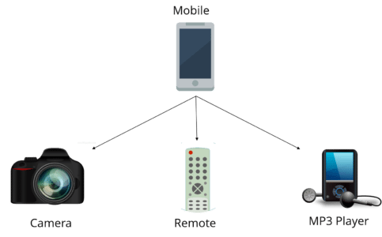

1. **What is composition in Java?**

Composition is again a specialized form of Aggregation and we can call this as a “death” relationship. It is a strong type of Aggregation. Child object does not have their lifecycle and if parent object deletes all child object will also be deleted. Let’s take again an example of a relationship between House and rooms. House can contain multiple rooms there is no independent life of room and any room can not belongs to two different houses if we delete the house room will automatically delete.

1. **What is a servlet?**

* Java Servlet is server-side technologies to extend the capability of web servers by providing support for dynamic response and data persistence.
* The javax.servlet and javax.servlet.http packages provide interfaces and classes for writing our own servlets.
* All servlets must implement the javax.servlet.Servlet interface, which defines servlet lifecycle methods. When implementing a generic service, we can extend the GenericServlet class provided with the Java Servlet API. The HttpServlet class provides methods, such as doGet() and doPost(), for handling HTTP-specific services.
* Most of the times, web applications are accessed using HTTP protocol and thats why we mostly extend HttpServlet class. Servlet API hierarchy is shown in below image.

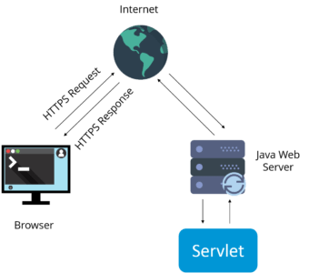

1. **What are the differences between Get and Post methods?**

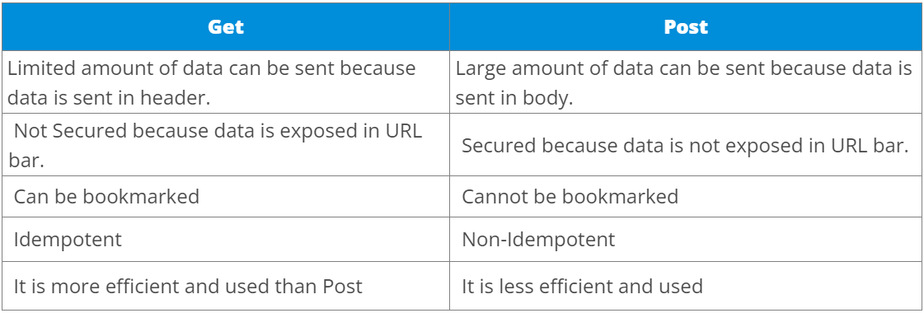

Get and post are two different HTTP verbs for two different actions. Get is used for querying already available resources. Keep in mind that using get, the request body must be empty, we can specify the query with request parameters (query string). Post is for creating new resources. The new object to create is mostly sent in the request body e.g. in JSON format.

Example:

GET /items: The response will contain all available resources on this location.

POST /items: We send a new resource in the request body, the server might response with the URL of the newly created object, in this case let it be /items/5.

GET /items/5: Now the response will contain the resource with an ID of 5, our newly created object.

1. **What is Request Dispatcher?**

RequestDispatcher interface is used to forward the request to another resource that can be HTML, JSP or another servlet in same application. We can also use this to include the content of another resource to the response.

There are two methods defined in this interface:

* void forward()
* void include()

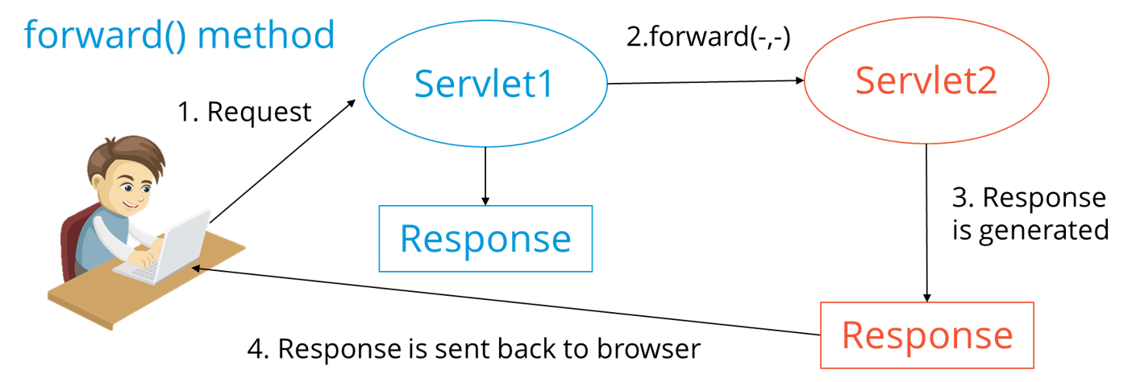

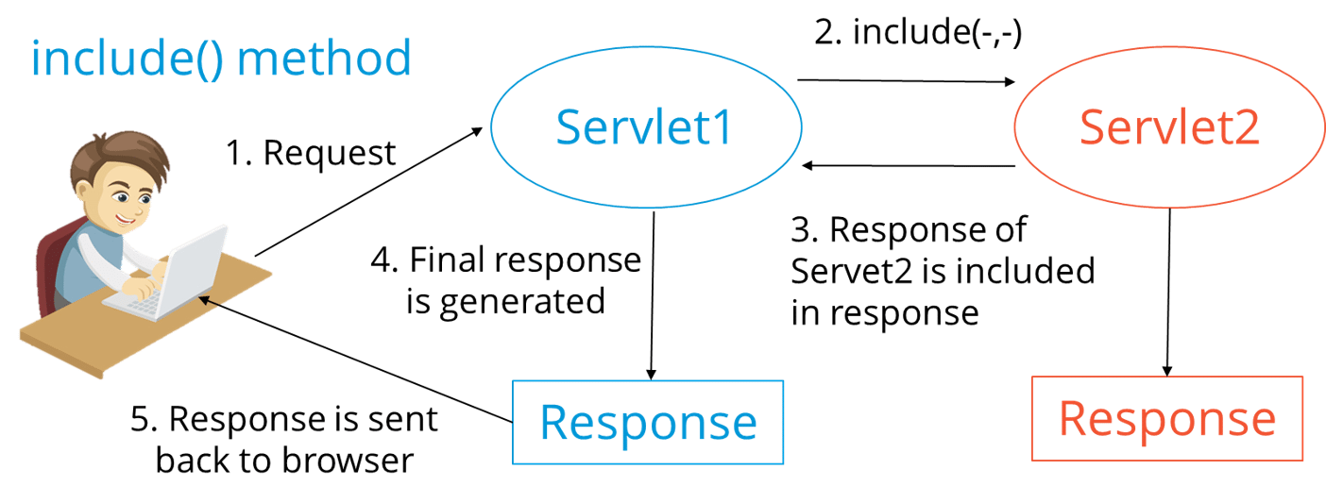

1. **What are the differences between forward() method and sendRedirect() methods?**

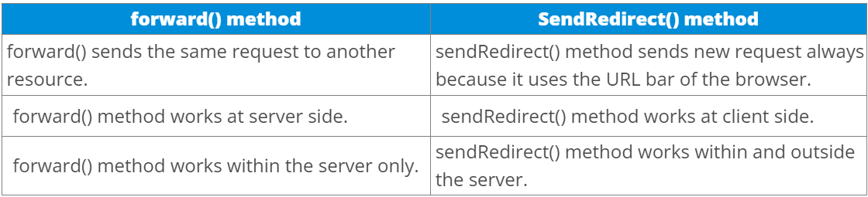

1. **What is the life-cycle of a servlet?**

There are 5 stages in the lifecycle of a servlet:

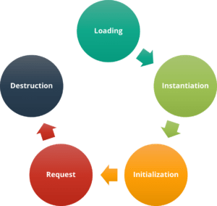

* Servlet is loaded
* Servlet is instantiated
* Servlet is initialized
* Service the request
* Servlet is destroyed

1. **How does cookies work in Servlets?**

* Cookies are text data sent by server to the client and it gets saved at the client local machine.
* Servlet API provides cookies support through javax.servlet.http.Cookie class that implements Serializable and Cloneable interfaces.
* HttpServletRequest getCookies() method is provided to get the array of Cookies from request, since there is no point of adding Cookie to request, there are no methods to set or add cookie to request. All matching cookies are sent automatically every request.
* Similarly HttpServletResponse addCookie(Cookie c) method is provided to attach cookie in response header, there are no getter methods for cookie.

1. **What are the differences between ServletContext vs ServletConfig?**

The difference between ServletContext and ServletConfig in Servlets JSP is in below tabular format.

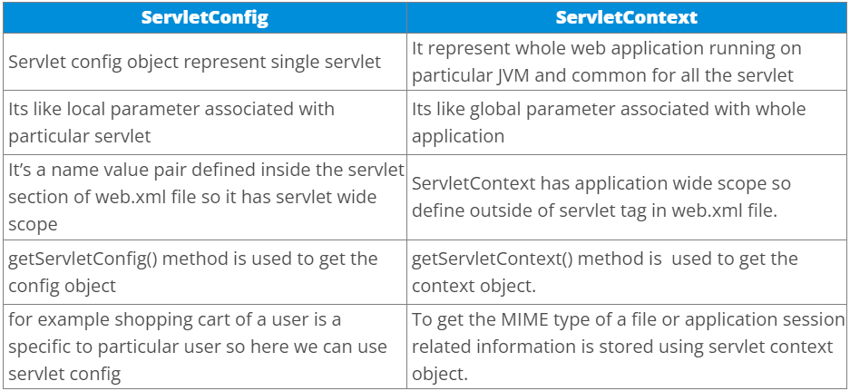

1. **What are the different methods of session management in servlets?**

Session is a conversational state between client and server and it can consists of multiple request and response between client and server. Since HTTP and Web Server both are stateless, the only way to maintain a session is when some unique information about the session (session id) is passed between server and client in every request and response.

Some of the common ways of session management in servlets are:

* User Authentication
* HTML Hidden Field
* Cookies
* URL Rewriting
* Session Management API

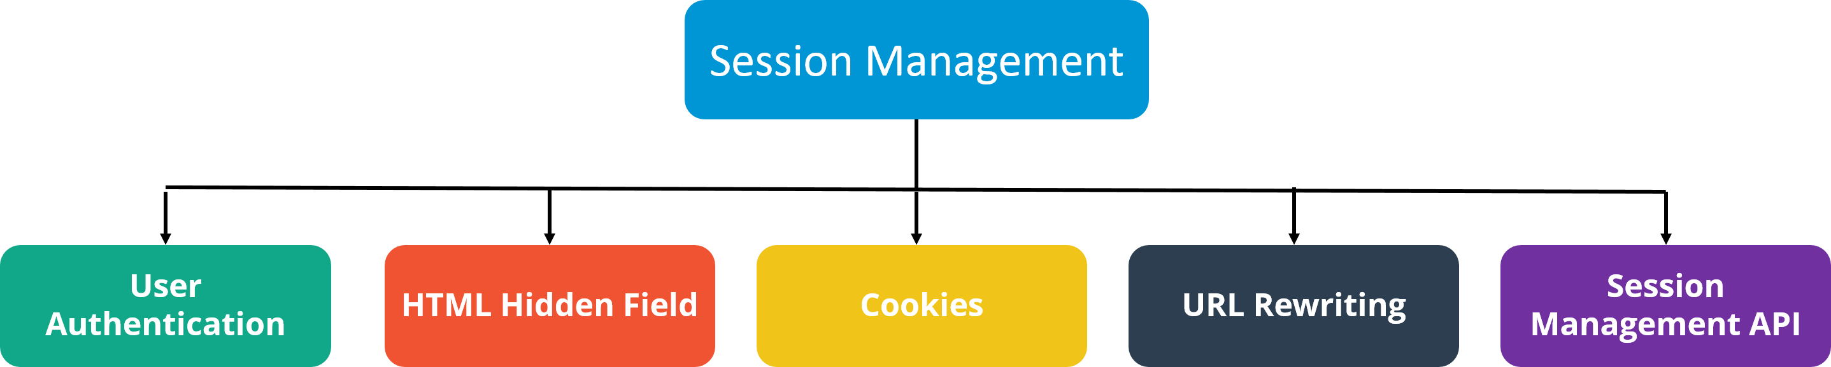

1. **Name the different modules of the Spring framework.**

Some of the important Spring Framework modules are:

* Spring Context – for dependency injection.
* Spring AOP – for aspect oriented programming.
* Spring DAO – for database operations using DAO pattern
* Spring JDBC – for JDBC and DataSource support.
* Spring ORM – for ORM tools support such as Hibernate
* Spring Web Module – for creating web applications.
* Spring MVC – Model-View-Controller implementation for creating web applications, web services etc.

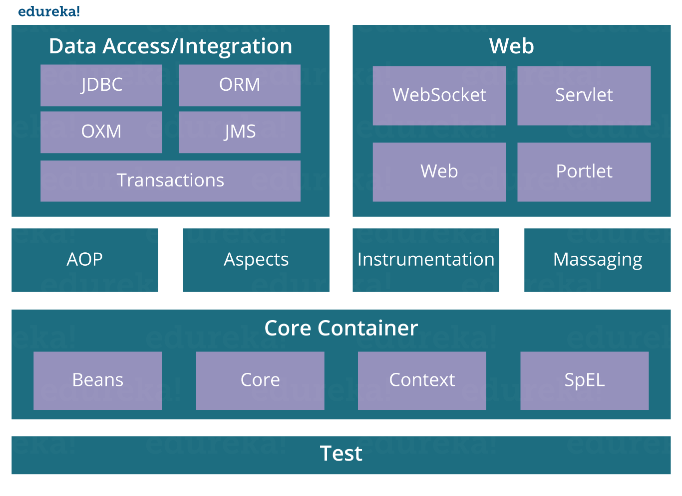

1. **List some of the important annotations in annotation-based Spring configuration.**

The important annotations are:

* @Required
* @Autowired
* @Qualifier
* @Resource
* @PostConstruct
* @PreDestroy

1. **Explain Bean in Spring and List the different Scopes of Spring bean.**

Beans are objects that form the backbone of a Spring application. They are managed by the Spring IoC container. In other words, a bean is an object that is instantiated, assembled, and managed by a Spring IoC container.

There are five Scopes defined in Spring beans.

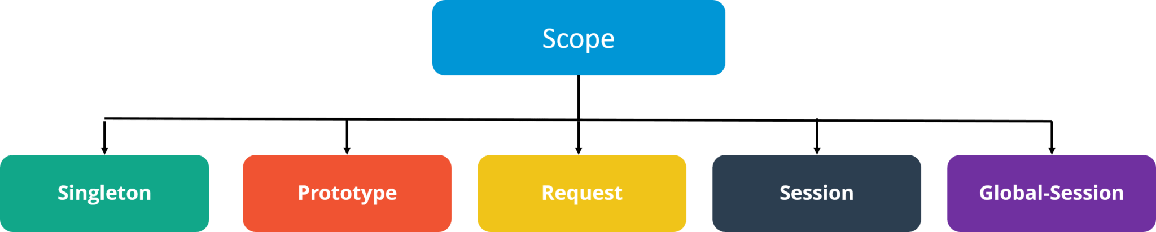

* Singleton: Only one instance of the bean will be created for each container. This is the default scope for the spring beans. While using this scope, make sure spring bean doesn’t have shared instance variables otherwise it might lead to data inconsistency issues because it’s not thread-safe.
* Prototype: A new instance will be created every time the bean is requested.
* Request: This is same as prototype scope, however it’s meant to be used for web applications. A new instance of the bean will be created for each HTTP request.
* Session: A new bean will be created for each HTTP session by the container.
* Global-session: This is used to create global session beans for Portlet applications.

1. **Explain the role of DispatcherServlet and ContextLoaderListener.**

DispatcherServlet is basically the front controller in the Spring MVC application as it loads the spring bean configuration file and initializes all the beans that have been configured. If annotations are enabled, it also scans the packages to configure any bean annotated with @Component, @Controller, @Repository or @Service annotations.

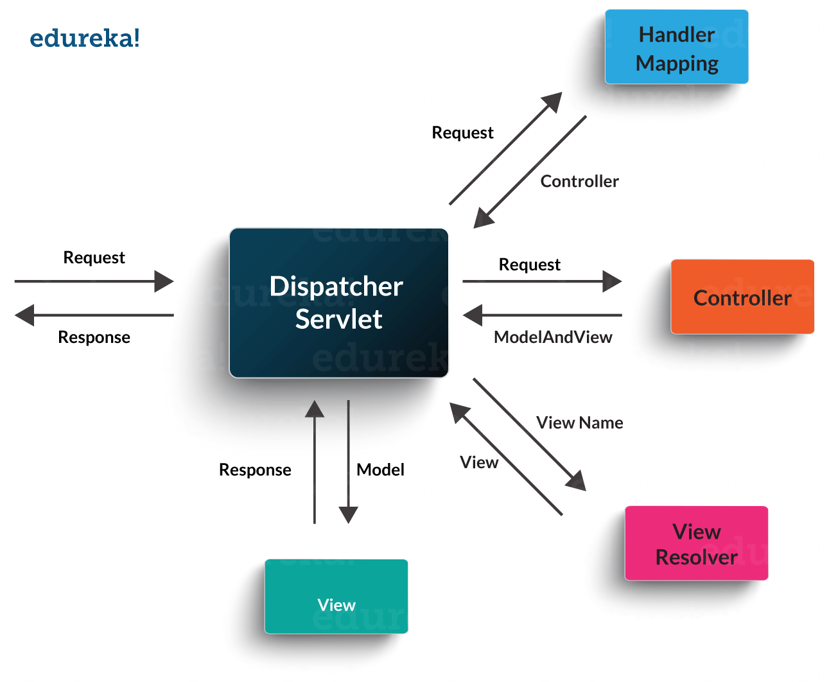

ContextLoaderListener, on the other hand, is the listener to start up and shut down the WebApplicationContext in Spring root. Some of its important functions includes tying up the lifecycle of Application Context to the lifecycle of the ServletContext and automating the creation of ApplicationContext.

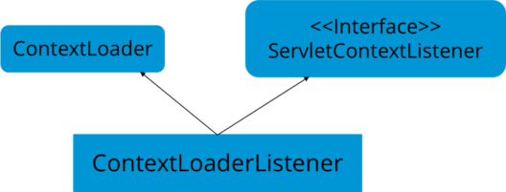

1. **What are the differences between constructor injection and setter injection?**

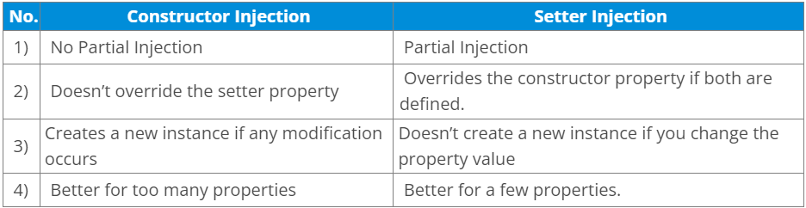

1. **What is autowiring in Spring? What are the autowiring modes?**

Autowiring enables the programmer to inject the bean automatically. We don’t need to write explicit injection logic. Let’s see the code to inject bean using dependency injection.

* <bean id=“emp” class=“com.javatpoint.Employee” autowire=“byName” />

The autowiring modes are given below:

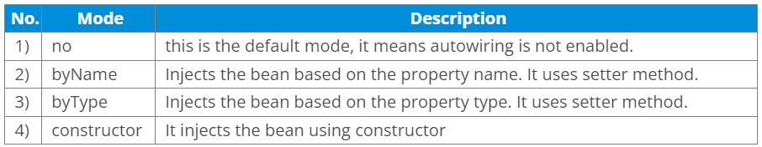

1. **What are some of the important Spring annotations?**

* @Controller – for controller classes in Spring MVC project.
* @RequestMapping – for configuring URI mapping in controller handler methods. This is a very important annotation, so you should go through Spring MVC RequestMapping Annotation Examples
* @ResponseBody – for sending Object as response, usually for sending XML or JSON data as response.
* @PathVariable – for mapping dynamic values from the URI to handler method arguments.
* @Autowired – for autowiring dependencies in spring beans.
* @Qualifier – with @Autowired annotation to avoid confusion when multiple instances of bean type is present.
* @Service – for service classes.
* @Scope – for configuring the scope of the spring bean.
* @Configuration, @ComponentScan and @Bean – for java based configurations.
* AspectJ annotations for configuring aspects and advices , @Aspect, @Before, @After, @Around, @Pointcut, etc.

1. **How to integrate Spring and Hibernate Frameworks?**

We can use Spring ORM module to integrate Spring and Hibernate frameworks if you are using Hibernate 3+ where SessionFactory provides current session, then you should avoid using HibernateTemplate or HibernateDaoSupport classes and better to use DAO pattern with dependency injection for the integration.

Also, Spring ORM provides support for using Spring declarative transaction management, so you should utilize that rather than going for hibernate boiler-plate code for transaction management.

1. **Name the types of transaction management that Spring supports.**

Two types of transaction management are supported by Spring. They are:

* Programmatic transaction management: In this, the transaction is managed with the help of programming. It provides you extreme flexibility, but it is very difficult to maintain.
* Declarative transaction management: In this, transaction management is separated from the business code. Only annotations or XML based configurations are used to manage the transactions.

1. **What is Hibernate Framework?**

Object-relational mapping or ORM is the programming technique to map application domain model objects to the relational database tables. Hibernate is Java-based ORM tool that provides a framework for mapping application domain objects to the relational database tables and vice versa.

Hibernate provides a reference implementation of Java Persistence API, that makes it a great choice as ORM tool with benefits of loose coupling. We can use the Hibernate persistence API for CRUD operations. Hibernate framework provide option to map plain old java objects to traditional database tables with the use of JPA annotations as well as XML based configuration.

Similarly, hibernate configurations are flexible and can be done from XML configuration file as well as programmatically.

1. **What are the important benefits of using Hibernate Framework?**

Some of the important benefits of using hibernate framework are:

* Hibernate eliminates all the boiler-plate code that comes with JDBC and takes care of managing resources, so we can focus on business logic.
* Hibernate framework provides support for XML as well as JPA annotations, that makes our code implementation independent.
* Hibernate provides a powerful query language (HQL) that is similar to SQL. However, HQL is fully object-oriented and understands concepts like inheritance, polymorphism, and association.
* Hibernate is an open source project from Red Hat Community and used worldwide. This makes it a better choice than others because learning curve is small and there are tons of online documentation and help is easily available in forums.
* Hibernate is easy to integrate with other Java EE frameworks, it’s so popular that Spring Framework provides built-in support for integrating hibernate with Spring applications.
* Hibernate supports lazy initialization using proxy objects and perform actual database queries only when it’s required.
* Hibernate cache helps us in getting better performance.
* For database vendor specific feature, hibernate is suitable because we can also execute native sql queries.

Overall hibernate is the best choice in current market for ORM tool, it contains all the features that you will ever need in an ORM tool.

1. **Explain Hibernate architecture.**

Hibernate has a layered architecture which helps the user to operate without having to know the underlying APIs. Hibernate makes use of the database and configuration data to provide persistence services (and persistent objects) to the application. It includes many objects such as persistent object, session factory, transaction factory, connection factory, session, transaction etc.

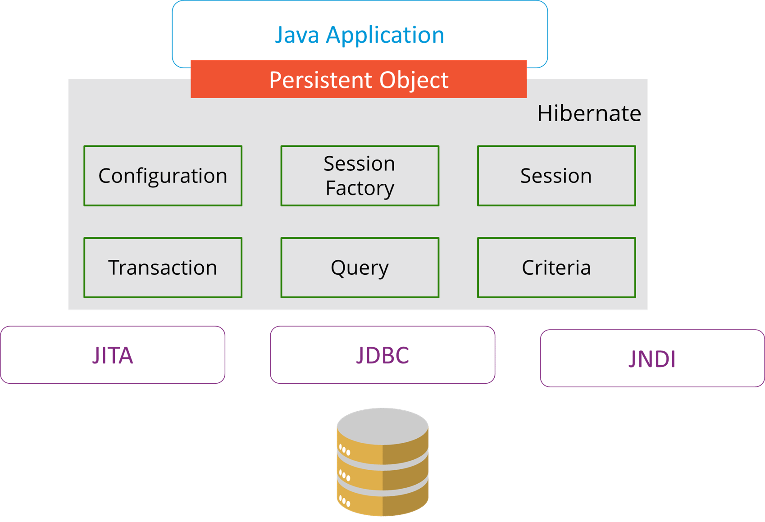

The Hibernate architecture is categorized in four layers.

* Java application layer
* Hibernate framework layer
* Backhand API layer
* Database layer

1. **What are the differences between get and load methods?**

The differences between get() and load() methods are given below.

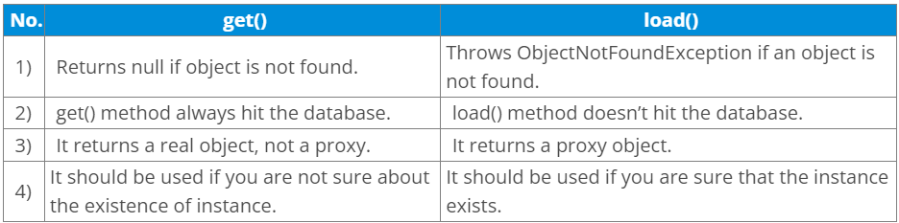

1. **What are the advantages of Hibernate over JDBC?**

Some of the important advantages of Hibernate framework over JDBC are:

* Hibernate removes a lot of boiler-plate code that comes with JDBC API, the code looks cleaner and readable.
* Hibernate supports inheritance, associations, and collections. These features are not present with JDBC API.
* Hibernate implicitly provides transaction management, in fact, most of the queries can’t be executed outside transaction. In JDBC API, we need to write code for transaction management using commit and rollback.
* JDBC API throws SQLException that is a checked exception, so we need to write a lot of try-catch block code. Most of the times it’s redundant in every JDBC call and used for transaction management. Hibernate wraps JDBC exceptions and throw JDBCException or HibernateException un-checked exception, so we don’t need to write code to handle it. Hibernate built-in transaction management removes the usage of try-catch blocks.
* Hibernate Query Language (HQL) is more object-oriented and close to Java programming language. For JDBC, we need to write native SQL queries.
* Hibernate supports caching that is better for performance, JDBC queries are not cached hence performance is low.
* Hibernate provides option through which we can create database tables too, for JDBC tables must exist in the database.
* Hibernate configuration helps us in using JDBC like connection as well as JNDI DataSource for the connection pool. This is a very important feature in enterprise application and completely missing in JDBC API.
* Hibernate supports JPA annotations, so the code is independent of the implementation and easily replaceable with other ORM tools. JDBC code is very tightly coupled with the application.

1. **What are the life-cycle methods for a jsp?**

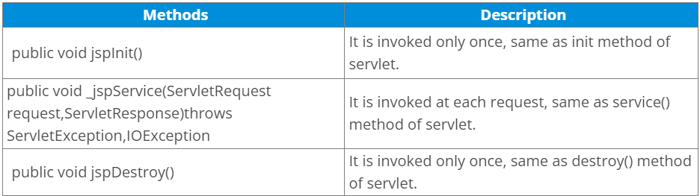

1. **What are the JSP implicit objects?**

JSP provides 9 implicit objects by default. They are as follows:

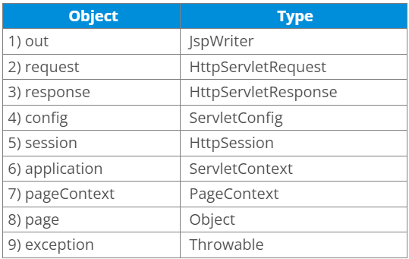

1. **What are the differences between include directive and include action?**

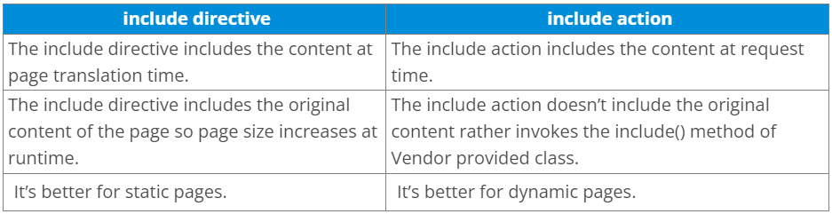

1. **How to disable caching on back button of the browser?**

response.setHeader("Cache-Control", "no-store");

response.setHeader("Pragma", "no-cache");

response.setHeader("Expires", "0"); // Prevents caching at the proxy server

1. **What are the different tags provided in JSTL?**

There are 5 type of JSTL tags.

* core tags
* sql tags
* xml tags
* internationalization tags
* functions tags

1. **How to disable session in JSP?**

<%@ page session=“false” %>

1. **How to delete a Cookie in a JSP?**

The following code explains how to delete a Cookie in a JSP:

Cookie mycook = new Cookie("name1","value1");

response.addCookie(mycook1);

Cookie killmycook = new Cookie("mycook1","value1");

killmycook . set MaxAge ( 0 );

killmycook . set Path ("/");

killmycook . addCookie ( killmycook 1 );

1. **Explain the jspDestroy() method.**

jspDestry() method is invoked from javax.servlet.jsp.JspPage interface whenever a JSP page is about to be destroyed. Servlets destroy methods can be easily overridden to perform cleanup, like when closing a database connection.

1. **How is JSP better than Servlet technology?**

JSP is a technology on the server’s side to make content generation simple. They are document-centric, whereas servlets are programs. A Java server page can contain fragments of Java program, which execute and instantiate Java classes. However, they occur inside an HTML template file. It provides the framework for the development of a Web Application.

1. **What are the different categories of Java Design patterns?**

Java Design patterns can be broadly categorized into three main categories: creational patterns, structural patterns, and behavioral patterns. Let’s explore each category in more detail:

* Creational Patterns: These patterns deal with object creation mechanisms, providing ways to create objects in a flexible and reusable manner. Some common creational patterns include:
  + Singleton: Ensures that only one instance of a class is created and provides a global point of access to it.
  + Factory Method: Defines an interface for creating objects, but lets subclasses decide which class to instantiate.
  + Abstract Factory: Provides an interface for creating families of related or dependent objects without specifying their concrete classes.
* Structural Patterns: These patterns focus on the composition of classes and objects, defining how they can be structured to form larger structures while keeping the system flexible and efficient. Some examples of structural patterns include:
  + Adapter: Converts the interface of a class into another interface that clients expect.
  + Decorator: Dynamically adds new behaviors or responsibilities to an object.
  + Composite: Treats a group of objects as a single object, allowing clients to treat individual objects and compositions uniformly.
* Behavioral Patterns: These patterns address the interaction and communication between objects, defining how they collaborate and fulfill their responsibilities. Some common behavioral patterns are:
  + Observer: Defines a one-to-many dependency between objects so that when one object changes state, all its dependents are notified and updated automatically.
  + Strategy: Defines a family of algorithms, encapsulates each one, and makes them interchangeable at runtime.
  + Command: Encapsulates a request as an object, allowing you to parameterize clients with queues, requests, and operations.

These divisions offer a methodical approach to categorize and comprehend many Java design patterns. It is noteworthy that certain design patterns might fall into more than one category or have variants and combinations, and that these categories are not exclusive of one another. Other design patterns that fall outside of these categories include concurrency patterns and architectural patterns, both of which are applicable to Java programming.

1. **Why should we not configure JSP standard tags in web.xml?**

We don’t need to configure JSP standard tags in web.xml because when container loads the web application and find TLD files, it automatically configures them to be used directly in the application JSP pages. We just need to include it in the JSP page using taglib directive.

1. **How will you use JSP EL in order to get the HTTP method name?**

Using pageContext JSP EL implicit object you can get the request object reference and make use of the dot operator to retrieve the HTTP method name in the JSP page. The JSP EL code for this purpose will look like ${pageContext.request.method}.

1. **What is the difference between Error and Exception?**

An error is an irrecoverable condition occurring at runtime. Such as OutOfMemory error. These JVM errors you cannot repair them at runtime. Though error can be caught in the catch block but the execution of application will come to a halt and is not recoverable.

While exceptions are conditions that occur because of bad input or human error etc. e.g. FileNotFoundException will be thrown if the specified file does not exist. Or a NullPointerException will take place if you try using a null reference. In most of the cases it is possible to recover from an exception (probably by giving the user feedback for entering proper values etc.

1. **Will the finally block get executed when the return statement is written at the end of try block and catch block as shown below?**

The finally block always gets executed even when the return statement is written at the end of the try block and the catch block. It always executes , whether there is an exception or not. There are only a few situations in which the finally block does not execute, such as VM crash, power failure, software crash, etc. If you don’t want to execute the finally block, you need to call the System.exit() method explicitly in the finally block.

1. **What are the important methods of Java Exception Class?**

Exception and all of it’s subclasses doesn’t provide any specific methods and all of the methods are defined in the base class Throwable.

* String getMessage() – This method returns the message String of Throwable and the message can be provided while creating the exception through it’s constructor.
* String getLocalizedMessage() – This method is provided so that subclasses can override it to provide locale specific message to the calling program. Throwable class implementation of this method simply use getMessage() method to return the exception message.
* Synchronized Throwable getCause() – This method returns the cause of the exception or null id the cause is unknown.
* String toString() – This method returns the information about Throwable in String format, the returned String contains the name of Throwable class and localized message.
* void printStackTrace() – This method prints the stack trace information to the standard error stream, this method is overloaded and we can pass PrintStream or PrintWriter as an argument to write the stack trace information to the file or stream.

1. **What is OutOfMemoryError in Java?**

OutOfMemoryError is the subclass of java.lang.Error which generally occurs when our JVM runs out of memory.

1. **What are the different types of garbage collectors in Java?**

Garbage collection in Java a program which helps in implicit memory management. Since in Java, using the new keyword you can create objects dynamically, which once created will consume some memory. Once the job is done and there are no more references left to the object, Java using garbage collection destroys the object and relieves the memory occupied by it. Java provides four types of garbage collectors:

* Serial Garbage Collector
* Parallel Garbage Collector
* CMS Garbage Collector
* G1 Garbage Collector

The Java programming language has four types of garbage collectors:

* Serial Garbage Collector: Using only a single thread for garbage collection, the serial garbage collector works by holding all the application threads. It is designed especially for single-threaded environments. Because serial garbage collector freezes all application threads while performing garbage collection, it is most suitable for command-line programs only. For using the serial garbage collector, one needs to turn on the -XX:+UseSerialGC JVM argument.
* Parallel Garbage Collector: Also known as the throughput collector, the parallel garbage collector is the default garbage collector of the JVM. It uses multiple threads for garbage collection, and like a serial garbage collector freezes all application threads during garbage collection.
* CMS Garbage Collector: Short for Concurrent Mark Sweep, CMS garbage collector uses multiple threads for scanning the heap memory for marking instances for eviction, followed by sweeping the marked instances. There are only two scenarios when the CMS garbage collector holds all the application threads:
  + When marking the referenced objects in the tenured generation space.
  + If there is a change in the heap memory while performing the garbage collection, CMS garbage collector ensures better application throughput over parallel garbage collectors by using more CPU resources. For using the CMS garbage collector, the XX:+USeParNewGC JVM argument needs to be turned on.
* G1 Garbage Collector: Used for large heap memory areas, G1 garbage collector works by separating the heap memory into multiple regions and then executing garbage collection in them in parallel. Unlike the CMS garbage collector that compacts the memory on STW (Stop The World) situations, G1 garbage collector compacts the free heap space right after reclaiming the memory. Also, the G1 garbage collector prioritizes the region with the most garbage. Turning on the –XX:+UseG1GC JVM argument is required for using the G1 garbage collector.

[Top 50+ Core Java Interview Questions and Answers (2023) (softwaretestinghelp.com)](https://www.softwaretestinghelp.com/core-java-interview-questions/)

1. **How does Java enable high performance?**

Java uses Just In Time compiler to enable high performance. It is used to convert the instructions into bytecodes.

1. **Name the Java IDE’s?**

Eclipse and NetBeans are the IDE’s of JAVA.

1. **What are the OOPs concepts?**

OOPs concepts include:

* Inheritance
* Encapsulation
* Polymorphism
* Abstraction
* Interface

1. **What is Polymorphism?**

Polymorphism means many forms.

A single object can refer to the super-class or sub-class depending on the reference type which is called polymorphism.

Example:

Public class Manipulation() { //Super class

>public void add() {}

}

public class Addition extends Manipulation() { // Sub class

>public void add() {}

>public static void main(String args[]) {

>>Manipulation addition = new Addition(); //Manipulation is reference type and Addition is reference type

>>addition.add();

>}

}

Using the Manipulation reference type we can call the Addition class “add()” method. This ability is known as Polymorphism. Polymorphism is applicable for overriding and not for overloading.

1. **Explain about Public and Private access specifiers.**

Methods and instance variables are known as members.

Public:

Public members are visible in the same package as well as the outside package that is for other packages.

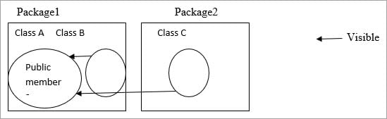

Public members of Class A are visible to Class B (same package) as well as Class C (different packages).

Private:

Private members are visible in the same class only and not for the other classes in the same package as well as classes in the outside packages.

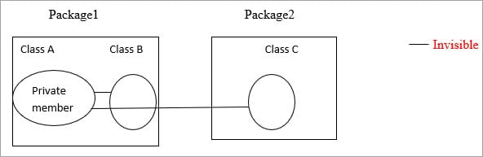

Private members in class A are visible only in that class. It is invisible for class B as well as class C.

1. **Difference between Default and Protected access specifiers.**

Default: Methods and variables declared in a class without any access specifiers are called default.

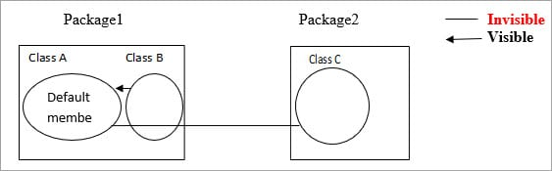

Default members in Class A are visible to the other classes which are inside the package and invisible to the classes which are outside the package.

So Class A members are visible to Class B and invisible to Class C.

Protected:

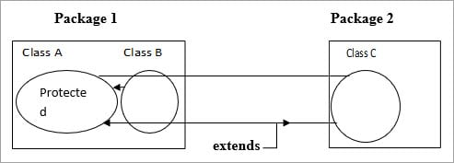

Protected is the same as Default but if a class extends then it is visible even if it is outside the package.

Class A members are visible to Class B because it is inside the package. For Class C it is invisible but if Class C extends Class A then the members are visible to Class C even if it is outside the package.

1. **What is the meaning of Collections in Java?**

Collection is a framework that is designed to store the objects and manipulate the design to store the objects.

Collections are used to perform the following operations:

* Searching
* Sorting
* Manipulation
* Insertion
* Deletion

A group of objects is known as collections. All the classes and interfaces for collecting are available in Java util package.

1. **What are all the Classes and Interfaces that are available in the collections?**

Given below are the Classes and Interfaces that are available in Collections:

Interfaces:

* Collection
* List
* Set
* Map
* Sorted Set
* Sorted Map
* Queue

Classes:

Lists:

* Array List
* Vector
* Linked List

Sets:

* Hash set
* Linked Hash Set
* Tree Set

Maps:

* Hash Map
* Hash Table
* TreeMap
* Linked Hashed Map

Queue:

* Priority Queue

1. **What is meant by Ordered and Sorted in collections?**

Ordered: It means the values that are stored in a collection is based on the values that are added to the collection. So we can iterate the values from the collection in a specific order.

Sorted: Sorting mechanisms can be applied internally or externally so that the group of objects sorted in a particular collection is based on the properties of the objects.

1. **Explain the different lists available in the collection.**

Values added to the list are based on the index position and it is ordered by index position. Duplicates are allowed.

The types of Lists are:

* Array List:
  + Fast iteration and fast Random Access.
  + It is an ordered collection (by index) and not sorted.
  + It implements the Random Access Interface.

Example:

public class Fruits {

>public static void main(String[] args) {

>>ArrayList < String > names = new ArrayList < String > ();

>>names.add(“apple”);

>>names.add(“cherry”);

>>names.add(“kiwi”);

>>names.add(“banana”);

>>names.add(“cherry”);

>>System.out.println(names);

>}

}

Output:

[Apple, cherry, kiwi, banana, cherry]

From the output, Array List maintains the insertion order and it accepts the duplicates. But it’s not sorted.

* Vector:
  + It is the same as Array List.
  + Vector methods are synchronized.
  + Thread safety.
  + It also implements Random Access.
  + Thread safety usually causes a performance hit.

Example:

public class Fruit {

>public static void main(String[] args) {

>>Vector < String > names = new Vector < String > ();

>>names.add(“cherry”);

>>names.add(“apple”);

>>names.add(“banana”);

>>names.add(“kiwi”);

>>names.add(“apple”);

>>System.out.println(“names”);

>}

}

Output:

[cherry,apple,banana,kiwi,apple]

Vector also maintains the insertion order and accepts the duplicates.

* Linked List:
  + Elements are doubly linked to one another.
  + Performance is slower than the Array list.
  + Good choice for insertion and deletion.
  + In Java 5.0 it supports common queue methods peek( ), Pool ( ), Offer ( ) etc.

Example:

public class Fruit {

>public static void main(String[] args) {

>>Linkedlist < String > names = new linkedlist < String > ();

>>names.add(“banana”);

>>names.add(“cherry”);

>>names.add(“apple”);

>>names.add(“kiwi”);

>>names.add(“banana”);

>>System.out.println(names);

>}

}

Output:

[ banana,cherry,apple,kiwi,banana]

Maintains the insertion order and accepts the duplicates.

1. **Explain about Set and their types in a collection.**

Set cares about uniqueness. It doesn’t allow duplications. Here “equals ( )” method is used to determine whether two objects are identical or not.

* Hash Set:
  + Unordered and unsorted.
  + Uses the hash code of the object to insert the values.
  + Use this when the requirement is “no duplicates and don’t care about the order”.

Example:

public class Fruit {

>public static void main(String[] args) {

>>HashSet < String > names = new HashSet <= String > ();

>>names.add(“banana”);

>>names.add(“cherry”);

>>names.add(“apple”);

>>names.add(“kiwi”);

>>names.add(“banana”);

>>System.out.println(names);

>}

}

Output:

[banana, cherry, kiwi, apple]

It doesn’t follow any insertion order. Duplicates are not allowed.

* Linked Hash set:
  + An ordered version of the hash set is known as Linked Hash Set.
  + Maintains a doubly-Linked list of all the elements.
  + Use this when an iteration order is required.

Example:

public class Fruit {

>public static void main(String[] args) {

>>LinkedHashSet < String > ;

>>names = new LinkedHashSet < String > ();

>>names.add(“banana”);

>>names.add(“cherry”);

>>names.add(“apple”);

>>names.add(“kiwi”);

>>names.add(“banana”);

>>System.out.println(names);

>}

}

Output:

[banana, cherry, apple, kiwi]

It maintains the insertion order in which they have been added to the Set. Duplicates are not allowed.

* Tree Set:
  + It is one of the two sorted collections.
  + Uses the “Read-Black” tree structure and guarantees that the elements will be in ascending order.
  + We can construct a tree set with the constructor by using a comparable (or) comparator.

Example:

public class Fruits {

>public static void main(String[] args) {

>>Treeset < String > names = new TreeSet < String > ();

>>names.add(“cherry”);

>>names.add(“banana”);

>>names.add(“apple”);

>>names.add(“kiwi”);

>>names.add(“cherry”);

>>System.out.println(names);

>}

}

Output:

[apple, banana, cherry, kiwi]

TreeSet sorts the elements in ascending order. And duplicates are not allowed.

1. **Explain the Priority Queue.**

Queue Interface

Priority Queue: Linked list class has been enhanced to implement the queue interface. Queues can be handled with a linked list. The purpose of a queue is “Priority-in, Priority-out”.

Hence elements are ordered either naturally or according to the comparator. The elements ordering represents their relative priority.

A priority queue, like a regular queue, is an abstract data type, but it has a priority associated with each element contained by it.

The element with the high priority is served before the element with low priority in a priority queue. Elements in a priority queue are ordered either according to the comparator or naturally. The order of the elements in a priority queue represents their relative priority.

1. **What are the types of Exceptions?**

There are two types of Exceptions. They are explained below in detail.

* Checked Exception:

These exceptions are checked by the compiler at the time of compilation. Classes that extend Throwable class except Runtime exception and Error are called checked Exception.

Checked Exceptions must either declare the exception using throws keyword (or) surrounded by appropriate try/catch.

For Example, ClassNotFound Exception

* Unchecked Exception:

These exceptions are not checked during the compile time by the compiler. The compiler doesn’t force to handle these exceptions. It includes:

Arithmetic Exception

ArrayIndexOutOfBounds Exception

1. **What are the advantages of Exception handling?**

The advantages of exception handling are as follows:

* The normal flow of the execution won’t be terminated if an exception gets handled
* We can identify the problem by using catch declaration

1. **What are the Exception handling keywords in Java?**

Enlisted below are the three Exception Handling Keywords:

* try:

When a risky code is surrounded by a try block. An exception occurring in the try block is caught by a catch block. Try can be followed either by catch (or) finally (or) both. But any one of the blocks is mandatory.

* catch:

This is followed by a try block. Exceptions are caught here.

* finally:

This is followed either by try block (or) catch block. This block gets executed regardless of an exception. So generally clean up codes are provided here.

1. **What does the yield method of the Thread class do?**

A yield () method moves the currently running thread to a runnable state and allows the other threads for execution. So that equal priority threads have a chance to run. It is a static method. It doesn’t release any lock.

Yield () method moves the thread back to the Runnable state only, and not the thread to sleep (), wait () (or) block.

Example:

public static void main(String[] args) {

>Thread t = new Thread();

>t.start();

}

public void run() {

>Thread.yield();

}

1. **How to stop a thread in java? Explain about sleep () method in a thread?**

We can stop a thread by using the following thread methods:

* Sleeping
* Waiting
* Blocked

Sleep: Sleep () method is used to sleep the currently executing thread for the given amount of time. Once the thread is wake up it can move to the runnable state. So sleep () method is used to delay the execution for some period.

It is a static method.

Example:

Thread. Sleep (2000)

So it delays the thread to sleep 2000 milliseconds. Sleep () method throws an uninterrupted exception, hence we need to surround the block with try/catch.

public class ExampleThread implements Runnable {

>public static void main(String[] args) {

>>Thread t = new Thread();

>>t.start();

>}

>public void run() {

>>try {

>>>Thread.sleep(2000);

>>} catch (InterruptedException e) {}

>}

}

* Blocking: This method is used to put the thread in a blocked state. The execution resumes as soon as the condition of the blocking is met. For instance, the ServerSocket.accept() is a blocking method that listens for incoming socket connections and resumes the blocked thread only when a connection is made.
* Sleeping: This method is used for delaying the execution of the thread for some time. A thread upon which the sleep() method is used is said to enter the sleep state. It enters the runnable state as soon as it wakes up i.e., the sleep state is finished. The time for which the thread needs to enter the sleep state is mentioned inside the braces of the sleep() method. It is a static method.
* Waiting: Although it can be called on any Java object, the wait() method can only be called from a synchronized block.

1. **When to use the Runnable interface Vs Thread class in Java?**

If we need our class to extend some other classes other than the thread then we can go with the runnable interface because in java we can extend only one class.

If we are not going to extend any class then we can extend the thread class.

1. **Difference between start() and run() method of thread class.**

Start() method creates a new thread and the code inside the run () method is executed in the new thread. If we directly called the run() method then a new thread is not created and the currently executing thread will continue to execute the run() method.

1. **What is the disadvantage of Synchronization?**

Synchronization is not recommended to implement all the methods. Because if one thread accesses the synchronized code then the next thread should have to wait. So it makes a slow performance on the other end.

1. **What is SerialVersionUID?**

Whenever an object is Serialized, the object is stamped with a version ID number for the object class. This ID is called the SerialVersionUID. This is used during deserialization to verify that the sender and receiver that are compatible with the Serialization.

[Top 80 Java Interview Questions and Answers [2023] (hackr.io)](https://hackr.io/blog/java-interview-questions)

1. **What are Java IDEs?**

A Java IDE is a software that allows Java developers to easily write as well as debug Java programs. It is basically a collection of various programming tools, accessible via a single interface, and several helpful features, such as code completion and syntax highlighting.

Codenvy, Eclipse, and NetBeans are some of the most popular Java IDEs.

1. **Explain Typecasting.**

The concept of assigning a variable of one data type to a variable of another data type. This is not possible for the boolean data type. There are two types: implicit and explicit.

1. **What are the different types of typecasting?**

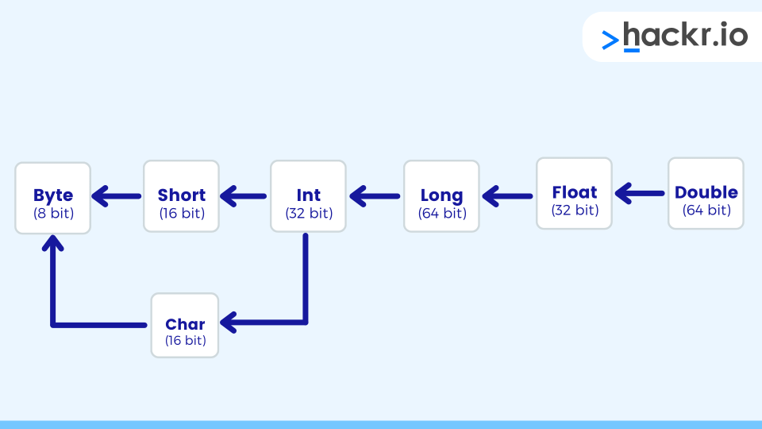

The different types of typecasting are:

* Implicit: Storing values from a smaller data type to the larger data type. It is automatically done by the compiler.
* Explicit: Storing the value of a larger data type into a smaller data type. This results in information loss:
* Truncation:While converting a value from a larger data type to a smaller data type, the extra data will be truncated. This code example explains it :

float f = 3.14f;

int i = (int) f;

After execution, the variable i will contain only 3 and not the decimal portion.

* Out of Range:Typecasting does not allow assigning value more than its range; if that happens then the data is lost in such cases. This code example explains it:

long l = 123456789;

byte b = (byte) l; // byte is of not the same range as long so there will be loss of data.

1. **Please explain Abstract class and Abstract method.**

An abstract class in Java is a class that can't be instantiated. Such a class is typically used for providing a base for subclasses to extend as well as implementing the abstract methods and overriding or using the implemented methods defined in the abstract class.

To create an abstract class, it needs to be followed by the abstract keyword. Any abstract class can have both abstract as well as non-abstract methods. A method in Java that only has the declaration and not implementation is known as an abstract method. Also, an abstract method name is followed by the abstract keyword. Any concrete subclass that extends the abstract class must provide an implementation for abstract methods.

1. **Write suitable code examples to demonstrate the use of final, final, and finalize.**

Final: The final keyword is used for restricting a class, method, and variable. A final class can't be inherited, a final method is disabled from overriding, and a final variable becomes a constant i.e., its value can't be changed.

classFinalVarExample {

>publicstaticvoidmain(String args[]) {

>>final int a = 10;

>>a = 50; /* Will result in an error as the value can’t be changed now*/

>}

}

Finally: Any code inside the final block will be executed, irrespective of whether an exception is handled or not.

classFinallyExample {

>publicstaticvoidmain(String args[]) {

>>try {

>>>int x = 100;

>>} catch (Exception e) {

>>>System.out.println(e);

>>} finally {

>>>System.out.println("finally block is executing");

>>}

>}

}

Finalize: The finalize method performs the clean up just before the object is garbage collected.

classFinalizeExample {

>public void finalize() {

>>System.out.println("Finalize is called");

>}

>public static void main(String args[]) {

>>FinalizeExample f1 = new FinalizeExample();

>>FinalizeExample f2 = new FinalizeExample();

>>f1 = NULL;

>>f2 = NULL;

>>System.gc();

>}

}

1. **Please compare serialization and deserialization.**

Serialization is the process by which Java objects are converted into the byte stream.

Deserialization is the exact opposite process of serialization where Java objects are retrieved from the byte stream.

A Java object is serialized by writing it to an ObjectOutputStream and deserialized by reading it from an ObjectInputStream.

1. **Explain the concept of boxing, unboxing, autoboxing, and auto unboxing.**

* Boxing: The concept of putting a primitive value inside an object is called boxing.
* Unboxing: Getting the primitive value from the object.
* Autoboxing: Assigning a value directly to an integer object.
* Auto unboxing: Getting the primitive value directly into the integer object.

public class BoxUnbox {

>public static void main(String args[]) {

>>int i = 5;

>>Integer ii = new Integer(i); /*Boxing*/

>>Integer jj = i; /*Unboxing*/

>>int j = jj.intValue(); /*Unboxing*/

>>int k = jj; /*AutoUnboxing*/

>}

}

1. **Take a look at the two code snippets below. What is the important difference between the two?**

i.

class Adder {

>Static int add(int a, int b) {

>>return a + b;

>}

>Static double add(double a, double b) {

>>return a + b;

>}

>public static void main(String args[]) {

>>System.out.println(Adder.add(11, 11));

>>System.out.println(Adder.add(12.3, 12.6));

>}

}

ii.

class Car {

>void run() {

>>System.out.println(“car is running”);

>}

>Class Audi extends Car {

>>void run() {

>>>System.out.prinltn(“Audi is running safely with 100 km”);

>>}

>>public static void main(String args[]) {

>>>Car b = new Audi();

>>>b.run();

>>}

>}

}

Code snippet i. is an example of method overloading while the code snippet ii. demonstrates method overriding.

1. **Write a program for string reversal without using an inbuilt function.**

public class Reversal {

>public static void main(String args[]) {

>>String input = "Java Interview";

>>System.out.println("Given String -> " + "Java Interview");

>>char charArray[] = input.toCharArray();

>>System.out.println("Reversed String -> ");

>>for (int i = charArray.length - 1; i >= 0; i--) {

>>>System.out.print(charArray[i]);

>>}

>>System.out.println();

>}

}

1. **Write a program to delete duplicates from an array.**

class RemoveDuplicates {

>public static void main(String args[]) {

>>/*create ArrayList with duplicate elements*/

>>ArrayList duplicate = new ArrayList();

>>duplicate.add(5);

>>duplicate.add(7);

>>duplicate.add(1);

>>duplicate.add(4);

>>duplicate.add(1);

>>duplicate.add(7);

>>System.out.println("Given array: " + duplicate);

>>Set < Integer > withoutDuplicates = new LinkedHashSet < Integer > (duplicate)

>>duplicate.clear();

>>duplicate.addAll(withoutDuplicates);

>>System.out.println("Array without duplicates: " + duplicate);

>}

}

1. **Write a program to reverse a number.**

public class NumberReversal {

>public static void main(String args[]) {

>>System.out.println("Please enter the number to be reversed");

>>Scanner sc = new Scanner(System.in);

>>int number = sc.nextInt();

>>int reverse = reverse(number);

>>System.out.println("Reverse of number: " + number + " is " + reverse(number));

>}

>public static int reverse(int number) {

>>int reverse = 0;

>>int remainder = 0;

>>do {

>>>remainder = number % 10;

>>>reverse = reverse * 10 + remainder;

>>>number = number / 10;

>>} while (number > 0);

>>return reverse;

>}

}

1. **Write a program that implements binary search.**

public class Binary {

>public static void main(String[] args) {

>>System.out.println("Enter total number of elements : ");

>>Scanner s = new Scanner(System.in);

>>int length = s.nextInt();

>>int[] input = newint[length];

>>System.out.printf("Enter %d integers", length);

>>for (int i = 0; i < length; i++) {

>>>input[i] = s.nextInt();

>>}

>>/* binary search requires the input array to be sorted so we must sort the array first*/

>>Arrays.sort(input);

>>System.out.print("the sorted array is: ");

>>for (int i = 0; i <= length - 1; i++) {

>>>System.out.println(input[i] + " ,");

>>}

>>System.out.println("Please enter number to be searched in sorted array");

>>int key = s.nextInt();

>>int index = BSearch(input, key);

>>if (index == -1) {

>>>System.out.printf("Sorry, %d is not found in array %n", key);

>>} else {

>>>System.out.printf("%d is found in array at index %d %n", key,

>>>>index);

>>}

>}

>public static int BSearch(int[] input, int number) {

>>int low = 0;

>>int high = input.length - 1;

>>while (high >= low) {

>>>int middle = (low + high) / 2;

>>>if (input[middle] == number) {

>>>>return middle;

>>>} else if (input[middle] < number) {

>>>>low = middle + 1;

>>>} else if (input[middle] > number) {

>>>>high = middle - 1;

>>>}

>>}

>>return -1;

>}

}

1. **Write a program to check if a number is prime.**

public class Prime {

>public static void main(String args[]) {

>>System.out.println("Enter the number to check: ");

>>Scanner sc = new Scanner(System.in);

>>int num = sc.nextInt();

>>boolean isPrime = false;

>>if (num != 0) {

>>>isPrime = checkPrime(num);

>>} else {

>>>System.out.println("Enter valid number");

>>}

>>if (isPrime == false) {

>>>System.out.println(" NOT PRIME!!");

>>} else {

>>>System.out.println("PRIME!!");

>>}

>}

>public static boolean checkPrime(int number) {

>>int sqrt = (int) Math.sqrt(number) + 1;

>>for (int i = 2; i < sqrt; i++) {

>>>if (number % i == 0) {

>>>>return false;

>>>}

>>}

>>return true;

>}

}

1. **Write a program to print Fibonacci series.**

public class Fibo {

>public static void main(String args[]) {

>>System.out.println("Enter the number upto which Fibonacci series should be printed ");

>>Scanner sc = new Scanner(System.in);

>>int num = sc.nextInt();

>>System.out.println("Fibonacci Series upto %d is" + num);

>>for (int i = 1; i <= num; i++) {

>>>System.out.print(fib(i) + " ");

>>}

>}

>public static int fib(int n) {

>>if (n == 1 || n == 2) {

>>>return 1;

>>}

>>return fib(n - 1) + fib(n - 2);

>}

}

1. **Write a program to check if the given string is a palindrome.**

public class PalinDrome {

>public static void main(String args[]) {

>>System.out.println("Enter the string to check");

>>Scanner sc = new Scanner(System.in);

>>String str = sc.nextLine();

>>boolean isPalindrome;

>>isPalindrome = checkPalindrome(str);

>>if (str.equals(" ")) {

>>>System.out.println("Enter valid string");

>>} else {

>>>if (isPalindrome) {

>>>>System.out.println("PALINDROME!!");

>>>} else {

>>>>System.out.println("NOT A PALINDROME!!");

>>>}

>>}

>}

>public static boolean checkPalindrome(String input) {

>>int str_length = input.length();

>>int i = 0, j = str_length - 1;

>>while (i < j) {

>>>if (input.charAt(i) != input.charAt(j))

>>>>return false;

>>>i++;

>>>j--;

>>}

>>return true;

>}

}

1. **Write a program to print the following pattern.**

*

* *

* * *

* * * *

* * * * *

Answer:

public class Pattern {

>public static void main(String args[]) {

>>for (int i = 5; i >= 0; i--) {

>>>System.out.println();

>>>for (int j = i; j < 5; j++) {

>>>>System.out.print(" * ");

>>>}

>>}

>>System.out.println();

>}

}

1. **Write a program to swap two numbers.**

public class Swap {

>public static void main(String args[]) {

>>Scanner s = new Scanner(System.in);

>>System.out.println("Enter a number: ");

>>int a = s.nextInt();

>>System.out.println("Enter second number: ");

>>int b = s.nextInt();

>>System.out.println("Value of a and b before swapping: " + "a = " + a + " b = " + b);

>>swap(a, b);

>}

>public static void swap(int a, int b) {

>>int swap_variable;

>>swap_variable = a;

>>a = b;

>>b = swap_variable;

>>System.out.println("Value of a and b after swapping: " + "a = " + a + " b = " + b);

>}

}

1. **Write a program to check if the given number is an Armstrong number.**

public class Armstrong {

>public static void main(String args[]) {

>>Scanner s = new Scanner(System.in);

>>System.out.println("Enter a number: ");

>>int number = s.nextInt();

>>int a = number, sum = 0, num = 0;

>>while (a % 10 != 0) {

>>>num = a % 10;

>>>sum = sum + (num * num * num);

>>>a = a / 10;

>>}

>>if (sum == number) {

>>>System.out.println("Armstrong Number!");

>>} else {

>>>System.out.println("Not an Armstrong Number!");

>>}

>}

}

[Top 50 Java Programming Interview Questions | DigitalOcean](https://www.digitalocean.com/community/tutorials/java-programming-interview-questions)

1. **How do you swap two numbers without using a third variable in Java?**

Swapping numbers without using a third variable is a three-step process that’s better visualized in code:

b = b + a; // now b is sum of both the numbers

a = b - a; // b - a = (b + a) - a = b (a is swapped)

b = b - a; // (b + a) - b = a (b is swapped)

The following example code shows one way to implement the number swap method:

public class SwapNumbers {

>public static void main(String[] args) {

>>int a = 10;

>>int b = 20;

>>System.out.println("a is " + a + " and b is " + b);

>>a = a + b;

>>b = a - b;

>>a = a - b;

>>System.out.println("After swapping, a is " + a + " and b is " + b);

>}

}

The output shows that the integer values are swapped:

Output

a is 10 and b is 20

After swapping, a is 20 and b is 10

1. **Write a Java program to check if a vowel is present in a string.**

The following example code shows how to use a regular expression to check whether the string contains vowels:

public class StringContainsVowels {

>public static void main(String[] args) {

>>System.out.println(stringContainsVowels("Hello")); // true

>>System.out.println(stringContainsVowels("TV")); // false

>}

>public static boolean stringContainsVowels(String input) {

>>return input.toLowerCase().matches(".*[aeiou].*");

>}

}

1. **How do you check if a list of integers contains only odd numbers in Java?**

You can use a for loop and check whether each element is odd:

public static boolean onlyOddNumbers(List < Integer > list) {

>for (int i: list) {

>>if (i % 2 == 0)

>>>return false;

>}

>return true;

}

If the list is large, you can use parallel stream for faster processing, as shown in the following example code:

public static boolean onlyOddNumbers(List < Integer > list) {

>return list

>>.parallelStream() // parallel stream for faster processing

>>.anyMatch(x - > x % 2 != 0); // return as soon as any elements match the condition

}

1. **How do you remove spaces from a string in Java?**

The following example code shows one way to remove spaces from a string using with the Character.isWhitespace() method:

String removeWhiteSpaces(String input) {

>StringBuilder output = new StringBuilder();

>char[] charArray = input.toCharArray();

>for (char c: charArray) {

>>if (!Character.isWhitespace(c))

>>>output.append(c);

>}

>return output.toString();

}

1. **How do you remove leading and trailing spaces from a string in Java?**

The String class contains two methods to remove leading and trailing whitespaces: trim() and strip(). The strip() method was added to the String class in Java 11. The strip() method uses the Character.isWhitespace() method to check if the character is a whitespace. This method uses Unicode code points, while the trim() method identifies any character with a codepoint value less than or equal to U+0020 as a whitespace character.

The strip() method is the recommended way to remove whitespaces because it uses the Unicode standard. The following example code shows how to use the strip() method to remove whitespaces:

String s = " abc def\t";

s = s.strip();

System.out.println(s);

Because String is immutable, you have to assign the strip() output to the string.

1. **How do you sort an array in Java?**

The Arrays utility class has many overloaded sort() methods to sort primitive and to object arrays. If you are sorting a primitive array in the natural order, then you can use the Arrays.sort() method, as shown in the following example:

int[] array = {1, 2, 3, -1, -2, 4};

Arrays.sort(array);

System.out.println(Arrays.toString(array));

However, if you want to sort an array of objects, then the object must implement the Comparable interface. If you want to specify the sorting criteria, then you can pass the Comparator for the sorting logic. Learn more about Comparable and Comparator in Java.

1. **How do you create a deadlock scenario programmatically in Java?**

Deadlock is a scenario in a multi-threaded Java environment where two or more threads are blocked forever. The deadlock situation arises with at two or more threads. The following example code creates a deadlock scenario:

public class ThreadDeadlock {

>public static void main(String[] args) throws InterruptedException {

>>Object obj1 = new Object();

>>Object obj2 = new Object();

>>Object obj3 = new Object();

>>Thread t1 = new Thread(new SyncThread(obj1, obj2), "t1");

>>Thread t2 = new Thread(new SyncThread(obj2, obj3), "t2");

>>Thread t3 = new Thread(new SyncThread(obj3, obj1), "t3");

>>t1.start();

>>Thread.sleep(5000);

>>t2.start();

>>Thread.sleep(5000);

>>t3.start();

>}

}

class SyncThread implements Runnable {

>private Object obj1;

>private Object obj2;

>public SyncThread(Object o1, Object o2) {

>>this.obj1 = o1;

>>this.obj2 = o2;

>}

>@Override

>public void run() {

>>String name = Thread.currentThread().getName();

>>System.out.println(name + " acquiring lock on " + obj1);

>>synchronized(obj1) {

>>>System.out.println(name + " acquired lock on " + obj1);

>>>work();

>>>System.out.println(name + " acquiring lock on " + obj2);

>>>synchronized(obj2) {

>>>>System.out.println(name + " acquired lock on " + obj2);

>>>>work();

>>>}

>>>System.out.println(name + " released lock on " + obj2);

>>}

>>System.out.println(name + " released lock on " + obj1);

>>System.out.println(name + " finished execution.");

>}

>private void work() {

>>try {

>>>Thread.sleep(30000);

>>} catch (InterruptedException e) {

>>>e.printStackTrace();

>>}

>}

}

All three threads will be able to acquire a lock on the first object. However, they are using shared resources and are started in such a way that they will keep on waiting indefinitely to acquire the lock on the second object. You can use the Java thread dump to detect the deadlocks.

1. **How can you find the factorial of an integer in Java?**

The factorial of an integer is calculated by multiplying all the numbers from 1 to the given number:

F(n) = F(1)*F(2)...F(n-1)*F(n)

The following example code shows how to use recursion to find the factorial of an integer:

public static long factorial(long n) {

>if (n == 1)

>>return 1;

>else

>>return (n * factorial(n - 1));

}

1. **How do you reverse a linked list in Java?**

LinkedList descendingIterator() returns an iterator that iterates over the element in reverse order. The following example code shows how to use this iterator to create a new Linked List with elements listed in the reverse order:

LinkedList < Integer > ll = new LinkedList < > ();

ll.add(1);

ll.add(2);

ll.add(3);

System.out.println(ll);

LinkedList < Integer > ll1 = new LinkedList < > ();

ll.descendingIterator().forEachRemaining(ll1::add);

System.out.println(ll1);

1. **Write a Java program that illustrates merge sort.**

Merge sort is one of the most efficient sorting algorithms. It works on the principle of “divide and conquer”. It is based on the idea of breaking down a list into several sub-lists until each sub-list consists of a single element, and then merging those sub-lists in a manner that results in a sorted list. The following example code shows one way to use merge sort:

public class MergeSort {

>public static void main(String[] args) {

>>int[] arr = { 70, 50, 30, 10, 20, 40, 60 };

>>int[] merged = mergeSort(arr, 0, arr.length - 1);

>>for (int val: merged) {

>>>System.out.print(val + " ");

>>}

>}

>public static int[] mergeTwoSortedArrays(int[] one, int[] two) {

>>int[] sorted = new int[one.length + two.length];

>>int i = 0;

>>int j = 0;

>>int k = 0;

>>while (i < one.length && j < two.length) {

>>>if (one[i] < two[j]) {

>>>>sorted[k] = one[i];

>>>>k++;

>>>>i++;

>>>} else {

>>>>sorted[k] = two[j];

>>>>k++;

>>>>j++;

>>>}

>>}

>>if (i == one.length) {

>>>while (j < two.length) {

>>>>sorted[k] = two[j];

>>>>k++;

>>>>j++;

>>>}

>>}

>>if (j == two.length) {

>>>while (i < one.length) {

>>>>sorted[k] = one[i];

>>>>k++;

>>>>i++;

>>>}

>>}

>>return sorted;

>}

>public static int[] mergeSort(int[] arr, int lo, int hi) {

>>if (lo == hi) {

>>>int[] br = new int[1];

>>>br[0] = arr[lo];

>>>return br;

>>}

>>int mid = (lo + hi) / 2;

>>int[] fh = mergeSort(arr, lo, mid);

>>int[] sh = mergeSort(arr, mid + 1, hi);

>>int[] merged = mergeTwoSortedArrays(fh, sh);

>>return merged;

>}

}

1. **Can you create a pyramid of characters in Java?**

class Pyramid {

>public static void main(String[] args) {

>>int size = 10;

>>for (int i = 0; i < size; i++) {

>>>for (int j = 0; j < size - i; j++) {

>>>>System.out.print(" ");

>>>}

>>>for (int j = 0; j < 2 * i + 1; j++) {

>>>>System.out.print("#");

>>>}

>>>System.out.println();

>>}

>}

}

Output:

>> #

>> ###

>>#####

> #######

> #########

> ###########

>#############

###############

#################

###################

1. **Write Java program that checks if two arrays contain the same elements.**

To check if two arrays contain the same elements, you need to first create a set of elements from both the arrays, and then compare the elements in these sets to find if there is an element that is not present in both sets. The following example code shows how to check if two arrays only contain common elements:

public class ArraySameElements {

>public static void main(String[] args) {

>>Integer[] a1 = { 1, 2, 3, 2, 1 };

>>Integer[] a2 = { 1, 2, 3 };

>>Integer[] a3 = { 1, 2, 3, 4 };

>>System.out.println(sameElements(a1, a2));

>>System.out.println(sameElements(a1, a3));

>}

>static boolean sameElements(Object[] array1, Object[] array2) {

>>Set<Object> uniqueElements1 = new HashSet<>(Arrays.asList(array1));

>>Set<Object> uniqueElements2 = new HashSet<>(Arrays.asList(array2));

>>// if size is different, means there will be a mismatch

>>if (uniqueElements1.size() != uniqueElements2.size()) return false;

>>for (Object obj : uniqueElements1) {

>>>// element not present in both?

>>>if (!uniqueElements2.contains(obj)) return false;

>>}

>>return true;

>}

}

Output

true

false

1. **How do you get the sum of all elements in an integer array in Java?**

You can use a for loop to iterate over the array elements and add them to get the final sum:

int[] array = { 1, 2, 3, 4, 5 };

int sum = 0;

for (int i : array)

>sum += i;

System.out.println(sum);

1. **How do you find the second largest number in an array in Java?**

There are many ways to solve this problem. You can sort the array in natural ascending order and take the second last value. However, sorting is an expensive operation. You can also use two variables to find the second largest value in a single iteration, as shown in the following example:

private static int findSecondHighest(int[] array) {

>int highest = Integer.MIN_VALUE;

>int secondHighest = Integer.MIN_VALUE;

>for (int i: array) {

>>if (i > highest) {

>>>secondHighest = highest;

>>>highest = i;

>>} else if (i > secondHighest) {

>>>secondHighest = i;

>>}

>}

>return secondHighest;

}

1. **How do you shuffle an array in Java?**

The following example code shows how to use the Random class to generate random index numbers and shuffle the elements:

int[] array = { 1, 2, 3, 4, 5, 6, 7 };

Random rand = new Random();

for (int i = 0; i < array.length; i++) {

>int randomIndexToSwap = rand.nextInt(array.length);

>int temp = array[randomIndexToSwap];

>array[randomIndexToSwap] = array[i];

>array[i] = temp;

}

System.out.println(Arrays.toString(array));

You can run the shuffling code inside another for loop to shuffle multiple rounds.

1. **How can you find a string in a text file in Java?**

The following example code shows how to use the Scanner class to read the file contents line by line and then use the String contains() method to check if the string is present in the file:

boolean findStringInFile(String filePath, String str) throws FileNotFoundException {

>File file = new File(filePath);

>Scanner scanner = new Scanner(file);

>// read the file line by line

>while (scanner.hasNextLine()) {

>>String line = scanner.nextLine();

>>if (line.contains(str)) {

>>>scanner.close();

>>>return true;

>>}

>}

>scanner.close();

>return false;

}

Note that the example code assumes that the string that you’re searching for in the file doesn’t contain newline characters.

1. **How do you print a date in specific format in Java?**

The following example code shows how to use the SimpleDateFormat class to format the date string:

String pattern = "MM-dd-yyyy";

SimpleDateFormat simpleDateFormat = new SimpleDateFormat(pattern);

String date = simpleDateFormat.format(new Date());

System.out.println(date); // 06-23-2020

1. **How do you merge two lists in Java?**

The following example code shows how to use the addAll() method to merge multiple lists in Java:

List<String> list1 = new ArrayList<>();

list1.add("1");

List<String> list2 = new ArrayList<>();

list2.add("2");

List<String> mergedList = new ArrayList<>(list1);

mergedList.addAll(list2);

System.out.println(mergedList); // [1, 2]

1. **Write a Java program that sorts HashMap by value.**

HashMap is not an ordered collection. The following example code shows how to sort the entries based on value and store them into LinkedHashMap, which maintains the order of insertion:

public class SortHashMapByValue {

>public static void main(String[] args) {

>>Map < String, Integer > scores = new HashMap < > ();

>>scores.put("David", 95);

>>scores.put("Jane", 80);

>>scores.put("Mary", 97);

>>scores.put("Lisa", 78);

>>scores.put("Dino", 65);

>>System.out.println(scores);

>>scores = sortByValue(scores);

>>System.out.println(scores);

>}

>private static Map < String, Integer > sortByValue(Map < String, Integer > scores) {

>>Map < String, Integer > sortedByValue = new LinkedHashMap < > ();

>>// get the entry set

>>Set < Entry < String, Integer >> entrySet = scores.entrySet();

>>System.out.println(entrySet);

>>// create a list since the set is unordered

>>List < Entry < String, Integer >> entryList = new ArrayList < > (entrySet);

>>System.out.println(entryList);

>>// sort the list by value

>>entryList.sort((x, y) - > x.getValue().compareTo(y.getValue()));

>>System.out.println(entryList);

>>// populate the new hash map

>>for (Entry < String, Integer > e: entryList)

>>>sortedByValue.put(e.getKey(), e.getValue());

>>return sortedByValue;

>}

}

1. **How do you remove all occurrences of a given character from an input string in Java?**

The String class doesn’t have a method to remove characters. The following example code shows how to use the replace() method to create a new string without the given character:

String str1 = "abcdABCDabcdABCD";

str1 = str1.replace("a", "");

System.out.println(str1); // bcdABCDbcdABCD

String is immutable in Java. All the string manipulation methods return a new string, which is why you need to assign it to another variable.

1. **How do you get distinct characters and their count in a string in Java?**

You can create the character array from the string. Then iterate over it and create a HashMap with the character as key and their count as value. The following example code shows how to extract and count the characters of a string:

String str1 = "abcdABCDabcd";

char[] chars = str1.toCharArray();

Map < Character, Integer > charsCount = new HashMap < > ();

for (char c: chars) {

>if (charsCount.containsKey(c)) {

>>charsCount.put(c, charsCount.get(c) + 1);

>} else

>>charsCount.put(c, 1);

}

System.out.println(charsCount); // {a=2, A=1, b=2, B=1, c=2, C=1, d=2, D=1}

1. **Can you prove that a String object in Java is immutable programmatically?**

The following example code shows how to prove that a String object is immutable and the comments in the code explain each step:

String s1 = "Java"; // "Java" String created in pool and reference assigned to s1

String s2 = s1; //s2 also has the same reference to "Java" in the pool

System.out.println(s1 == s2); // proof that s1 and s2 have the same reference

s1 = "Python";

//s1 value got changed above, so how String is immutable?

//in the above case a new String "Python" got created in the pool

//s1 is now referring to the new String in the pool

//BUT, the original String "Java" is still unchanged and remains in the pool

//s2 is still referring to the original String "Java" in the pool

// proof that s1 and s2 have different reference

System.out.println(s1 == s2);

System.out.println(s2);

// prints "Java" supporting the fact that original String value is unchanged, hence String is immutable

1. **Can you write some code to showcase inheritance in Java?**

The following example code shows how to use the extends keyword to create a subclass of the class Animal. The new class Cat inherits the variable from the Animal class and adds more code that only belongs to the Cat class.

class Animal {

>String color;

}

class Cat extends Animal {

>void meow() {

>>System.out.println("Meow");

>}

}

1. **How do you show a diamond problem with multiple inheritance in Java?**

The diamond problem occurs when a class inherits from multiple classes and ambiguity occurs when it’s unclear which method to execute from which class. Java doesn’t allow extending multiple classes to avoid the diamond problem illustrated by the following example:

interface I {

>void foo();

}

class A implements I {

>public void foo() {}

}

class B implements I {

>public void foo() {}

}

class C extends A, B { // won't compile

>public void bar() {

>>super.foo();

>}

}

1. **How do you illustrate a try catch example in Java?**

The following example code shows an example of try-catch:

try {

>FileInputStream fis = new FileInputStream("test.txt");

} catch (FileNotFoundException e) {

>e.printStackTrace();

}

From Java 7 onwards, you can also catch multiple exceptions in a single catch block, as shown in the following example. It’s useful when you have the same code in all the catch blocks.

public static void foo(int x) throws IllegalArgumentException, NullPointerException {

>// some code

}

public static void main(String[] args) {

>try {

>>foo(10);

>} catch (IllegalArgumentException | NullPointerException e) {

>>System.out.println(e.getMessage());

>}

}

1. **Write a Java program to show a NullPointerException.**

If you are calling a function on null, it will throw a NullPointerException, as shown in the following example code:

public static void main(String[] args) {

>printString(null, 3);

}

static void printString(String s, int count) {

>for (int i = 0; i < count; i++) {

>>System.out.println(s.toUpperCase()); // Exception in thread "main" java.lang.NullPointerException

>}

}

You should have null check in place for early validation, as shown in the following example code:

static void printString(String s, int count) {

>if (s == null) return;

>for (int i = 0; i < count; i++) {

>>System.out.println(s.toUpperCase());

>}

}

You can also throw IllegalArgumentException based on the project requirements.

1. **How do you create a record in Java?**

Records was added as a standard feature in Java 16. Records enable you to create a POJO class with minimal code. Records automatically generates hashCode(), equals(), getter methods, and toString() method code for the class. Records are final and implicitly extend the java.lang.Record class. The following example code shows one way to cerate a record:

public record EmpRecord(int id, String name, long salary, Map < String, String > addresses) {}

1. **How do you create text blocks in Java?**

Java 15 added the text blocks feature. You can create multiline strings using text blocks. The multiline string has to be written inside of a pair of triple-double quotes, as shown in the following example:

String textBlock = """

>>Hi

>>Hello

>>Yes""";

It’s the same as creating a string, such as \nHi\nHello\nYes.

1. **Show an example of switch expressions and multi-label case statements in Java.**

The switch expressions were added as a standard feature in Java 14. The following examples show switch expressions as well as multi-label case statements:

int choice = 2;

int x =

>switch (choice) {

>>case 1, 2, 3:

>>>yield choice;

>>default:

>>>yield - 1;

>};

System.out.println("x = " + x); // x = 2

You can also use lambda expressions in switch expressions.

String day = "TH";

String result =

>switch (day) {

>>case "M", "W", "F" - > "MWF";

>>case "T", "TH", "S" - > "TTS";

>>default - > {

>>>if (day.isEmpty())

>>>>yield "Please insert a valid day.";

>>>else

>>>>yield "Looks like a Sunday.";

>>}

>};

System.out.println(result); // TTH

1. **How do you compile and run a Java class from the command line?**

This example refers to the following Java file:

public class Test {

public static void main(String args[]) {

>>System.out.println("Hi");

>}

}

You can compile it using the following command in your terminal:

javac Test.java

To run the class, use the following command in your terminal:

java Test

For the recent releases, the java command will also compile the program if the class file is not present. If the class is in a package, such as com.example, then it should be inside the folder com/example. The command to compile and run is:

java com/example/Test.java

If your class requires some additional JARs to compile and run, you can use the java -cp option. For example:

java -cp .:~/.m2/repository/log4j/log4j/1.2.17/log4j-1.2.17.jar com/example/Test.java

1. **How do you create an enum in Java?**

The following example code shows how to create a basic enum:

public enum ThreadStates {

>START,

>RUNNING,

>WAITING,

>DEAD;

}

ThreadStates is the enum with fixed constants fields START, RUNNING, WAITING, and DEAD. All enums implicitly extend the java.lang.Enum class and implement the Serializable and Comparable interfaces. Enum can have methods also.

1. **How do you use the forEach() method in Java?**

The forEach() method provides a shortcut to perform an action on all the elements of an iterable. The following example code shows how to iterate over the list elements and print them:

List<String> list = new ArrayList<>();

Iterator<String> it = list.iterator();

while (it.hasNext()) {

>System.out.println(it.next());

}

You can use the forEach() method with a lambda expression to reduce the code size, as shown in the following example code:

List<String> list = new ArrayList<>();

list.forEach(System.out::print);

1. **How do you write an interface with default and static method?**

Java 8 introduced default and static methods in interfaces. This bridged the gap between interfaces and abstract classes. The following example code shows one way to write an interface with the default and static method:

public interface Interface1 {

>// regular abstract method

>void method1(String str);

>default void log(String str) {

>>System.out.println("I1 logging::" + str);

>}

>static boolean isNull(String str) {

>>System.out.println("Interface Null Check");

>>return str == null ? true : "".equals(str) ? true : false;

>}

}

1. **How do you create a functional interface?**

An interface with exactly one abstract method is called a functional interface. The major benefit of functional interfaces is that you can use lambda expressions to instantiate them and avoid using bulky anonymous class implementation. The @FunctionalInterface annotation indicates a functional interface, as shown in the following example code:

@FunctionalInterface

interface Foo {

>void test();

}

1. **Show an example of using lambda expressions in Java.**

Runnable is an excellent example of a functional interface. You can use lambda expressions to create a runnable, as shown in the following example code:

Runnable r1 = () -> System.out.println("My Runnable");

1. **Guess the Output**

Test yourself by guessing the output of the following code snippets.

* String s1 = "abc";

String s2 = "abc";

System.out.println("s1 == s2 is:" + s1 == s2);

Output

false

The output of the given statement is false because the + operator has a higher precedence than the == operator. So the given expression is evaluated to “s1 == s2 is:abc” == “abc”, which is false.

* String s3 = "JournalDev";

int start = 1;

char end = 5;

System.out.println(s3.substring(start, end));

Output

ourn

The output of the given statement is ourn. The first character is automatically type cast to int. Then, since the first character index is 0, it will start from o and print until n. Note that the String substring method creates a substring that begins at index start and extends to the character at index end - 1.

* HashSet shortSet = new HashSet();

for (short i = 0; i < 100; i++) {

>shortSet.add(i);

>shortSet.remove(i - 1);

}

System.out.println(shortSet.size());

Output

100

The size of the shortSet is 100. The autoboxing feature in Java means that the expression i, which has the primitive type short, converts to a Short object. Similarly, the expression i - 1 has the primitive type int and is autoboxed to an Integer object. Since there is no Integer object in the HashSet, nothing is removed and the size is 100.

* try {

>if (flag) {

>>while (true) {}

>} else {

>>System.exit(1);

>}

} finally {

>System.out.println("In Finally");

}

Output

No output. This code results in an infinite loop if the flag is true and the program exists if the flag is false. The finally block will never be reached.

* String str = null;

String str1="abc";

System.out.println(str1.equals("abc") || str.equals(null));

Output

Exception in thread "main" java.lang.NullPointerException: Cannot invoke "String.equals(Object)" because "<local1>" is null

The given print statement will throw a java.lang.NullPointerException because the OR logical operator evaluates both the literals before returning the result. Since str is null, the .equals() method will throw an exception. Its always advisable to use short-circuit logical operators, such as || and &&, which evaluate the literal values from left to right. In this case, since the first literal would return true, it would skip the second literal evaluation.

* String x = "abc";

String y = "abc";

x.concat(y);

System.out.print(x);

Output

abc

The x.concat(y) creates a new string but is not assigned to x, so the value of x is not changed.

* public class MathTest {

>public void main(String[] args) {

>>int x = 10 * 10 - 10;

>>System.out.println(x);

>}

}

Output

Error: Main method is not static in class MathTest, please define the main method as:

public static void main(String[] args)

While it might seem like this question is about the order of execution of the mathematical operators, the question is really about noticing that the main method wasn’t declared static.

* public class Test {

>public static void main(String[] args) {

>>try {

>>>throw new IOException("Hello");

>>} catch (IOException | Exception e) {

>>>System.out.println(e.getMessage());

>>}

>}

}

Output

Test.java:5: error: cannot find symbol

>>>throw new IOException("Hello");

>>>>> ^

symbol: class IOException

location: class Test

Test.java:6: error: cannot find symbol

>>}catch(IOException | Exception e) {

>>> ^

symbol: class IOException

location: class Test

2 errors

This code results in a compile time error. The exception IOException is already caught by the alternative Exception.

1. **Find 5 mistakes in the following code snippet.**

package com.digitalocean.programming-interviews;

public class String Programs {

>static void main(String[10] args) {

>>String s = "abc"

>>System.out.println(s);

>}

}

Answers

* The package name can’t have hyphens.
* The class name can’t have spaces.
* The main method is not public, so it won’t run.
* The main method argument shouldn’t specify the size.
* The semicolon is missing in the string definition.

<https://javarevisited.blogspot.com/2015/10/133-java-interview-questions-answers-from-last-5-years.html>

1. **Can we make array volatile in Java?**

This is one of the tricky Java multi-threading questions you will see in senior Java developer Interview. Yes, you can make an array volatile in Java but only the reference which is pointing to an array, not the whole array. What I mean, if one thread changes the reference variable to points to another array, that will provide a volatile guarantee, but if multiple threads are changing individual array elements they won't be having happens before guarantee provided by the volatile modifier.

1. **Can volatile make a non-atomic operation to atomic?**

This another good question I love to ask on volatile, mostly as a follow-up of the previous question. This question is also not easy to answer because volatile is not about atomicity, but there are cases where you can use a volatile variable to make the operation atomic.

One example I have seen is having a long field in your class. If you know that a long field is accessed by more than one thread e.g. a counter, a price field or anything, you better make it volatile. Why? because reading to a long variable is not atomic in Java and done in two steps, If one thread is writing or updating long value, it's possible for another thread to see half value (fist 32-bit). While reading/writing a volatile long or double (64 bit) is atomic.

1. **What are practical uses of volatile modifier?**

One of the practical use of the volatile variable is to make reading double and long atomic. Both double and long are 64-bit wide and they are read in two parts, first 32-bit first time and next 32-bit second time, which is non-atomic but volatile double and long read is atomic in Java.

Another use of the volatile variable is to provide a memory barrier, just like it is used in Disruptor framework. Basically, Java Memory model inserts a write barrier after you write to a volatile variable and a read barrier before you read it.

Which means, if you write to volatile field then it's guaranteed that any thread accessing that variable will see the value you wrote and anything you did before doing that right into the thread is guaranteed to have happened and any updated data values will also be visible to all threads, because the memory barrier flushed all other writes to the cache.

1. **What guarantee volatile variable provides?**

Volatile variables provide the guarantee about ordering and visibility e.g. volatile assignment cannot be re-ordered with other statements but in the absence of any synchronization instruction compiler, JVM or JIT are free to reorder statements for better performance. volatile also provides the happens-before guarantee which ensures changes made in one thread is visible to others.

In some cases volatile also provide atomicity e.g. reading 64-bit data types like long and double are not atomic but read of volatile double or long is atomic.

1. **Which one would be easy to write? synchronization code for 10 threads or 2 threads?**

In terms of writing code, both will be of same complexity because synchronization code is independent of a number of threads. Choice of synchronization though depends upon a number of threads because the number of thread present more contention, so you go for advanced synchronization technique e.g. lock stripping, which requires more complex code and expertise.

1. **How do you call wait() method? using if block or loop? Why?**

wait() method should always be called in loop because it's possible that until thread gets CPU to start running again the condition might not hold, so it's always better to check condition in loop before proceeding. Here is the standard idiom of using wait and notify method in Java:

// The standard idiom for using the wait method

synchronized (obj) {

while (condition does not hold)

> obj.wait(); // (Releases lock, and reacquires on wakeup)

> ... // Perform action appropriate to condition

}

1. **What is false sharing in the context of multi-threading?**

false sharing is one of the well-known performance issues on multi-core systems, where each process has its local cache. false sharing occurs when threads on different processor modify variables that reside on same cache line as shown in the following image:

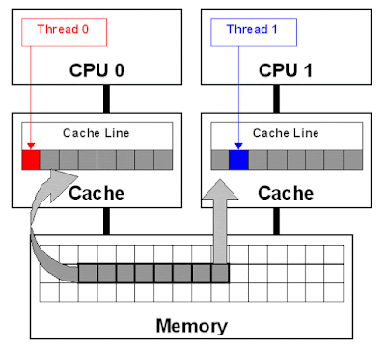

False sharing is very hard to detect because the thread may be accessing completely different global variables that happen to be relatively close together in memory. Like many concurrency issues, the primary way to avoid false sharing is careful code review and aligning your data structure with the size of a cache line.

1. **What is busy spin? Why should you use it?**

Busy spin is one of the technique to wait for events without releasing CPU. It's often done to avoid losing data in CPU cached which is lost if the thread is paused and resumed in some other core. So, if you are working on low latency system where your order processing thread currently doesn't have any order, instead of sleeping or calling wait(), you can just loop and then again check the queue for new messages.

It's only beneficial if you need to wait for a very small amount of time e.g. in microseconds or nanoseconds. LMAX Disrupter framework, a high-performance inter-thread messaging library has a BusySpinWaitStrategy which is based on this concept and uses a busy spin loop for EventProcessors waiting on the barrier.

1. **How do you take thread dump in Java?**

You can take a thread dump of Java application in Linux by using kill -3 PID, where PID is the process id of Java process. In Windows, you can press Ctrl + Break. This will instruct JVM to print thread dump in standard out or err and it could go to console or log file depending upon your application configuration.

1. **Is Swing thread-safe?**

No, Swing is not thread-safe. You cannot update Swing components e.g. JTable, JList or JPanel from any thread, in fact, they must be updated from GUI or AWT thread. That's why swings provide invokeAndWait() and invokeLater() method to request GUI update from any other threads.

This methods put update request in AWT threads queue and can wait till update or return immediately for an asynchronous update.

1. **What is a thread local variable in Java?**

Thread-local variables are variables confined to a thread, its like thread's own copy which is not shared between multiple threads. Java provides a ThreadLocal class to support thread-local variables. It's one of the many ways to achieve thread-safety.

Though be careful while using thread local variable in managed environment e.g. with web servers where worker thread out lives any application variable. Any thread local variable which is not removed once its work is done can potentially cause a memory leak in Java application.

1. **Write wait-notify code for producer-consumer problem?**

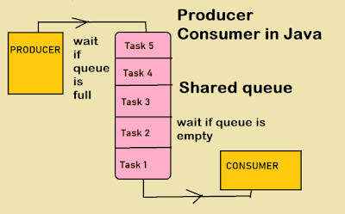

/**

* Java program to solve Producer Consumer problem using wait and notify

* method in Java. Producer Consumer is also a popular concurrency design pattern.

*

* @author Javin Paul

*/

public class ProducerConsumerSolution {

>public static void main(String args[]) {

>>Vector sharedQueue = new Vector();

>>int size = 4;

>>Thread prodThread = new Thread(new Producer(sharedQueue, size), "Producer");

>>Thread consThread = new Thread(new Consumer(sharedQueue, size), "Consumer");

>>prodThread.start();

>>consThread.start();

>}

}

class Producer implements Runnable {

>private final Vector sharedQueue;

>private final int SIZE;

>public Producer(Vector sharedQueue, int size) {

>>this.sharedQueue = sharedQueue;

>>this.SIZE = size;

>}

>@Override

>public void run() {

>>for (int i = 0; i < 7; i++) {

>>>System.out.println("Produced: " + i);

>>>try {

>>>>produce(i);

>>>} catch (InterruptedException ex) {

>>>>Logger.getLogger(Producer.class.getName()).log(Level.SEVERE, null, ex);

>>>}

>>}

>}

>private void produce(int i) throws InterruptedException {

>>//wait if the queue is full

>>while (sharedQueue.size() == SIZE) {

>>>synchronized(sharedQueue) {

>>>>System.out.println("The queue is full " + Thread.currentThread().getName() +

>>>>>" is waiting , size: " + sharedQueue.size());

>>>>sharedQueue.wait();

>>>}

>>}

>>//producing element and notify consumers

>>synchronized(sharedQueue) {

>>>sharedQueue.add(i);

>>>sharedQueue.notifyAll();

>>}

>}

}

class Consumer implements Runnable {

>private final Vector sharedQueue;

>private final int SIZE;

>public Consumer(Vector sharedQueue, int size) {

>>this.sharedQueue = sharedQueue;

>>this.SIZE = size;

>}

>@Override

>public void run() {

>>while (true) {

>>>try {

>>>>System.out.println("Consumed: " + consume());

>>>>Thread.sleep(50);

>>>} catch (InterruptedException ex) {

>>>>Logger.getLogger(Consumer.class.getName()).log(Level.SEVERE, null, ex);

>>>}

>>}

>}

>private int consume() throws InterruptedException {

>>//wait if the queue is empty

>>while (sharedQueue.isEmpty()) {

>>>synchronized(sharedQueue) {

>>>>System.out.println("The queue is empty " + Thread.currentThread().getName() +

>>>>>" is waiting , size: " + sharedQueue.size());

>>>>sharedQueue.wait();

>>>}

>>}

>>//Otherwise consume element and notify the waiting producer

>>synchronized(sharedQueue) {

>>>sharedQueue.notifyAll();

>>>return (Integer) sharedQueue.remove(0);

>>}

>}

}

Output:

Produced: 0

The queue is empty Consumer is waiting, size: 0

Produced: 1

Consumed: 0

Produced: 2

Produced: 3

Produced: 4

Produced: 5

The queue is full Producer is waiting, size: 4

Consumed: 1

Produced: 6

The queue is full Producer is waiting, size: 4

Consumed: 2

Consumed: 3

Consumed: 4

Consumed: 5

Consumed: 6

The queue is empty Consumer is waiting, size: 0

1. **Write code for thread-safe Singleton in Java?**

Using enum:

public enum Singleton{

>INSTANCE;

>public void show(){

>>System.out.println("Singleton using Enum in Java");

>}

}

//You can access this Singleton as Singleton.INSTANCE and call any method like below

Singleton.INSTANCE.show();

Using static field initialization:

public class Singleton{

>private static final Singleton INSTANCE = new Singleton();

>private Singleton(){ }

>public static Singleton getInstance(){

>>return INSTANCE;

>}

>public void show(){

>>System.out.println("Singleon using static initialization in Java");

>}

}

//Here is how to access this Singleton class

Singleton.getInstance().show();

1. **The difference between sleep and wait in Java?**

Though both are used to pause currently running thread, sleep() is actually meant for short pause because it doesn't release lock, while wait() is meant for conditional wait and that's why it release lock which can then be acquired by another thread to change the condition on which it is waiting.

1. **What is an immutable object? How do you create an Immutable object in Java?**

Immutable objects are those whose state cannot be changed once created. Any modification will result in a new object e.g. String, Integer, and other wrapper class. Please see the answer for step by step guide to creating Immutable class in Java.

1. **Can we create an Immutable object, which contains a mutable object?**

Yes, its possible to create an Immutable object which may contain a mutable object, you just need to be a little bit careful not to share the reference of the mutable component, instead, you should return a copy of it if you have to. Most common example is an Object which contain the reference of java.util.Date object.

1. **What is the right data type to represent a price in Java?**

BigDecimal if memory is not a concern and Performance is not critical, otherwise double with predefined precision.

1. **How do you convert bytes to String?**

You can convert bytes to the string using string constructor which accepts byte[], just make sure that right character encoding otherwise platform's default character encoding will be used which may or may not be same.

1. **How do you convert bytes to long in Java?**

One method is to convert bytes to string first using the method in the previous question, then using Long.parseLong() you can convert that string to a long value. If the primitive type of long is required instead of the object type, you don’t have to deal with that, autoboxing takes care of it automatically.

1. **Can we cast an int value into byte variable? what will happen if the value of int is larger than byte?**

Yes, we can cast but int is 32 bit long in java while byte is 8 bit long in java so when you cast an int to byte higher 24 bits are lost and a byte can only hold a value from -128 to 128.

1. **There are two classes B extends A and C extends B, Can we cast B into C e.g. C = (C) B?**

No. The reason for that is because C is a derivative of B. If we could cast B into C then the parts of C “would be missing” from B, for instance, if we called a method or modified a variable which exists in C but not in B there would be nothing to call or modify. So as a result, casting a parent class to a derivative class would result in a compile-time error.

1. **Which class contains clone method? Cloneable or Object?**

java.lang.Cloneable is marker interface and doesn't contain any method clone method is defined in the object class. It is also knowing that clone() is a native method means it's implemented in C or C++ or any other native language.

1. **Is ++ operator is thread-safe in Java?**

No it's not a thread safe operator because its involve multiple instructions like reading a value, incriminating it and storing it back into memory which can be overlapped between multiple threads.

1. **Difference between a = a + b and a += b ?**

The += operator implicitly cast the result of addition into the type of variable used to hold the result. When you add two integral variable e.g. variable of type byte, short, or int then they are first promoted to int and them addition happens. If result of addition is more than maximum value of a then a + b will give compile time error but a += b will be ok as shown below

byte a = 127;

byte b = 127;

b = a + b; // error : cannot convert from int to byte

b += a; // ok

1. **Can I store a double value in a long variable without casting?**

No, you cannot store a double value into a long variable without casting because the range of double is more that long and you we need to type cast. It's not dificult to answer this question but many develoepr get it wrong due to confusion on which one is bigger between double and long in Java.

1. **What will this return 3*0.1 == 0.3? true or false?**

This is one of the really tricky questions. Out of 100, only 5 developers answered this question and only of them have explained the concept correctly. The short answer is false because some floating point numbers can not be represented exactly.

1. **Which one will take more memory, an int or Integer?**

An Integer object will take more memory an Integer is the an object and it store meta data overhead about the object and int is primitive type so its takes less space.

1. **Can we use String in the switch case?**

Yes from Java 7 onward we can use String in switch case but it is just syntactic sugar. Internally string hash code is used for the switch.

1. **What is the size of int in 64-bit JVM?**

The size of an int variable is constant in Java, it's always 32-bit irrespective of platform. Which means the size of primitive int is same in both 32-bit and 64-bit Java virtual machine.

1. **A difference between WeakReference and SoftReference in Java?**

Though both WeakReference and SoftReference helps garbage collector and memory efficient, WeakReference becomes eligible for garbage collection as soon as last strong reference is lost but SoftReference even thought it can not prevent GC, it can delay it until JVM absolutely need memory.

1. **How do WeakHashMap works?**

WeakHashMap works like a normal HashMap but uses WeakReference for keys, which means if the key object doesn't have any reference then both key/value mapping will become eligible for garbage collection.

1. **What is -XX:+UseCompressedOops JVM option? Why use it?**

When you go migrate your Java application from 32-bit to 64-bit JVM, the heap requirement suddenly increases, almost double, due to increasing size of ordinary object pointer from 32 bit to 64 bit. This also adversely affect how much data you can keep in CPU cache, which is much smaller than memory. Since main motivation for moving to 64-bit JVM is to specify large heap size, you can save some memory by using compressed OOP. By using -XX:+UseCompressedOops, JVM uses 32-bit OOP instead of 64-bit OOP.

1. **How do you find if JVM is 32-bit or 64-bit from Java Program?**

You can find that by checking some system properties like sun.arch.data.model or os.arch

1. **What is the maximum heap size of 32-bit and 64-bit JVM?**

Theoretically, the maximum heap memory you can assign to a 32-bit JVM is 2^32 which is 4GB but practically the limit is much smaller. It also varies between operating systems e.g. form 1.5GB in Windows to almost 3GB in Solaris. 64-bit JVM allows you to specify larger heap size, theoretically 2^64 which is quite large but practically you can specify heap space up to 100GBs. There are even JVM e.g. Azul where heap space of 1000 gigs is also possible.

1. **Explain Java Heap space and Garbage collection?**

When a Java process is started using java command, memory is allocated to it. Part of this memory is used to create heap space, which is used to allocate memory to objects whenever they are created in the program. Garbage collection is the process inside JVM which reclaims memory from dead objects for future allocation.

1. **Can you guarantee the garbage collection process?**

No, you cannot guarantee the garbage collection, though you can make a request using System.gc() or Runtime.gc() method.

1. **How do you find memory usage from Java program? How much percent of the heap is used?**

You can use memory related methods from java.lang.Runtime class to get the free memory, total memory and maximum heap memory in Java. By using these methods, you can find out how many percents of the heap is used and how much heap space is remaining. Runtime.freeMemory() return amount of free memory in bytes, Runtime.totalMemory() returns total memory in bytes and Runtime.maxMemory() returns maximum memory in bytes.

1. **What is a.hashCode() used for? How is it related to a.equals(b)?**

hashCode() method returns an int hash value corresponding to an object. It's used in hash based collection classes e.g Hashtable, HashMap, LinkedHashMap and so on. It's very tightly related to equals() method. According to Java specification, two objects which are equal to each other using equals() method must have same hash code.

1. **What is a compile time constant in Java? What is the risk of using it?**

public static final variables are also known as a compile time constant, the public is optional there. They are replaced with actual values at compile time because compiler know their value up-front and also knows that it cannot be changed during run-time.

One of the problem with this is that if you happened to use a public static final variable from some in-house or third party library and their value changed later than your client will still be using old value even after you deploy a new version of JARs. To avoid that, make sure you compile your program when you upgrade dependency JAR files

1. **Difference between poll() and remove() method?**

Both poll() and remove() take out the object from the Queue but if poll() fails then it returns null but if remove fails it throws Exception.

1. **The difference between LinkedHashMap and PriorityQueue in Java?**

PriorityQueue guarantees that lowest or highest priority element always remain at the head of the queue, but LinkedHashMap maintains the order on which elements are inserted. When you iterate over a PriorityQueue, iterator doesn't guarantee any order but iterator of LinkedHashMap does guarantee the order on which elements are inserted.

1. **What is a couple of ways that you could sort a collection?**

You can either use the Sorted collection like TreeSet or TreeMap or you can sort using the ordered collection like a list and using Collections.sort() method.

1. **How do you print Array in Java?**

You can print an array by using the Arrays.toString() and Arrays.deepToString() method. Since array doesn't implement toString() by itself, just passing an array to System.out.println() will not print its contents but Arrays.toString() will print each element.

1. **LinkedList in Java is doubly or singly linked list?**

It's a doubly linked list, you can check the code in JDK. In Eclipse, you can use the shortcut, Ctrl + T to directly open this class in Editor.

1. **Which kind of tree is used to implement TreeMap in Java?**

A Red Black tree is used to implement TreeMap in Java.

1. **How HashSet works internally in Java?**

HashSet is internally implemented using an HashMap. Since a Map needs key and value, a default value is used for all keys. Similar to HashMap, HashSet doesn't allow duplicate keys and only one null key, I mean you can only store one null object in HashSet.

1. **Write code to remove elements from ArrayList while iterating?**

Key here is to check whether candidate uses ArrayList's remove() or Iterator's remove(). Here is the sample code which uses right way to remove elements from ArrayList while looping over and avoids ConcurrentModificationException.

Here is the Java program to demonstrate one scenario where you get the ConcurrentModificationException even if just one thread is modifying the ArrayList. In this example, we are looping over ArrayList using advanced for loop and removing selected elements, but because we are using ArrayList's remove() method.

/**

* Java Program to demonstrate how to deal with

* ConcurrentModificationException.

* Unlike the name suggests, this error can come even if only

* one thread is modifying the collection e.g. List.

* It happens when you modify collection

* while iterating over it e.g. adding new element or removing elements.

*

* If you want to remove elements while traversing list then

* make sure you use Iterator's remove() method or not ArrayList's remove()

* method() to avoid ConcurrentModificationExcetpion.

*

* @author WINDOWS 8

*

*/

public class ConcurrentModExceptionDemo{

>public static void main(String args[]) {

>>List<String> listOfPhones = new ArrayList<String>(Arrays.asList(

>>>>"iPhone 6S", "iPhone 6", "iPhone 5", "Samsung Galaxy 4",

>>>> "Lumia Nokia"));

>>System.out.println("list of phones: " + listOfPhones);

>>// Iterating and removing objects from list

>>// This is wrong way, will throw ConcurrentModificationException

>>for(String phone : listOfPhones){

>>>if(phone.startsWith("iPhone")){

>>> // listOfPhones.remove(phone); // will throw exception

>>>}

>>}

>>// The Right way, iterating elements using Iterator's remove() method

>>for(Iterator<String> itr = listOfPhones.iterator();

>>>>>>>> itr.hasNext();){>>>

>>>String phone = itr.next();>>>

>>>if(phone.startsWith("iPhone")){

>>>>// listOfPhones.remove(phone); // wrong again

>>>>itr.remove(); // right call

>>>}

>>}

>>System.out.println("list after removal: " + listOfPhones);

>}

}

Output :

list of phones: [iPhone 6S, iPhone 6, iPhone 5, Samsung Galaxy 4,

Lumia Nokia]

list after removal: [Samsung Galaxy 4, Lumia Nokia]

If you uncomment the commented code in the first loop and second loop, you will get the following exception:

Exception in thread "main" java.util.ConcurrentModificationException

at java.util.ArrayList$Itr.checkForComodification(Unknown Source)

at java.util.ArrayList$Itr.next(Unknown Source)

at dto.ReverseArrayInPlace.main(ReverseArrayInPlace.java:28)

because we are using ArrayList's remove() method. In the second example, we have used the remove() method of Iterator and that's why we are successfully able to delete selected elements from the ArrayList without ConcurrentModificationException.

1. **Can I write my own container class and use it in the for-each loop?**

Yes, you can write your own container class. You need to implement the Iterable interface if you want to loop over advanced for loop in Java, though. If you implement Collection then you by default get that property.

1. **What is default size of ArrayList and HashMap in Java?**

As of Java 7 now, default size of ArrayList is 10 and default capacity of HashMap is 16, it must be power of 2. Here is code snippet from ArrayList and HashMap class :

// from ArrayList.java JDK 1.7

private static final int DEFAULT_CAPACITY = 10;

//from HashMap.java JDK 7

static final int DEFAULT_INITIAL_CAPACITY = 1 << 4; // aka 16

1. **Is it possible for two unequal objects to have the same hashcode?**

Yes, two unequal objects can have same hashcode that's why collision happen in a hashmap.

the equal hashcode contract only says that two equal objects must have the same hashcode it doesn't say anything about the unequal object.

1. **Can two equal object have the different hash code?**

No, thats not possible according to hash code contract.

1. **Can we use random numbers in the hashcode() method?**

No, because hashcode of an object should be always same.

1. **Why you need to override hashcode, when you override equals in Java?**

Because equals have code contract mandates to override equals and hashcode together .since many container class like HashMap or HashSet depends on hashcode and equals contract.

1. **What best practices you follow while writing multi-threaded code in Java?**

Here are couple of best practices which I follow while writing concurrent code in Java:

* Always name your thread, this will help in debugging.
* minimize the scope of synchronization, instead of making whole method synchronized, only critical section should be synchronized.
* prefer volatile over synchronized if you can can.
* use higher level concurrency utilities instead of wait() and notify for inter thread communication e.g. BlockingQueue, CountDownLatch and Semaphore.
* Prefer concurrent collection over synchronized collection in Java. They provide better scalability.

1. **Tell me few best practices you apply while using Collections in Java?**

Here are couple of best practices I follow while using Collection classes from Java:

* Always use the right collection e.g. if you need non-synchronized list then use ArrayList and not Vector.
* Prefer concurrent collection over synchronized collection because they are more scalable.
* Always use interface to a represent and access a collection e.g. use List to store ArrayList, Map to store HashMap and so on.
* Use iterator to loop over collection.
* Always use generics with collection.

1. **Can you tell us at least 5 best practice you use while using threads in Java?**

This is similar to the previous question and you can use the answer given there. Particularly with thread, you should:

* name your thread
* keep your task and thread separate, use Runnable or Callable with thread pool executor.
* use thread pool
* use volatile to indicate compiler about ordering, visibility, and atomicity.
* avoid thread local variable because incorrect use of ThreadLocal class in Java can create a memory leak.

1. **Name 5 IO best practices?**

IO is very important for performance of your Java application. Ideally you should avoid IO in critical path of your application. Here are couple of Java IO best practices you can follow:

* Use buffered IO classes instead of reading individual bytes and char.
* Use classes from NIO and NIO2
* Always close streams in finally block or use try-with-resource statements.
* use memory mapped file for faster IO.

If a Java candidate doesn't know about IO and NIO, especially if he has at least 2 to 4 years of experience, he needs some reading.

1. **Name 5 JDBC best practices your follow?**

Another good Java best practices for experienced Java developer of 7 to 8 years experience. Why it's important? because they are the ones which set the trend in the code and educate junior developers. There are many best practices and you can name as per your comfort and convenience. Here are some of the more common ones:

* use batch statement for inserting and updating data.
* use PreparedStatement to avoid SQL exception and better performance.
* use database connection pool
* access resultset using column name instead of column indexes.
* Don't generate dynamic SQL by concatenating String with user input.

1. **Name couple of method overloading best practices in Java?**

Here are some best practices you can follow while overloading a method in Java to avoid confusion with auto-boxing:

* Don't overload method where one accepts int and other accepts Integer.
* Don't overload method where number of argument is same and only order of argument is different.
* Use varargs after overloaded methods has more than 5 arguments.

1. **Does SimpleDateFormat is safe to use in the multi-threaded program?**

No, unfortunately, DateFormat and all its implementations including SimpleDateFormat is not thread-safe, hence should not be used in the multi-threaded program until external thread-safety measures are applied e.g. confining SimpleDateFormat object into a ThreadLocal variable.

If you don't do that, you will get an incorrect result while parsing or formatting dates in Java. Though, for all practical date time purpose, I highly recommend joda-time library.

1. **How do you format a date in Java? e.g. in the ddMMyyyy format?**

You can either use SimpleDateFormat class or joda-time library to format date in Java. DateFormat class allows you to format date on many popular formats. Please see the answer for code samples to format date into different formats e.g. dd-MM-yyyy or ddMMyyyy